## install git (version control system) to ubuntu

sudo apt-get install git git-core git-gui git-doc

note: in case need remove the git , use the following command

sudo apt-get remove git git-core git-gui git-doc

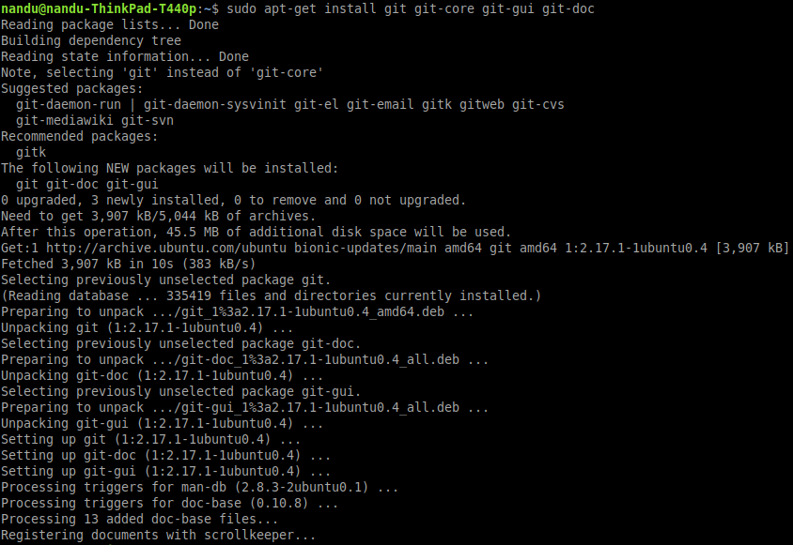

## check the git verison

git --version



## Signup and create a account on GitHub

https://github.com/

## Add your github email and username to git

git config --global user.email "yourGitHub@email.com"

git config --global user.name "yourGitHubusername"

note: change the email and user name as per the account used in hithub

## create a new git repository

<https://github.com/new>

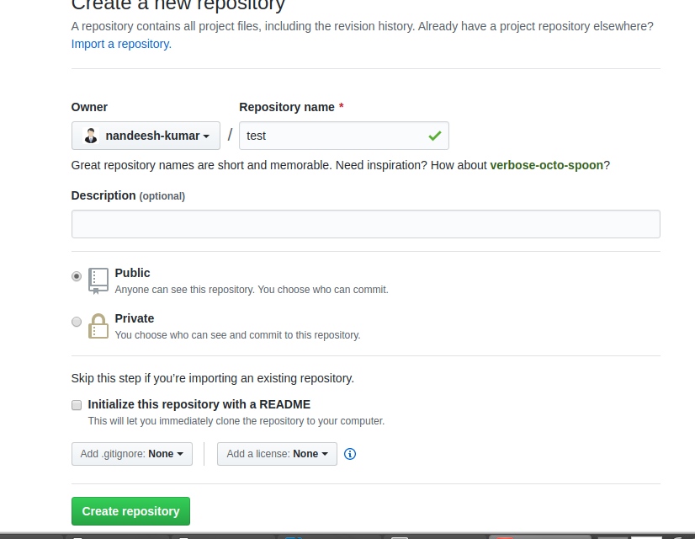

## create a empty directory and run the following command

git init

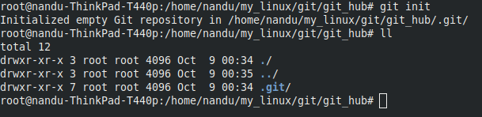

when repository already exists and have file the use following commands to clone it

git clone <remote git url>

e.g: git clone <https://github.com/nandeesh-kumar/test.git>

to get all latest file from repository

git pull origin master

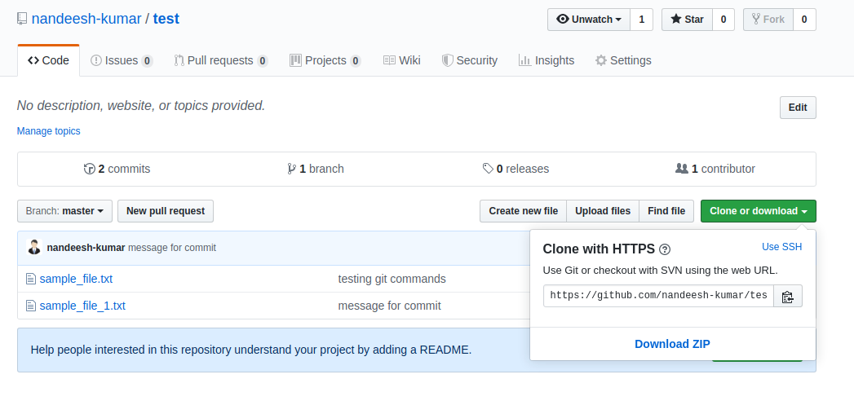

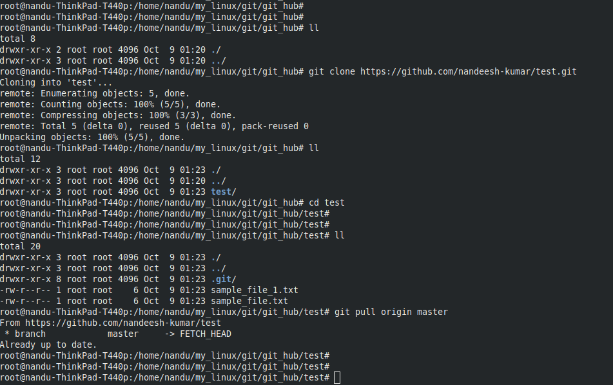

## set up the remote, which tells git where the repository is located

git remote add origin https://github.com/<USER_NAME>/<REPOSITORY_NAME>.git

e.g git remote add origin https://github.com/nandeesh-kumar/test.git

ignore the error “remote origin already exists” and contibue to add file



git status

can be used to check the changes made in local repository

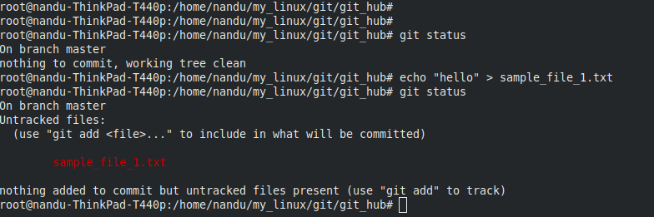

git remote -v

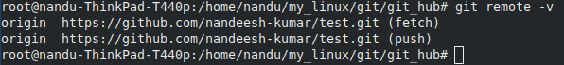

## add file to git

git add <file_name>

if we have a lot of files to be transferred from the folder to our git account, then we can use the command.

git add .



git status

to check the changes made to local directory

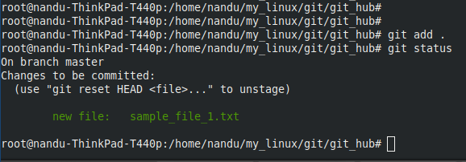

## commit changes

git commit -m ‘your_message’

git commit -a -m "message for commit"

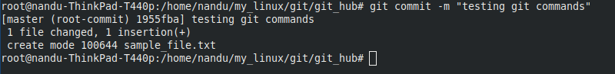

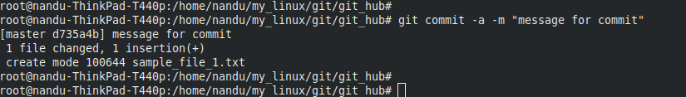

## push changes to git hub reository

git push origin master

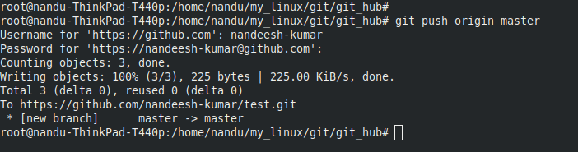

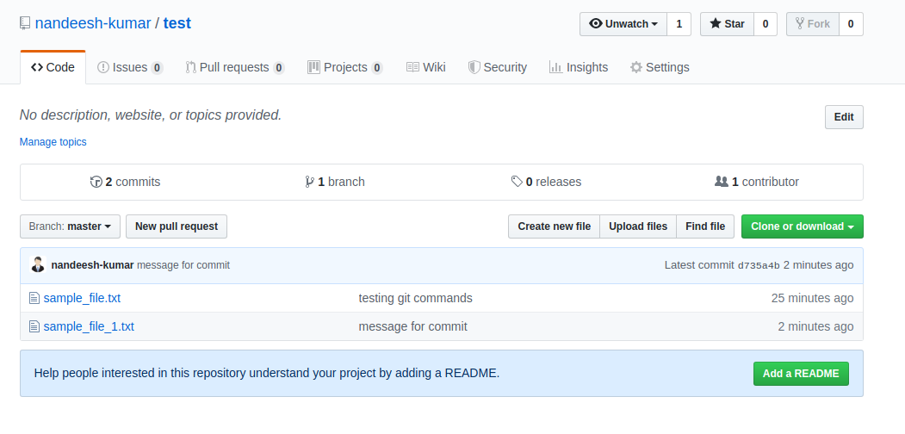

## links

<https://linuxtechlab.com/how-to-install-github-on-ubuntu-step-by-step/>

<https://www.geeksforgeeks.org/git-lets-get-into-it/>

<https://www.geeksforgeeks.org/how-to-install-configure-and-use-git-on-ubuntu/>

<https://www.geeksforgeeks.org/ultimate-guide-git-github/>

<https://www.geeksforgeeks.org/list-useful-github-commands/>