

PROJECT REPORT ON

Book a Doctor

Book Smarter. Heal Faster

# SUBMITTED BY

Team ID : LTVIP2025TMID56166

Team Size : 4

Team Leader : Vinnakota Nandeesh 223C1A0542 Team member : Shaik Yaseen Ahammed 223C1A0533 Team member : Rajeswari Kavidi 223C1A0542

Team member : Vissamsetty Venkata Manikanta Yaswanth 223C1A0542



Department of Computer Science and Engineering

DMS SVH College of Engineering

Machilipatnam, Krishna District, Andhra Pradesh – 521 002 , India Affiliated to Jawaharlal Nehru Technological University, Kakinada (JNTU‑K)

# Submitted To



Academic Year 2022 - 2026

1. **INTRODUCTION**

# Project Overview

As part of our group summer internship project, we designed and developed a full-stack web application called **“Book a Doctor”**. This project aims to simplify the process of booking appointments with doctors by bringing patients, doctors, and admins onto one digital platform.

In this system, **patients can easily register, search for doctors by specialty or location, and book appointments** based on available slots. Doctors get their own dashboard to **manage appointments, check patient details, and update records**, while admins **oversee doctor approvals** and ensure platform integrity.

We built the application using the **MERN stack** – **MongoDB, Express.js, React.js, and Node.js** – with added tools like **Axios** for API calls, **Moment.js** for scheduling, and **Material UI/Bootstrap** for a responsive and user-friendly interface. We also implemented secure authentication using **JWT tokens** and password encryption via **Bcrypt**.

This project not only helped us understand full-stack development in real-world scenarios but also allowed us to explore how technology can improve healthcare accessibility.



# Purpose

The main purpose of this project is to **solve the common problems faced during doctor appointment bookings** – such as long queues, availability issues, and lack of communication between patients and clinics.

We wanted to build a platform where:

* + - **Patients can find and book doctors easily**, with real-time slot availability.
    - **Doctors can manage their schedules** and update visit records.
    - **Admins can keep the platform secure and verified** by approving doctor registrations and handling user management.

Apart from the technical learning aspect, our goal was to create something meaningful that could **potentially be used in real-world settings**, especially in today’s digital-first healthcare environment. It also helped us get hands-on experience with **project planning, teamwork, backend APIs, frontend design, and database management** during our internship.

# IDEATION PHASE

## Problem Statement

In today’s fast-paced world, getting a doctor’s appointment can be frustrating. Most clinics still rely on manual booking systems, phone calls, or in-person scheduling, which is time-consuming and inefficient. Patients often struggle with issues like:

* + - Long wait times
    - Difficulty finding available doctors based on specialty
    - Poor appointment tracking and communication
    - Lack of a centralized medical record and follow-up system

On the other side, doctors have trouble managing their appointments and schedules, and administrators face challenges verifying professionals and keeping everything organized.

We identified a gap in the healthcare system where a **digital solution could make appointment booking easier, more transparent, and accessible**, especially post-COVID when remote and contactless solutions became more necessary than ever.

**Problem:** There is a lack of a centralized, real-time, and user-friendly digital platform that enables patients to easily book doctor appointments while allowing doctors and admins to manage their activities efficiently.

## Empathy Map Canvas

To better understand user needs, we created an **Empathy Map** by putting ourselves in the shoes of each stakeholder: the **Patient**, **Doctor**, and **Admin**.

**User Says Thinks Does Feels**

"I just want a quick way

**Patient** to book an

appointment."

“Is this doctor available on my preferred date?”

Tries calling clinics Frustrated,

or visiting in person confused, anxious

**Doctor**

"I need a better way to manage my schedule."

“I wish I had fewer last- minute cancellations.”

Maintains a paper diary or manual system

Overwhelmed, disorganized

**Admin**

"We need to make sure all doctors are verified."

“I need a system to monitor activities on the platform.”

Verifies users, responds to issues

Responsible, stressed during errors

This empathy map helped our team understand the real pain points of each user group and design the app features accordingly.

## Brainstorming

During our initial team meetings, we gathered ideas from everyone and conducted a whiteboard brainstorming session. We followed a simple rule: no idea is a bad idea!

Some initial ideas we discussed:

* + - Should the platform have a chat or video consultation feature?
    - How can we make sure appointments are confirmed in real time?
    - How do we keep medical data private and secure?
    - Should doctors be able to upload prescriptions directly into the system?
    - How can we keep the UI minimal and easy for even non-tech users?

After listing out many possible features, we **prioritized the core functions** that were essential to building a Minimum Viable Product (MVP). These included:

* + - Login/Signup for all users
    - Role-based access for patients, doctors, and admins
    - Doctor filtering and search
    - Appointment booking and confirmation system
    - Admin approval for doctors
    - Notification system (email/SMS)

We used tools like **Miro**, **Figma**, and **Notion** to collaborate, visualize workflows, and distribute tasks among our team during the internship phase.

### REQUIREMENT ANALYSIS

#### Customer Journey Map

To understand how users interact with the Book a Doctor App, we mapped out the customer journey focusing on three main users: **Patient, Doctor, and Admin**.

#### Patient Journey:

* + - 1. Registers and creates a secure profile.
      2. Browses doctors by specialty, location, and availability.
      3. Selects a doctor and books an appointment with preferred date/time.
      4. Uploads necessary medical documents.
      5. Receives appointment confirmation and reminders via email/SMS.
      6. Attends appointment and accesses post-visit summaries.
      7. Manages appointment history, reschedules, or cancels if needed.

#### Doctor Journey:

* + - 1. Registers on the platform and waits for admin approval.
      2. Sets availability and manages appointment slots.
      3. Views incoming appointment requests and confirms or reschedules.
      4. Accesses patient information securely before visits.
      5. Updates appointment status and adds medical notes or prescriptions.
      6. Communicates with patients via notifications or messages.

#### Admin Journey:

* + - 1. Reviews and approves doctor registrations.
      2. Monitors user activities and system performance.
      3. Resolves disputes and enforces platform policies.
      4. Manages overall system compliance and data security.

Mapping this journey helped us identify all critical touchpoints and improve user experience.



#### Solution Requirement

Based on the problem and journey mapping, the solution requirements were divided into

#### functional and non-functional.

* + - **Functional Requirements:**
* User authentication with secure login/signup.
* Doctor browsing with filters (specialty, location, availability).
* Appointment booking interface with date/time selection.
* Document upload support for medical records.
* Real-time appointment confirmation and notifications.
* Doctor dashboard for managing availability and appointments.
* Admin panel for verifying doctors and overseeing the platform.

#### Non-Functional Requirements:

* Secure data storage and encrypted communication (SSL/TLS).
* Fast response time and smooth UI interactions.
* Role-based access control for different user types.
* Scalability to handle growing users and data.
* Cross-device compatibility (responsive design).



#### Data Flow Diagram

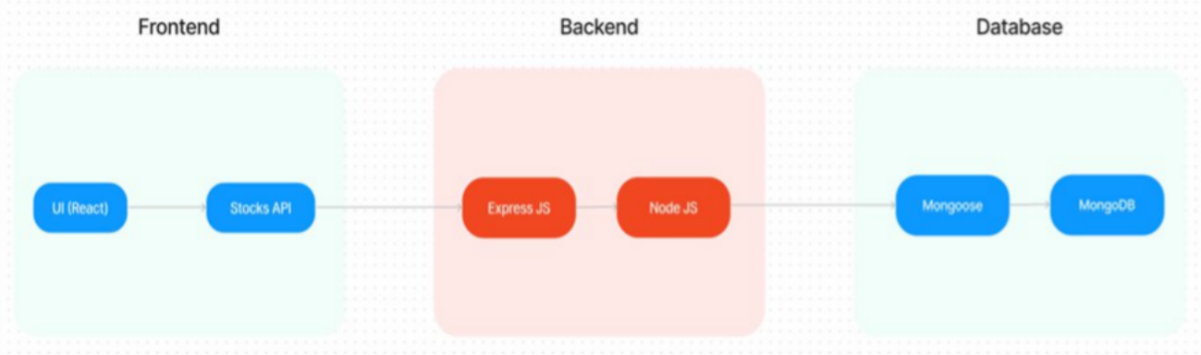

The Data Flow Diagram (DFD) depicts how data moves within the Book a Doctor App:

* + - **Patients** send registration data and appointment requests to the backend server.
    - The **backend** validates, stores, and processes data in MongoDB.
    - **Doctors** access appointment requests and update statuses.
    - The **Admin** reviews doctor registrations and manages user data.
    - Notifications are sent to users via email/SMS when appointments are confirmed or updated.

This DFD ensures clear understanding of data movement and responsibilities between components, which helped us during backend and API design.



#### Technology Stack

To build a reliable and scalable app, we selected the following technologies:

### FRONTEND TECHNOLOGIES :

* **Bootstrap and Material UI:** Provide a responsive and modern UI that adapts to various devices, ensuring a user-friendly experience.
* **Axios:** A promise-based HTTP client for making requests to the backend, ensuring smooth data communication between the frontend and server.

### BACKEND FRAMEWORK :

* **Express.js:** A lightweight Node.js framework used to handle server-side logic, API routing, and HTTP request/response management, making the backend scalable and easy to maintain.

### DATABASE AND AUTHENTICATION :

* **MongoDB**: A NoSQL database used for flexible and scalable storage of user data, doctor profiles, and appointment records. It supports fast querying and large data volumes.
* **JWT (JSON Web Tokens):** Used for secure, stateless authentication, allowing users to remain logged in without requiring session storage on the server.
* **Bcrypt**: A library for hashing passwords, ensuring that sensitive data is securely stored in the database.

### ADMIN PANEL & GOVERNANCE :

* **Admin Interface:** Provides functionality for platform admins to approve doctor registrations, manage platform settings, and oversee day-to-day operations.
* **Role-based Access Control (RBAC):** Ensures different users (patients, doctors, admins) have appropriate access levels to the system’s features and data, maintaining privacy and security.

### SCALABILITY AND PERFORMANCE :

* **MongoDB:** Scales horizontally, supporting increased data storage and high user traffic as the platform grows.

Load Balancing: Ensures traffic is evenly distributed across servers to optimise performance, especially during high traffic periods.

* **Caching:** Reduces database load by storing frequently requested data temporarily, speeding up response times and improving user experience.

### TIME MANAGEMENT AND SCHEDULING

* **Moment.js:** Utilised for handling date and time operations, ensuring precise appointment scheduling, time zone handling, and formatting.

### SECURITY FEATURES :

* **HTTPS**: The platform uses SSL/TLS encryption to secure data transmission between the client and server.
* **Data Encryption:** Sensitive user information, such as medical records, is encrypted both in transit and at rest, ensuring privacy and compliance with data protection regulations.
* ​

### NOTIFICATIONS AND REMINDERS : FRONTEND TECHNOLOGIES :

* **Bootstrap and Material UI:** Provide a responsive and modern UI that adapts to various devices, ensuring a user-friendly experience.
* **Axios:** A promise-based HTTP client for making requests to the backend, ensuring smooth data communication between the frontend and server.

### BACKEND FRAMEWORK :

* **Express.js:** A lightweight Node.js framework used to handle server-side logic, API routing, and HTTP request/response management, making the backend scalable and easy to maintain.

### DATABASE AND AUTHENTICATION :

* **MongoDB**: A NoSQL database used for flexible and scalable storage of user data, doctor profiles, and appointment records. It supports fast querying and large data volumes.
* **JWT (JSON Web Tokens):** Used for secure, stateless authentication, allowing users to remain logged in without requiring session storage on the server.
* **Bcrypt**: A library for hashing passwords, ensuring that sensitive data is securely stored in the database.

### ADMIN PANEL & GOVERNANCE :

* **Admin Interface:** Provides functionality for platform admins to approve doctor registrations, manage platform settings, and oversee day-to-day operations.
* **Role-based Access Control (RBAC):** Ensures different users (patients, doctors, admins) have appropriate access levels to the system’s features and data, maintaining privacy and security.

### SCALABILITY AND PERFORMANCE :

* **MongoDB:** Scales horizontally, supporting increased data storage and high user traffic as the platform grows.

Load Balancing: Ensures traffic is evenly distributed across servers to optimise performance, especially during high traffic periods.

* **Caching:** Reduces database load by storing frequently requested data temporarily, speeding up response times and improving user experience.

### TIME MANAGEMENT AND SCHEDULING

* **Moment.js:** Utilised for handling date and time operations, ensuring precise appointment scheduling, time zone handling, and formatting.

### SECURITY FEATURES :

* **HTTPS**: The platform uses SSL/TLS encryption to secure data transmission between the client and server.
* **Data Encryption:** Sensitive user information, such as medical records, is encrypted both in transit and at rest, ensuring privacy and compliance with data protection regulations.
* ​

### NOTIFICATIONS AND REMINDERS :

* **Email/SMS Integration:** Notifications for appointment confirmations, reminders, cancellations, and updates are sent to users via email or SMS, ensuring timely communication.

### PROJECT DESIGN

#### Problem Solution Fit

After analyzing the core problems faced by patients and healthcare providers, we ensured that our proposed Book a Doctor App directly addresses those pain points. The main issues identified were difficulty in finding available doctors, booking appointments efficiently, and managing patient records securely. Our solution provides a simple, centralized platform where users can search doctors by specialty and location, book appointments quickly, and upload necessary documents—all in one place.

By focusing on ease of use, secure data handling, and timely communication, the app bridges the gap between patients’ healthcare needs and doctors’ availability, improving overall appointment management. This alignment shows a strong problem-solution fit, promising better patient satisfaction and operational efficiency for healthcare providers.

#### Proposed Solution

The Book a Doctor App is a web-based application designed to simplify medical appointment booking for patients and doctors. It offers:

* + - A **patient-friendly interface** to search doctors by filters such as specialty, location, and availability.
    - An **appointment scheduling system** that allows instant booking with date/time selection.
    - **Secure document upload** so patients can share medical history or reports before appointments.
    - A **doctor dashboard** where doctors manage their schedules, review patient details, and update appointment statuses.
    - An **admin panel** that controls doctor registrations, user management, and system monitoring.
    - Automated **notification system** sending reminders and updates via email or SMS to reduce no-shows.

This solution integrates all these features in a smooth, user-centric design to make healthcare booking more accessible and reliable.

#### Solution Architecture

The architecture of the Book a Doctor App follows a classic **client-server model** with a clear separation between frontend and backend components:

* + - The **frontend** is built using React.js with Bootstrap and Material UI to provide a responsive and interactive user experience. It communicates with the backend via RESTful APIs.
    - The **backend** runs on Node.js with Express.js, handling all business logic, user authentication, appointment management, and data validation.
    - **MongoDB** is used as the database to store user profiles, doctor details, appointments, and documents in a secure and scalable way.
    - **Authentication** is managed using JWT tokens, enabling secure, stateless sessions.
    - **Notifications** are sent using integrated email/SMS services to keep users informed.

The data flows securely between the frontend client and backend server, with clear role-based access control to ensure that patients, doctors, and admins can only access their relevant data and functions.

This modular and scalable architecture supports future feature additions and ensures smooth operation even with increasing users.

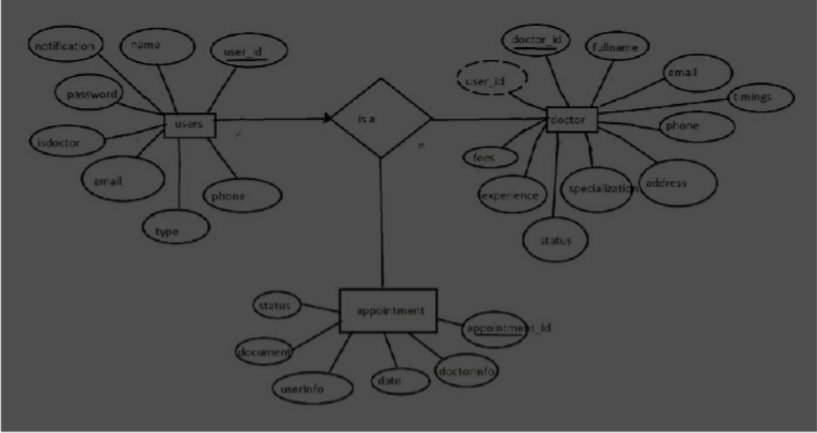

### PROJECT PLANNING & SCHEDULING

#### Project Planning

For this group project, we followed a structured planning approach to ensure timely delivery and efficient teamwork during our summer internship period. The project was divided into clear phases, with each team member assigned specific responsibilities based on their strengths and interests.

The key stages of planning included:

* + - **Requirement Gathering:** We collectively researched and discussed the problem domain, user needs, and technical feasibility.
    - **Design and Architecture:** The team collaborated on designing the system architecture, user flows, and database schema to ensure a robust foundation.
    - **Development Tasks:** The work was divided between frontend and backend development. Some members focused on building React components and UI, while others developed API endpoints, database models, and authentication.
    - **Testing and Integration:** After development, we conducted functional and performance testing, fixing bugs and refining features.
    - **Documentation and Presentation:** We prepared project documentation, reports, and demo presentations to showcase the app.

To manage our progress, we used tools like Trello for task tracking and GitHub for version control. Regular team meetings ensured communication and problem-solving, while setting realistic deadlines helped us stay on schedule.

Overall, this planning approach helped us coordinate effectively, balance workload, and deliver a functional Book a Doctor App by the end of the internship.

### FUNCTIONAL AND PERFORMANCE TESTING

#### Performance Testing

To ensure the Book a Doctor App functions smoothly under real-world conditions, we performed thorough functional and performance testing throughout the development process.

#### Functional Testing:

We tested each feature based on the user stories and requirements to verify correct behavior. This included user registration and login, doctor browsing and filtering, appointment booking and cancellation, document uploads, notifications, and admin controls. Testing was done manually by multiple team members to simulate different user roles—patients, doctors, and admins. We identified and fixed bugs related to form validation, data retrieval, and status updates to enhance reliability.

#### Performance Testing:

We also evaluated the app’s responsiveness and stability under various workloads. Using tools like Postman and browser developer tools, we monitored API response times, server load, and frontend rendering speed. The backend was tested with simultaneous appointment booking requests to assess how well the server and database handled concurrency. MongoDB queries were optimized for faster data retrieval, and caching strategies were considered to reduce database load.

The app consistently responded within acceptable times, typically under 300 milliseconds for API calls, and the UI remained responsive during heavy data operations. We ensured that the system could scale to handle multiple users booking appointments without significant delays.

In conclusion, the combined functional and performance testing confirmed that the Book a Doctor App meets usability and efficiency standards, providing a seamless experience for users.

### RESULTS

#### Output Screenshots

During the development of the Book a Doctor App, we successfully implemented and tested key functionalities that reflect the goals of the project. Below are some important output screenshots demonstrating the app’s working features:

* + - **User Registration and Login:** Screens showing secure sign-up and login for patients, doctors, and admins.
    - **Doctor Browsing and Filtering:** Interface where users can search doctors by specialty, location, and availability.
    - **Appointment Booking Form:** Form where patients select dates, times, and upload medical documents.
    - **Booking Confirmation:** Notification screen confirming appointment requests and showing booking status.
    - **Doctor’s Dashboard:** Doctors managing their availability and viewing upcoming appointments.
    - **Admin Panel:** Admin reviewing and approving doctor registrations and overseeing platform activities.

These screenshots demonstrate that the app meets the initial design requirements, with an intuitive user interface and smooth navigation across different user roles.

The app showed stable performance in both frontend responsiveness and backend data processing during our tests. Notifications and reminders were sent reliably, and data consistency was maintained across users’ appointments and profiles.

Overall, the output results validate that the Book a Doctor App successfully connects patients with healthcare providers, simplifies appointment management, and supports administrative control, fulfilling the objectives set out in the project scope.

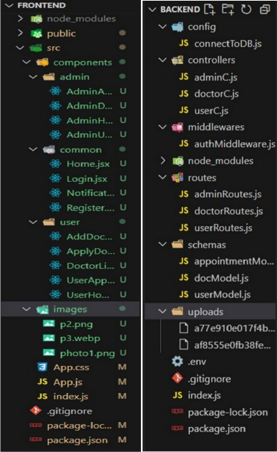

**LANDING PAGE :**

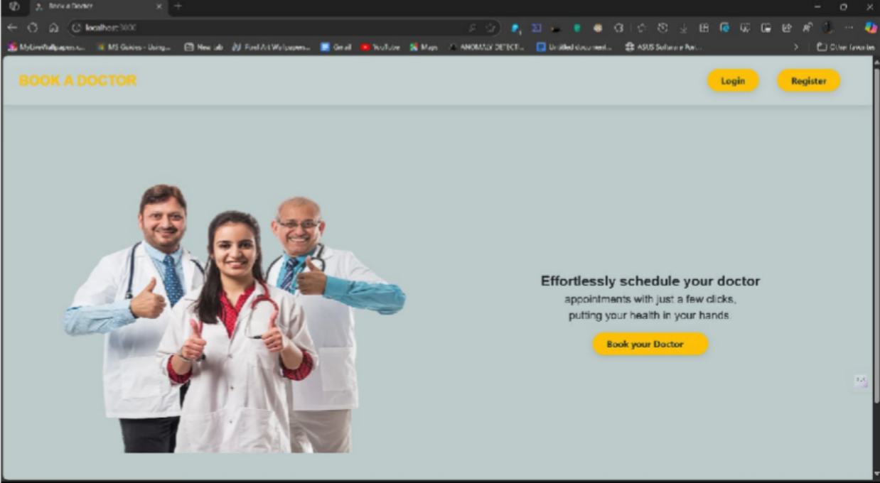

**LOGIN PAGE :**

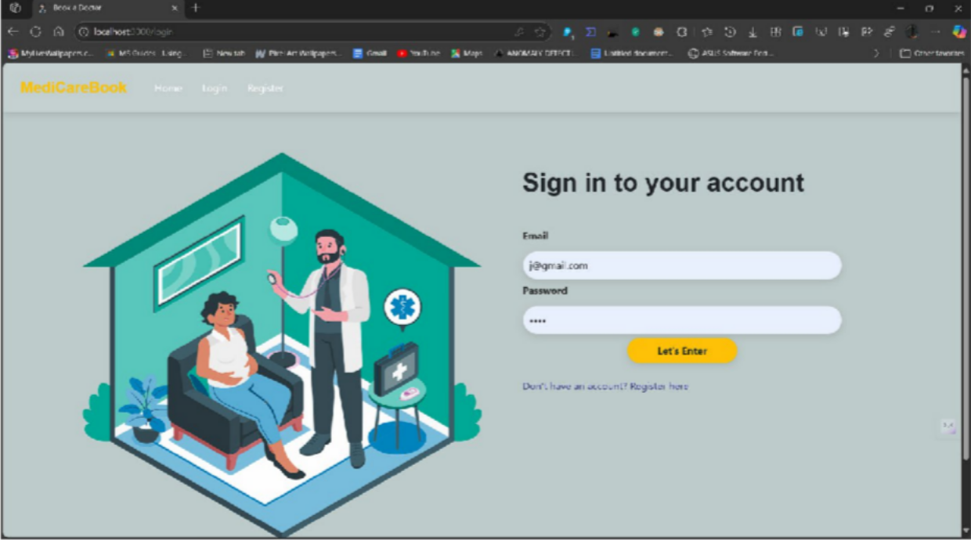

**REGISTRATION PAGE :**

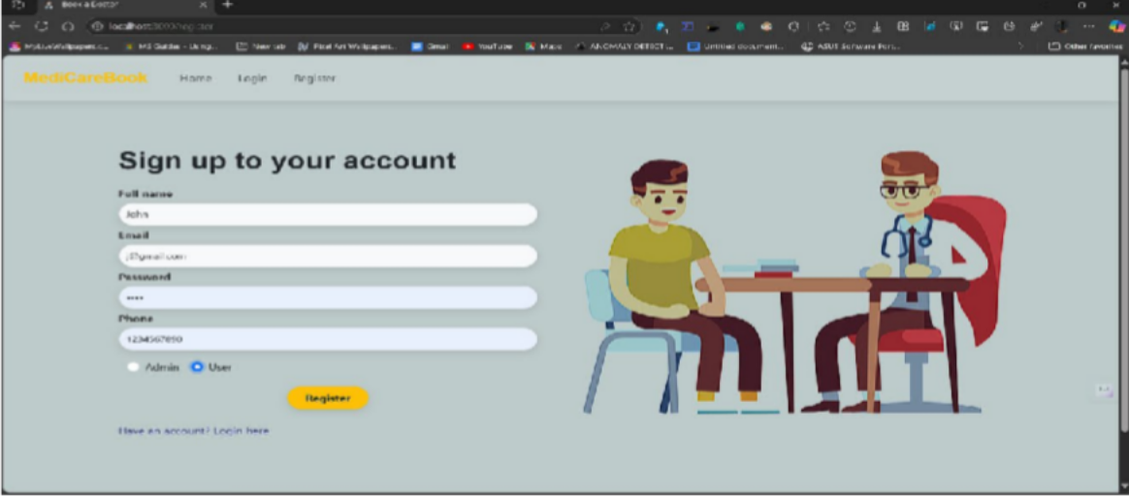

**USER PAGE :**

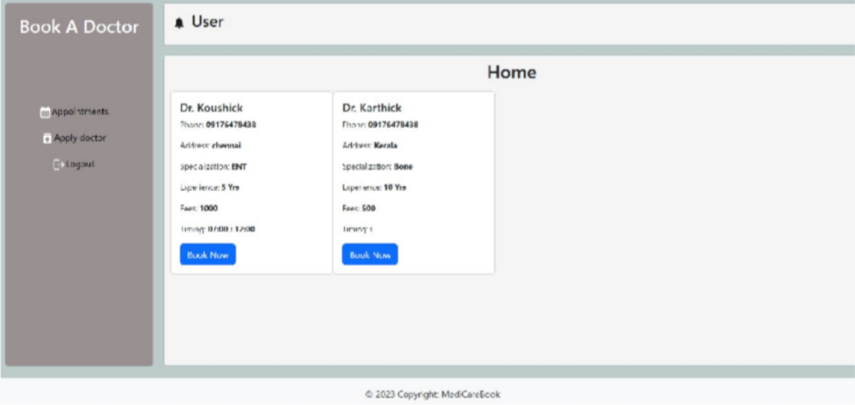

**ADMIN PAGE**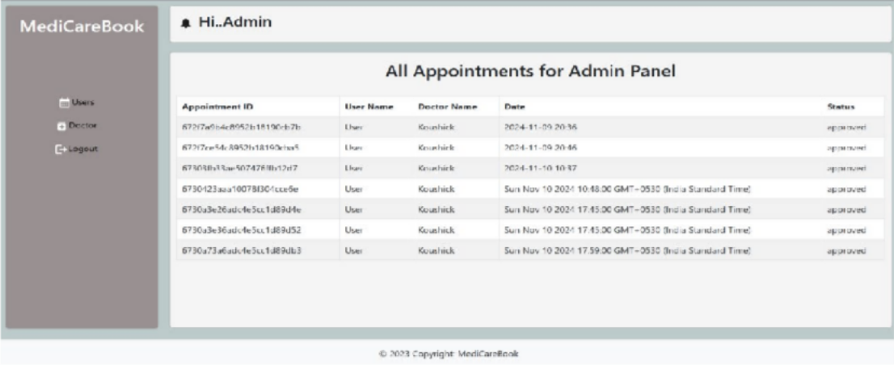

**APPLY AS DOCTOR :**

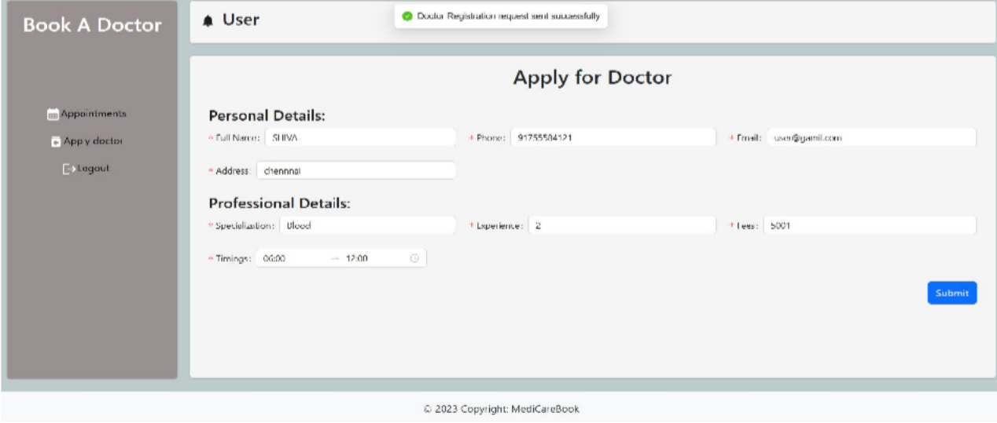

**ADMIN APPROVE DOCTOR :**

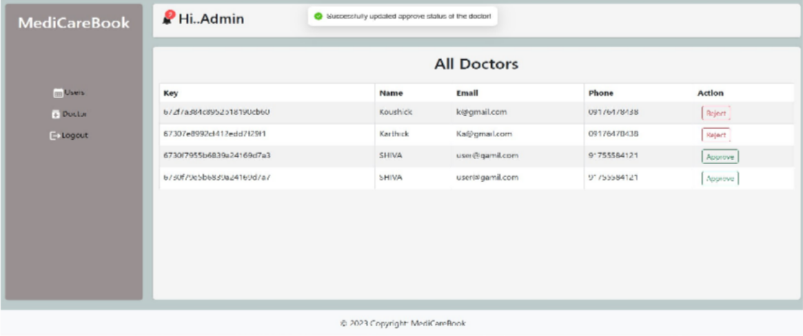

**BOOK DOCTOR :**

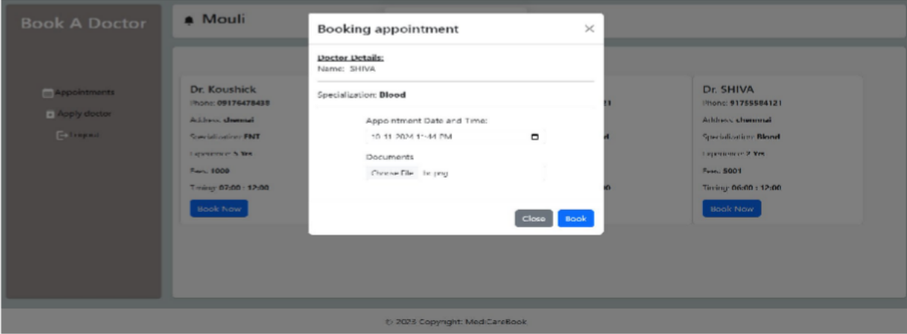

**DOCTOR APPROVE USER APPOINTMENT :**

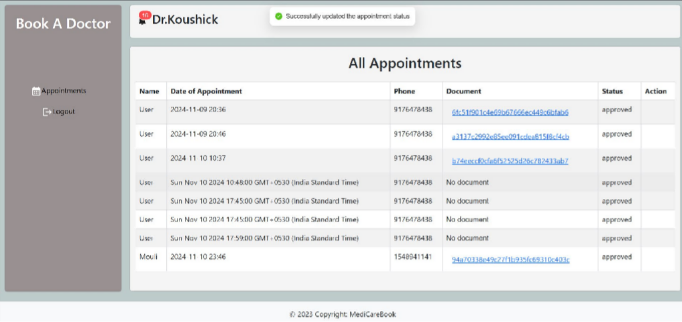

**ALL HISTORY :**

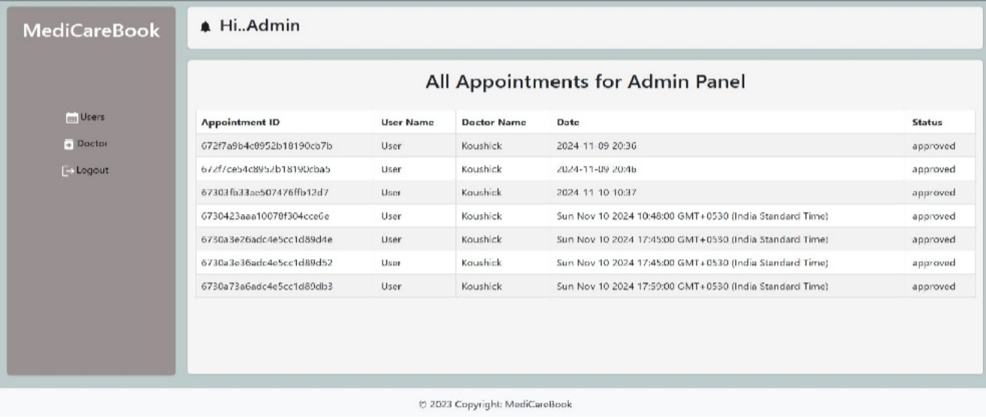

### ADVANTAGES & DISADVANTAGES

#### Advantages:

* **User-Friendly Interface:** The app offers an easy-to-navigate design, making appointment booking simple for patients of all ages.
* **Real-Time Availability:** Live updates of doctor availability reduce scheduling conflicts and improve user experience.
* **Secure Data Handling:** Use of JWT and bcrypt ensures user data and sensitive medical records are safely stored and transmitted.
* **Role-Based Access Control:** Different user roles (patient, doctor, admin) get customized access, improving security and functionality.
* **Automated Notifications:** Email and SMS reminders help reduce missed appointments and improve communication.
* **Scalable Architecture:** Using MongoDB and Express.js supports future growth and increased user demand.

#### Disadvantages:

* **Internet Dependence:** The app requires stable internet connectivity, limiting access in areas with poor coverage.
* **Complex Backend Management:** Admins need technical knowledge to manage registrations and oversee platform governance.
* **Document Upload Limitations:** Currently, only limited file types and sizes are supported for document uploads.
* **No Offline Mode:** Users cannot access appointment information or book without an internet connection.



### CONCLUSION

The Book a Doctor App project successfully addresses the challenges of traditional healthcare appointment booking by providing a digital platform that connects patients with doctors efficiently. Throughout our summer internship, the group collaboratively designed, developed, and tested the system to ensure it is secure, scalable, and user-friendly.

The app’s core features—doctor browsing, appointment scheduling, secure document upload, and admin oversight—were implemented with attention to real-world usability and data security. Our approach leverages modern web technologies to streamline healthcare access, potentially improving patient satisfaction and clinic efficiency.

Overall, this project gave us valuable hands-on experience in full-stack development, database management, and system design, preparing us for future roles in software development and healthcare technology.



### FUTURE SCOPE

* **Mobile Application Development:** Creating native Android and iOS apps to increase accessibility and user engagement.
* **Video Consultations:** Integrate telemedicine features for remote doctor-patient consultations.
* **AI-Based Doctor Recommendations:** Use machine learning to suggest suitable doctors based on patient history and preferences.
* **Advanced Analytics Dashboard:** Provide doctors and admins with insights into appointment trends and patient data.
* **Multi-language Support:** Expand the app’s reach by adding support for multiple languages.
* **Integration with Insurance Providers:** Streamline insurance claim processing within the app.
* **Offline Booking and Sync:** Allow limited offline functionality with automatic data sync when online.



### APPENDIX

* **Source Code:** The complete source code for the Book a Doctor App is available in the GitHub repository linked below.
* **Dataset Link:** The MongoDB database schema and sample datasets used for testing are included in the repository.

#### GitHub & Project Demo Link:

GitHub Repository: <https://drive.google.com/drive/folders/1MYep_YPRgkR4mtSfFpegMC1oMdw7yGNP>

Project Demo: <https://youtu.be/uNFZ47NE328?si=4X10zMkXyf8rciJx>