Selenium with Java Automation -Isha
Driver Link:
https://drive.google.com/drive/folders/1EkacPDFkaPyIlu_atHINdqCMXjuigNHS
Recording Link:
https://www.youtube.com/watch?v=aeeFaS_fuGk&list=PLpVPFODLvNXPl3KniOmUfAHCeNU4JuYVz&index=11
nandeesh.apjkalam@gmail.com
Git Hub:
nandeeshclmysore@gmail.com
Repositories:
Notes:
Code:

- Why Automation testing
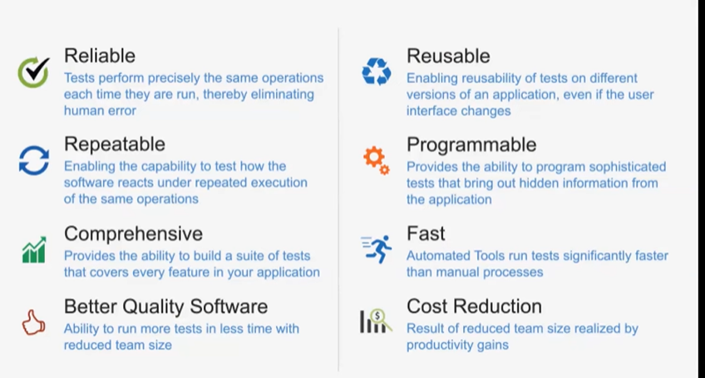

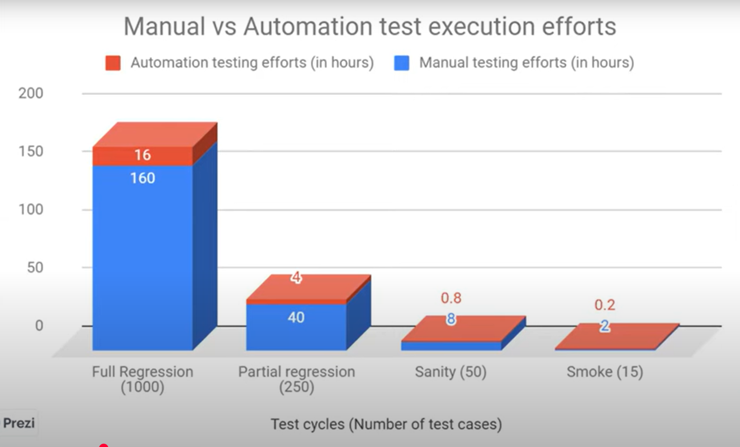
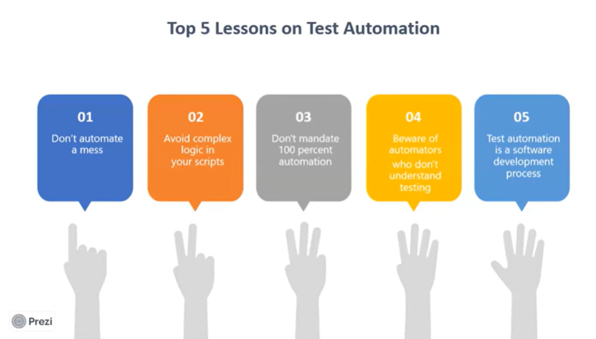
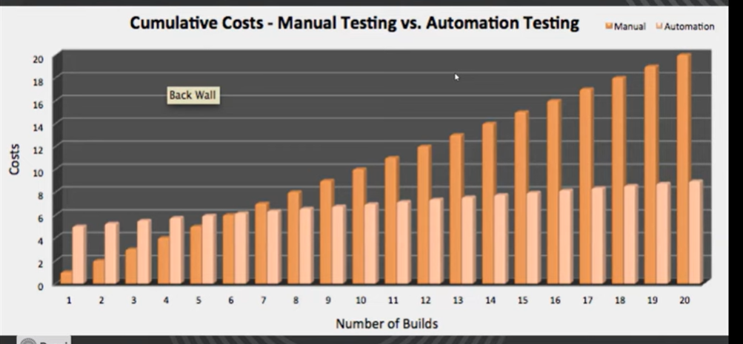

- Selenium Overview
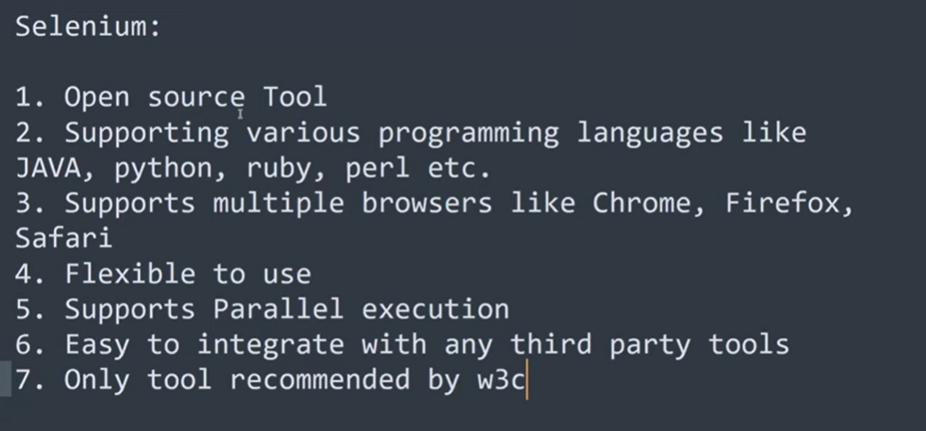

- Test Automation Software
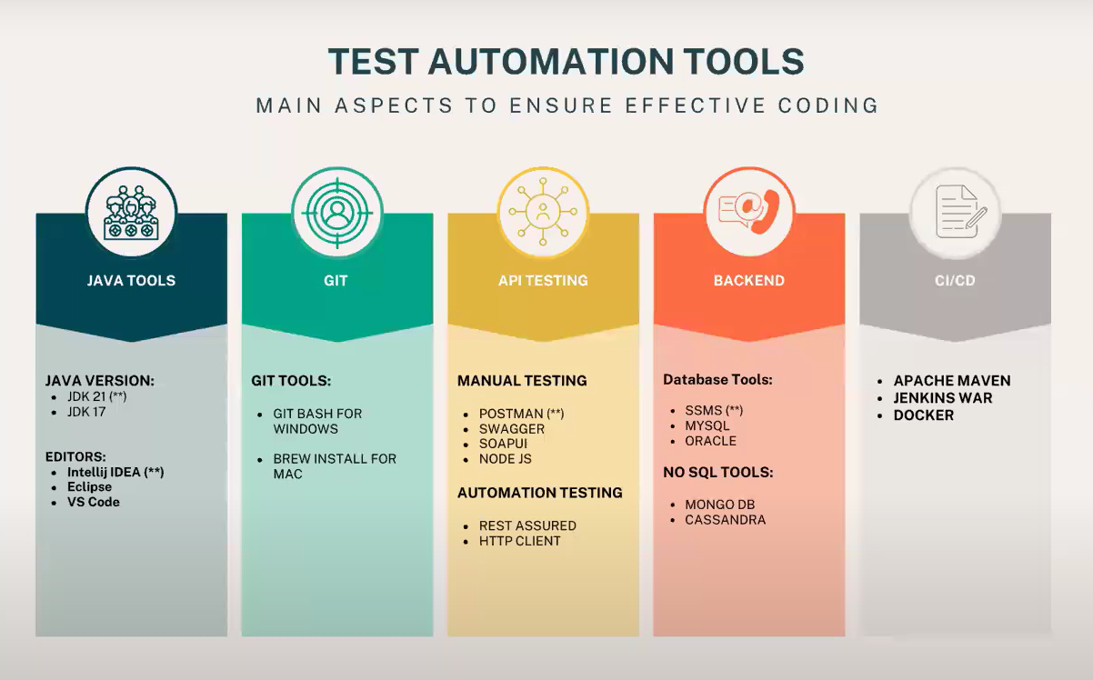
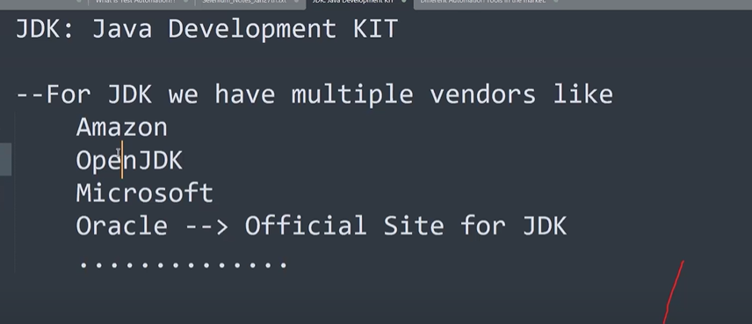

JDK Download [Oracle/OpenJDK]
Oracle JDK download

Open JDK download
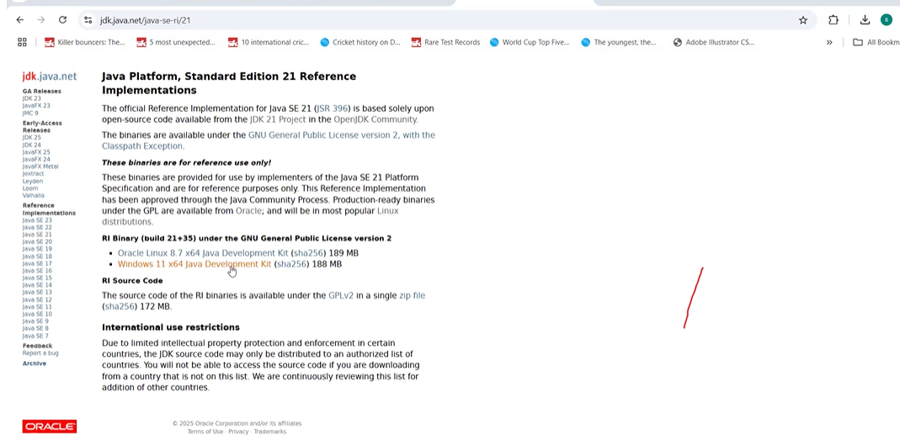

IntelliJ Download
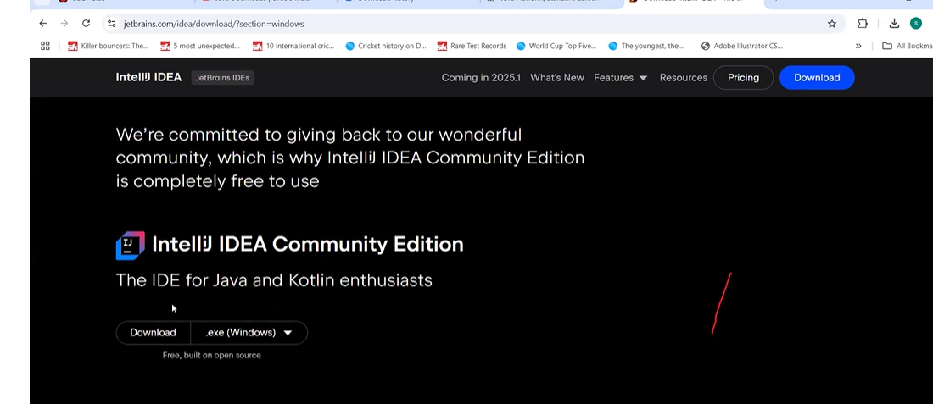

Git Download
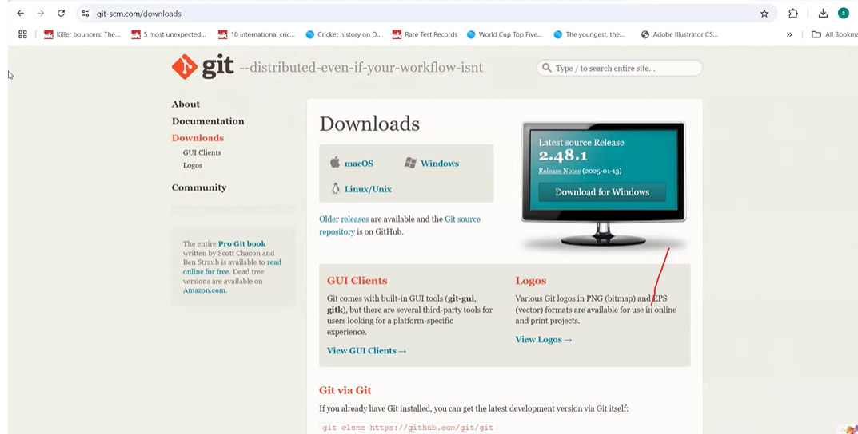
SSMS Download
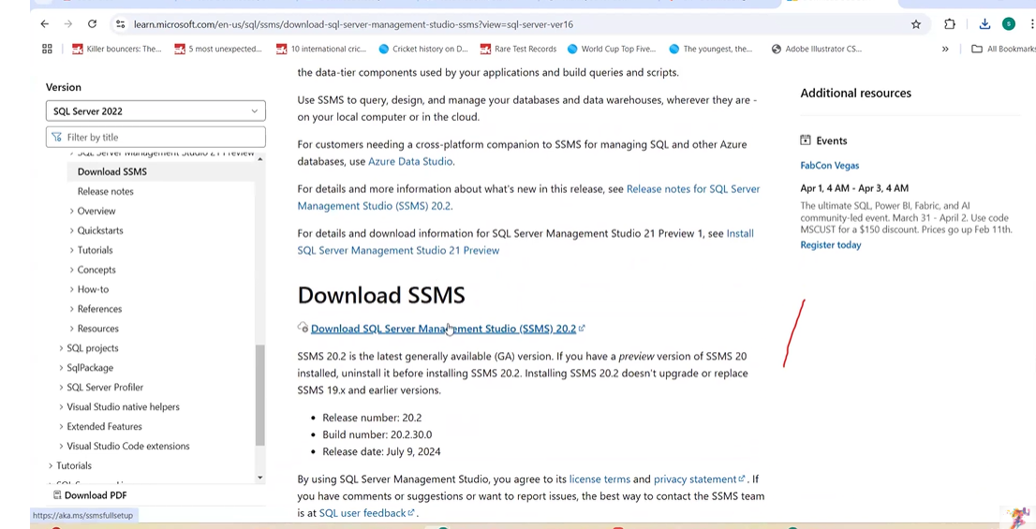

- IntelliJ Shortcuts
System.out.println(): sout Enter key
void main(): main Enter key

- Java Programming
- Nomenclature
Package names: Camel case
Class names: Pascal case
- Escape character
\t \n \r \b
- Print statement
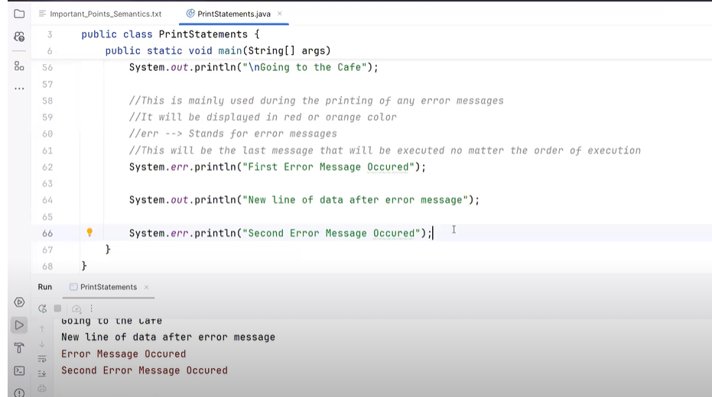
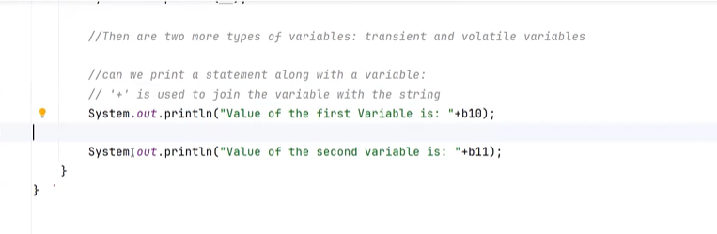

- Variables and Data types
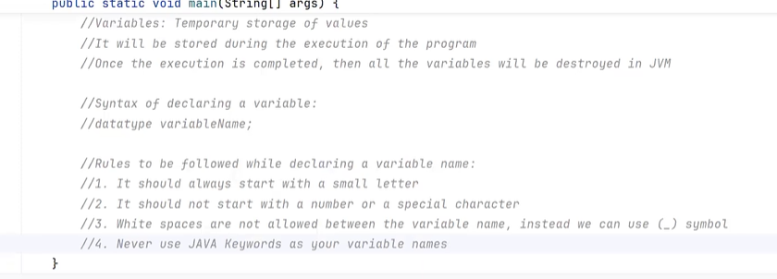

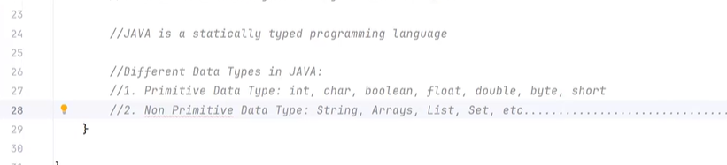
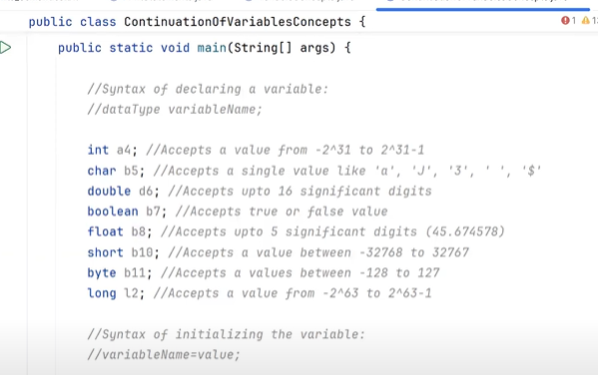

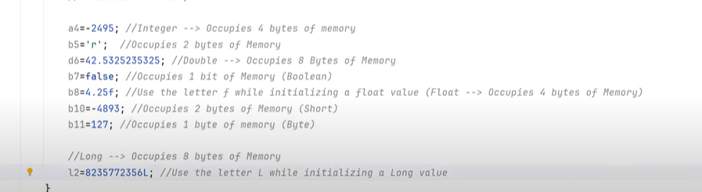

var: If we are not aware of data type then we can use var and store value, but once we store value then it considers that type as its data type and can’t be changed in further
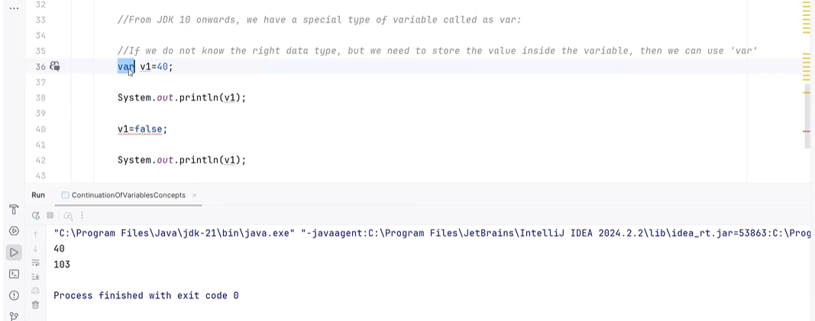

//Printing variable value with string -printf() / println()
println()/printf() : can be used for normal concatenation with +
printf(): If we need to use %d then we must use printf(), println() not works
printf():print and cursor stay in same line
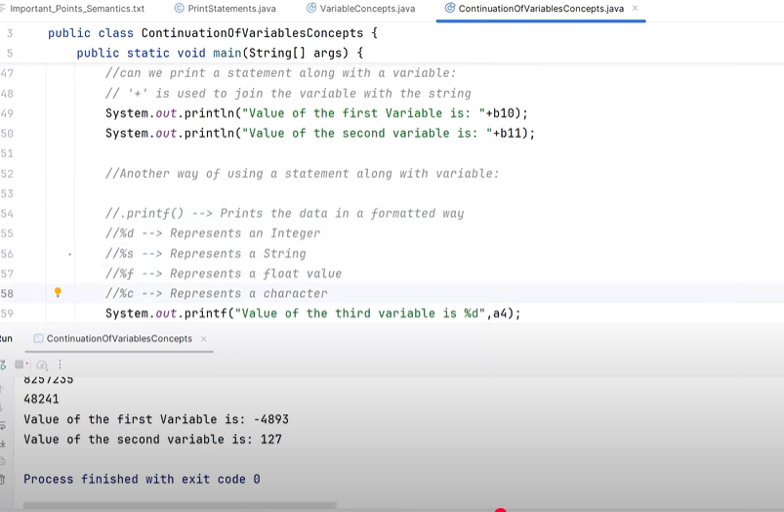
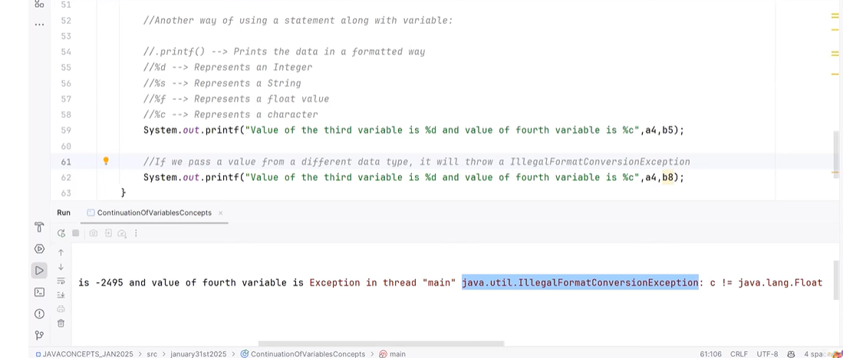
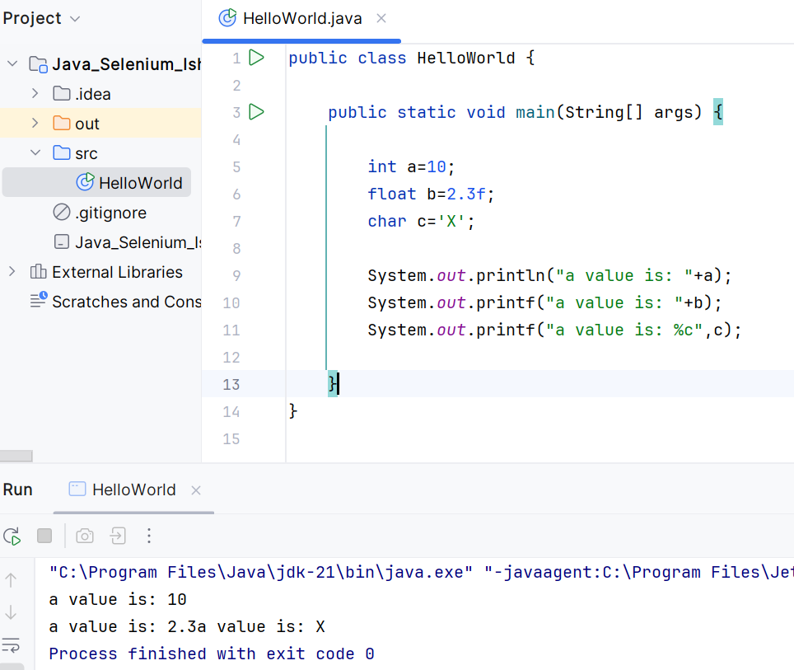
- String
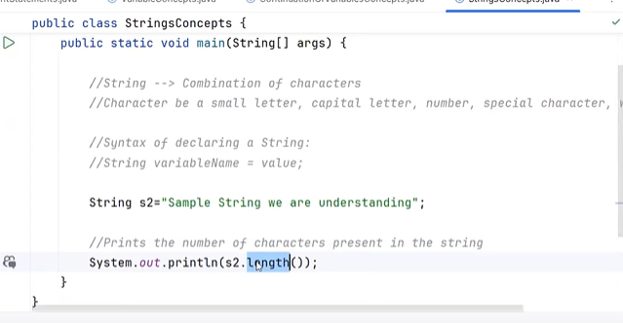
String functions:
length()
isEmpty() : Empty string
isBlank(): Only white spaces
toUpperCase()/toLowerCase()
startsWith(“substring”) / endsWith(“substring”)
replace(“oldstring”,”newstring”) : Replace all old string with new string
replaceFirst(“oldstring”,”newstring”): Replace only first occurrence with new string
repeat(numberoftimes)
charAt(indexposition): If not found then it returns indexOutofBoundException
substring(beginindex,endindex)
substring(beginindex)
indexOf(“substring”) : First occurrence index position/ -1 if not found
lastIndexOf(“substring”)
codePointAt(index) : returns the asci value of character at index position
s1.equals(s2)/s1.equalgnoreCase(s2) : Content comparison
s1==s2 // reference value comparison
s1.compareTo(s2): 0: same +: s1>s2 -:s2>s1
s1.trim() : Start and end white spaces remove
s1.stripLeading()/s1.stripTrialing() : Start or End white space remove
s1.concat(s2) : Combine 2 string
s1.contains(“substring”) : To check the string contains given substring
To make string as constant value so no one can modified
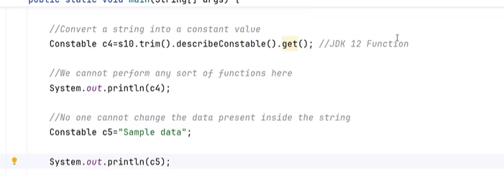

- Conditional Statements
Logical operator: && || ~
Assignment operator: !=
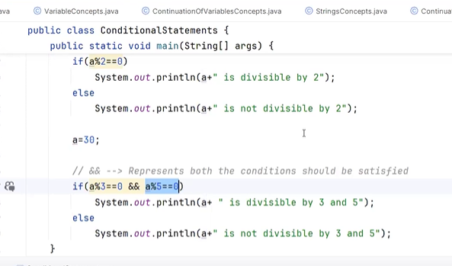

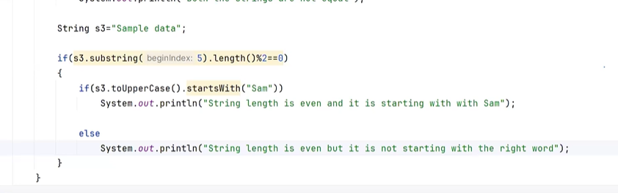
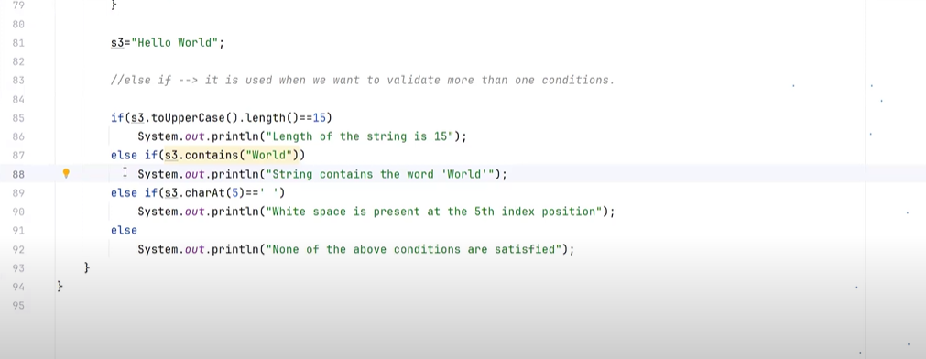
Ternary Operator
public class TernayOperator {
public static void main(String[] args) {
int a = 10, b = 20;
int c = a > b ? a : b;
System.out.println(c);
}
}
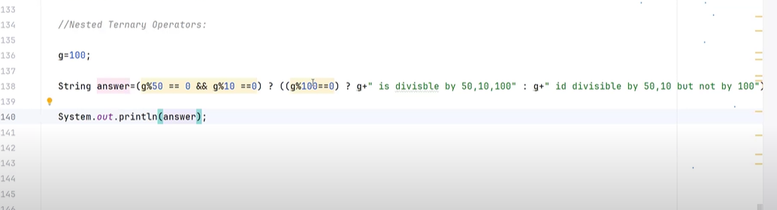

- Loops
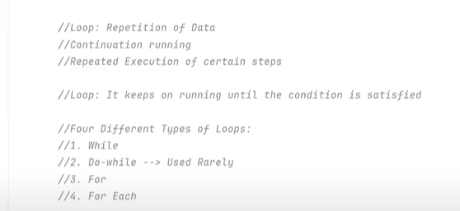
while loop:
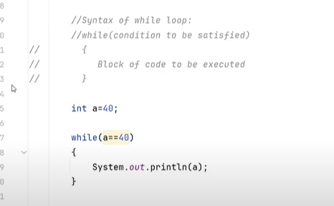
do while loop:
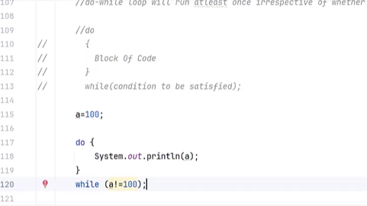
String to Integer, Double,… conversion:[Wrapper class]
Conversion of String to Object type and then to Primitive type
public class StringConversions {
public static void main(String[] args) {
String a="1";
String b="2.4";
int x=Integer.parseInt(a); //int<-Integer
double y=Double.parseDouble(b); //double<- Double
System.out.println(a+" "+x);
System.out.println(b+" "+y);
}
}
for loop:
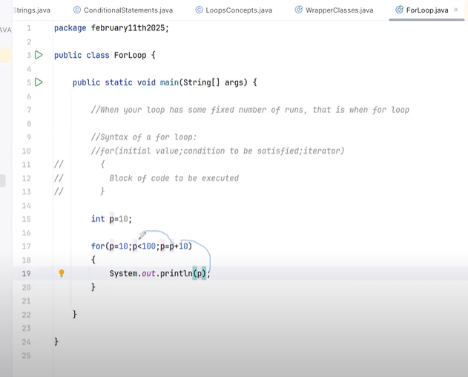
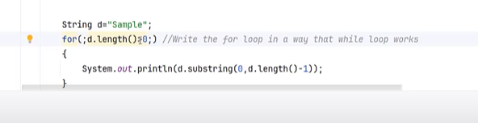

for each loop:
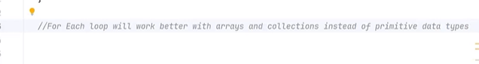
break and continue:
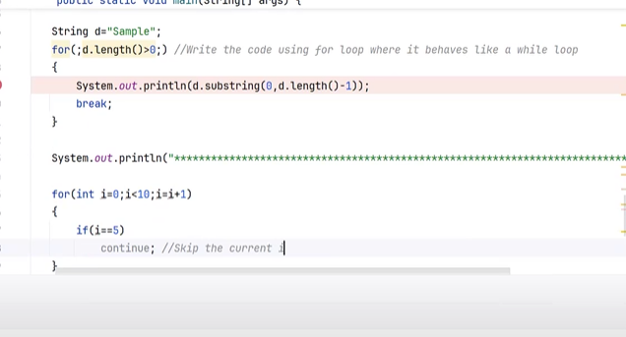
- Scanner class
->To accept input from keyboard
import java.util.Scanner;
public class ScannerClass {
public static void main(String[] args) {
Scanner sc=new Scanner(System.in);
String greet=sc.next();
System.out.println("Hello "+greet);
}
}

Note:
->If we take any character in arithmetic operation then it takes its Ascii value
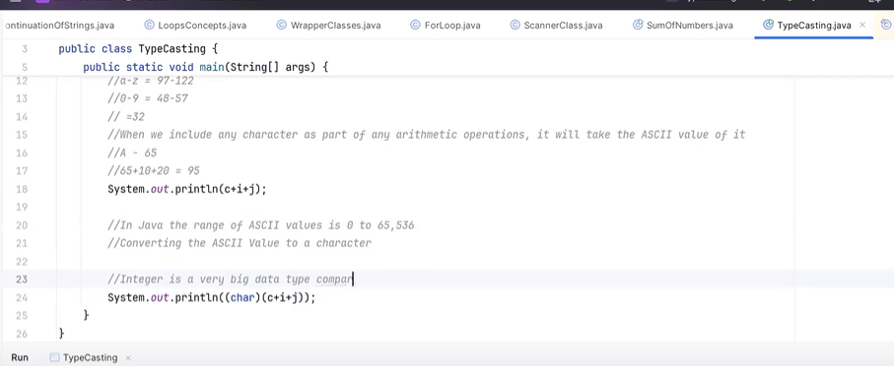

- Type Casting
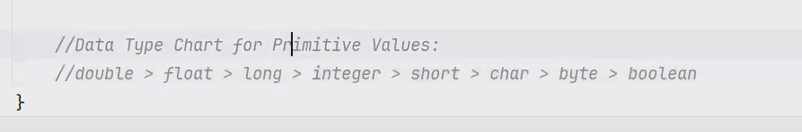
Implicit Type casting: High<-Low
Explicit Type casting: Low<-High [Using cast operator]

- GIT
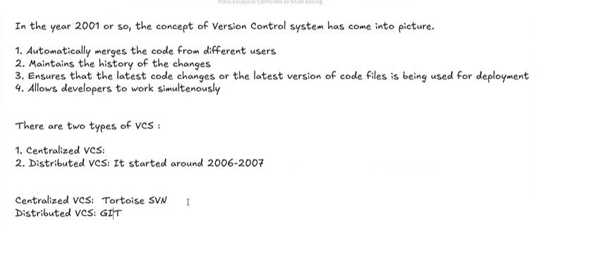
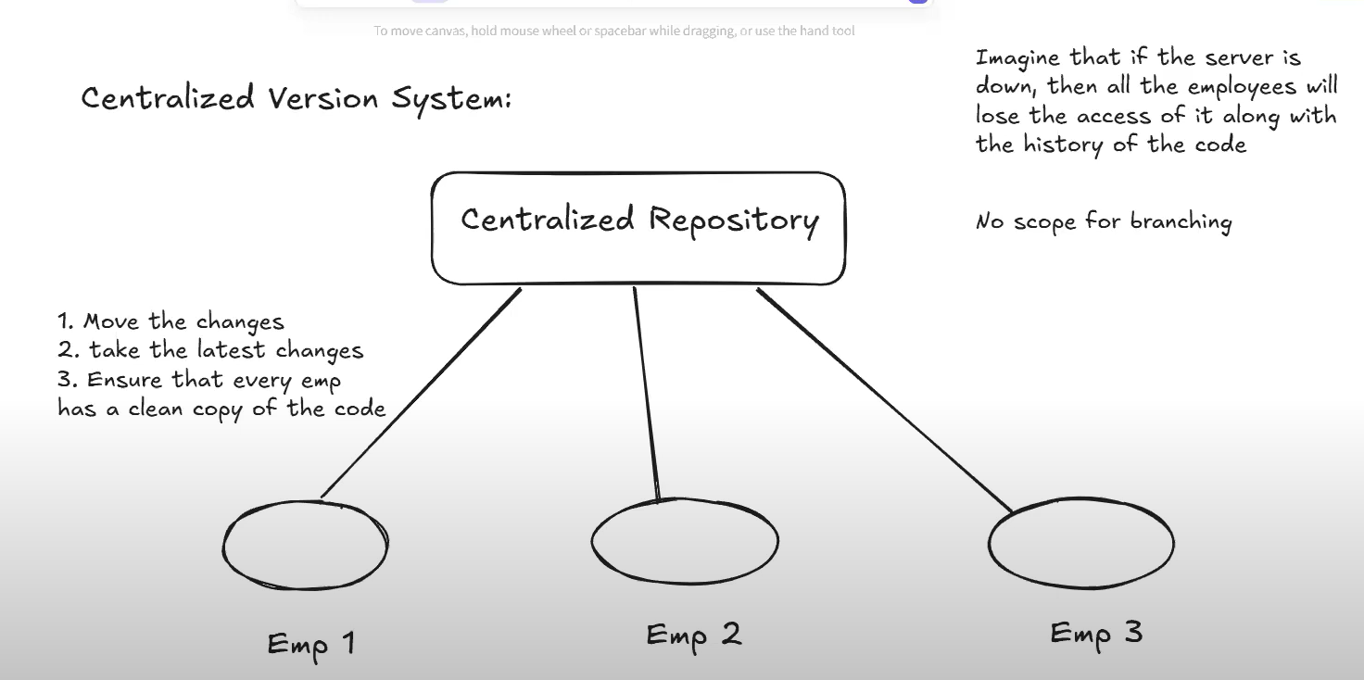
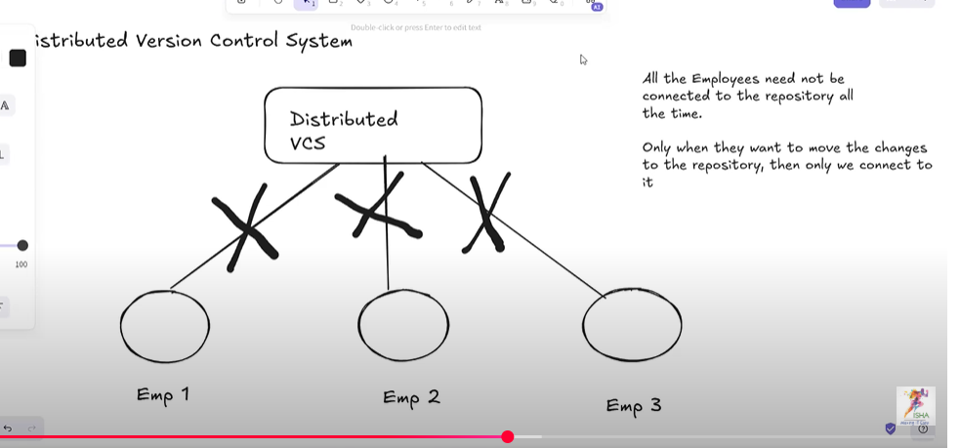
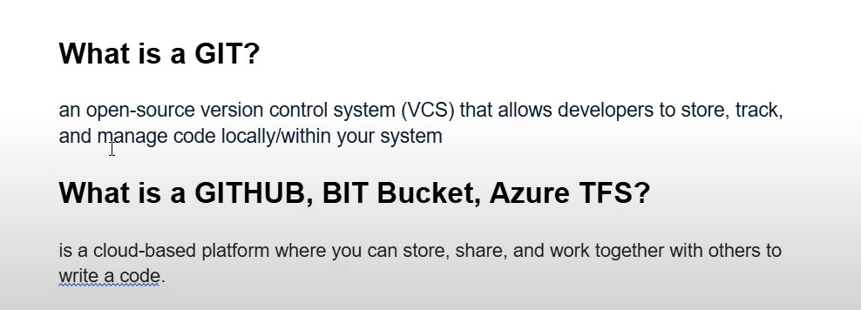
Creates local git folder
git init
To show Untracked -> Red colour and Tracked files -> Green colour
git status
To move files to Staging [Yet to Commit] [Untrack ->Tracked files]
git add <files or folder or *>
To move files from Staging to local Git repository
git commit -m <message>
To see commit logs
git log
git log --oneline

