REST ASSURED AUTOMATION

COURSE CONTENTS:
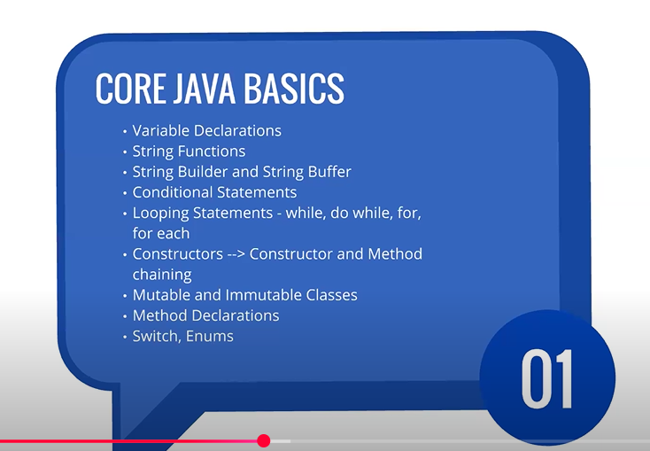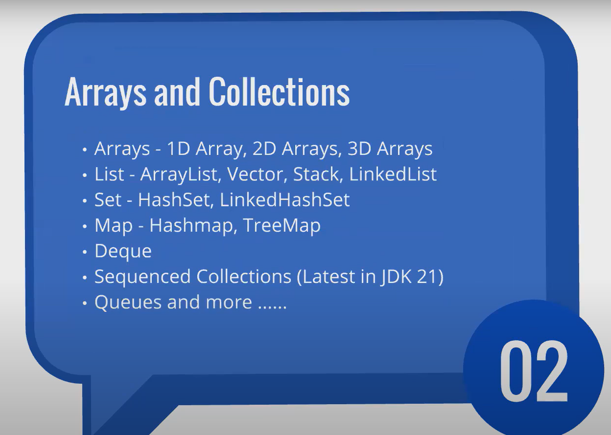
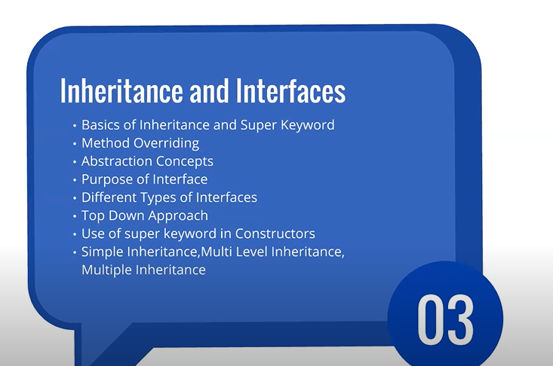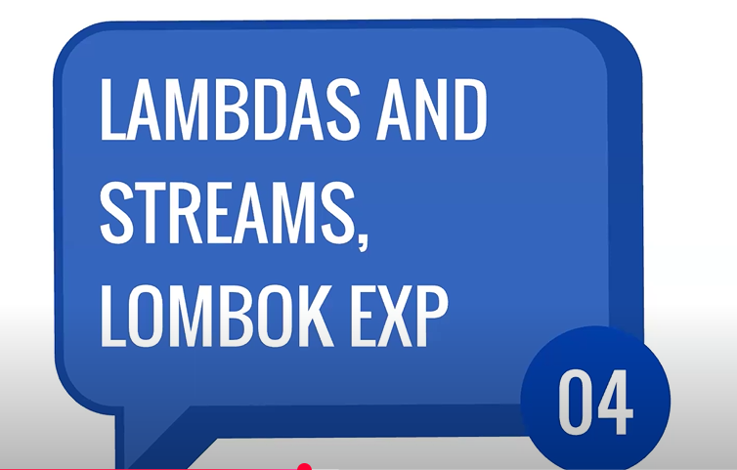
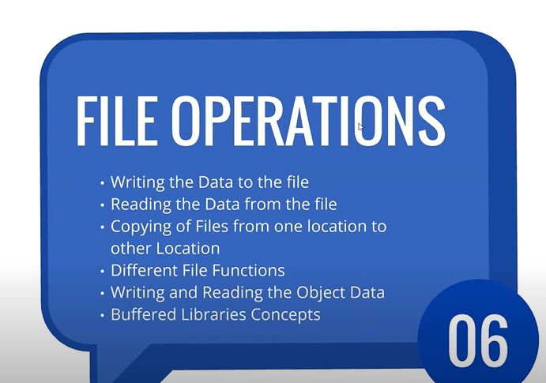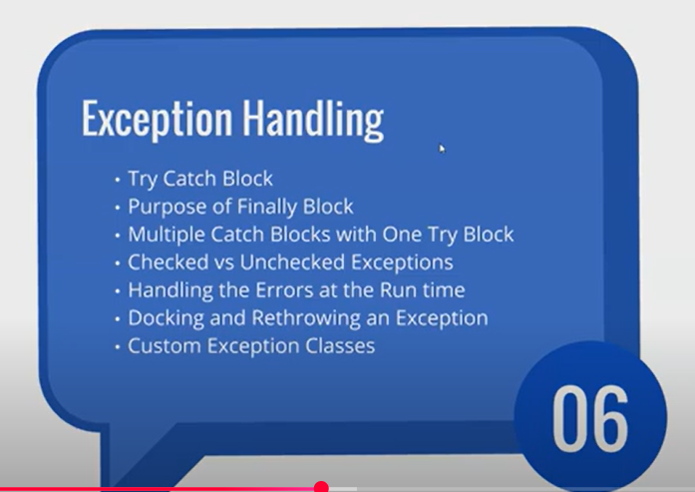
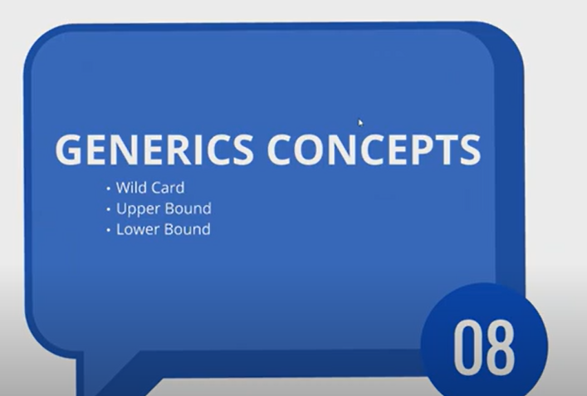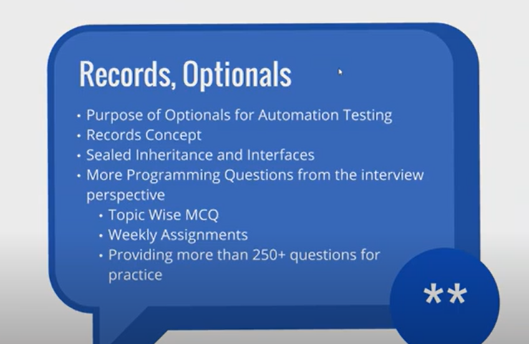
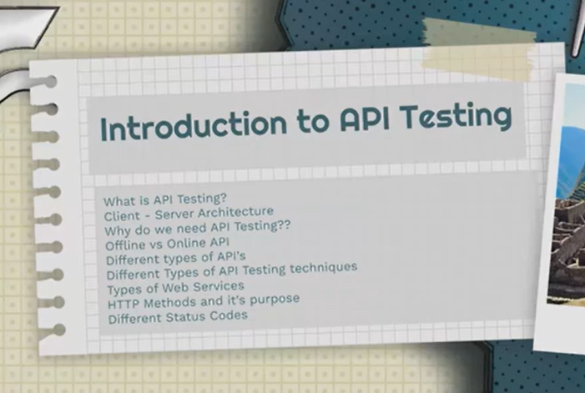
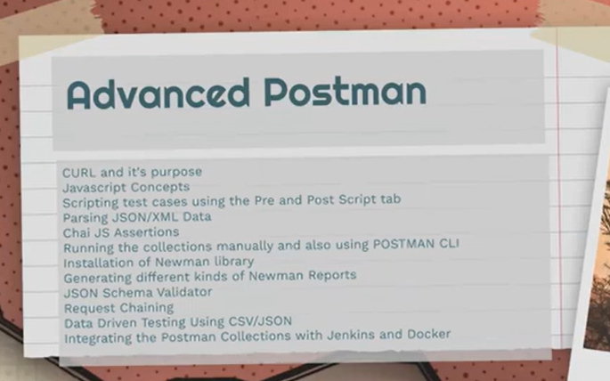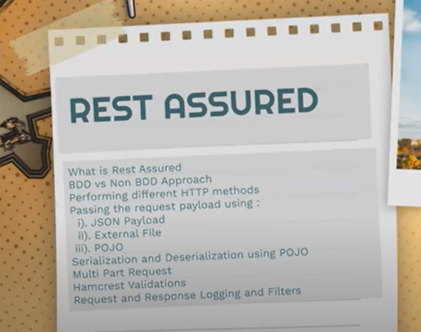
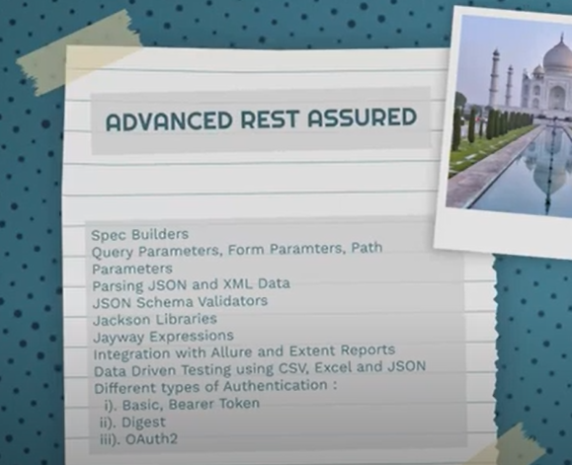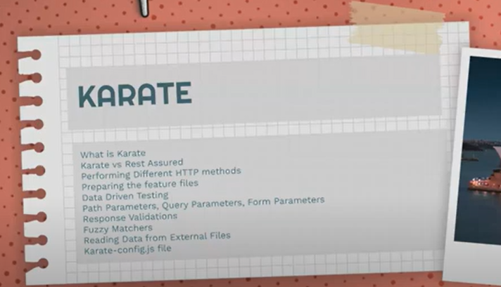

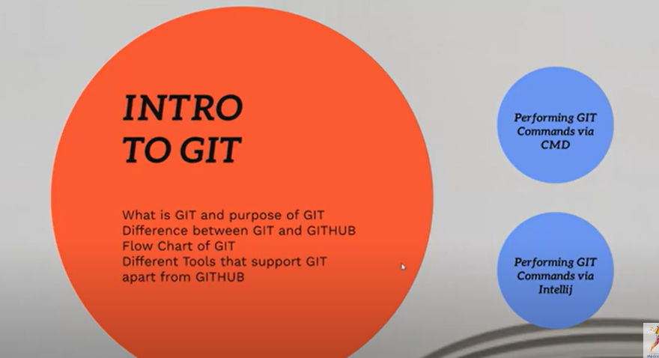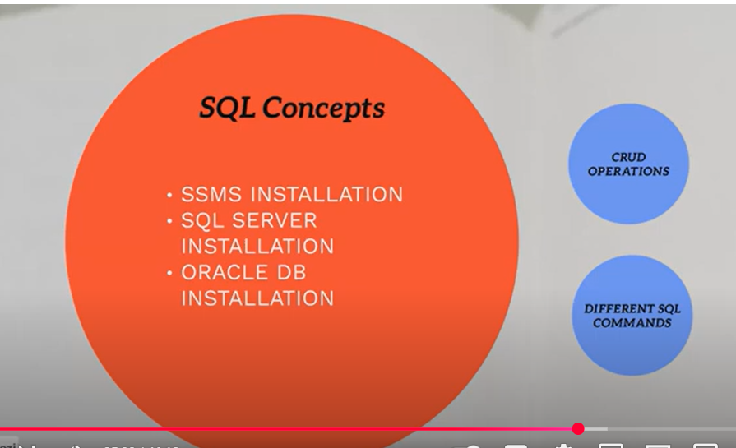

TOOLS
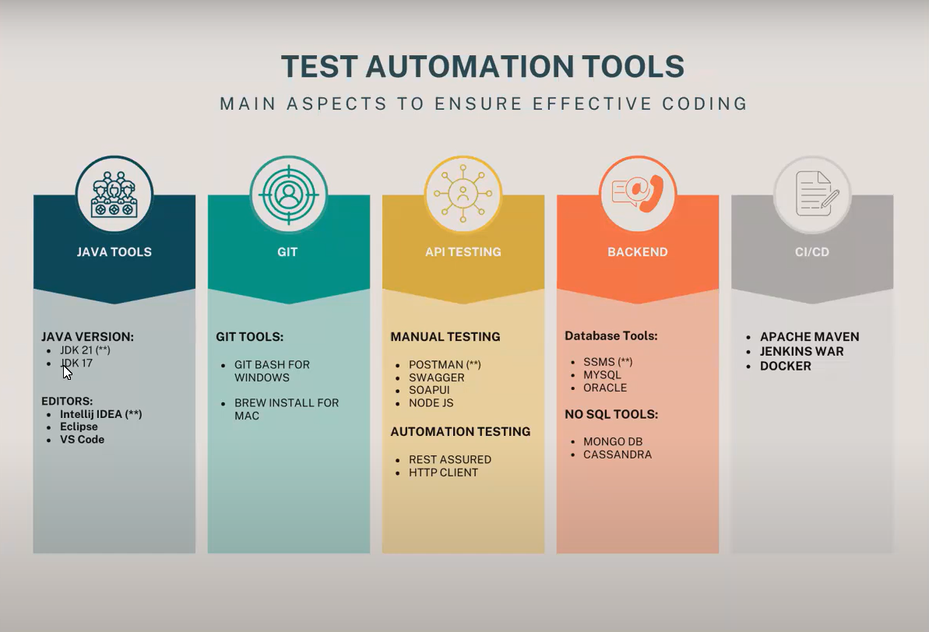

Repo URL:
https://github.com/nandeeshclmysore/Selenium-with-Java-Notes-Isha
Nandeeshclmysore
Notes:
https://gist.github.com/sprahul333/f523dea10ab1bf70e8d0f045a302df06
Class Link:
API Testing, Demo on 4th Aug Batch 2025 @9 PM Pls contact or whatsapp us on +91-9133190573
2025-Rest Assured API Aug @9 PM (IST) by Rahul sir
https://drive.google.com/drive/folders/1Fvjb52XEi12GYj64xvhgH1FOnzgOTshR
https://drive.google.com/drive/folders/1GDPZvfFyENvYIPVDYac9xoEMZP4TIyOa

CODEPOINT

- In Java, the method codePointAt(int index) is used with String, StringBuffer, or StringBuilder.
int codePointAt(int index)
- It returns the Unicode code point (an integer) of the character at the specified index.
- Unlike charAt(), which just gives you the 16-bit char, codePointAt() can handle Unicode characters outside the Basic Multilingual Plane (BMP) (those that need 2 char values — called a surrogate pair).

public class CodePointExample {
public static void main(String[] args) {
String str = "A😊C"; // contains a surrogate pair (😊)

// Normal charAt()
System.out.println("charAt(1): " + str.charAt(1));
// Prints part of emoji (not full)

// Using codePointAt()
int codePoint = str.codePointAt(1);
System.out.println("codePointAt(1): " + codePoint);
System.out.println("Character: " + new String(Character.toChars(codePoint)));
}
}

OUTPUT:
charAt(1): ?
codePointAt(1): 128522
Character: 😊

- So charAt() fails with emoji/special chars (gives half symbol), but codePointAt() correctly gives the full Unicode point.

JAVA Course Content
Java Skill Up: https://www.geeksforgeeks.org/batch/skill-up-java?tab=Chapters
Day 1 – Java Basics and Features
Get introduced to Java, its core principles and why it's one of the most widely used programming languages.
- What is Java?
- Features of Java
- JDK, JRE and JVM
Day 2 – Environment Setup and Hello World
Install everything you need to start writing Java code and run your first program.
- Install JDK and Set Environment Variables
- Write Your First Java Program
- Java Program Structure & Execution Flow
Day 3 – Java Syntax and Data Types
Learn the basic building blocks of Java syntax and how to work with different data types.
- Basic Syntax
- Identifiers
- Data Types
Day 4 – Variables and Type Casting
Discover how Java stores data using variables and how to convert between different data types.
- Variables
- Literals
- Type Casting
Day 5 – Operators and Input/Output
Use Java operators to perform calculations and take user input using standard methods.
- Operators and Expressions
- Input/Output in Java
Day 6 – Conditional and Looping Constructs
You can add logic to your Java programs with decision-making and loops.
- Conditional Statements
- Loops in Java
Day 7 – Mini Project: Tic-Tac-Toe Game
- Put your knowledge to the test by building a simple console-based Tic-Tac-Toe game in Java.
- Apply variables, conditionals, loops and I/O in a real-world project.
- Practice clean code formatting and logical thinking.

Day 8 : Java Methods Deep Dive
Learn how to write reusable blocks of code to simplify programming and reduce duplication.
- How to Call Methods?
- Static Methods vs Instance Methods
- Command Line Arguments
- Variable Arguments (Varargs)
Day 9 : Arrays
Understand how to store and manipulate collections of similar data types
- Introduction to Arrays
- Single and Multi-Dimensional Arrays
Day 10 : Advanced Arrays and Utilities
Explore specialized arrays and array-related utility classes.
- Jagged Arrays
- Arrays Class
- Final Arrays
Day 11 : Strings
Master the most commonly used Java class.
- Introduction to Strings
- Why Strings are Immutable in Java?
- Java String Concatenation
Day 12 : String Class and Its Methods
Dive deeper into the String class and its powerful built-in methods
- String Class
- String Methods
Day 13 : StringBuffer and StringBuilder
Learn mutable string classes that help with efficient string manipulation.
- StringBuffer Class
- StringBuilder Class
- Strings vs StringBuffer vs StringBuilder
- Regular Expressions
Day 14 : Mini Project: Memory Game
Consolidate everything from the week with a fun console-based Java game.
Project: Memory Game
- Create a simple memory matching game where users guess pairs in a 2D array.
- Use methods for logic, arrays for data and StringBuilder for display.
- Add a score counter and replay option.
Day 15 : OOP Basics and Constructors
- Learn the core concepts of Object-Oriented Programming.
- Understand what OOPs concepts are and how they work in Java.
- Create classes and objects, and use constructors with the this keyword.
Break Day
Test your knowledge with a full recap mcqs covering all 15 days. Use this day to revise and strengthen your understanding.
Day 16 : Inheritance, Polymorphism, Abstraction and Encapsulation
- Use super and extends to implement inheritance.
- Understand polymorphism through method overloading and overriding.
- Learn abstraction using abstract classes and interfaces.
- Explore encapsulation to protect data within classes.
Day 17 : Inner Classes & Access Control
- Learn how to define and use inner classes in Java.
- Understand different access modifiers and their scope.
Day 18 : Final Keyword & Object Class
- Use the final keyword to create constants and prevent modification.
- Explore methods inherited from Java’s Object class.
Day 19 : Interfaces
- Understand how to define and implement interfaces in Java.
- Learn about functional interfaces and their use with lambda expressions.
Day 20 : Nested, Marker & Comparator Interfaces
- Explore nested interfaces declared within other classes or interfaces.
- Learn about marker interfaces and their role.
- Use the Comparator interface to sort custom objects.
Day 21 : Mini Project - Library Management System
- Build a Library Management System using a switch-case menu in Java.
- Apply OOP concepts like classes, interfaces, and user-defined methods.
Day 22 : Java Memory Management
Understand how Java handles memory behind the scenes.
- What is Memory Management
- How are Java Objects Stored in Memory
Day 23 : Stack vs Heap & JVM Memory
Dig deeper into memory areas used by the Java Virtual Machine.
- Stack vs Heap memory
- Java Virtual Machine (JVM) Stack Area
- Types of Memory Areas Allocated by JVM
Day 24 : Garbage Collection in Java
Learn how Java automatically clears unused memory.
- What is Garbage Collection?
- The finalize() method (deprecated in recent versions)
- Garbage Collection algorithms: Mark & Sweep (overview)
Day 25 : Memory Leaks and Reference Types
Avoid common pitfalls in Java memory handling.
- What is a Memory Leak in Java?
- Reference Types in Java
Day 26 : Java Packages Overview
Organize your code better with packages.
- Introduction to Packages
- Built-in Packages (e.g., java.util, java.io)
- User-defined Packages
Day 27 : Importing Packages & Naming Conventions
Follow best practices in modular coding.
- How to Import Packages
- Java Naming Conventions (packages, classes, constants, variables)
Day 29 : Java Exception Handling Essentials
- Java Exception Handling
- Checked vs Unchecked Exceptions
- Final, Finally, and Finalize
- Throw and Throws
Day 30: Advanced Exception Techniques
- Customized Exception Handling (User-defined exceptions)
- Chained Exceptions
- Null Pointer Exceptions
- Exception Handling with Method Overriding
Day 31: Wrapper Classes and Autoboxing
- Introduction to Wrapper Classes
- Primitive vs Wrapper
Day 32: Introduction to Java Generics
- Introduction to Generics
- Generic Classes and Methods
Day 33: Advanced Generics and Wildcards
- Generic Constructors and Interfaces
- Bounded Type Parameters
- Wildcards in Generics (?, extends, super)
Day 34: Generics with Collections
- Generics with Collections
- Type Safety and Type Erasure
Day 35: Mini Project – Inventory System
Project: Inventory System (Console-based)
Objectives:
- Add, update, and delete products
- Store product details (name, price, quantity) using wrapper classes
- Use generics for flexible product handling
- Implement custom exceptions (e.g., ProductNotFoundException)
- Use collections (e.g., ArrayList<Product>) for inventory storage

DAY 1 – JAVA BASICS AND FEATURES
- Introduction to Java
Java is a high-level, object-oriented programming language developed by Sun Microsystems in 1995. It is platform-independent, which means we can write code once and run it anywhere using the Java Virtual Machine (JVM). Java is mostly used for building desktop applications, web applications, Android apps, and enterprise systems.
- Key Features of Java
- Platform Independent: Java is famous for its Write Once, Run Anywhere (WORA) feature. This means we can write our Java code once, and it will run on any device or operating system without changing anything.
- Simple: Java syntax is very straightforward and very easy to learn. Java removes complex features like pointers and multiple inheritance, which makes it a good choice for beginners.
- Object-Oriented: Java follows the object-oriented programming. This makes code clean and reusable.
- Secured: Java does not support pointers, it includes built-in protections to keep our programs secure from common problems like memory leakage.
- Multithreading: Java programs can do many things at the same time using multiple threads. This is useful for handling complex tasks like processing transactions.
- Just-In-Time (JIT) Compiler: Java uses a JIT compiler. It improves performance by converting the bytecode into machine readable code at the time of execution.
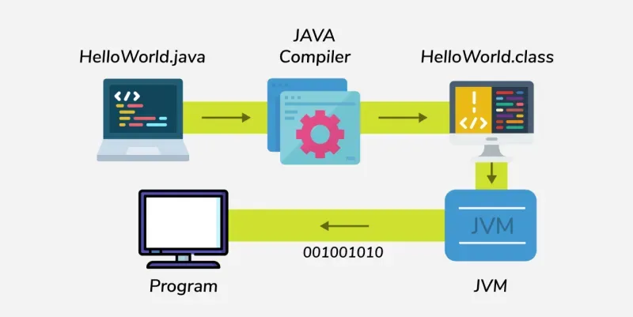
- Write code in a file like HelloWorld.java.
- The Java Compiler "javac" compiles it into bytecode "HelloWorld.class".
- The JVM (Java Virtual Machine) reads the .class file and interprets the bytecode.
- JVM converts bytecode to machine readable code i.e. "binary" (001001010) and then execute the program.

- Comments in Java
The comments are the notes written inside the code to explain what we are doing. The comment lines are not executed while we run the program.
Single-line comment
// This is a comment
Multi-line comment
/*
This is a multi-line comment.
This is useful for explaining larger sections of code.
*/
- Differences Between JDK, JRE and JVM
Understanding the difference between JDK, JRE, and JVM plays a vital role in understanding how Java works and how each component contributes to the development and execution of Java applications.
- JDK: JDK stands for Java Development Kit. It is a set of development tools and libraries used to create Java programs. It works together with the JVM and JRE to run and build Java applications.
- JRE: JRE stands for Java Runtime Environment, and it provides an environment to run Java programs on the system. The environment includes Standard Libraries and JVM.
- JVM: JVM stands for Java Virtual Machine. It's responsible for executing the Java program.
Aspect | JDK | JRE | JVM
Purpose | Used to develop Java applications | Used to run Java applications | Executes Java bytecode
Platform Dependency | Platform-dependent (OS specific) | Platform-dependent (OS specific) | JVM is OS-specific, but bytecode is platform-independent
Includes | JRE + Development tools (javac, debugger, etc.) | JVM + Libraries (e.g., rt.jar) | ClassLoader, JIT Compiler, Garbage Collector
Use Case | Writing and compiling Java code | Running a Java application on a system | Convert bytecode into native machine code

