A Project On

SEISMIC ACQUISITION 3D MAPPING SYSTEM

GROUP – 2 (METAMINDS)
NANDEESWAR BADUGU
SAITEJA SIRIPURAPU
JAYTHRI PUPPALA
SAI KISHORE BHADRAGIRI

Table of Contents

- VERSION TABLE 3
- PROJECT OVERVIEW 3
- IS/IS NOT 3
- RISK ANALYSIS AND MITIGATION 4
- HARDWARE AND SOFTWARE REQUIREMENTS 4
- PROJECT SCHEDULE 4
- KEY DELIVERABLES 5
- ACTIVITY BAR CHART 6
- FLEXIBILITY MATRIX 7
- CONCLUSION 7

- VERSION TABLE

Version | Date | Author | Description of Changes | Reviewed By
1.0 | 11/04/2024 | Saiteja/Jaythri | Initial draft of the project plan. | Dr. Thomas Dillon J
1.1 | 11/11/2024 | Saiteja/Jaythri | Updated flexibility matrix and version control. | Yet to Review

- PROJECT OVERVIEW

The Seismic Acquisition 3D Mapping System aims to create a sophisticated software-based solution for the collection and analysis of seismic data. This system will enhance the accuracy and efficiency of seismic mapping by generating detailed multiplicity and offset curves, crucial for geophysical exploration. The goal of this project is to calculate and analyze the multiplicity and offset curve in a seismic survey, given the distance between geophones and the range of sources. These parameters are critical for optimizing the survey design and ensuring proper subsurface coverage for high-quality 3D seismic imaging.

- IS / IS NOT
IS:
- A software solution for seismic data acquisition, processing, and visualization.
- Focused on generating multiplicity and offset curves.
- Designed to operate within existing seismic acquisition frameworks.
- Aimed at enhancing subsurface imaging quality for geophysical exploration
- Supporting real-time visualization of seismic data
- Compliant with industry standards for data privacy and security

IS NOT:
- A hardware-based seismic data collection system
- A physical field study or examination.
- A standalone system without integration capabilities.
- Focused on providing geophysical interpretations or analysis expertise
- Designed for long-term data storage or archival solutions
- Intended to generate reports on compliance or regulatory requirements

- RISK ANALYSIS AND MITIGATION

- Software Development Delays: Risk of not meeting deadlines due to unforeseen technical challenges.
Mitigation: Implement agile development practices with iterative testing and regular check-ins.

- Data Simulation Inaccuracies: Potential discrepancies between simulated and actual data.
Mitigation: Use validated simulation models and conduct rigorous testing.

- Algorithm Performance Issues: Algorithms may not perform as expected under certain conditions.
Mitigation: Carry out performance testing early in development to identify and address issues.

- Resource Availability: Potential unavailability of key personnel or resources.
Mitigation: Cross-train team members to ensure coverage.

HARDWARE AND SOFTWARE REQUIREMENTS
Hardware Requirements:
- Processor: i5 and above
- RAM: 8 GB and above.
- Hard disk: more than 30 GB in local
Software Requirements:
- Python 3.7 or later
- Framework: Django

- PROJECT SCHEDULE

Start Date | End Date | Activity | Responsible | Deliverables
22-Oct-2024 | 24-Oct-2024 | Project Kick-off Meeting | All | Agenda, minutes, project charter.
28-Oct-2024 | 30-Oct-2024 | Research and Requirement Gathering | All | Requirements document, user personas, research summary.
02-Nov-2024 | 06-Nov-2024 | Design Phase: System Architecture | Jaythri, Kishore | Architecture diagrams, design document, wireframes.
07-Nov-2024 | 07-Nov-2024 | Development Environment Setup | All | Setup guide, tools list, verification report.
08-Nov-2024 | 25-Nov-2024 | Development | Nandeeswar, Saiteja | Source code, code documentation, progress reports.
26-Nov-2024 | 28-Nov-2024 | Output - Generate Multiplicity and Offset Curves | Nandeeswar, Saiteja | Generated curves, data files, methodology.
29-Nov-2024 | 03-Dec-2024 | Testing | Jaythri, Kishore | Test plan, test cases, results report.
03-Dec-2024 | 05-Dec-2024 | Review and Validation of Results | All | Review minutes, validation report, feedback summary.
02-Nov-24 | 06-Dec-24 | Documentation | All | Document Plan
07-Dec-2024 | 07-Dec-2024 | Final Project Review and Submission | All | Final report, submission package, presentation slides.

- KEY DELIVERABLES

- Requirements Specification Document: Detailed documentation of functional and non-functional requirements, including specifications for multiplicity and offset curve calculation, data collection parameters, and analysis requirements.

- System Architecture and Design Document: Comprehensive design of the software solution, including data flow diagrams, system components, and integration points for efficient processing of seismic data.

- Data Acquisition Module: A module for collecting seismic data, designed to handle inputs such as geophone locations, source positions, and acquisition parameters.

- Multiplicity and Offset Calculation Engine: Core algorithms and logic for calculating multiplicity and offset curves based on given geophone distances and source ranges, ensuring accurate survey results.

- 3D Seismic Imaging Module: A robust imaging solution that uses processed data to generate 3D visualizations of the subsurface, enhancing geophysical analysis.

- Reporting and Visualization Tools: Tools for generating detailed reports and visualizations of seismic data, including graphs of multiplicity and offset curves, enabling easy analysis and interpretation.

- System Testing and Validation Reports: Comprehensive testing documentation, covering unit, integration, and system testing to validate functionality, performance, and data accuracy.

- User Training and Documentation: User manuals, technical documentation, and training materials to guide users through system features, data analysis procedures, and troubleshooting steps.

- Final Project Report and Presentation Package: A consolidated report summarizing the project’s goals, methods, outcomes, and conclusions, along with presentation slides for final review.

- ACTIVITY BAR CHART

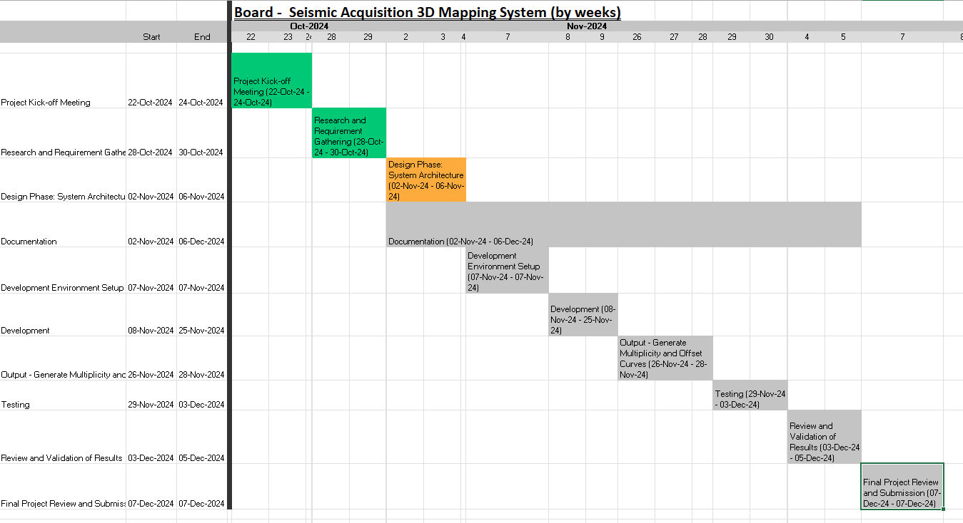

- FLEXIBILITY MATRIX

Aspect | Least Flexible | Moderate Flexible | Most Flexible
Schedule |  | ✔️
Scope |  |  | ✔️
Resources | ✔️

- CONCLUSION

This comprehensive project plan outlines the key components of the Seismic Acquisition 3D Mapping System. By clearly defining the project's scope, deliverables, risks, and flexibility, we aim to successfully deliver accurate multiplicity and offset curves within the established timeline.

