**SRI SIVASUBRAMANIYA NADAR COLLEGE OF ENGINEERING**

**UIT2602 WEB PROGRAMMING LABORATORY**

**Ex 4: Webpage creation using Ruby on Rails**

**Name: Nandha Krishna**

**Reg No: 3122 21 5002 067**

**Aim:**

Create a simple Rails web page or web application that displays your resume data.

**Steps:**

Step 1: create a new Rails application

• rails new resume_app

• cd resume_app

Step 2:generate a scaffold for the resume data

rails generate scaffold Resume name:string email:string phone:string

summary:text education:text experience:text skills:text

Step 3:Run the migration to create the database table

rails db:migrate

Step 4:populate the db/seeds.rb file with some sample data

# db/seeds.rb

Resume.create!(

name: "Raja",

email: "john@example.com",

phone: "123-456-7890",

summary: "Experienced web developer with expertise in Ruby on Rails.",

education: "Bachelor of Science in Computer Science, University XYZ",

experience: "Senior Developer at ABC Company (2018 - Present)",

skills: "Ruby on Rails, HTML/CSS, JavaScript, SQL"

)

Step 5:Run the seed data

rails db:seed

Step 6:modify the config/routes.rb file to set the root route to the resumes index

# config/routes.rb

Rails.application.routes.draw do

resources :resumes

root 'resumes#index'

end

Step 7:Modify the app/views/resumes/index.html.erb file to display the resume data

<!-- app/views/resumes/index.html.erb -->

<h1>Resume</h1>

<% @resumes.each do |resume| %>

<h2><%= resume.name %></h2>

<p><strong>Email:</strong> <%= resume.email %></p>

<p><strong>Phone:</strong> <%= resume.phone %></p>

<p><strong>Summary:</strong> <%= resume.summary %></p>

<p><strong>Education:</strong> <%= resume.education %></p>

<p><strong>Experience:</strong> <%= resume.experience %></p>

<p><strong>Skills:</strong> <%= resume.skills %></p>

<% end %>

Step 8:start the Rails server

rails server

Step 9:now visit http://localhost:3000 in your browser to see your resume data displayed.

**Sample Output:**

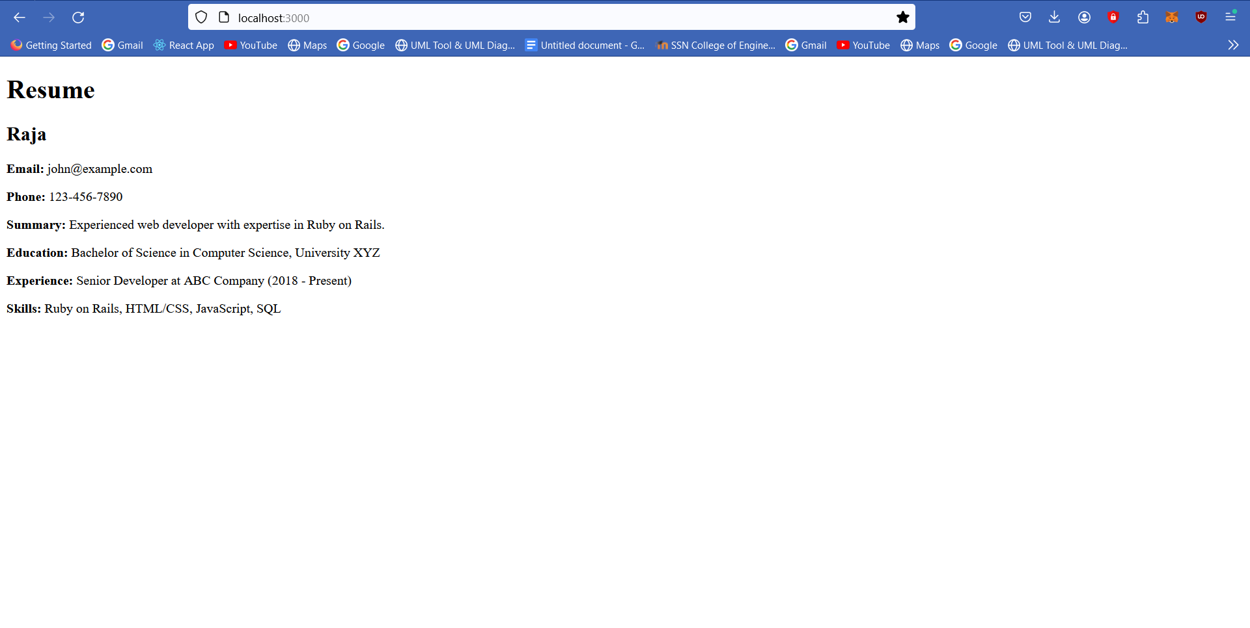

**Conclusion:**

A Webpage has been created and executed using Ruby and rails successfully.