**UIT2602 WEB PROGRAMMING**

Ex. No 01: HTML Web Page Creation

**Name**  : Santhosh Kumar S

**Class**  : IT - B

**Reg No** : 3122215002095

**Objective:**

Design a web site using HTML and DHTML. Use Internal hyperlinking, basic text formatting, images, forms, frames, links, tables, CSS, animations.

**Aim:**

The aim is to develop a comprehensive inventory and sales management system for stores. This system will efficiently manage product details, purchase records, sales transactions, and stock levels. Objectives include providing accurate inventory information, facilitating smooth purchase and sales processes, and optimizing stock management.

**Required Web Tools and Methodology:**

The chosen web tools for this project include HTML 4, CSS 2, HTML 5, and CSS 3. HTML 4 and CSS 2 provide a foundational structure and styling. HTML 5 introduces new features, while CSS 3 adds advanced styling features to enhance web development. The methodology involves utilizing these tools for effective content structure and appealing design.

**Implementation Procedure:**

To create the stock maintenance web page, HTML 5's new structural elements, including headers, sections, and forms, will be used. Product details like Product Code, Product Name, Opening Stock, and Prices will be presented in a simple table using HTML 4 tags. Purchase and sales details will be captured through HTML 5 forms. CSS 3 will be employed for borders, text effects, and animations to enhance visual appeal. Internal hyperlinks for easy navigation and Geo-location functionality using HTML 5's Geo Location API will be integrated. Modern CSS positioning and layout techniques (CSS 2) will be used for consistent styling.

**Code snippets:**

HTML

/head>

   <body onload="loadCSVData()" onscroll="moveImage()">

    <div class="navbar" id="nav">

        <a href="#home">Home</a>

        <a href="#contacts-header">Products</a>

        <a href="#foot">Contact</a>

        <a href="about.html">About</a>

        <a class="icon" onclick="myfunction()">

            <i class="fa fa-bars"></i>

        </a>

    </div>

    <div id="image-container">

        <img id="topimage" class="image" src="images/stock.jpg" alt="icon">

    </div>

    <div id="content-container"></div>

    <h1 id="contacts-header">Stock Maintenance</h1>

    <section id="stock">

        <div class="table-container">

            <table>

                <thead>

                    <tr>

                        <th>Product ID</th>

                        <th>Opening Stock</th>

                        <th>Purchase Stock</th>

                        <th>Sales Stock</th>

                        <th>Current Stock</th>

                    </tr>

                </thead>

                <tbody>

                </tbody>

            </table>

        </div>

    </section>

    <button id="addStockButton" style="display: none;" onclick="addStock()">Add Stock</button>

    <form id="addStockForm" style="display: none;">

        <label for="productId">Product ID:</label>

        <input type="text" id="productId" name="productId" required>

        <label for="openingStock">Opening Stock:</label>

        <input type="text" id="openingStock" name="openingStock" required>

        <label for="purchaseStock">Purchase Stock:</label>

        <input type="text" id="purchaseStock" name="purchaseStock" required>

        <label for="salesStock">Sales Stock:</label>

        <input type="text" id="salesStock" name="salesStock" required>

        <button type="button" onclick="submitStock()">Submit</button>

    </form>

CSS

body {

  font-family: Arial, sans-serif;

  margin: 0;

  padding: 0;

  background-color: #f0f0f0;

  margin-top: 40px;

}

section {

  padding: 17px;

}

.footer {

  overflow: hidden;

  background-color: gray;

  color: white;

  text-align: center;

  text-decoration: none;

  padding: 1.8% 1.5%;

  font-size: 100%;

}

table {

  font-family: arial, sans-serif;

  border-collapse: collapse;

  width: 100%;

}

th, td {

  border: 1px solid #ddd;

  padding: 8px;

  text-align: left;

}

th {

  background-color: #f2f2f2;

}

tr:nth-child(even) {

  background-color: #dddddd;

}

#topimage {

  width: 100%;

  height: 40%;

  background-size: 100% 100%;

}

.navbar {

  overflow: hidden;

  background-color: grey;

  position: fixed;

  top: 0;

  width: 100%;

  z-index: 1000;

}

.navbar a {

  float: left;

  color: white;

  text-align: center;

  padding: 0.8% 1.5%;

  font-size: 100%;

  text-decoration: none;

}

.navbar a:hover {

  background-color: #C7C3BA;

  color: black;

}

.navbar a.icon {

  display: none;

}

@media screen and (max-width: 600px) {

  .navbar a:not(:first-child) {

      display: none;

  }

  .navbar a.icon {

      float: right;

      display: block;

  }

  .navbar.responsive {

      position: relative;

  }

  .navbar.responsive .icon {

      position: absolute;

      right: 0;

      top: 0;

  }

  .navbar.responsive a {

      float: none;

      display: block;

      text-align: left;

  }

}

**Output:**

Image Insertion, Internal links, External links, Animations:

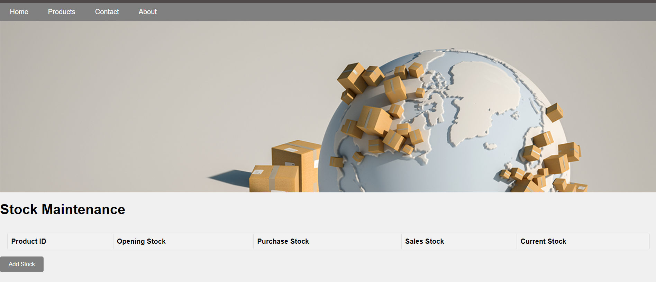

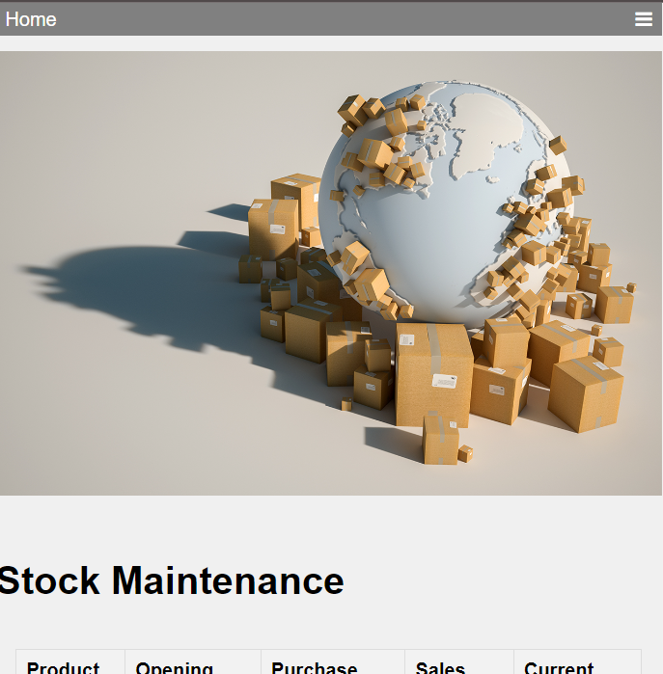

Problem features, Products:

Table, SVGs, Links:

Image, Text effects:

**Conclusion:**

The output will be a user-friendly interface with organized product, purchase, sales, and stock details. HTML 4 tags ensure simplicity in displaying product details within a table, while CSS 3 introduces visually appealing features such as borders, text effects, and animations for an enhanced user experience. The use of HTML 5's structural elements organizes information efficiently, while CSS 3 enhances the visual appeal. This implementation provides an effective solution for managing inventory and sales with a focus on user experience.