1. FIND-S Algorithm
Aim:
To implement and demonstrate the FIND-S algorithm to find the most specific hypothesis from a given set of training data samples.
Procedure:
- Initialize the hypothesis with the most specific values.
- Read the training data.
- Check each training example.
- If the example is positive, compare it with the current hypothesis.
- Generalize the hypothesis when the attribute values are different.
- Ignore negative examples.
- Display the final most specific hypothesis.
Program Code:
# FIND-S Algorithm

data = [
['Sunny', 'Warm', 'Normal', 'Strong', 'Yes'],
['Sunny', 'Warm', 'High', 'Strong', 'Yes'],
['Rainy', 'Cold', 'High', 'Strong', 'No'],
['Sunny', 'Warm', 'High', 'Weak', 'Yes']
]

h = ['Ø', 'Ø', 'Ø', 'Ø']

for row in data:
if row[-1] == 'Yes':
for i in range(4):
if h[i] == 'Ø':
h[i] = row[i]
elif h[i] != row[i]:
h[i] = '?'

print("Training Data:")
for row in data:
print(row)

print("\nMost Specific Hypothesis:")
print(h)
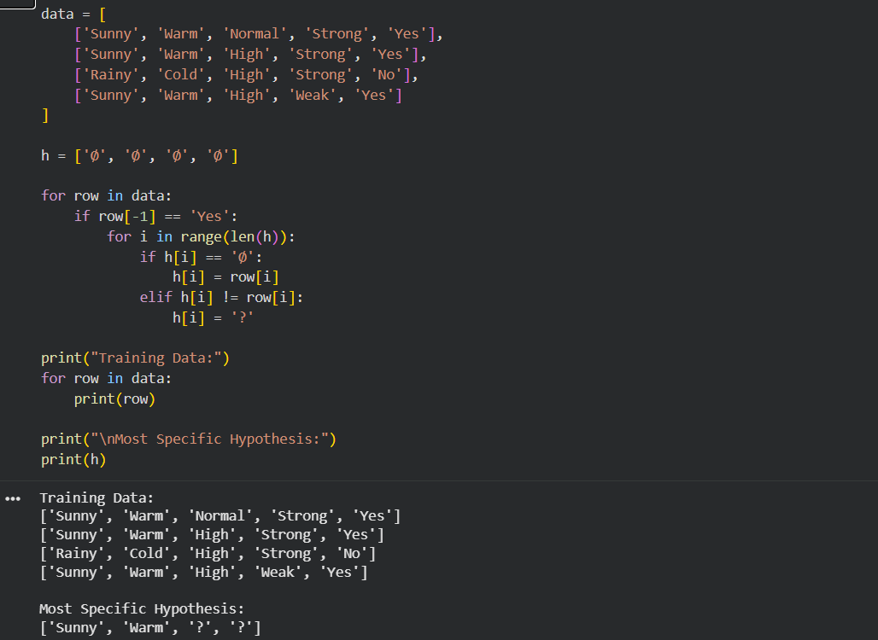
Output:
Result:
Thus, the FIND-S algorithm was successfully implemented, and the most specific hypothesis obtained is:
<Sunny, Warm, ?, ?>
Conclusion:
Thus, the FIND-S algorithm was successfully implemented using a set of training examples. The algorithm identified the most specific hypothesis that is consistent with all the positive training examples.

