2. Candidate-Elimination Algorithm
Aim
To implement and demonstrate the Candidate-Elimination algorithm using training data stored in a CSV file, and find the set of all hypotheses consistent with the training examples.
Procedure
- Create a CSV file containing the training examples.
- Read the CSV file using Python.
- Initialize the Specific boundary (S) with the most specific hypothesis.
- Initialize the General boundary (G) with the most general hypothesis.
- Read each training example one by one.
- For a positive example, generalize S and specialize G if required.
- For a negative example, specialize G and keep consistent hypotheses.
- Remove inconsistent hypotheses from both boundaries.
- Display the final S and G boundaries.
Program Code
First create a file named training_data.csv with this data:
Sky,AirTemp,Humidity,Wind,EnjoySport
Sunny,Warm,Normal,Strong,Yes
Sunny,Warm,High,Strong,Yes
Rainy,Cold,High,Strong,No
Sunny,Warm,High,Weak,Yes
Then run this code in Google Colab:
import csv

# Read CSV file
with open('training_data.csv', 'r') as file:
data = list(csv.reader(file))

attributes = data[0][:-1]
examples = data[1:]

# Initialize Specific and General boundaries
S = ['Ø'] * len(attributes)
G = [['?'] * len(attributes)]

# Candidate-Elimination
for example in examples:
x = example[:-1]
label = example[-1]

if label == 'Yes':
# Remove inconsistent hypotheses from G
G = [g for g in G if all(g[i] == '?' or g[i] == x[i] for i in range(len(x)))]

# Generalize S
for i in range(len(x)):
if S[i] == 'Ø':
S[i] = x[i]
elif S[i] != x[i]:
S[i] = '?'

else:
new_G = []

# Specialize G for negative example
for g in G:
for i in range(len(x)):
if g[i] == '?':
if S[i] != '?' and S[i] != 'Ø':
new_h = g.copy()
new_h[i] = S[i]
new_G.append(new_h)

G = new_G

print("Attributes:")
print(attributes)

print("\nSpecific Boundary (S):")
print(S)

print("\nGeneral Boundary (G):")
for g in G:
print(g)
Output
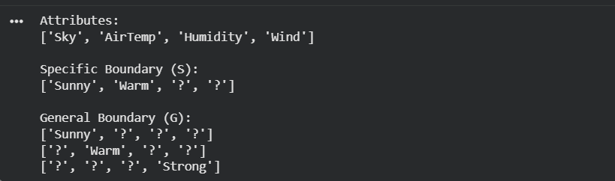
Result:
Thus, the Candidate-Elimination algorithm was successfully implemented using training data stored in a CSV file.
The final boundaries are:
Specific Boundary:
<Sunny, Warm, ?, ?>
General Boundary:
<Sunny, ?, ?, ?>
<?, Warm, ?, ?>
These boundaries represent the set of hypotheses consistent with the given training examples.
Conclusion:
Thus, the Candidate-Elimination algorithm was successfully implemented using training data stored in a CSV file. The algorithm generated the Specific Boundary (S) and General Boundary (G), representing the set of hypotheses consistent with the given training data.

