3. ID3 Decision Tree Algorithm
Aim
To demonstrate the working of the Decision Tree based ID3 algorithm by building a decision tree using a suitable dataset and using the tree to classify a new sample.
Procedure
- Create a training dataset containing attributes and a target class.
- Calculate the entropy of the target attribute.
- Calculate the information gain for each attribute.
- Select the attribute with the highest information gain as the decision node.
- Repeat the process for the remaining attributes.
- Construct the complete decision tree.
- Give a new sample to the decision tree.
- Traverse the tree and predict its class.
Program Code — Google Colab
import pandas as pd
from sklearn.tree import DecisionTreeClassifier, plot_tree
import matplotlib.pyplot as plt

# Create dataset
data = {
'Outlook': ['Sunny', 'Sunny', 'Overcast', 'Rain', 'Rain', 'Rain',
'Overcast', 'Sunny', 'Sunny', 'Rain', 'Sunny', 'Overcast',
'Overcast', 'Rain'],

'Temperature': ['Hot', 'Hot', 'Hot', 'Mild', 'Cool', 'Cool',
'Cool', 'Mild', 'Cool', 'Mild', 'Mild', 'Mild',
'Hot', 'Mild'],

'Humidity': ['High', 'High', 'High', 'High', 'Normal', 'Normal',
'Normal', 'High', 'Normal', 'Normal', 'Normal', 'High',
'Normal', 'High'],

'Wind': ['Weak', 'Strong', 'Weak', 'Weak', 'Weak', 'Strong',
'Strong', 'Weak', 'Weak', 'Weak', 'Strong', 'Strong',
'Weak', 'Strong'],

'Play': ['No', 'No', 'Yes', 'Yes', 'Yes', 'No',
'Yes', 'No', 'Yes', 'Yes', 'Yes', 'Yes',
'Yes', 'No']
}

df = pd.DataFrame(data)

print("Training Dataset:")
print(df)

# Convert categorical values to numbers
X = pd.get_dummies(df[['Outlook', 'Temperature', 'Humidity', 'Wind']])
y = df['Play'].map({'No': 0, 'Yes': 1})

# Build ID3 decision tree
model = DecisionTreeClassifier(criterion='entropy', random_state=0)
model.fit(X, y)

# Display decision tree
plt.figure(figsize=(15, 8))
plot_tree(
model,
feature_names=X.columns,
class_names=['No', 'Yes'],
filled=True
)
plt.show()

# New sample
new_sample = pd.DataFrame([{
'Outlook': 'Sunny',
'Temperature': 'Cool',
'Humidity': 'High',
'Wind': 'Strong'
}])

# Convert new sample in the same format
new_sample = pd.get_dummies(new_sample)
new_sample = new_sample.reindex(columns=X.columns, fill_value=0)

# Prediction
prediction = model.predict(new_sample)

if prediction[0] == 1:
print("New Sample Classification: Yes - Play Tennis")
else:
print("New Sample Classification: No - Do Not Play Tennis")

Output
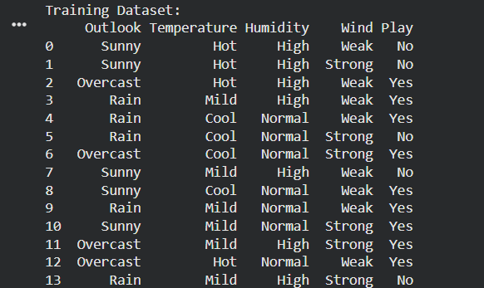
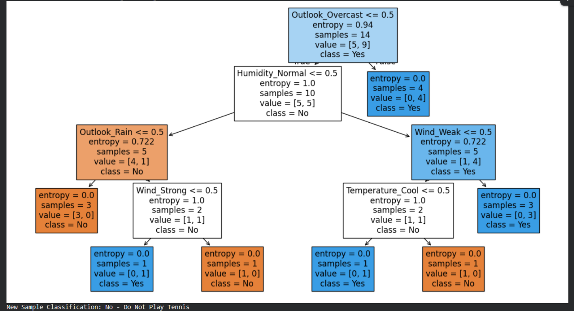
Result
Thus, the ID3 decision tree algorithm was successfully implemented using the Play Tennis dataset. The decision tree was constructed using entropy and information gain, and a new sample was successfully classified as:
No – Do Not Play Tennis
Conclusion:
Thus, the ID3 decision tree algorithm was successfully implemented using the Play Tennis dataset. The algorithm constructed a decision tree using entropy and information gain and successfully classified a new sample based on the learned decision tree.

