Vehicle showcase Augmented Reality App with

AI Bot

Nandhakumar. S Sajan. S Vigneshwar. D.K

B.E CSE B.E CSE B.E CSE

KGiSL Institute of Technology KGiSL Institute of Technology KGiSL Institute of Technology

Coimbatore Coimbatore Coimbatore

[Rsnk2013@gmail.com](mailto:Rsnk2013@gmail.com) [sajansanju127@gmail.com](mailto:sajansanju127@gmail.com) vigneshwar17k@gmail.com

**Abstract- The aim of this project is to develop AR vehicle showcase android app using Unity 3D and Vuforia. A voice controlled cloud based machine learning AI bot is integrated with wit.ai API. This app will project 3D model of vehicle in the real world, which makes the user to experience the view of real car showcase. Then by using our voice commands, the integrated bot will react to perform particular operation like open the car doors, change the colours, start the engine etc. The traditional way of buying a car is by visiting a car showroom and buying a car of our choice based on the features and accessories. The work pressure of the customer has been reduced. However, in Augmented Reality we will be projecting the car through the android application. Therefore, we can see the car in 360 degree in every angle. Through the projection, the customer gets full satisfaction as they are seeing the car in front of their eyes. We can also view the car through virtual projection and can alter the car that we want to like changing the color of the car, changing the alloys of wheels and we can redesign the car in our manner. We will be connecting our project with wit.ai bot so that it understands the human natural language and it proceeds upon that command. Finally, we can see our car in the way we want to alter it or view it in format of design.**

**Keywords: Unity 3D, Vuforia, Augmented Reality, AI, Speech Recognition.**

# INTRODUCTION

**Augmented reality** (**AR**) is an interactive experience of a real-world environment where the objects that reside in the real-world are "augmented" by computer-generated perceptual information, sometimes across multiple sensory modalities, including [visual](https://en.wikipedia.org/wiki/Visual), [auditory](https://en.wikipedia.org/wiki/Hearing), [haptic](https://en.wikipedia.org/wiki/Haptic_perception), [somatosensory](https://en.wikipedia.org/wiki/Somatosensory_system), and [olfactory](https://en.wikipedia.org/wiki/Olfactory). The overlaid sensory information can be constructive (i.e. additive to the natural environment) or destructive (i.e. masking of the natural environment) and is seamlessly interwoven with the physical world such that it is perceived as an [immersive](https://en.wikipedia.org/wiki/Immersion_(virtual_reality)) aspect of the real environment. In this way, augmented reality alters one's ongoing perception of a real-world environment, whereas [virtual reality](https://en.wikipedia.org/wiki/Virtual_reality) completely replaces the user's real-world environment with a simulated one. Augmented reality is related to two largely synonymous terms: [mixed reality](https://en.wikipedia.org/wiki/Mixed_reality) and [computer-mediated reality](https://en.wikipedia.org/wiki/Computer-mediated_reality).

The primary value of augmented reality is that it brings components of the digital world into a person's perception of the real world, and does so not as a simple display of data, but through the integration of immersive sensations that are perceived as natural parts of an environment. The first functional AR systems that provided immersive mixed reality experiences for users were invented in the early 1990s, starting with the [Virtual Fixtures](https://en.wikipedia.org/wiki/Virtual_Fixtures) system developed at the U.S. Air Force's [Armstrong Laboratory](https://en.wikipedia.org/wiki/Armstrong_Laboratory) in 1992.The first commercial augmented reality experiences were used largely in the entertainment and gaming businesses, but now other industries are also getting interested about AR's possibilities for example in knowledge sharing, educating, managing the information flood and organizing distant meetings. Augmented reality is also transforming the world of education, where content may be accessed by scanning or viewing an image with a mobile device or by bringing immersive, marker less AR experiences to the classroom. Another example is an AR helmet for construction workers, which display information about the construction sites.

Augmented reality is used to enhance natural environments or situations and offer perceptually enriched experiences. With the help of advanced AR technologies (e.g. adding [computer vision](https://en.wikipedia.org/wiki/Computer_vision) and [object recognition](https://en.wikipedia.org/wiki/Object_recognition)) the information about the surrounding real world of the user becomes [interactive](https://en.wikipedia.org/wiki/Interactive) and digitally manipulable. Information about the environment and its objects is overlaid on the real world. This information can be virtual or real, e.g. seeing other real sensed or measured information such as electromagnetic radio waves overlaid in exact alignment with where they actually are in space. Augmented reality also has a lot of potential in the gathering and sharing of tacit knowledge. Augmentation techniques are typically performed in real time and in semantic context with environmental elements. Immersive perceptual information is sometimes combined with supplemental information like scores over a live video feed of a sporting event. This combines the benefits of both augmented reality technology and [heads up display](https://en.wikipedia.org/wiki/Heads_up_display) technology (HUD).

**DFD LEVEL 0**

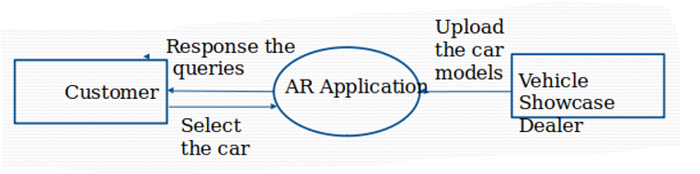

Figure 1: DFD Level 0 Diagram

**DFD LEVEL 1**

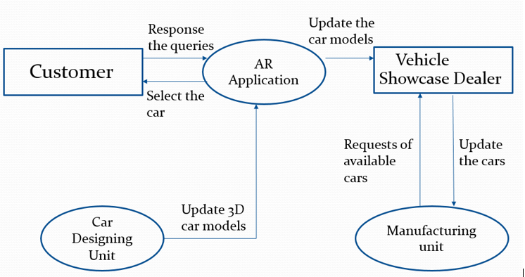

Figure 2: DFD Level 1 Diagram

Some of the applications of the twitter have been described below

* **Education:**

Nowadays 80% of young people own smartphones. Most of them are active smartphone users that use these gadgets to access social platforms, play games and to be in connection with friends and relatives. In the meantime, much lesser part of young adults uses phones for studying purposes, to do the homework, dig information about a subject, etc. The potential of combining smartphones and Augmented Reality for education is big, though it still has to be fully discovered. AR, in various ways, could grant students extra digital information about any subject, and make complex information easier to understand. Nowadays we may find some excellent examples of augmented reality in education worldwide. Ability to connect reality and digital content has been steadily improving, opening more options for teachers and students.

* **Sales & Marketing:**

AR has become a game-changer for marketing and selling industrial products, with companies seeing a rapid return on these AR investments.

Senior analysts at Ventana Research have investigated this emergence of AR for industrial sales use cases.

Get your copy to learn:

* Current market pressures behind innovations like AR.
* Why industrial markets are so well suited for AR.
* Common applications of AR throughout a buying journey.
* How AR applications are improving the sales process.
* If you are interested in AR’s potential for your organization, this report provides specific and tangible guidance, based on real-world success.
* **Entertainment:**

Augmented reality (AR) refers to computer displays that add virtual information to a user's sensory perceptions. Most AR research focuses on "see-through" devices, usually worn on the head, which overlay graphics and text on the user's view of his or her surroundings. (Virtual information can also be in other sensory forms, such as sound or touch, but this article will concentrate on visual enhancements.) AR systems track the position and orientation of the user's head so that the overlaid material can be aligned with the user's view of the world. This process is called registration. Thru it, graphics software can place a three-dimensional image of a teacup, for example, on top of a real saucer and keep the teacup fixed in that position as the user moves about the room. AR systems employ similar technologies used in virtual-reality research, but where virtual reality attempts to replace the real world in an encompassing way, augmented reality only supplements it.

* **Medical Fields:**

One clear technological advance in medicine in the last few decades has been imaging technology, which has further benefited from advances in general computer technology. The real-time detailed images we can produce now have transformed the practice of medicine in many areas. As a neurologist, for example, I can now get an MRI scan on a patient in the emergency room and determine definitively if they are having a stroke. Surgeons also have many anatomical data from images at their disposal, but they are mostly looking at 2-dimensional displays that they review prior to surgery, or have to look away from the patient during surgery. AR has the potential of providing a heads-up display, giving vital information to surgeons overlaid on the patient.

1. LITERATURE REVIEW

**Drawbacks of existing methods**

In previous versions of AR, applications 2D Object recognition were used which won’t give complete user experience. To overcome this we have implemented 3D Object recognition with Ground plane detection.

1. PROPOSED SYSTEM

AR is all about superimposing computer-generated images on top of your view of reality, thus creating a composite view that augments the real world. In our App, we are implementing 3D Object recognition and Ground plane detection is possible.

**Advantages over existing methods:**

The AR car showroom app allows user to view the car in the manner they want and can alter the parts in imaginary that will project in real world.

**Future enhancement:**

Future work holds how engine works and damaged parts replacement with image recognition.

1. CONCLUSION

The main aim of this paper is to create a vehicle showcase app.  Projecting a full size vehicle in the real world.  Then using voice commands open the car doors, change the colors etc. Even view a car promotional video on an augmented reality video screen placed on the dashboard of the car. In addition,to build commercial ready apps, record your voice in unityand automatically send the voice command through to an online AI, which we train along the way.  The AI learns and processes your voice request, returning commands to the code in Unity.  Using the response, we then manipulate the scene.  The additional benefit of this is that you will learn how to send and receive information from an app to a websiteAPI.  Opening doors for other development projects, you may have where information would need saving online or retrieving.

1. REFERENCES

**1.** P. Milgram, F. Kishino, "A taxonomy of mixed reality visual displays", IEICE Trans. Inf. Syst., pp. 1321-1329, 1994.

**2.** P. Wellner, W. Mackay, R. Gold, "Computer augmented environments: Back to the real world", Commun. ACM, vol. 36, no. 7, pp. 24-26, 1993.

**3.** S. Feiner, B. Macintyre, D. Seligmann, "Knowledge-based augmented reality", Commun. ACM, vol. 36, no. 7, pp. 53-62, 1993.

**4.** W. Mackay, G. Velay, K. Carter, C. Ma, D. Pagani, "Augmenting reality: Adding computational dimensions to paper", Commun. ACM, vol. 36, no. 7, pp. 96-97, 1993.

**5.** T. Caudell, D. Mizell, "Augmented reality: An application of heads-up display technology to manual manufacturing technology augmented reality", Proc. Hawaii Int. Conf. on Syst. Sci., 1992.

**6.** D. Roberts, J. Strohbehn, J. Hatch, W. Murray, H. Kettenberger, "A frameless stereotaxic integration of computerized tomographic imaging and the operating microscope", J. Neurosurg., vol. 65, no. 4, pp. 545-549, 1986.

**7.** I. Sutherland, "A head-mounted three dimensional display", Proc. Fall Joint Computer Conf., pp. 757-764, 1968.

**8.** H. Steinhaus, "Sur la localization au moyen des rayons x", Comptes Rendus de L'Acad. des Sci., vol. 206, pp. 1473-1475, 1938.