Courier Management System (CMS)
A Salesforce Implementation Case Study — Zippy Logistics Pvt Ltd

User Story
Independent courier operators and regional logistics companies often run day-to-day operations out of notebooks, WhatsApp threads, and disconnected spreadsheets. Without one system to follow a parcel from pickup to final delivery, hub staff lose visibility the moment it leaves the counter.
Riders are assigned over phone calls, which invites double-booked pickups and missed collection windows. Because nothing notifies a client automatically when a parcel's status changes, they call in again and again for an update, and hub supervisors have no dashboard that shows how a route, a rider, or a branch is actually performing.
Multiplied across several hubs, this patchwork of manual habits produces missed delivery windows, frustrated clients, wasted rider time, and a leadership team that cannot see revenue or performance until the end of the month — if at all.

Table of Contents
1. Introduction
2. Ideation Phase
3. Requirement Analysis Phase
4. Project Design Phase
5. Project Planning & Scheduling
6. Project Development Phase (Milestones 1–12)
7. Functional & Performance Testing
8. Advantages & Disadvantages
9. Conclusion
10. Future Scope
11. Appendix

Executive Summary
This report documents the design and build of a Courier Management System (CMS) for Zippy Logistics, implemented end-to-end on the Salesforce platform. It walks through the discovery work that shaped the solution — problem statements, empathy mapping and idea prioritization — before moving into requirements, architecture, sprint planning, and a milestone-by-milestone build of the underlying Salesforce org.
The build covers six custom objects (Client, Parcel, Rider, Hub, Tracking Event and Billing), the relationships between them, validation rules that keep the data clean, page layouts, a record-triggered flow that keeps parcel status current automatically, a dedicated Lightning App, a four-tier profile and role hierarchy, and a reporting layer that rolls everything up into one live dashboard for hub leadership.
Taken together, these pieces move Zippy Logistics from paper waybills and phone-based coordination to a single, permission-aware system of record — the foundation this report's Future Scope section builds on with mobile, GPS and AI-driven enhancements.

1. Introduction

1.1 Project Overview
Zippy Logistics — like most courier operators — needs to move a parcel from booking to doorstep without losing track of it along the way. The Courier Management System (CMS) is a cloud application built on the Salesforce platform that brings parcel booking, live tracking, rider assignment, automatic status alerts, billing, and analytics into a single connected workspace.
Instead of chasing updates across phone calls and paper logs, every hub works from the same live record, and every status change is visible the moment it happens — to hub staff, to riders, and to the client.

1.2 Purpose
The purpose of CMS is to remove the manual, disconnected habits that slow courier operations down. Built on Salesforce, it gives every hub a single place to create a booking, assign a rider, log a tracking event, generate an invoice, and pull a performance report — all from the same underlying data model.
By replacing fragmented registers with one unified platform across every branch, CMS improves operational visibility, sharpens client communication, cuts down on errors and delays, and lets managers make decisions from live numbers instead of a month-end guess. The end goal is straightforward: faster deliveries, fewer escalations, and a healthier bottom line.

2. Ideation Phase

2.1 Problem Statement
Two recurring pain points shaped the direction of this project — one from the operations side and one from the client side.
PS | I am | I'm trying to | But | Because | Which makes me feel
PS-1 | Hub Supervisor | manage pickups and drop-offs smoothly | handoffs still happen over phone calls | hubs don't share one system | overwhelmed
PS-2 | Client | know where my parcel is right now | the status page barely ever updates | there is no live tracking feed | anxious
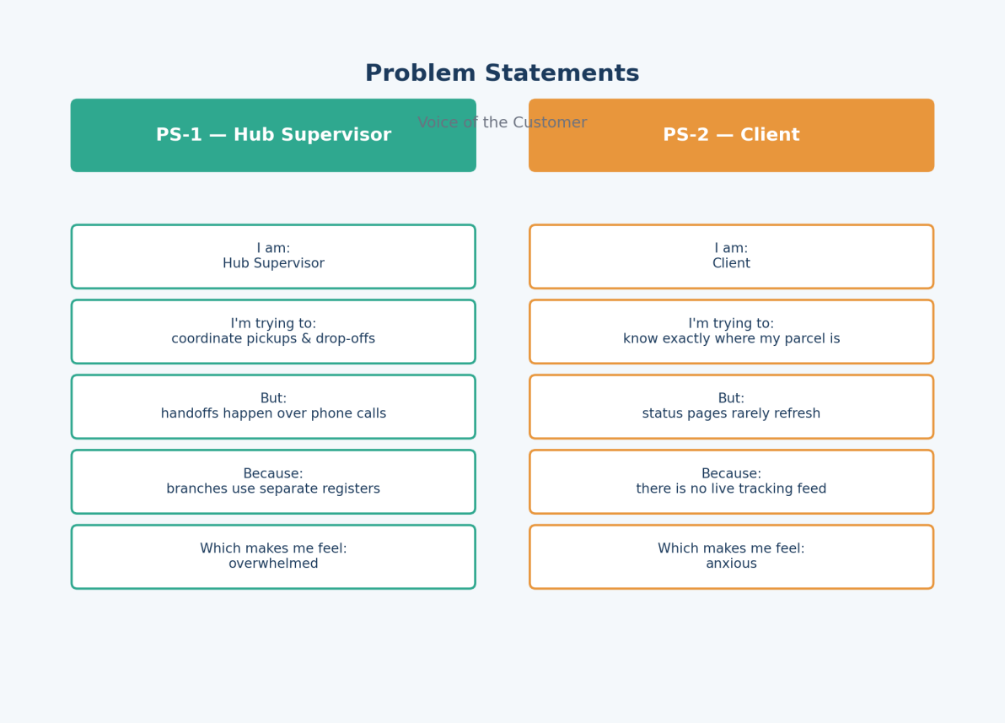

2.2 Empathy Map Canvas
User Persona: Hub Supervisor
- Think & Feel: Worried about missed handovers and inaccurate delivery windows
- Hear: Repeated escalation calls asking “where is my parcel”
- See: Paper waybills, WhatsApp threads, scattered spreadsheets
- Say & Do: Chases riders by phone, re-enters the same booking twice
- Pain: Double data entry and delayed handovers
- Gain: One live dashboard shared across every hub
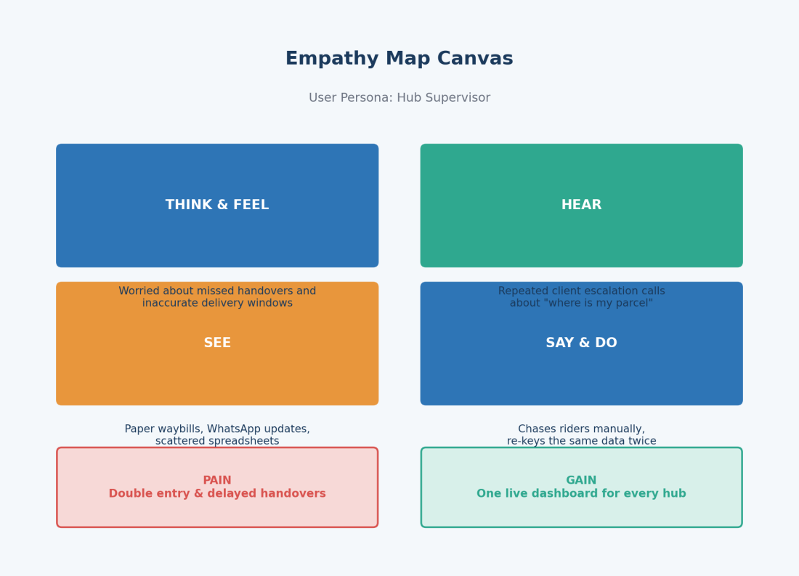

2.3 Brainstorming & Idea Prioritization

Ideas Considered
- Paper waybills
- Shared spreadsheets
- Custom-built web portal
- Salesforce Cloud Platform

Final Selection
Salesforce Cloud Platform was selected because it offered:
- Built-in automation tooling (Flow Builder) with no separate integration layer
- Elastic scalability as new hubs come online
- Live, permission-aware visibility for every role in the business
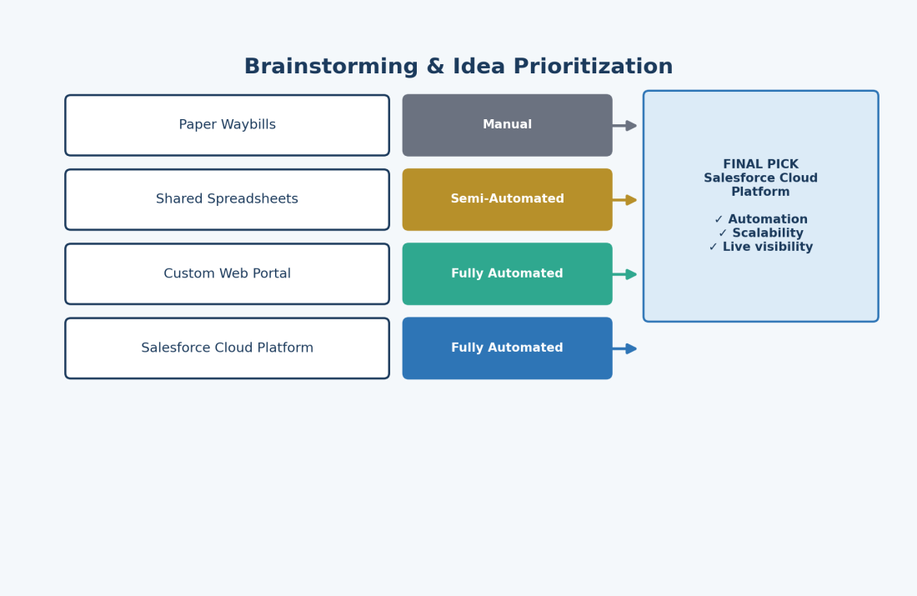

3. Requirement Analysis Phase

3.1 Client Journey Map
Stages: Booking → Parcel Creation → Rider Assignment → In Transit → Tracking Event → Billing → Insights
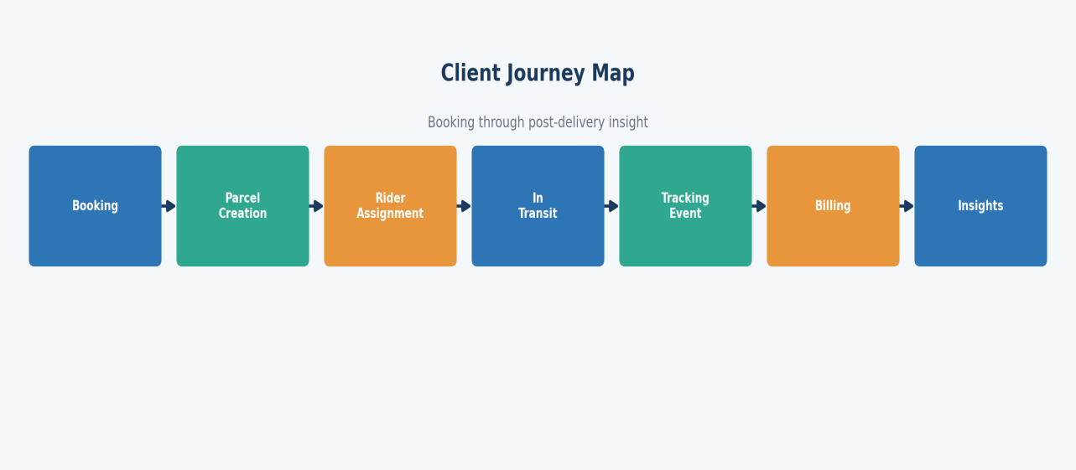

3.2 Solution Requirements

Functional Requirements
FR No | Requirement
FR-1 | Client management
FR-2 | Parcel booking
FR-3 | Rider assignment
FR-4 | Live tracking events
FR-5 | Billing / invoice generation
FR-6 | Reports & dashboards

Non-Functional Requirements
NFR | Description
Usability | Clean Lightning workspace usable by non-technical hub staff
Security | Role-based visibility scoped to hub and function
Reliability | Automation-driven, low-error-rate status propagation
Performance | Near-instant tracking refresh on the parcel record page
Availability | 24/7 cloud access from any hub or device
Scalability | New hubs onboard without re-architecting the system

3.3 Data Flow Diagram
Flow: Client Input → Parcel Record → Validation → Rider Assignment → Tracking Update → Billing → Insights
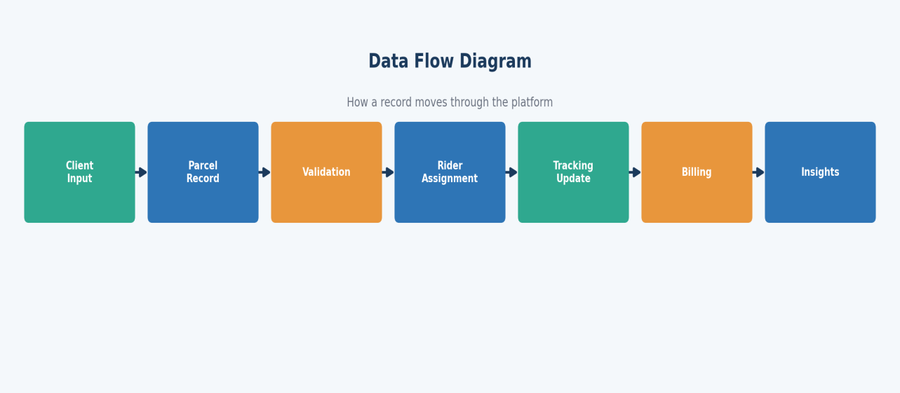

3.4 Technology Stack
Layer | Technology
UI | Salesforce Lightning Experience
Logic | Salesforce Flow Builder
Database | Salesforce custom objects
Automation | Validation rules & record-triggered flows
Security | Profiles, roles & permission sets
Reporting | Reports & dashboards

4. Project Design Phase

4.1 Problem–Solution Fit
CMS replaces scattered waybills and phone-based coordination with one centralized cloud record for every parcel — covering booking, live tracking, rider assignment, billing, and reporting inside a single Salesforce platform.

4.2 Proposed Solution
Parameter | Description
Problem | Manual, paper-based parcel handling
Solution | RapidTrack Courier Cloud, built on Salesforce
Innovation | Automated status propagation & billing
Impact | Shorter handling time, fewer client escalations
Business Model | Courier & last-mile logistics services
Scalability | Ready for multi-hub, multi-city rollout

4.3 Solution Architecture
Components:
- Client Object
- Parcel Object
- Rider Object
- Hub Object
- Tracking Event Object
- Billing Object
- Flows
- Reports
- Dashboards
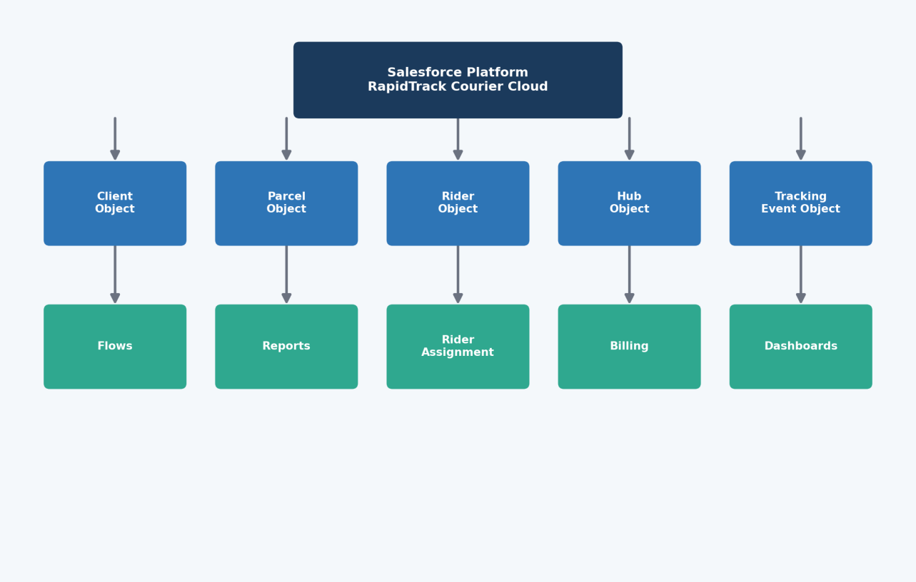

5. Project Planning & Scheduling

5.1 Project Planning
- Agile methodology
- Epics → Stories → Story Points
- Sprint-based execution
- Velocity calculation used for estimation

Product Backlog & Sprint Schedule
Sprint | Epic | USN | User Story / Task | Points | Priority | Owner
Sprint-1 | Developer Setup | USN-1 | As a system administrator, I want to create and configure a Salesforce developer org so that I can build and deploy the Courier Management System. | 3 | High | Ananya
Sprint-2 | Data Modeling | USN-2 | As an admin, I want to create Client, Parcel, Rider, Hub and Billing objects with proper relationships so that courier data is captured accurately. | 5 | High | Karthik
Sprint-2 | Data Modeling | USN-3 | As a staff member, I want tabs and a Lightning App for every courier module so that I can navigate my daily work in one place. | 5 | High | Divya
Sprint-3 | Automation | USN-4 | As a system, I want to validate parcel details such as expected delivery date, weight and mandatory fields so that incomplete bookings are rejected. | 3 | High | Rohit
Sprint-3 | Automation | USN-5 | As a dispatcher, I want an automated flow that pushes tracking updates onto the parcel record so that status changes without manual re-entry. | 3 | High | Rohit
Sprint-4 | Security | USN-6 | As an administrator, I want role-based access for supervisors, riders and support staff so that billing and client data stay protected. | 5 | High | Karthik
Sprint-5 | Reports | USN-7 | As a hub supervisor, I want reports on delivery performance, parcel status and revenue so that I can make informed operating decisions. | 4 | High | Divya
Sprint-6 | Dashboards | USN-8 | As a hub supervisor, I want a dashboard summarizing delivery performance, parcel status and revenue so that I can monitor operations at a glance. | 4 | Medium | Rohit

Project Tracker, Velocity & Burndown
Sprint | Story Points | Duration | Start Date | Planned End | Completed | Released
Sprint-1 | 20 | 6 Days | 12 Jan 2026 | 17 Jan 2026 | 20 | 17 Jan 2026
Sprint-2 | 20 | 6 Days | 19 Jan 2026 | 24 Jan 2026 | — | —
Sprint-3 | 20 | 6 Days | 26 Jan 2026 | 31 Jan 2026 | — | —
Sprint-4 | 20 | 6 Days | 02 Feb 2026 | 07 Feb 2026 | — | —

5.2 Risks & Mitigation
Risk | Impact | Mitigation
Data migration errors when importing legacy hub registers | Incorrect client or parcel history | Stage imports in a sandbox and validate row counts before go-live
Low rider adoption of the new status-update process | Tracking events fall behind reality | Keep the update form to three taps and run a one-week shadow period
Peak-season volume spikes | Slower record saves during festival rush | Load-test flows and reports against simulated peak volumes
Profile misconfiguration exposing billing data | Unauthorized visibility into invoices | Peer-review every profile change before deployment

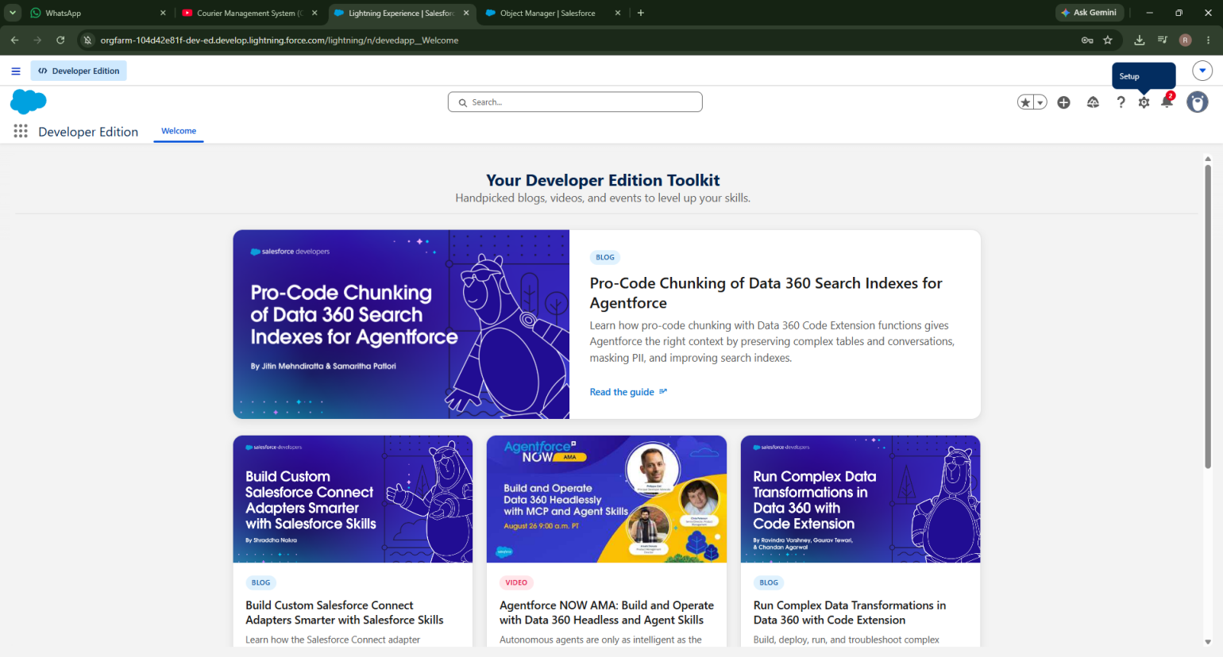

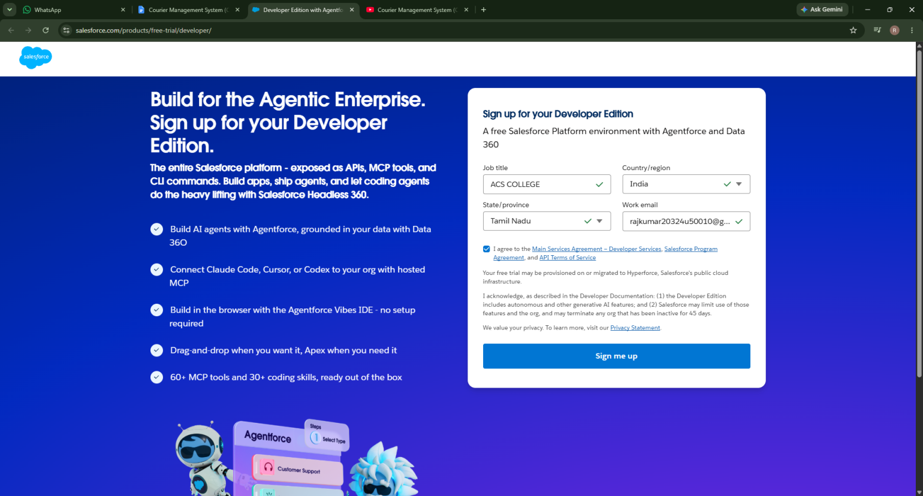

6. Project Development Phase
What you'll learn:
- Real-time Salesforce project implementation
- Designing custom objects and relationships
- Creating page layouts & record types
- Writing validation rules
- Building automation with Flows
- Developing reports & dashboards
- Setting up security with profiles, permission sets, and sharing
- End-to-end application testing

Milestone 1 — Salesforce Developer Account
New to Salesforce and wondering how a real logistics application gets built on the platform? This milestone walks through spinning up the environment CMS will live in.

What Is Salesforce?
Salesforce is a cloud platform for selling, servicing, marketing to, and connecting with customers. Using standard building blocks — objects, automation, security and reporting — a team can model an entire business process, like a courier operation, without standing up its own servers.

Activity 1: Creating a Developer Org
- Go to https://developer.salesforce.com/signup
- Enter First Name & Last Name
- Enter a work email address
- Job Title: Solution Developer
- Company: Zippy Logistics
- Country: India
- Click Sign Me Up

Activity 2: Account Activation
- Open the inbox for the email used at signup
- Click Verify Account (allow up to a couple of hours for delivery)
- Set a password and a security question, then click Change Password
- You will land on the Salesforce Setup home page

Courier Management System

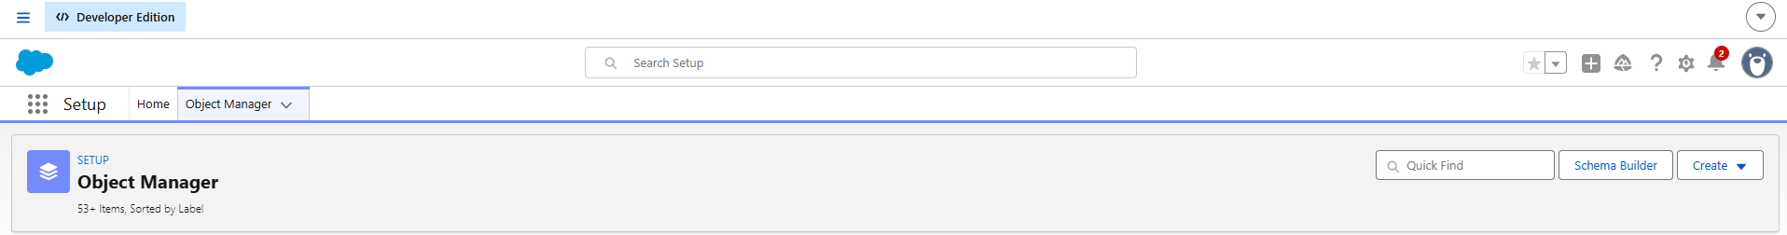

Milestone 2 — Objects

What Is an Object?
A Salesforce object is a database table scoped to an organization — fields become columns, and records become rows. CMS is modeled around six custom objects.

Custom Objects Created
- Client__c — stores client personal and contact information
- Parcel__c — manages pickup, drop, weight and tracking details
- Rider__c — maintains rider profiles and hub assignment
- Hub__c — represents each courier branch office
- Tracking_Event__c — stores every status change for a parcel
- Billing__c — manages invoicing for delivered parcels

Relationships
- Client → Parcel (Lookup)
- Parcel → Rider (Lookup)
- Rider → Hub (Lookup)
- Tracking Event → Parcel (Master-Detail)
- Billing → Parcel (Lookup)

Steps to Implement
Activity 1: Create the Client Object
- Setup → Object Manager → Create → Custom Object
- Label: Client, Plural Label: Clients, Record Name: Client Name (Text)
- Under Optional Features, enable Allow Reports and Track Field History
- Under Search Status, check Allow Search
- Under Object Creation Options, check Add Notes and Attachments related list
- Click Save
Activity 2: Create the Parcel Object
- Label: Parcel, Plural Label: Parcels
- Record Name: Tracking Number (Auto Number), Format: PCL-{00000}, Start: 0
- Enable Allow Reports and Track Field History, then Save
Activity 3: Create the Rider Object
- Label: Rider, Plural Label: Riders, Record Name: Rider Name (Text)
- Enable Allow Reports and Track Field History, then Save
Activity 4: Create the Hub Object
- Label: Hub, Plural Label: Hubs, Record Name: Hub Name (Text)
- Enable Allow Reports, then Save
Activity 5: Create the Tracking Event Object
- Label: Tracking Event, Plural Label: Tracking Events
- Record Name: Update Number (Auto Number), Format: TRK-{0000}, Start: 0
- Enable Allow Reports and Track Field History, then Save
Activity 6: Create the Billing Object
- Label: Billing, Plural Label: Billing Records
- Record Name: Invoice Number (Auto Number), Format: INV-{0000}, Start: 0
- Enable Allow Reports and Track Field History, then Save

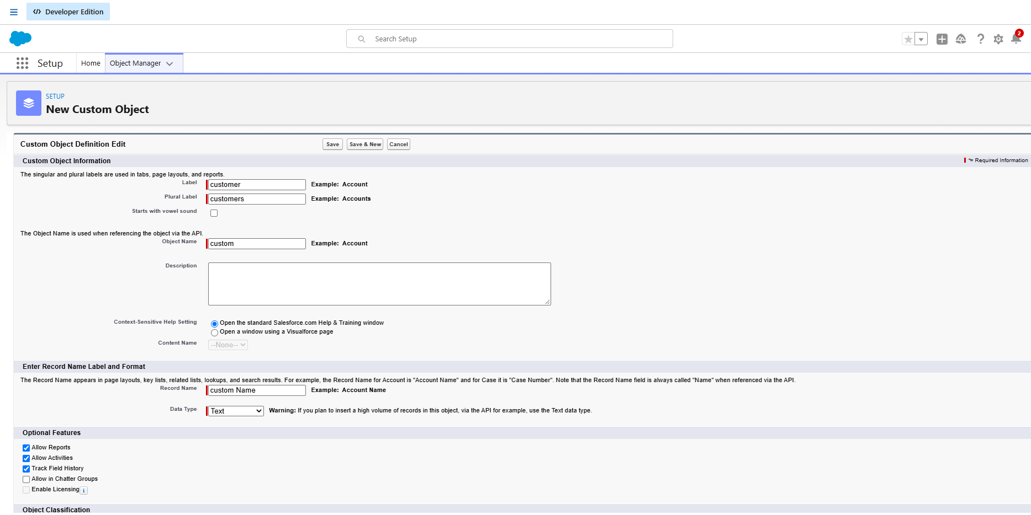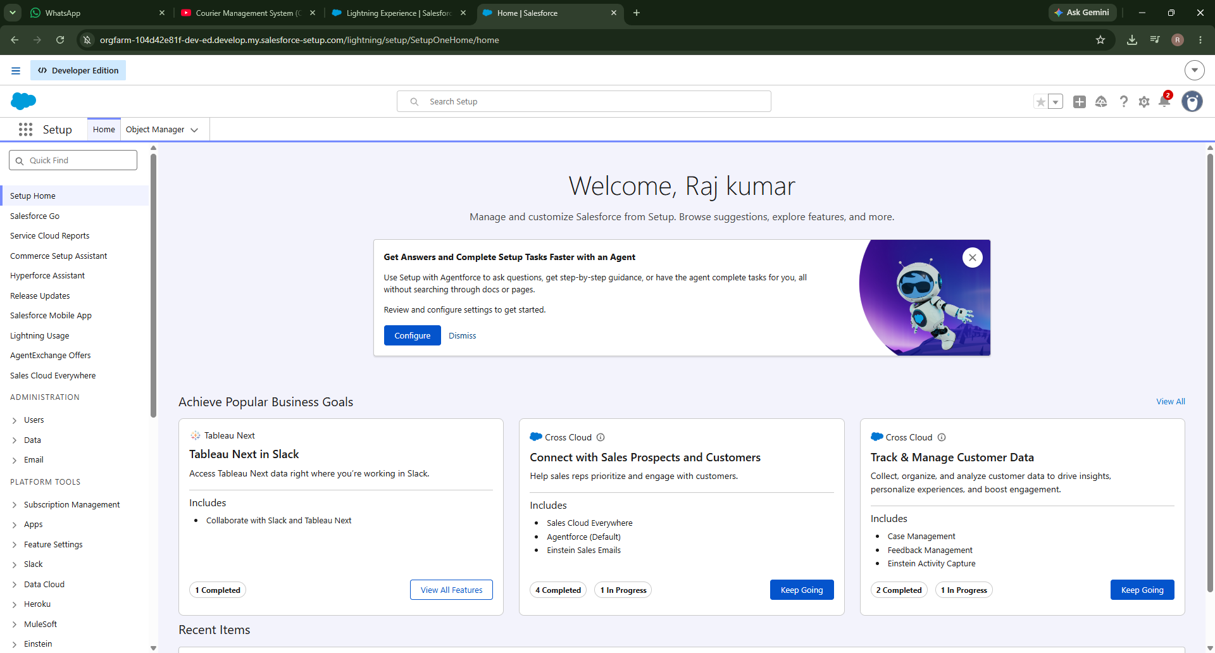

Milestone 3 — Tabs
Tabs surface an object's records at a glance and give users a place to click into their day-to-day work.

Activity 1–6: Creating Tabs
Repeat the following for Client, Parcel, Rider, Hub, Tracking Event and Billing:
- Click Home, type Tabs in Quick Find, and select Tabs
- Under Custom Object Tabs, click New
- For Object, select the relevant custom object
- For Tab Style, choose any icon
- Leave all default settings as they are
- Click Next, Next, and Save
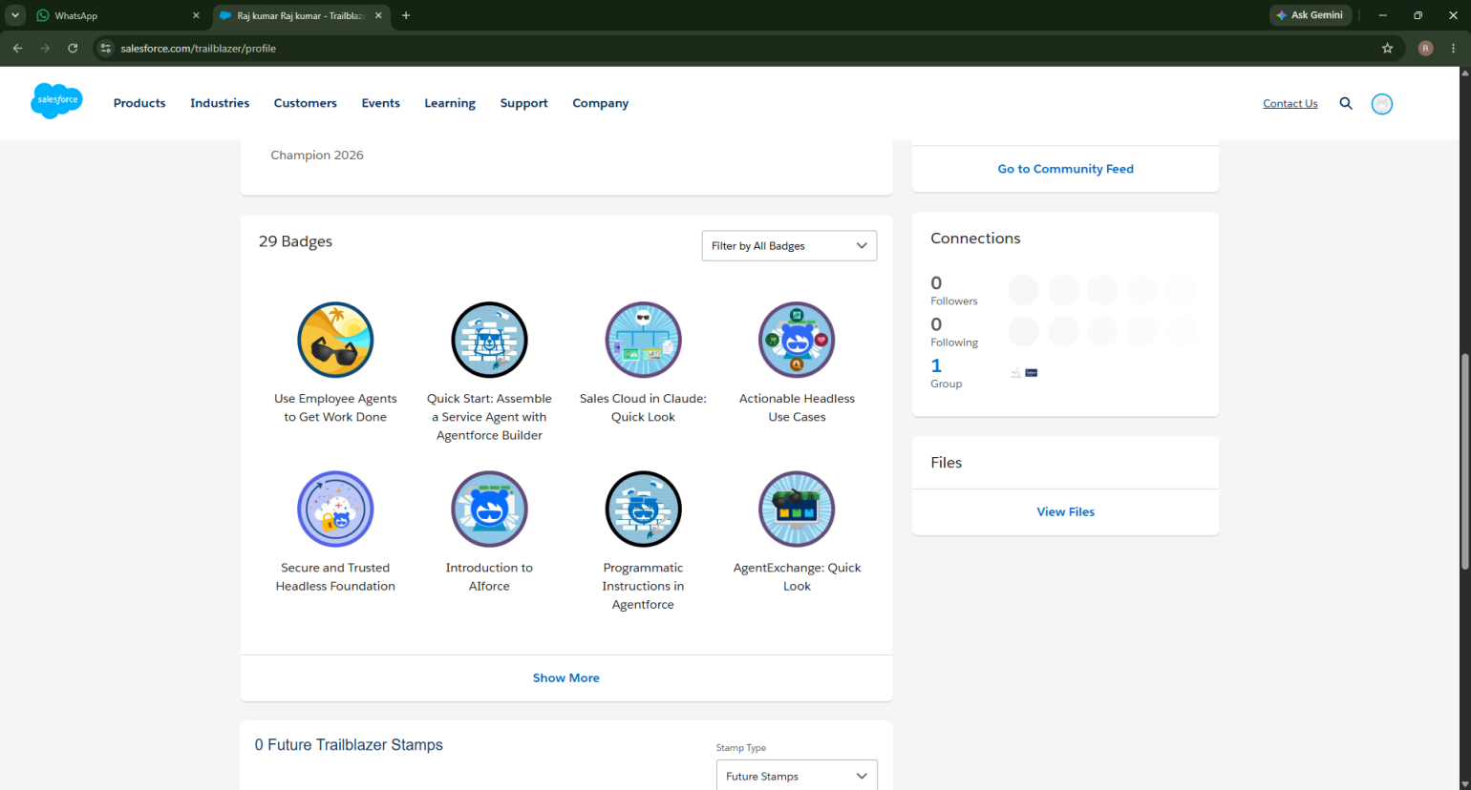

Milestone 4 — Fields & Relationships
Fields are the columns that hold the data a record needs. The tables below list every field created for CMS.

Client__c Fields
Field | API Name | Type | Required | Description
Client Name | Name | Text | Yes | Full name of client
Email | Email__c | Email | Yes | Client email address
Phone | Phone__c | Phone | Yes | Client contact number
Address | Address__c | Text Area | Yes | Client address
Client Type | Client_Type__c | Picklist | Yes | Individual / Enterprise
City | City__c | Text | No | Client city
State | State__c | Text | No | Client state
Postal Code | Postal_Code__c | Text | No | Postal code
Is Active | Is_Active__c | Checkbox | No | Active status

Parcel__c Fields
Field | API Name | Type | Required | Description
Tracking Number | Name | Auto Number | Yes | Unique parcel ID
Client | Client__c | Lookup (Client) | Yes | Related client
Pickup Address | Pickup_Address__c | Text Area | Yes | Pickup location
Drop Address | Drop_Address__c | Text Area | Yes | Delivery location
Weight | Weight__c | Number | Yes | Parcel weight
Shipping Charge | Shipping_Charge__c | Currency | Yes | Shipping charge
Status | Status__c | Picklist | Yes | Parcel status
Expected Delivery Date | Expected_Delivery_Date__c | Date | Yes | Delivery estimate
Assigned Rider | Assigned_Rider__c | Lookup (Rider) | No | Delivery rider
Parcel Category | Parcel_Category__c | Picklist | Yes | Domestic / International

Rider__c Fields
Field | API Name | Type | Required
Rider Name | Name | Text | Yes
Email | Email__c | Email | Yes
Phone | Phone__c | Phone | Yes
Hub | Hub__c | Lookup | Yes
Status | Status__c | Picklist | Yes
Joining Date | Joining_Date__c | Date | No

Hub__c Fields
Field | API Name | Type | Required
Hub Name | Name | Text | Yes
Hub Code | Hub_Code__c | Text | Yes
City | City__c | Text | Yes
State | State__c | Text | Yes
Supervisor Name | Supervisor_Name__c | Text | No

Tracking_Event__c Fields
Field | API Name | Type | Required
Update Number | Name | Auto Number | Yes
Parcel | Parcel__c | Master-Detail | Yes
Status | Status__c | Picklist | Yes
Event Timestamp | Event_Timestamp__c | DateTime | Yes
Remarks | Remarks__c | Text | No

Billing__c Fields
Field | API Name | Type | Required
Invoice Number | Name | Auto Number | Yes
Parcel | Parcel__c | Lookup | Yes
Amount | Amount__c | Currency | Yes
Billing Date | Billing_Date__c | Date | Yes
Payment Status | Payment_Status__c | Picklist | Yes

Relationship Summary
Child Object | Field | Parent Object | Type
Parcel | Client__c | Client | Lookup
Parcel | Assigned_Rider__c | Rider | Lookup
Rider | Hub__c | Hub | Lookup
Tracking Event | Parcel__c | Parcel | Master-Detail
Billing | Parcel__c | Parcel | Lookup

Creating a Tab for Customer Object

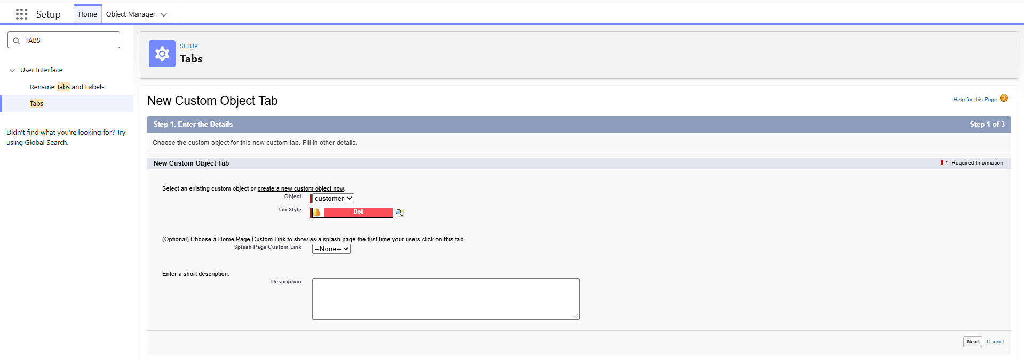

Milestone 5 — Validation Rules
Validation rules run when a record is saved, blocking it with an error message until the data meets the stated condition.

Client__c
- Email_Required — ISBLANK(Email__c) → “Email is required.”
- Validate_Phone_Number — LEN(Phone__c) <> 10 → “Phone number must contain 10 digits.”
- Validate_Postal_Code — LEN(Postal_Code__c) <> 6 → “Postal code must contain 6 digits.”

Parcel__c
- Validate_Weight — Weight__c <= 0 → “Weight must be greater than zero.”
- Validate_Shipping_Charge — Shipping_Charge__c <= 0 → “Shipping charge must be greater than zero.”
- Validate_Expected_Date — Expected_Delivery_Date__c < TODAY() → “Expected delivery date cannot be in the past.”

Rider__c
- Validate_Rider_Email — NOT(CONTAINS(Email__c, "@")) → “Enter a valid email address.”

Hub__c
- Hub_Code_Required — ISBLANK(Hub_Code__c) → “Hub code is mandatory.”

Tracking_Event__c
- Remarks_Required_For_Delay — AND(ISPICKVAL(Status__c, "Delayed"), ISBLANK(Remarks__c)) → “Remarks are required when status is Delayed.”
Steps (repeated for each rule): Setup → Object Manager → select the object → Validation Rules → New → enter the rule name → mark it Active → paste the formula → Check Syntax → enter the error message and field location → Save.

Flows

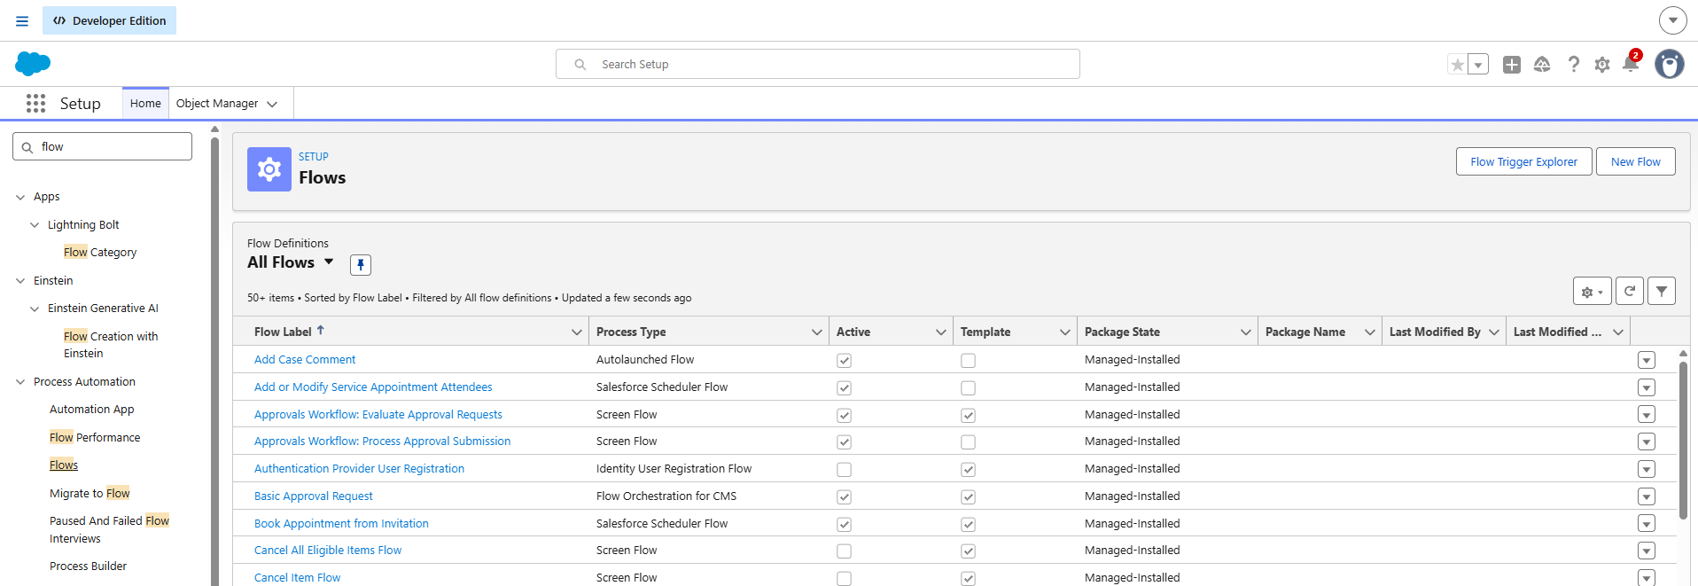

Milestone 6 — Page Layouts
Page layouts control what a user sees on a record and how fields, sections and related lists are arranged.

Client__c Layout
Section 1 — Client Information: Client Name, Client Type, Email, Phone, Is Active
Section 2 — Address Details: Address, City, State, Postal Code

Parcel__c Layout
Section 1 — Parcel Details: Tracking Number, Client, Parcel Category, Weight, Shipping Charge, Status
Section 2 — Address Information: Pickup Address, Drop Address
Section 3 — Delivery Information: Expected Delivery Date, Assigned Rider

Rider__c Layout
Rider Details: Rider Name, Email, Phone, Hub, Status, Joining Date
Additional Information: Related Parcels, Related Tracking Events

Hub__c Layout
Hub Information: Hub Name, Hub Code, City, State, Supervisor Name

Tracking_Event__c Layout
Update Information: Update Number, Parcel, Status, Event Timestamp, Remarks

Billing__c Layout
Billing Details: Invoice Number, Parcel, Amount, Billing Date, Payment Status
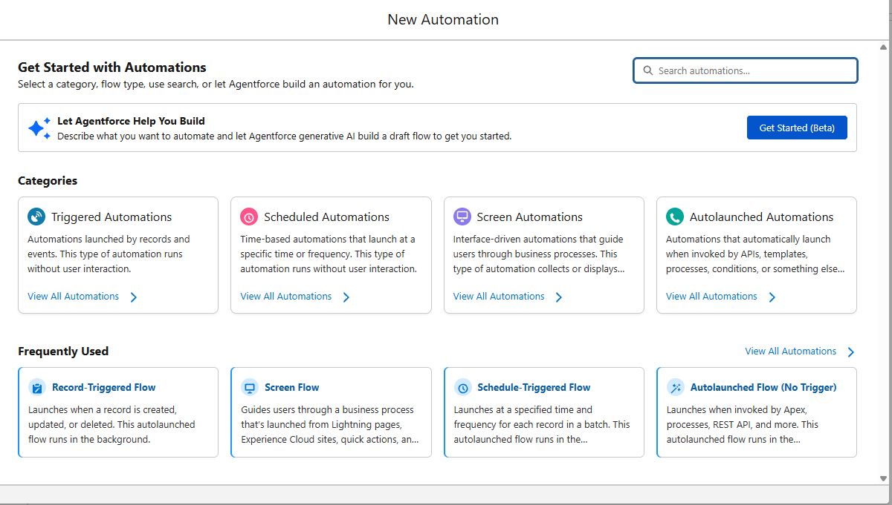

Milestone 7 — Flows
A Flow automates a business process visually, without writing code. CMS uses a record-triggered flow to keep the parcel status in sync with the latest tracking event.

Activity 1: Auto-Update Parcel Status When a Tracking Event Is Created
Scenario: whenever a Tracking_Event__c record is created, the related Parcel__c Status field should update automatically to match.
Step 1 — Open Flow Builder: Setup → Quick Find → Flows → New Flow → select Record-Triggered Flow → Create.
Step 2 — Configure the Start: Object – Tracking_Event__c; Trigger – A record is created; Condition – None (always run); Optimize for – Actions and Related Records.
Step 3 — Add an Update Records element: Label – Update_Parcel_Status; Find records by – specify conditions; Object – Parcel__c; Field – Id equals {!$Record.Parcel__c}.
Step 4 — Set field values: Status__c = {!$Record.Status__c}.
Step 5 — Save as Auto_Update_Parcel_Status and Activate the flow.
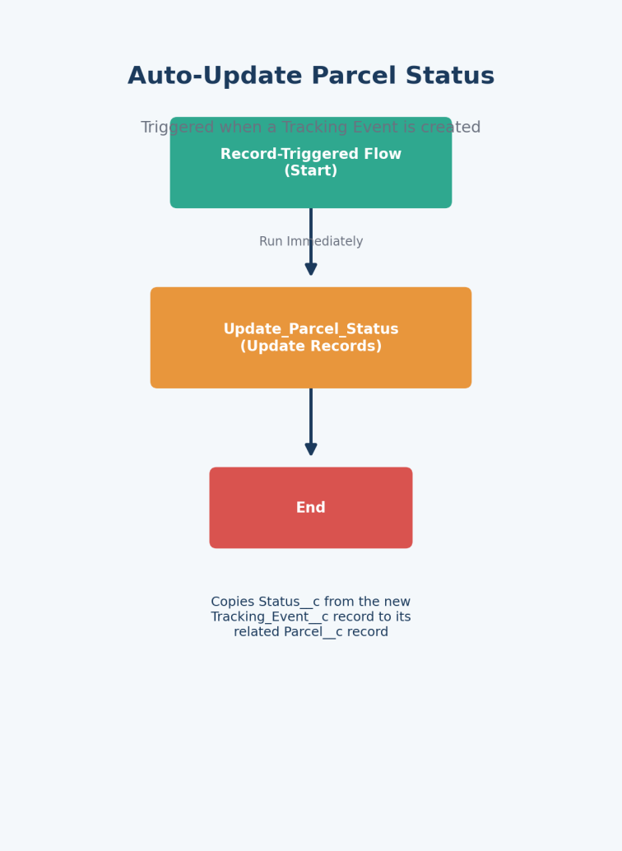

Milestone 8 — The Lightning App
An App in Salesforce groups related tabs into one working environment with its own name, logo and set of tabs.

Activity 1: Create the RapidTrack Courier Cloud App
- From Setup, enter App Manager in Quick Find and select App Manager
- Click New Lightning App and name it RapidTrack Courier Cloud
- Upload a logo/icon and choose a primary color, then click Next
- Leave App Options and Utility Items at their defaults, then click Next
- Move Clients, Parcels, Riders, Hubs, Tracking Events, Billing, Reports and Dashboards to Selected Items
- Click Next, assign the System Administrator profile, then click Save & Finish

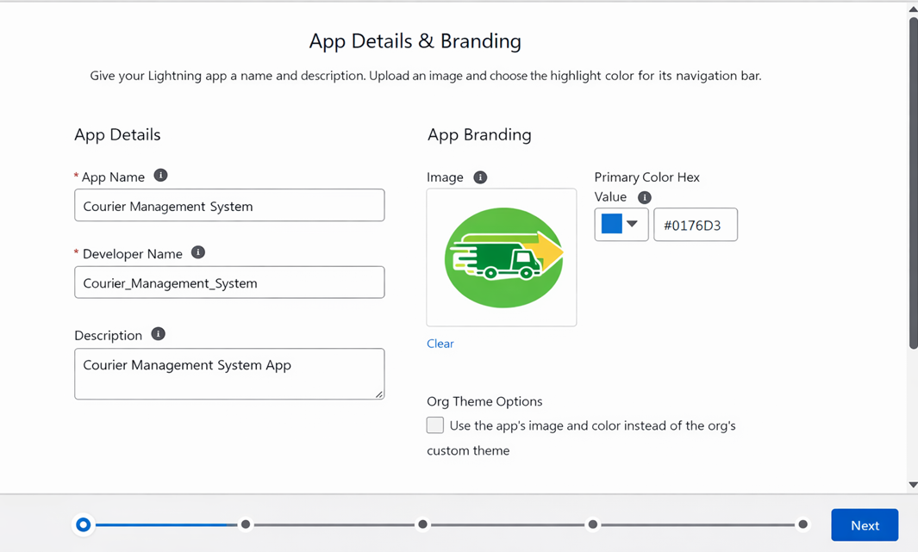

Milestone 9 — Profiles
A profile is the collection of permissions that defines what a user can see and do — object access, field access, app and tab visibility, page layouts, login hours and more. A user is assigned exactly one profile at a time.

Activity 1: Courier Admin (cloned from System Administrator)
Cloning System Administrator gives Courier Admin full CRUD access, Modify All Data and Customize Application out of the box, which can be narrowed later if required.

Activity 2: Hub Supervisor (cloned from Standard Platform User)
Default app: RapidTrack Courier Cloud. Visible tabs: Clients, Parcels, Riders, Hubs, Tracking Events, Billing, Reports, Dashboards.
Object | Permissions Granted
Client__c | Create, Read, Edit
Parcel__c | Create, Read, Edit
Rider__c | Read, Edit
Hub__c | Read, Edit
Tracking_Event__c | Create, Read, Edit
Billing__c | Read
Session timeout: 2 hours of inactivity. Passwords: minimum length 8, set to never expire.

Activity 3: Rider (cloned from Standard Platform User)
Default app: RapidTrack Courier Cloud. Visible tabs: Parcels, Tracking Events.
Object | Permissions Granted
Parcel__c | Read, Edit
Tracking_Event__c | Create, Read, Edit
Client__c | Read
Billing__c | Read
Restrictions: no Hub editing, no delete permissions, limited reporting access.

Activity 4: Support Executive (cloned from Standard User)
Visible tabs: Clients, Parcels, Tracking Events.
Object | Permissions Granted
Client__c | Read, Edit
Parcel__c | Read, Edit
Tracking_Event__c | Read
Billing__c | Read

Final Profiles Created
Profile Name | Purpose
Courier Admin | Full system control
Hub Supervisor | Manages parcels and riders at a hub
Rider | Updates delivery status on assigned parcels
Support Executive | Handles clients and tracking queries

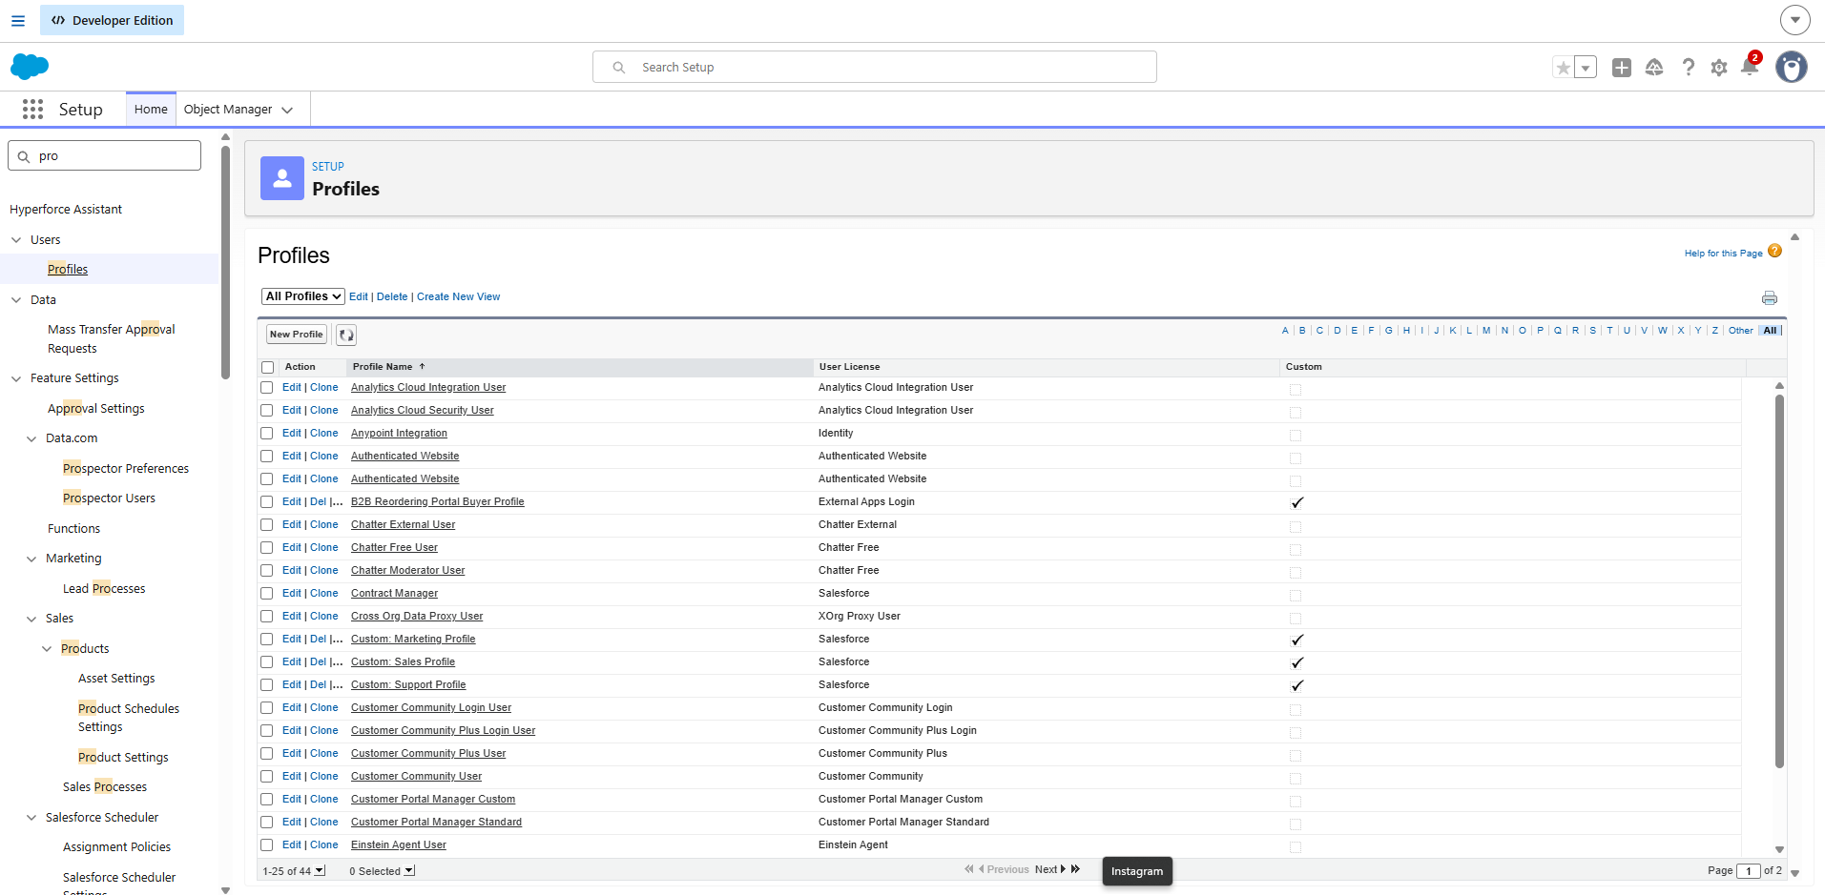

Milestone 10 — Roles
Roles define the reporting hierarchy and control which records a user can see above and below them in the org chart — a higher role sees more, not less.

Activity 1: Courier Admin Role
- Quick Find → Roles → Set Up Roles
- Expand All, click Add Role under CEO
- Label: Courier Admin (Role Name auto-populates) → Save

Activity 2: Hub Supervisor Role
- Below Courier Admin, click Add Role
- Label: Hub Supervisor → Save

Activity 3: Rider Role
- Below Hub Supervisor, click Add Role
- Label: Rider → Save

Activity 4: Support Executive Role
- Below Hub Supervisor, click Add Role
- Label: Support Executive → Save

Purpose of This Hierarchy
- Courier Admin — highest-level access to all data
- Hub Supervisor — manages hub-level operations
- Rider — access limited to assigned parcels
- Support Executive — limited access to client and tracking data
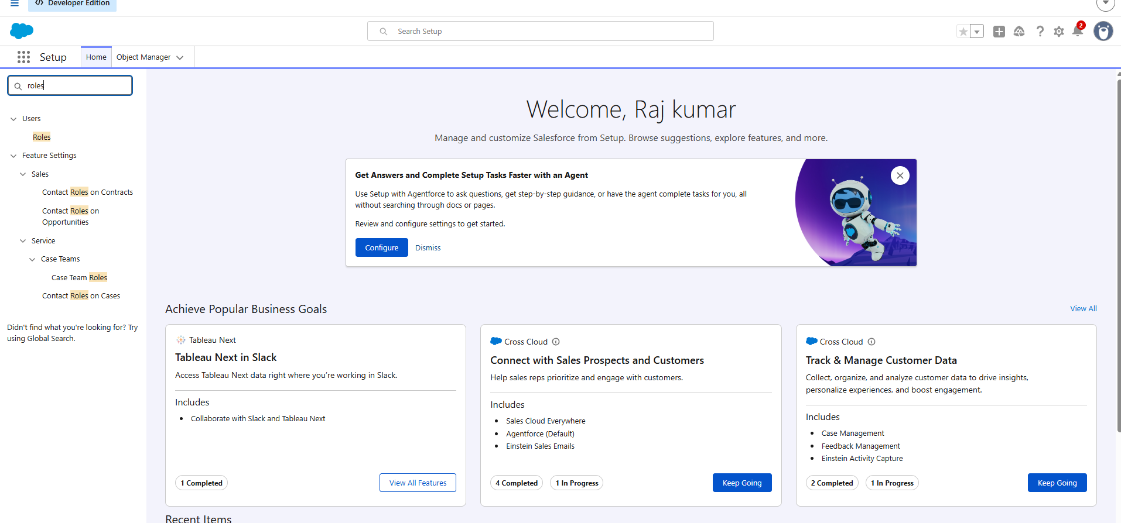

Milestone 11 — Users
A user is anyone who logs into Salesforce; their user record determines which features and records they can access.
Note: a developer org typically allows only two active Salesforce-licensed users at a time — deactivate an existing licensed user, or switch their license type, before adding a new one if you run out.

Activity 1: Create a User
- Setup → Quick Find → Users → New User
- Fill in First Name, Last Name, Alias, Email, Username (unique, text@text.text), Nickname
- Role: Courier Admin, User License: Salesforce, Profile: Courier Admin
- Click Save

Activity 2: Creating the Remaining Users
User Type | Role | License | Profile
Hub Supervisor | Hub Supervisor | Salesforce | Hub Supervisor
Rider | Rider | Salesforce Platform | Rider
Support Executive | Support Executive | Salesforce Platform | Support Executive

Important Points
- Every user needs a unique username, valid email, an assigned role and an assigned profile
- Profiles control what a user can do
- Roles control what data a user can see

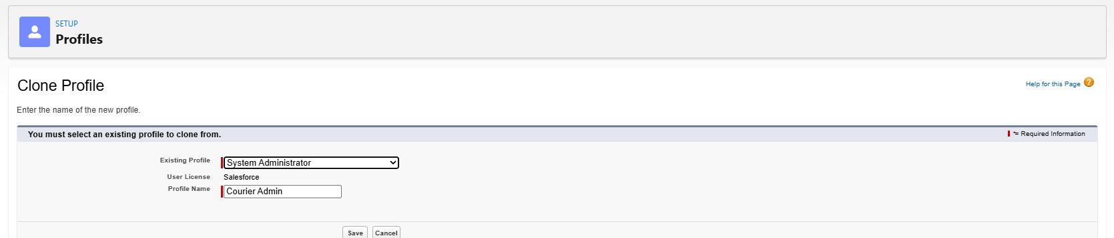

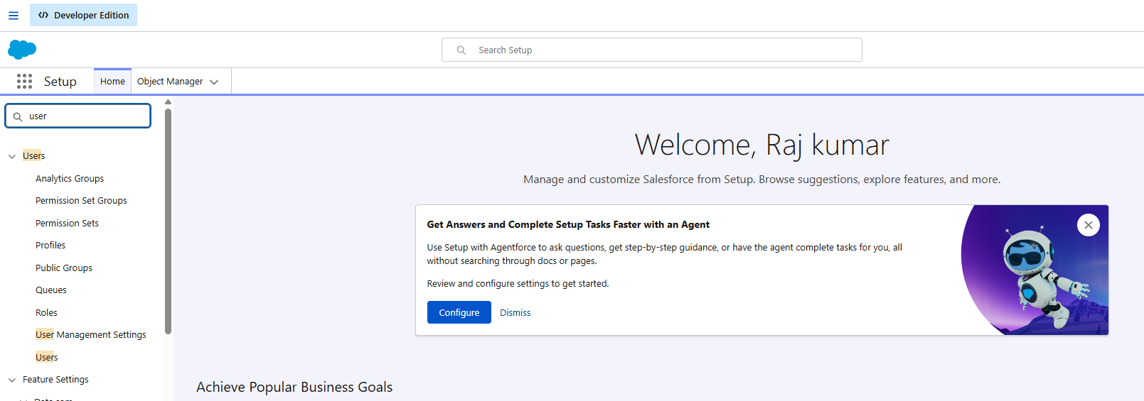

Milestone 12 — Reports & Dashboards
Reports and dashboards turn the data captured across CMS into decisions hub leadership can act on.

Activity 1: Custom Report Types
- Parcel Tracking Report — Primary Object: Parcel__c
- Client Summary Report — Primary Object: Client__c
- Rider Performance Report — Primary Object: Rider__c

Activity 2: Reports
Report 1 — Parcel Status Summary: columns Tracking Number, Client, Status, Expected Delivery Date, Assigned Rider; grouped by Status, summarized on Shipping Charge; filtered to this month.
Report 2 — Rider Performance Report: columns Rider Name, Hub, Parcel Count, Status; grouped by Rider.
Report 3 — Revenue by Hub: columns Tracking Number, Client, Shipping Charge, Payment Status; grouped by Hub and Month.

Activity 3: Dashboard
A new dashboard, RapidTrack Courier Dashboard, is built from these three reports:
- Parcel Status Overview — Donut Chart
- Rider Performance — Bar Chart
- Revenue by Hub — Column Chart
The dashboard is shared with Courier Admin, Hub Supervisors and the Support Executive team.

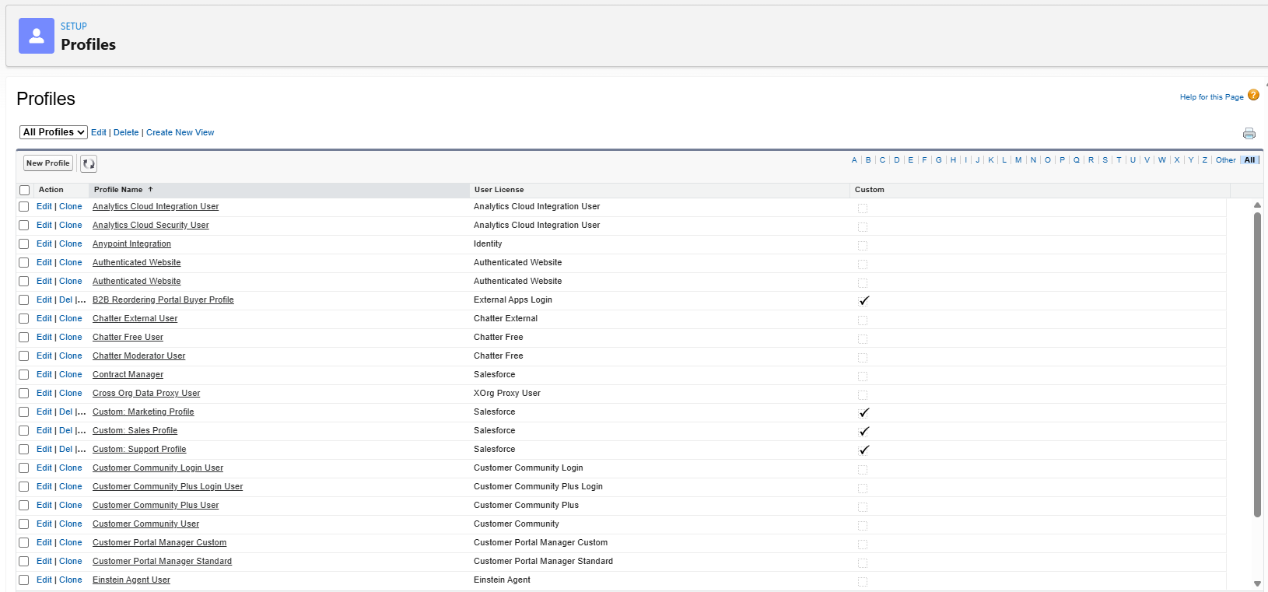
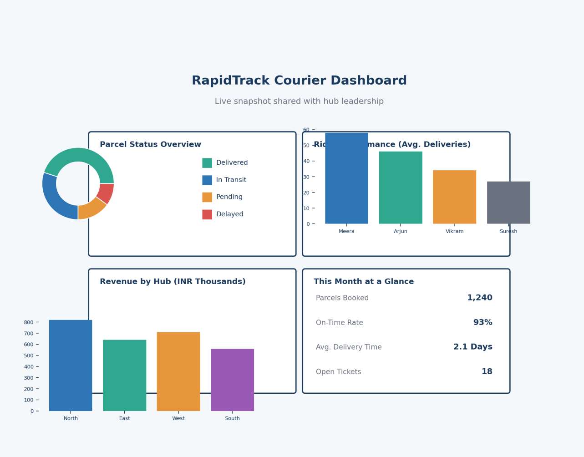

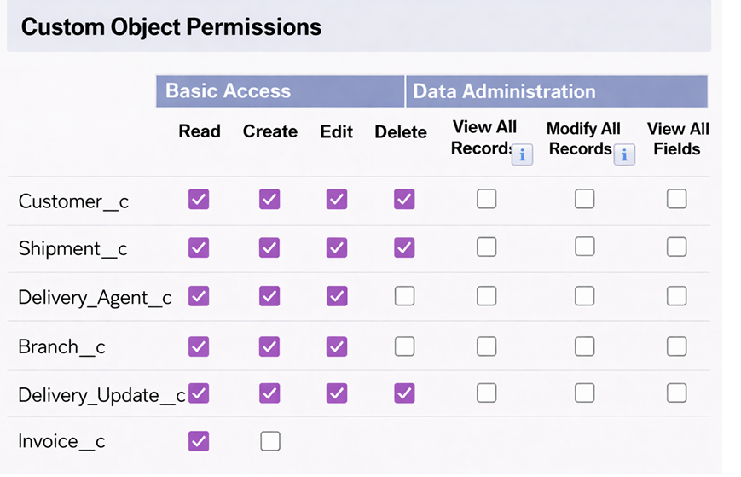

7. Functional & Performance Testing
Testing covered record creation across every object, enforcement of each validation rule, automatic status propagation from Tracking Events to Parcels, correct invoice generation, profile-based visibility for each role, and rendering of every report and dashboard component. Each scenario was run against the developer org and confirmed to behave as designed before sign-off.

8. Advantages & Disadvantages

Advantages
- One centralized, always-current source of parcel data
- Automated status updates remove manual re-entry
- Live reporting supports same-day operating decisions
- Role-based access keeps billing and client data protected

Disadvantages
- Operational dependency on the Salesforce platform
- Upfront configuration effort before go-live
- Ongoing admin attention needed as hubs and rules grow

9. Conclusion
The Courier Management System digitizes end-to-end courier operations on Salesforce, replacing scattered paper and phone-based coordination with one connected platform. The result is faster handoffs, fewer client escalations, and a leadership team that can finally see — in real time — how the business is actually performing.

10. Future Scope
- A dedicated mobile app for riders to update deliveries from the field
- GPS-based live location tracking for in-transit parcels
- SMS and WhatsApp notifications on every status change
- AI-assisted route optimization for multi-stop rider runs
- Predictive ETA modeling built on historical delivery data

11. Appendix
- Source Code: Salesforce configuration (objects, flows, validation rules)
- Dataset: Salesforce custom objects and sample records
- Demo Org: Salesforce Developer Edition environment
Thank You

