Quick Fix
(Google’s Android Mobile Application)

Fall 2008
Instructor:
Dr.Kwok-Bun Yue
Mentor:
Mr.Dilhar De Silva
Project Team Members:
Hari Kishan Kapa
Sumanth Kattamanchi
Dinesh Reddy Gudibandi
Sai Srinivas Pabbathi (Team Lead)

Acknowledgement
We take the opportunity to thank our instructor Dr. Kwok-Bun Yue and mentor Mr. Dilhar De Silva for the most effective and valuable guidance. Mr. Dilhar De Silva has been the inspiration and was always up front to motivate and encourage us for bringing out this project successfully.
We would also like to thank all the people who helped us in this project and whom we might not have mentioned here.

ABSTRACT
Android is the first complete, open and free mobile platform. It is developed by the Open Handset Alliance, a group of more than 30 technology and mobile companies. It is supported by Google and this project uses a Google Android Mobile SDK 1.0 for testing an application.
The aim of our project is to develop an integrated Web and mobile phone application prototype for connecting household service seekers and providers using Android. The Web interface is used by the service seeker who has household problems and they use the web interface to post their problems through their respective accounts. The service providers must belong to a company or they themselves can be a company for getting registered to the web application. The mobile application is to be installed on the mobile phone.
This project focuses on developing a web application that is developed using C# and ASP.NET where the service seeker and service providers can have their profiles to know about each other. This web application increases the security allowing the service seeker to know the person who is going to fix the problem posted by him. Both services provider and seeker will have an option to choose the person according to the ratings and reviews that are posted previously.
The main part of the project resides on the mobile phone which has application that is developed using java and XML. The service provider uses the application for tracking the service seeker within a given Zip-code that is shown on a Google Map. For displaying the set of service seekers and their problems this project uses a Google Map API and XML for displaying the content on the map. The service provider is allowed to see the problems posted and he is allowed to click on the information for more benefits such as calling a service seeker, route to the destination, route from the source, add to favorites and view profile.

Table of Contents
1. Introduction - 6 -
1.1 Purpose: - 6 -
1.2 SCOPE: - 6 -
2. SOFTWARE RequirementS Specification - 7 -
2.1 Mobile Application: - 7 -
2.2 Web Application: - 8 -
3. DESIGN and Implementation - 12 -
3.1. ASSUMPTIONS and DEPENDENCIES: - 12 -
3.2. CONSTRAINTS: - 12 -
3.3. DESIGN DETAILS: - 13 -
4. TECHNICAL Details - 14 -
4.1. Technologies USED: - 14 -
4.2. PROBLEMS FACED: - 16 -
5. Lessons Learned - 16 -
5.1 Importance of RESEARCH: - 16 -
5.2. TEAM WORK: - 17 -
5.3. TIME MANAGEMENT: - 17 -
6. References - 17 -
7. APPENDICES - 18 -
7.1. Appendix A: Project Management and Team Information - 18 -
7.2 Appendix B: Sequence Diagrams for the Web Application - 20 -
7.3. APPENDIX C: Class Diagram for the Web application - 22 -
7.4. APPENDIX D: User Interface - 23 -
7.5. Appendix E: Design Details of the Web Application - 23 -
7.6. APPENDIX f: Design Details of the mobile Application - 29 -
7.7 Appendix G: Major tasks and contributions - 33 -

1. Introduction

1.1 Purpose:
This project uses the Google Android platform to build an application where customers needing a service can announce the required service and mobile service providers can quickly identify the opportunity and contact the customer. The overall concept is where a customer would announce the required service (i.e. – needs plumbing services to unclog a drain in the house, etc.) through an innovative web application. A service provider using a smart phone running Google Android (for the project this will be an emulator) could either through GPS or by entering a zip code could request to show all customers needing the service (i.e plumbing service) in a 5 mile radius. The application will use Google maps to plot the customer location where the service provider could get extra information about the problem and then with a click initiate a call to the customer and discuss the possibilities of providing the service.

1.2 SCOPE:
Quick fix is a virtual meeting place for service providers and the service seekers to communicate with each other. The two main domains are the Web application and the Mobile application. The service providers shall use the Android mobile in order to learn the problems, which were faced by the customers. This application benefits both the service providers and seekers so that the problems can be addressed quickly and accounts for a friendly relationship between both the groups.

2. SOFTWARE RequirementS Specification
This section explains about the individual functionality and requirements of two major sections of this project
- Mobile Application
- Web Application
These requirements are identified from the sequence diagrams that are drawn to identify the flow of these two applications and the communication between them.
Refer Appendix B for the Sequence diagrams.

2.1 Mobile Application:
Application requires service providers User Name and password. When a service provider starts our application a menu showing last saved page or start new search will be displayed. If he selects the last saved then the application takes to the recent saved page. If he/she clicks on the start new then the map with the plotting (service seekers with a problem) will be displayed. When clicks on the Menu on the phone then a window consists of two text fields where in you type the zip code and radius will be displayed. When he/she clicks on submit then the application query the database and gets the information of the service seekers in the area provided. Then a map with the plotting of the service seekers in need of service in that area will be displayed. When Service provider clicks on the plotting then the description should be displayed, description includes the name of the service seeker, address, save page and more options link. When save page is clicked the particular pages showing the plotting will be saved. When the user clicks on the more options menu, the following details will be displayed
- Zoom into address (closer view of the location)
- Address –address of the service seeker (the physical address)
- Dial option to contact the service seeker. (To make a phone call)
- Directions to the service seeker location
- Directions from the service seeker location
- Log off
- Add to Favorites
Note: - When he/she clicks on add to favorites then that particular service seeker will be tagged as a favorite service seeker to this particular service provider in the database.

2.2 Web Application:
This application starts with a Flash intro and it later redirects the user into the web page where he can register, login and use the services according to his account type. It concentrates on the functionality and requirements for different type of users. This application has 3 types of users
- Service Seekers
- Service Providers
- Company Admin
These requirements are individually identified for each type of user and it is explained in detail as followed.

2.2.1 Registration
Each user must fill all the fields and get registered into the web application and later he is sent an e-mail to verify his identity. As soon as he/she clicks the link that is sent to his e-mail then he/she is redirected to their profile page where they are given access to take advantage of the application according to the user type.

2.2.2 Managing User Accounts:
This section explains the functionality of the user accounts that is provided after registration according to the user type.

2.2.2.1 Company Admin

Every page of the user profile shall have the links to every other page to which that particular user is permitted to use. User who created the company profile will have the admin rights. The home page of the admin shall have links

Home – Redirects to the Profile page

Edit Profile – Profile information shall be updated and edited

Organize Employees – Employees shall be managed by the company admin

Ratings – All the ratings posted to the employees shall be seen

Reviews – All the reviews posted to the employees shall be seen

History – All the work done by the employees till date shall be seen

Logout

2.2.2.2 Service Provider
He/she may be an employee of a company that has been previously registered by its admin or might be a single individual who is the owner as well as the employee of the company. These types of users are called service providers. The following links shall be displayed in the home page of the service provider
- Home
- Edit Profile
- Rating – Service provider shall rate the service seeker for whom he has worked for
- Reviews – Service provider may write reviews for whom he has worked for
- Favorites – List of favorite service seekers shall be seen
- History – Work done till date is displayed
- Logoff
They can see the list of service seekers that are in his/her favorites list on the right most corner of the profile page.

2.2.2.3 Service Seeker
This type of user can have problems and can post through the web application where he receives a response from the service provider using an android mobile phone. After the service seeker logs in he/she should be able to see the following links
- Home
- Post a problem – Service seeker is allowed to post a problem
- Edit profile
- Reviews – Shall write a review on a service provider
- Rating – Shall rate a service provider
- Favorites – Shall see a list of favorite service providers
- History – Problems posted till date and information related to it shall be seen
- Logout

3. DESIGN and Implementation

3.1. ASSUMPTIONS and DEPENDENCIES:
- The Mobile Application is dependent on the Web Application because the mobile application cannot work without the data from the web application and vice versa.
- The default settings on the mobile application will reflect on the Google maps.
Settings such as frequently used zip code and the radius can be made default, thereby providing an easy way for the service provider.
- Each Service provider having a Google Android phone.
Every service provider using this application shall possess a smart phone with Android Operating system on top of it.

3.2. CONSTRAINTS:
- Huge data shall not be stored on the mobile phone. As a matter of fact, the mobile phone consists of limited memory and storing excess information is not at all a good design.
- User of the mobile should have internet access. The Service provider should have the internet access in order to retrieve the service seeker’s information. Whenever he/she updates his/her profile over the mobile, the changes should be synchronized with the web application.

3.3. DESIGN DETAILS:
The design details include the following
- Static structure
- Behavior
- User Interface
- Components
These design details are individually given for both web application and mobile application.

3.3.1. Web Application

3.3.1.1 Static Structure
The static structures of the web application represent the class diagram and for the class diagram refer Appendix C.

3.3.1.2 Behavior
The behavior of the web application explains you the various actions and the flow of the web application. For the behavior refer Appendix B.

3.3.1.3 User Interface
The user interface is one of the major things on the web application end, since many users come to a conclusion on the standards and services of the application by looking at it. Having a good UI is very important.
For the user interface please refer Appendix D.

3.3.1.4 Components
This describes a class that includes the attributes and methods. It also says the exceptions that may rise on the web application part. For a detailed description refer Appendix E.

3.3.2. Mobile Application
This part explains the behavior and design details of the mobile application. For the class diagram and design details refer Appendix F.

4. TECHNICAL Details

4.1. Technologies USED:
This section focuses on technologies used in Web interface and Mobile Interface.

4.1.1. ASP.NET:
This was used to develop the website as it is the most widely used and easily understandable.

4.1.2. JAVA:
As the android platform understands Java the application was built on it.

4.1.3. XML:
XML is a simple, very flexible text format which was designed to carry data, not to display data.

4.1.4. MySQL Server:
Microsoft SQL Server is a relational database management system (RDBMS). In our application, to store and to retrieve the data from the database we use this technology. It is used for both Web and mobile application.

4.1.5. Android:
The Android platform is a software stack for mobile devices including an operating system, middleware and key applications. Developers have full access to the same framework APIs used by the core applications. The application architecture is designed to simplify the reuse of components; any application can publish its capabilities and any other application may then make use of those capabilities. Developers can create applications for the platform using the Android SDK. Applications are written using the Java programming language and run on Dalvik, a custom virtual machine designed for embedded use, which runs on top of a Linux kernel.

4.2. PROBLEMS FACED:
- Effect of Hurricane Ike
- MYSQL connectivity with web application
- External Database connection
- MAP API key
- Drawing overlays
- Integrating the Web client and the android client

Lessons Learned

5.1 Importance of RESEARCH:
We have used few technologies in our project, among them Android operating system is very important as our final application should run on this platform. We have spent many days learning Android as it was a new technology. Our application will be successfully built on this as we were able to use many built-in features of Android.

5.2. TEAM WORK:
By the end of this project we will end up as an effective and coordinating team as we understood the importance of the team work by the guidance of our mentor. Our team is a good combination of challenging and hardworking people. Throughout this project we have learnt a lot about team coordination, planning, presentation and developing personal attitude towards teamwork.

5.3. TIME MANAGEMENT:
To become successful, one must have good time management as it is considered as one of the important quality in the current competitive world. Keeping our mentor suggestions in mind we were able to implement and manage things in time. Meeting the various deadlines set by the instructor was tough and gave us a valuable experience of how to effectively manage time and as well the mentor’s expectations were sometimes very challenging and finally our project timeline was nearly accurate and we were following that from the initial stages onwards. Refer Appendix F for project timeline.

References
- Learn Android, http://code.google.com/android/
- MySQL, http://www.mysql.com/
- XML, http://www.w3schools.com/xml/default.asp
- XML, http://www.tizag.com/xmlTutorial/
- Android forum, http://www.anddev.org/

7. APPENDICES

7.1. Appendix A: Project Management and Team Information
Team Leader (Sai Srinivas Pabbathi): The Team Leader is responsible for organizing team efforts and ensuring that the team is satisfying the professor's Policies and Requirements document.
Webmaster (Dinesh): The Webmaster is responsible for maintaining the Project Web site.
Web Developers (Dinesh, Sumanth): Web developers are responsible for a well designed web application that supports the mobile application.
Testing (Sai, Hari): These people are supposed to test the web application and suggest the changes including reporting bugs.
DBA (Sumanth, Hari Kishan): The DBA is responsible for designing, documenting, implementing, and maintaining the project database.
Android Programmers (Sai (lead Programmer), Dinesh, Hari Kishan, and Sumanth): The Lead Programmer is responsible for designing the structure of the application modules, establishing a coding standard for the project, and guiding the coding efforts of other team members. Other programmers support the lead programmer for his successful outcome.
Technical Writer (Hari, Sumanth, Dinesh, and Sai): The Technical Writer is responsible for editing the documents such as Software Requirement Specifications, Design and Final report produced by the team and ensures that these were well documented, so the testing team can understand it clearly. Important thing is to note that the final report and other documents conform to the professor's Guidelines for Final Reports document.

7.2 Appendix B: Sequence Diagrams for the Web Application

7.2.1. Customer Registration:
The sequence diagram shown below explains the customer registration and the flow of the actions performed during registration.
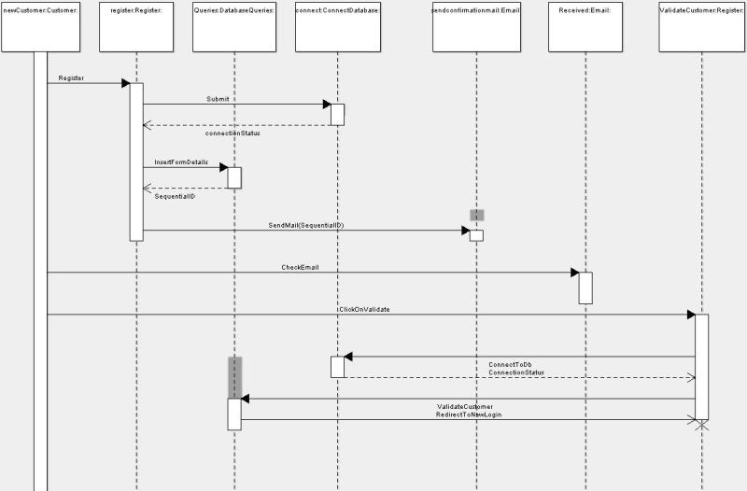

7.2.2. Customer posting a problem:
The sequence diagram shown below explains the customer posting a problem and the flow of the actions performed while posting a problem.
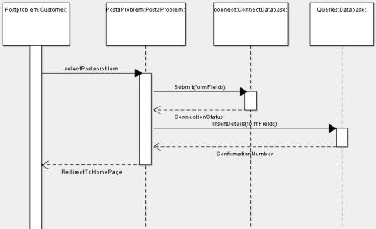

7.2.3. Service Provider registration
The sequence diagram shown below explains the Service provider registration and shows the flow of the actions performed during registration.
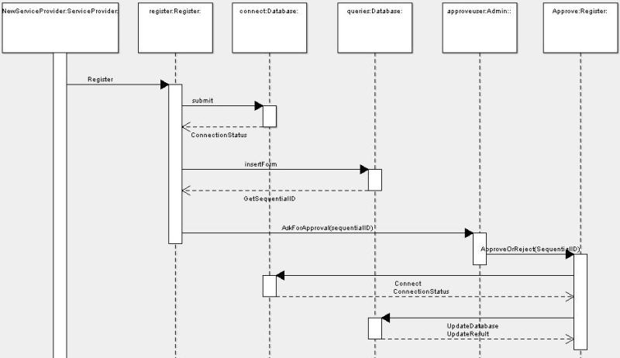

7.3. APPENDIX C: Class Diagram for the Web application
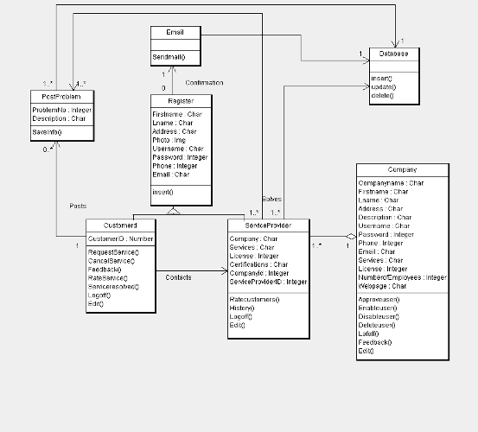

7.4. APPENDIX D: User Interface
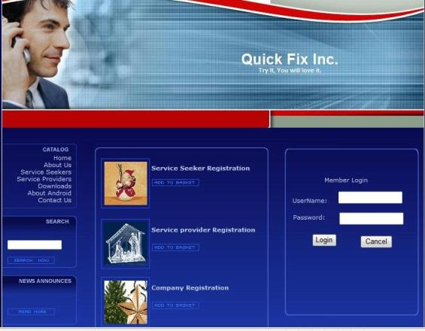

7.5. Appendix E: Design Details of the Web Application

7.5.1. Registration
This class takes care of the registration process and saves the entire user’s information.

7.5.1.2. Methods
- public Insert()
This class displays all the registration fields so that a first time user can register under his/her corresponding section.

7.5.1.3. Exceptions
Exceptions can be thrown under following conditions
- When the data access fails.

7.5.2. Service Seeker
This class has maintains details of the service seekers and all the actions performed in the service seekers page are managed by the methods of this class.

7.5.2.2. Methods
- public Edit()
With the help of this method, user can update or modify his personal information.
- public RequestService()
This method helps the customer to view a service provider’s profile and request his/her service
- public Cancel Service()
This method helps the user to cancel the specific service, if he/she is not satisfied by the service.
- public RateService()
This method helps a customer to rate a particular service provider
- public ServiceResolved()
If the problem got solved, the user can change the status of his/her problem.
- public Feedback()
This method provides the customer, a chance to give feedback regarding a particular service provider
- public Logoff()
This method ends the session of the user. It automatically redirects the user to corresponding login page.

7.5.2.3. Exceptions
Exceptions can be thrown under following conditions
- When the data access fails.

7.5.3. Service Provider
This class has maintains details of the service providers and all the actions performed in the service provider page are managed by the methods of this class.

7.5.3.2. Methods
- public Edit()
With the help of this method, service provider can update or modify his profile.
- public RateCustomer()
This method helps a service provider to rate a particular customer
- public History()
This method is responsible for storing all the previously solved problems by that specific service provider.
- public Logoff()
This method ends the session of the user. It automatically redirects the user to corresponding login page.

7.5.3.3. Exceptions
Exceptions can be thrown under following conditions
- When the data access fails.

7.5.4. Company
This class is responsible for managing all the service providers registered under a particular company.

7.5.4.2. Methods
- public ApproveUser()
This method is responsible for approving the newly registered service providers after evaluating his/her credentials.
- public EnableUser()
This method is used for enabling a previous customer (like reinstating a user after specific period)
- public DisableUser()
This method takes care of revoking all the previleges of a particular user, if anything goes wrong.
- public DeleteUser()
This method helps the admin to delete a specific user from the company.
- public Edit()
With the help of this method, admin can update or modify his company profile.
- public Feedback()
This method provides the service provider, a chance to give feedback regarding a particular user of the company
- public Logoff()
This method ends the session of the user. It automatically redirects the user to corresponding login page.

7.5.4.3. Exceptions
Exceptions can be thrown under following conditions
- When the data access fails.

7.5.5. PostProblem
This class takes care of the problems being posted by the customers.

7.5.5.2. Methods
- public SaveInfo()
This method saves all the problems posted by the customers in the database.

7.5.5.3. Exceptions
Exceptions can be thrown under following conditions
- When the data access fails.

7.6. APPENDIX f: Design Details of the mobile Application
This includes the design details of mobile application such as
UML diagrams, Class details and User Interface.

7.6.1. Class Diagram
This diagram explains the static structure of the mobile application using the class diagram as shown below.
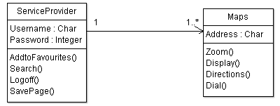

7.6.2. Sequence Diagram
This explains about the search scenario on the mobile application. The service provider passes an input after logging in and later this diagram explains how the result is retrived.
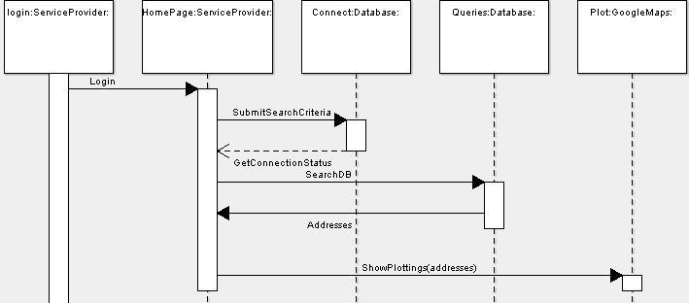

7.6.3. User interface Of the mobile application
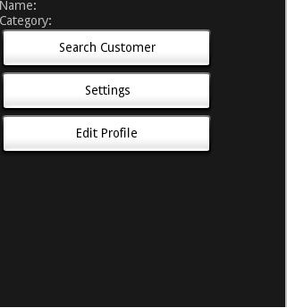

7.6.4. Design details of the Mobile application

7.6.4.1 Maps
Used for plotting all the address in a given Zip code.

7.6.4.1.1. Attributes
None.

7.6.4.1.2. Methods
- public Zoom(layoutparams.WRAP_CONTENT)
This method is used for wrapping the content according to the page size. The user can zoom into the specific address or zoom out of it. This method is called by the User Interface class when the user clicks the zoom button
- public Dial()
This method is used by the service provider to contact the customer.
- public Directions()
This method is used to navigate between addresses. Once this method is called, it returns with a list of directions to the destination address

7.6.4.1.3.Exceptions
Exceptions can be thrown under following conditions
- When the data access fails.

7.6.4.2. Service Provider
This class is used for Validating and forwarding the user to the home page. Once the used logs in, he can search for the service seekers within a specific range with the help of various settings.

7.6.4.2.1 Attributes
None

7.6.4.2.2 Methods
- public AddtoFavourites()
This method is used by the service provider to add his/her favorite users to a quick list. Once this method is called, it returns with a list of customers for a specific service provider.
- public Search(int zipcode, int radius)
This is a vital method used to search all the customers in a given zip code and radius. The return value of this method is a map plotted with bunch of customer addresses.
- public SavePage()
This method is used to save the last search made by the service provider.

7.6.4.2.3 Exceptions
Exceptions can be thrown under following conditions
- When the data access fails.

7.7 Appendix G: Major tasks and contributions
Team Leadership
- Sai Srinivas Pabbathi (60%) – Meeting agendas, meeting minutes, task assignment coordination, coordinated communication with mentor and professor, communicated with System Administrator
- Sumanth Kattamanchi (20%) – Meeting discussion, meeting minutes
- Hari Kishan Kapa (10%) – Meeting discussion, meeting minutes
- Dinesh Reddy Gudibandi (10%) – Meeting discussion, meeting minutes
Website creation and Maintenance
- Dinesh Gudibandi (55%) – Created and maintained
- Sai Srinivas Pabbathi (15%) –Maintained Web site
- Kishan Kapa (15%) – Maintained Web site
- Sumanth Kattamanchi (15%) – Edited content
Database Design and Implementation
- Sumanth Kattamanchi (45%) – Designed database draft, ER diagram, Implemented database.
- Hari Kishan Kapa (30%) – contributed to database design decisions
- Dinesh Gudibandi (15%) – contributed to database design decisions
- Sai Srinivas Pabbathi 10%) – contributed to database design
Prototype Design and Implementation
- Sumanth Kattamanchi (25%) – DBA, ER Diagram, Web Application Developer and support Android Developer
- Dinesh Gudibandi (25%) – Core Web Application Developer and support Android developer
- Sai Srinivas Pabbathi (25%) – Sequence Diagrams and Core Android Developer.
- Hari Kishan Kapa (25%) – Class Diagram, Use case Diagram and support Android Developer.
Documentation
- Sumanth Kattamanchi (35%) –Presentation Slides, Requirements Documents and Final report.
- Hari Kishan Kapa (35%) – Drafted Requirements document, Drafted Design document and Drafted Final Report
- Dinesh Gudibandi (15%) – Initiated Requirements Document
- Sai Srinivas Pabbathi (15%) – Drafted Requirements Document

