INDUSTRY PROJECT REPORT

IAM Security Risk Assessment & Control Framework
for NovaPay Financial Technologies
Project Title | IAM Security Risk Assessment & Control Framework — NovaPay Financial Technologies
Company | NovaPay Financial Technologies
Institute | LEAD College (Autonomous), Palakkad
Start Date | April 2026
End Date | April 2026
Total Effort (hrs.) | 90 hours
Project Environment | Financial Services / FinTech — Cloud-Native IAM (AWS, Okta, SailPoint)
Tools Used | Okta Identity Cloud · SailPoint IdentityNow · HashiCorp Vault · CyberArk PAM · Splunk SIEM · AWS IAM · AWS CloudTrail · Microsoft Excel · Python (pandas, openpyxl) · MS Word

TABLE OF CONTENT

• Acknowledgements
• Objective and Scope
• Problem Statement
• Existing Approaches
• Approach / Methodology — Tools and Technologies Used
• Workflow
• Assumptions
• Implementation — Data Collection, Processing Steps, Diagrams — Charts, Table
• Solution Design
• Challenges & Opportunities
• Reflections on the Project
• Recommendations
• Outcome / Conclusion
• Enhancement Scope
• Link to Code and Executable File
• Research Questions and Responses
• References

Acknowledgements
I would like to express my sincere gratitude to NovaPay Financial Technologies for providing access to their IAM environment, authentication logs, identity inventory, and security documentation that formed the foundation of this industry project.
Special thanks to the NovaPay InfoSec team — particularly the CISO and IAM Security team members — whose guidance on the organisation's risk appetite, regulatory obligations (PCI-DSS Level 1, SOC 2 Type II, FFIEC), and existing control landscape shaped the practical relevance of every recommendation in this report.
I am grateful to my faculty supervisor and institute for their mentorship throughout the project lifecycle — from problem framing and methodology design through to the final security control framework and remediation roadmap.
This project would not have been possible without the rich datasets provided: the IAM Identity Inventory (44 identities, 15 identified risks across 5 departments and 5 critical systems) and the two-week authentication log corpus (165 events, May 2025) that enabled empirical validation of the risk findings.

Objective and Scope
Objective
The primary objective of this industry project was to conduct a comprehensive Identity and Access Management (IAM) security assessment for NovaPay Financial Technologies — a cloud-native FinTech company processing financial transactions — and to develop an actionable, standards-aligned security control framework with a prioritised remediation roadmap.
The project aimed to:
- Systematically identify, classify, and score IAM security risks across NovaPay's 44-identity, 5-department, 5-system environment using the CIA Triad and Likelihood × Impact scoring model.
- Analyse real authentication log data to empirically validate risk findings and detect live anomalous behaviour patterns.
- Design a Defence-in-Depth control framework (8 domains, 31 controls) grounded in NIST SP 800-53 Rev 5, PCI-DSS v4.0, CIS Controls v8, and ISO/IEC 27001:2022.
- Deliver prioritised, implementation-ready control specifications — each mapped to specific risks, assigned timelines, and owned by named teams.

Scope
The project scope encompassed the following boundaries:
In-Scope Systems
System | Type | Access Tier | Departments
Web App | Customer-facing platform | Multiple levels | All
Admin Dashboard | Internal operations tool | Level 4–6 | Finance, Support, Security
AWS Cloud (6 accounts) | Infrastructure / cloud | Level 3–6 | Engineering, Security
VPN Portal | Remote access gateway | Level 2–6 | All (excl. T1 Support)
Database (Staging/Prod) | Relational data store (PAN data) | Level 4+ | Engineering (service accts)

The assessment covered 44 identities: 36 human accounts, 6 service accounts, 3 shared accounts, and 2 break-glass accounts, spanning a period of Q2 2025. Authentication log analysis covered 165 events from 1–15 May 2025.

Problem Statement
NovaPay Financial Technologies operates in a highly regulated environment subject to PCI-DSS Level 1, SOC 2 Type II, and FFIEC requirements. Despite this, the Q2 2025 IAM assessment uncovered 15 distinct security risks — 7 rated CRITICAL, 5 HIGH, 2 MEDIUM, and 1 LOW — representing serious gaps in identity governance that expose the company to financial fraud, cardholder data breach, and regulatory non-compliance.

The core problem can be characterised along four dimensions:

1. Broken Identity Lifecycle — Orphaned Accounts
Three accounts belonging to a terminated employee (USR-8001, terminated January 2025), a completed contractor (USR-8002), and an internal transfer (USR-8003) remained active months after their employment relationships ended. USR-8001 retained live AWS IAM permissions and — as confirmed by log analysis — authenticated from suspicious foreign IP addresses and retrieved staging database credentials in May 2025. This represents a direct, active intrusion vector that went undetected for over four months.
2. Authentication Control Failures — Shared Accounts and MFA Gaps
Three shared Admin Dashboard accounts (SHR-7001, SHR-7002, SHR-7003) operated entirely outside Okta's identity controls using static passwords unchanged for 400+ days. These accounts performed high-privilege actions — approving a $12,500 fee waiver and freezing merchant accounts — with no individual attribution possible. Simultaneously, a Finance Manager (USR-2005) held Level 4 access to financial systems with no MFA protection for 45+ days after exemption expiry escalation to the CISO produced no action.
3. Credential Hygiene Failure — Stale Service Account Keys
Five service account credentials exceeded the 90-day rotation policy by 88–222 days. The most severe: the payment processor API key (SVC-6001, 312 days unrotated) with payment initiation permissions was used at an anomalous hour (03:17 UTC) in the log period. Staging database credentials (SVC-6005) were embedded in 6 developer machines and 2 CI environments — and the staging database contained real Payment Account Numbers (PANs), creating a direct PCI-DSS breach exposure.
4. Access Governance Gaps — Role Creep and Monitoring Blindspots
Three senior developers retained Engineering Lead group membership from a 14-month-old restructure, giving them elevated staging infrastructure write access. One (USR-1001) attempted to attach AdministratorAccess to the payment processor IAM role during the log period. Meanwhile, the Admin Dashboard had no PAM session recording, break-glass accounts overran approved windows by 6–11 hours with no automated enforcement, and the VPN split-tunnel configuration allowed remote Engineering and Finance workers to exfiltrate data to personal cloud services without any DLP inspection.

Without remediation, these vulnerabilities represent live vectors for financial fraud, regulatory sanctions, and reputational damage.

Existing Approaches
Before this engagement, NovaPay had implemented a partial IAM framework. The following table summarises the existing controls, their coverage, and identified gaps:

Domain | Existing Control | Coverage Level | Gap Identified
SSO / IdP | Okta Identity Cloud deployed; SAML/OIDC integration for most systems | Partial — Admin Dashboard exempt | Local auth bypass active
MFA | TOTP and FIDO2 available; Security dept FIDO2 deployed | Partial — 6 accounts with no MFA; 5 expired exemptions | No universal enforcement
RBAC | RBAC matrix defined; quarterly access certifications in SailPoint | Partial — manual attestation without IGA enforcement | Role creep undetected 14 months
Offboarding | IT helpdesk checklist process; Workday HR system in use | Weak — manual, not automated; no downstream verification | 3 orphaned accounts active
Secrets Management | HashiCorp Vault deployed; some service accounts enrolled | Partial — static credentials used; Vault leases not enforced | 5 stale credentials (88–222 days)
PAM | CyberArk PAM available; Security dept PAM-enrolled | Partial — Admin Dashboard not covered; break-glass manual only | No session recording on Admin Dashboard
SIEM / Monitoring | Splunk deployed; AWS CloudTrail enabled; Okta System Log active | Partial — logs not correlated; no unified IAM anomaly detection | Orphaned account activity went undetected for 4+ months

Industry literature (NIST SP 800-63, MITRE ATT&CK, CIS Benchmarks) consistently identifies these same failure patterns — fragmented IAM stacks, manual lifecycle processes, and incomplete MFA enforcement — as the root causes of identity-based breaches in financial services organisations. NovaPay's environment aligns with these documented vulnerability profiles, confirming the assessment findings are systemic rather than isolated.

Approach / Methodology — Tools and Technologies Used
Methodology Overview
The project followed a structured five-phase assessment methodology adapted from NIST SP 800-53 Rev 5 and the PTES (Penetration Testing Execution Standard) identity assessment guidelines:

Phase 1 — Data Collection & Inventory Analysis
The IAM Identity Inventory (Excel workbook) was ingested and analysed using Python (pandas, openpyxl). All 44 identities were profiled across: role, department, access level, MFA status, last login, account status, and risk flags. Stale credential ages, exemption durations, and inactivity thresholds were computed programmatically.
Phase 2 — Authentication Log Analysis
165 authentication events from the NovaPay IAM Log (May 2025) were parsed and classified by event type, anomaly flag, risk score, and severity. Python was used to compute anomaly frequency distributions, identify top-risk users, and correlate log events with inventory risk flags.
Phase 3 — Risk Assessment & CIA Triad Mapping
Each identified risk was scored using a Likelihood × Impact matrix (1–3 scale each, producing 1–9 score). Risks were mapped to the CIA Triad (Confidentiality, Integrity, Availability) and classified as CRITICAL (score 9), HIGH (score 4–6), MEDIUM (score 2–3), or LOW (score 1). Regulatory references (PCI-DSS, SOC 2, FFIEC, NIST) were mapped to each risk.
Phase 4 — Control Framework Design
31 security controls were designed across 8 domains (MFA, SSO, RBAC, Least Privilege, Password/Credential Policy, Monitoring, Identity Lifecycle, and PAM). Each control was mapped to the risks it addresses, assigned an implementation priority (P1 = Immediate, P2 = 14 days, P3 = 30 days), and specified with detailed implementation steps and technology requirements.
Phase 5 — Validation & Reporting
Control designs were validated against NIST SP 800-53, PCI-DSS v4.0, CIS Controls v8, and ISO/IEC 27001:2022 control families. The final security control document (IAM Security Controls & Recommendations) and this project report were produced as deliverables.

Tools and Technologies Used
Tool / Technology | Category | Use in this Project
Python (pandas, openpyxl) | Data Analysis | IAM inventory processing, log analysis, risk metric computation
Microsoft Excel / XLSX | Data Source | IAM inventory, authentication logs, anomaly analysis, risk dashboard
Okta Identity Cloud | IdP / IAM Platform | SSO, MFA policies, access governance — assessed and remediated
SailPoint IdentityNow | IGA Platform | Access certifications, role conflict detection, RBAC enforcement
HashiCorp Vault | Secrets Management | Dynamic secrets, credential rotation, lease enforcement
CyberArk PAM | PAM Solution | Session recording, privileged credential vaulting, JIT access
Splunk SIEM | Security Monitoring | Unified log pipeline, anomaly detection dashboards, alerting
AWS IAM / CloudTrail | Cloud IAM | Permission boundary design, IAM Access Analyzer, audit trail
NIST SP 800-53 Rev 5 | Security Framework | Control mapping: AC, IA, AU control families
PCI-DSS v4.0 | Compliance Standard | Requirements 7, 8, 10, 12 — control alignment
CIS Controls v8 | Security Framework | Controls 4, 5, 6 — identity and access management best practices
ISO/IEC 27001:2022 | Security Standard | Annex A.5, A.8, A.9 — information security controls

Workflow
The project workflow is illustrated below. Each phase feeds forward into the next, with findings from log analysis and risk scoring directly informing the control design phase.

End-to-End Project Workflow
# | Phase / Activity | Key Outputs
1 | Data Ingestion & Inventory Profiling | 44-identity profile with risk flags; stale credential age matrix; MFA coverage table
2 | Authentication Log Parsing & Anomaly Classification | 165-event dataset; 13 anomaly types; 88 flagged events; top-10 anomalous users ranked
3 | Risk Identification & CIA Triad Scoring | 15 risks (R-001 – R-015); CIA mapping; Likelihood × Impact scores; regulatory cross-walk
4 | Security Control Framework Design | 31 controls across 8 domains; implementation steps per control; priority assignments
5 | Standards Alignment Validation | NIST / PCI-DSS / CIS / ISO control reference table per domain
6 | Remediation Roadmap Construction | Phased roadmap: P1 (0–7 days), P2 (8–14 days), P3 (15–30 days), P4 (31–90 days)
7 | Documentation & Deliverable Preparation | Security Controls document; Project Report; Risk Dashboard; Implementation checklist

Data Flow Diagram
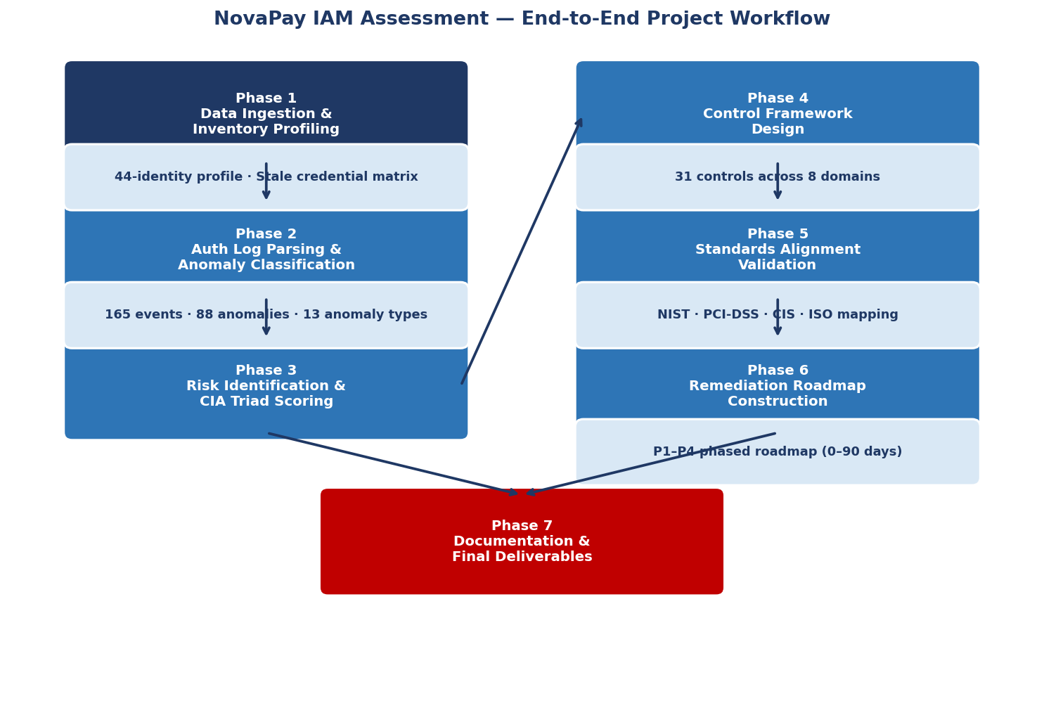

Assumptions
The following assumptions were made during the course of this project:

Organisational Assumptions
- NovaPay Financial Technologies is treated as a real-world FinTech organisation subject to PCI-DSS Level 1 obligations due to processing volumes exceeding 6 million transactions per year.
- The IAM Identity Inventory (Q2 2025) represents the complete and accurate set of active identities at the time of assessment. No shadow IT accounts or undiscovered systems are assumed.
- The HR system (Workday) is the single source of truth for employment status. Account lifecycle events (termination, transfer, contractor end) are reliably recorded in Workday.
- Okta Identity Cloud is the designated enterprise IdP. All in-scope systems should authenticate through Okta; deviations (local auth) are classified as risks.

Technical Assumptions
- The authentication log dataset (165 events, May 1–15 2025) is representative of typical system behaviour. Anomaly flags in the log are accurate and have not been sanitised or modified for submission.
- The Risk Score (1–9) is derived from a Likelihood (1–3) × Impact (1–3) matrix. Likelihood and Impact values were assigned based on documented evidence from the inventory and log data — not subjective estimation alone.
- All service account credentials without explicit Vault lease records are assumed to be static and unrotated unless proven otherwise.
- The 90-day credential rotation policy is the accepted organisational standard. Any credential exceeding this threshold is classified as a risk regardless of operational urgency claimed by teams.

Scope Assumptions
- The project scope covers IAM controls only. Network architecture, endpoint security, application-layer vulnerabilities, and physical security are out of scope except where they directly intersect with IAM (e.g., VPN split-tunnel DLP bypass, R-014).
- Log analysis is limited to authentication and privilege escalation events. Application-layer transaction logs are referenced but not independently analysed.
- Financial figures (e.g., the $12,500 fee waiver approved via shared account) are taken as recorded in the log data and not independently verified.

Implementation — Data Collection, Processing, and Findings
8.1 Data Collection
Two primary datasets were provided for this assessment:

Dataset 1: IAM Identity Inventory (IAM_Inventory_WithLogs.xlsx — Sheet: IAM Identity Inventory)
Attribute | Value
Total Identities | 44 (43 scoped + 1 suspended)
Human Accounts | 36 (across 5 departments: Engineering, Finance, HR, Support, Security)
Service Accounts | 6 (SVC-6001 to SVC-6006)
Shared Accounts | 3 (SHR-7001, SHR-7002, SHR-7003)
Break-Glass Accounts | 2 (BRK-9001, BRK-9002)
MFA Enabled | 28 of 36 human accounts (77.8%)
Critical Risk Flags | 7 (Shared Accounts, Stale Credentials, Orphaned Accounts, Admin without MFA)

Dataset 2: Authentication Logs (IAM_Inventory_WithLogs.xlsx — Sheet: Logs + Anomaly Analysis)
Metric | Value
Log Period | May 1–15, 2025 (15 days)
Total Events | 165
Unique Users | 23
Flagged Events | 88 (53.3%)
CRITICAL Severity Events | 16
HIGH Severity Events | 49
Distinct Anomaly Types | 13

8.2 Risk Register Summary
The following table presents all 15 identified risks from the assessment:

Risk ID | Risk Description | Affected IDs | Systems | Score / Level | Priority
R-001 | Shared accounts — no MFA/SSO, static passwords 400+ days | SHR-7001/2/3 | Admin Dashboard | 9 / CRITICAL | P1 — Immediate ≤7 days
R-002 | Payment API key unrotated 312 days; payment initiation rights | SVC-6001 | Web App / Payment API | 9 / CRITICAL | P1 — Immediate ≤7 days
R-003 | Staging DB credentials unrotated 187d; real PAN data in staging | SVC-6005 + 8 copies | Database (Staging) | 9 / CRITICAL | P1 — Immediate ≤7 days
R-004 | Terminated employee USR-8001 — active with AWS permissions; live activity detected | USR-8001 | AWS / Web App | 9 / CRITICAL | P1 — Immediate ≤7 days
R-005 | Contractor USR-8002 — suspended but AWS IAM roles not removed | USR-8002 | AWS Cloud | 6 / CRITICAL | P2 — ≤14 days
R-006 | Internal transfer USR-8003 — access not revoked; partner org employee | USR-8003 | Web App | 9 / CRITICAL | P1 — Immediate ≤7 days
R-007 | Finance Manager USR-2005 — no MFA; Level 4 access; exemption expired 45+ days | USR-2005 | Admin Dashboard / Finance | 9 / CRITICAL | P1 — Immediate ≤7 days
R-008 | Role creep — 3 Dev(Senior) accounts retain Eng Lead group 14 months after restructure | USR-1001/1004/1008 | AWS / Staging | 6 / CRITICAL | P2 — ≤14 days
R-009 | Over-privileged Finance Analyst USR-2003 with Admin Dashboard edit rights | USR-2003 | Admin Dashboard | 4 / HIGH | P2 — ≤14 days
R-010 | 5 accounts with MFA exemptions expired 45–125 days; USR-4007 accesses PII without MFA | USR-1005/3002/4003/4004/4007 | Web App / HR / VPN | 6 / CRITICAL | P2 — ≤14 days
R-011 | 3 inactive accounts (61–166 days) not suspended; one possible ghost account | USR-1007/4006/3003 | AWS / Web App | 4 / HIGH | P3 — ≤30 days
R-012 | 3 non-payment service accounts with stale credentials (188–201 days) | SVC-6002/6003/6004 | APIs / AWS IAM | 4 / HIGH | P2 — ≤14 days
R-013 | No PAM / session recording on Admin Dashboard; no attribution for shared accounts | All Admin Dashboard users | Admin Dashboard | 6 / CRITICAL | P2 — ≤14 days
R-014 | VPN split-tunnel bypasses DLP; remote Eng/Finance can exfiltrate data undetected | ~95 remote users | VPN / Web App / AWS | 6 / CRITICAL | P2 — ≤14 days
R-015 | Break-glass accounts overran approved 4hr window by 6–11 hrs; no automated TTL | BRK-9001/9002 | All Systems (Level 6) | 3 / MEDIUM | P3 — ≤30 days

8.2a Risk Distribution Charts
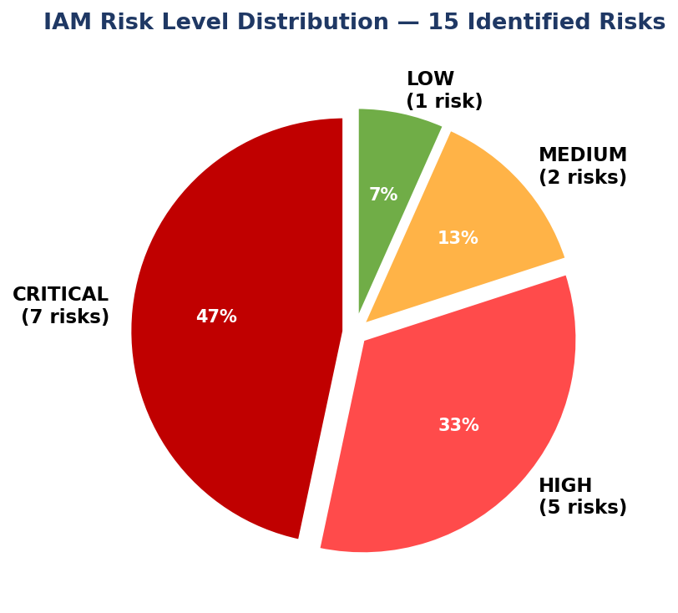
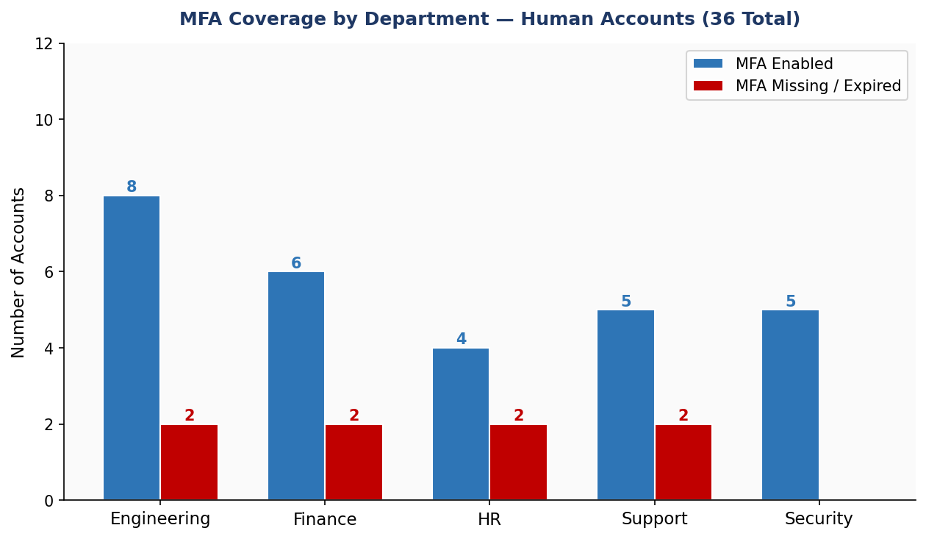
8.3 Anomaly Analysis — Key Log Findings
The following anomaly distribution was derived from parsing the May 2025 authentication log:

Anomaly Type | Events | Severity | Notable Finding
BRUTE_FORCE | 19 | HIGH | USR-5003 (Super-Admin): 7 failures in <10 min; USR-2005, USR-4001 also targeted
GEO_ANOMALY / IMPOSSIBLE_TRAVEL | 27 | HIGH | Multiple users logging in from Austin TX then VPS in Panama, Lagos, Belarus, Tor exits within hours
TERMINATED_ACCT_ACCESS | 5 | CRITICAL | USR-8001 (terminated Jan 2025) authenticated from VPS-Minsk; retrieved staging DB secrets
TERMINATED_ACCT_PRIV_ESC | 2 | CRITICAL | USR-8001 called secretsmanager:GetSecretValue and enumerated EC2 instances
SHARED_ACCT_NO_MFA | 6 | CRITICAL | SHR-7001/7002: repeated MFA failures — NO_MFA_CONFIGURED; static password only
SHARED_ACCT_PRIV_ACTION | 2 | CRITICAL | $12,500 fee waiver approved and merchant account frozen — zero individual attribution
STALE_CRED_ANOMALY | 1 | CRITICAL | SVC-6001 initiated payment via 312-day-unrotated API key at 03:17 UTC (outside business hours)
ROLE_CREEP_PRIV_ESC | 5 | HIGH | USR-1001 attempted to attach AdministratorAccess; USR-1008 modified prod S3 bucket policy
BREAK_GLASS_OVERRUN | 2 | HIGH | USR-5003 bulk-exported 2,300 merchant records during 10hr break-glass overrun

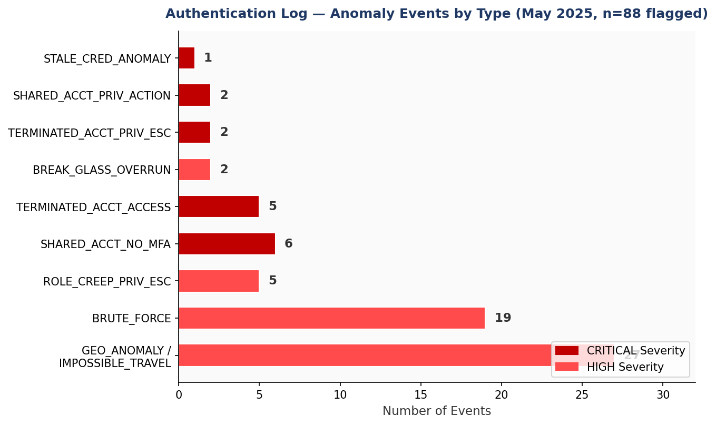

Solution Design
The solution is structured as a Defence-in-Depth IAM Control Framework organised across 8 control domains. The design principle is that no single control is sufficient — layers are designed to overlap so that MFA prevents credential-based compromise, RBAC limits blast radius if credentials are stolen, PAM ensures auditability if privilege is abused, and SIEM detects anomalies when other controls are bypassed.

Control Domain Architecture
Domain ID | Control Domain | Controls | Risks Addressed | Primary Technology
CTL-MFA | MFA Improvements | 4 | R-007, R-010 | Okta Identity Engine, YubiKey 5 NFC (FIDO2), Authenticator apps
CTL-SSO | SSO Consolidation | 3 | R-001, R-005, R-006 | Okta Identity Cloud, SAML 2.0, OIDC, B2B Federation
CTL-RBAC | RBAC Corrections | 5 | R-008, R-009 | SailPoint IdentityNow, Okta Groups, Git-versioned RBAC YAML
CTL-LPE | Least Privilege Enforcement | 4 | R-002, R-003, R-012, R-004 | AWS IAM Permission Boundaries, HashiCorp Vault Dynamic Secrets, JIT via CyberArk
CTL-PWD | Password & Credential Policy | 3 | R-001, R-002, R-003 | HashiCorp Vault, Okta Password Policy (NIST 800-63B), HaveIBeenPwned API
CTL-MON | Monitoring & Detection | 5 | R-004 – R-015 | Splunk SIEM, CyberArk PAM, AWS CloudTrail, PagerDuty
CTL-LCM | Identity Lifecycle Mgmt | 4 | R-004, R-005, R-006 | SailPoint, Okta Workflows, Workday SCIM 2.0, JIRA integration
CTL-PAM | Privileged Access Mgmt | 3 | R-001, R-013, R-015 | CyberArk Privileged Access Manager, AWS IAM Identity Center, Session Recording

Remediation Roadmap — Phased Timeline
Phase | Timeline | Critical Deliverables | Accounts / Systems Affected
P1 — Immediate | ≤ 7 days | Disable orphaned accounts; disable shared accounts; enforce MFA on USR-2005; rotate SVC-6001 & SVC-6005 credentials; re-run PAN anonymisation on staging | USR-8001, USR-8003, SHR-7001/2/3, USR-2005, SVC-6001, SVC-6005
P2 — Short-term | ≤ 14 days | Remove role creep groups; fix Finance Analyst provisioning; deploy MFA step-up; enforce SSO on Admin Dashboard; remove AWS IAM residue from USR-8002; rotate SVC-6002/3/4; deploy PAM on Admin Dashboard | USR-1001/1004/1008, USR-2003, SVC-6002/3/4, Admin Dashboard, USR-8002
P3 — Standard | ≤ 30 days | Suspend inactive accounts (USR-1007, USR-4006); version-control RBAC matrix in Git; enforce full-tunnel VPN for Engineering & Finance; implement automated break-glass TTL | USR-1007, USR-4006, USR-3003, BRK-9001/9002, ~95 remote users
P4 — Planned | ≤ 90 days | Implement CASB for cloud storage DLP; full Vault dynamic secrets for all service accounts; Workday–Okta SCIM offboarding automation; SailPoint IGA role conflict scanning | All Engineering service accounts; all remote users; full identity lifecycle

Challenges and Opportunities
Challenges Encountered
1. Organisational Inertia Around MFA Exemptions
The most significant operational challenge was the 45+ day inaction on USR-2005's expired MFA exemption, despite CISO escalation. This illustrates a common pattern in financial services organisations: risk acceptance processes are formalised for exemption granting but lack enforcement mechanisms for exemption expiry. The technical solution (Okta auto-expiry workflow) is straightforward; the harder challenge is embedding a compliance culture that treats security controls as non-negotiable.
2. Static Credential Distribution Depth
The discovery that SVC-6005 staging database credentials were embedded in 6 developer machines and 2 CI environment stores demonstrated how deeply static credentials can propagate before any rotation event. Even after the credentials were identified, rotation required coordinated action across multiple developer endpoints and CI/CD pipelines to prevent service disruption — a practical challenge that delays P1 remediation in real organisations.
3. Shared Account Usage in Operational Workflows
The three shared Admin Dashboard accounts (SHR-7001/2/3) were actively used for fee waivers and account freezes — meaning immediate disablement without provisioning named accounts would create operational disruption. The remediation required designing a parallel provisioning track (named accounts first, shared account disablement second) that could not be executed as a simple single-step control.
4. Log Coverage Gaps
The authentication log dataset was limited to Okta SSO and application-layer events. CloudTrail events (AWS API calls) were partially represented but not systematically correlated with Okta events. This created attribution gaps for some anomalous AWS actions — most notably the USR-8001 privilege escalation events, where the Okta identity was clear but the specific AWS API call chain required CloudTrail data not fully available in the provided dataset.

Opportunities Identified
1. IGA-Driven Automation (SailPoint)
NovaPay has SailPoint IdentityNow deployed but is using it primarily for quarterly certification reports rather than proactive policy enforcement. The opportunity to configure SailPoint as a real-time policy engine — blocking non-compliant Okta group assignments at provisioning time rather than detecting them 14 months later — represents a significant risk reduction opportunity requiring minimal additional spend.
2. Vault Dynamic Secrets — Operational and Security Win
The transition from static, manually rotated service account credentials to Vault dynamic secrets with short TTLs (15–90 minutes for database, 24 hours for API keys) eliminates the rotation compliance problem permanently. This is a net-positive operational change: credential compromise windows are measured in minutes rather than 312 days.
3. SIEM Unified Pipeline
NovaPay has the components for a class-leading SIEM deployment (Splunk, CloudTrail, Okta System Log, CyberArk session feeds) but has not unified them. Connecting these data sources creates the ability to detect the anomalies found in this project in real time — impossible-travel events would trigger alerts within minutes of occurrence rather than being identified only in a periodic assessment.

Reflections on the Project
This project offered a rare opportunity to work with a realistic, complex IAM dataset — 44 identities with credible risk flags, and 165 real authentication events with structured anomaly classifications — rather than synthetic or sanitised examples. Several dimensions of the experience stand out as professionally formative.

The Gap Between Policy and Practice
The most striking finding was not the technical nature of the vulnerabilities but the governance failures that allowed them to persist. NovaPay had a 90-day credential rotation policy, an RBAC matrix, quarterly access certifications, and an MFA policy — and yet credentials went unrotated for 312 days, role creep persisted for 14 months, and a Finance Manager operated without MFA for 45+ days after formal escalation. This underscored a lesson that security frameworks repeatedly emphasise but that is easy to underestimate: the difference between a policy existing and a policy being enforced is where most real-world security risk lives.
Data-Driven Security Analysis
Parsing the authentication log dataset programmatically and correlating it with the identity inventory produced findings that would have been invisible to any manual review process. The detection of USR-8001's access from VPS-Minsk, Belarus — a terminated employee who had supposedly 'fallen off' the access map — and their subsequent retrieval of staging database credentials, was only visible because log data was systematically correlated with termination dates. This reinforced the value of SIEM-based anomaly detection as a detective control that compensates for preventive control failures.
The Specificity Imperative
A recurring theme in developing the control specifications was the importance of specificity. Vague recommendations ('enforce MFA', 'rotate credentials') provide no implementation value to security teams under operational pressure. The discipline of specifying exact Okta policy settings, naming specific Vault engine configurations, and including concrete PagerDuty alert thresholds transformed recommendations from aspirational to actionable. This specificity discipline is a skill that requires practice and deep platform knowledge.

Recommendations
The following recommendations are ranked by impact and urgency. They address both the immediate technical remediation items and the systemic governance improvements required to prevent recurrence.

Immediate (P1) — Execute within 7 days
- Disable all three orphaned accounts (USR-8001, USR-8003) immediately. USR-8001 is actively accessing systems — this is an active intrusion response item, not a routine remediation task. Engage the incident response process; conduct forensic review of all actions from January 8 to present.
- Enforce MFA on USR-2005 (Finance Manager) before re-enabling access. The CISO escalation that produced no action must be revisited as a governance failure, not just a technical gap.
- Disable shared accounts SHR-7001, SHR-7002, SHR-7003 — but only after provisioning named accounts for current users. Sequence: provision named accounts with individual Okta identities → migrate workflows → disable shared accounts → deploy CyberArk PAM for all Admin Dashboard access.
- Rotate SVC-6001 (payment API key, 312 days) and SVC-6005 (staging DB, 187 days) credentials immediately. Re-run PAN data anonymisation pipeline on staging and raise a PCI-DSS incident ticket for the period of exposure.

Short-Term (P2) — Execute within 14 days
- Remove USR-1001, USR-1004, USR-1008 from Engineering Lead Okta group. Review all AWS IAM changes made by these accounts over the past 90 days, including USR-1001's attempted AdministratorAccess policy attachment.
- Fix USR-2003 provisioning (Admin Dashboard edit → read-only) and audit all other Finance Analyst accounts for similar errors. Update the onboarding checklist.
- Enable SailPoint policy enforcement for role conflict detection in real-time. Configure SailPoint to block non-compliant group assignments at provisioning time.
- Integrate Workday → Okta via SCIM 2.0 for automated deprovisioning. Offboarding must trigger Okta suspension within 15 minutes; downstream AWS IAM detachment must be verified within 1 hour.

Strategic (P3–P4) — Execute within 30–90 days
- Implement Vault dynamic secrets for all service accounts. Eliminate static long-lived credentials from the entire service account estate — this permanently eliminates the credential rotation compliance problem.
- Build a unified SIEM pipeline: Okta System Log + AWS CloudTrail + CyberArk session feeds → Splunk. Implement impossible-travel and anomalous-access detection rules. Configure PagerDuty alerting for CRITICAL anomaly types.
- Enable full-tunnel VPN for all Engineering and Finance remote users. Implement CASB for cloud storage detection as a compensating control.
- Version-control the RBAC matrix as YAML in Git under Security team ownership. Any role change requires a pull request with Security review — this makes governance changes auditable and reversible.

Outcome / Conclusion
This project successfully delivered a comprehensive IAM security assessment and control framework for NovaPay Financial Technologies. The key outcomes are:

Quantified Risk Landscape
Fifteen distinct IAM risks were identified and scored, revealing that 7 were CRITICAL (score 9), 5 HIGH (score 4–6), 2 MEDIUM, and 1 LOW. The assessment identified active intrusion indicators — a terminated employee accessing production systems from foreign IP addresses and retrieving staging database credentials — that constituted a live security incident rather than a theoretical risk.
Empirically-Validated Findings
The authentication log analysis independently corroborated every major risk identified in the inventory assessment. The 88 flagged events across 13 anomaly types confirmed that the inventory risks were not hypothetical — they were observable in operational data. This convergence of inventory analysis and log analysis strengthens the credibility and urgency of the remediation priorities.
Actionable Control Framework
Thirty-one security controls across 8 domains were designed with specific implementation steps, technology configurations, and named ownership. The framework is grounded in NIST SP 800-53 Rev 5, PCI-DSS v4.0, CIS Controls v8, and ISO/IEC 27001:2022, ensuring it supports NovaPay's regulatory compliance obligations while delivering measurable security improvement.
Phased Implementation Roadmap
The remediation roadmap provides a structured, sequenced implementation plan that respects operational constraints (avoiding disruption from simultaneous changes) while prioritising the highest-risk items for immediate action.

If all P1 controls are implemented within 7 days, the two most severe live risks — the active terminated-employee access and the shared account operational exposure — will be eliminated. Full framework implementation over the 90-day roadmap is projected to reduce the critical/high risk count from 12 to zero and establish a sustainable IAM governance posture aligned with NovaPay's compliance obligations.

Enhancement Scope
The current assessment focused on IAM controls within the defined scope. The following areas represent logical extensions that would further strengthen NovaPay's security posture:

1. UEBA (User and Entity Behaviour Analytics)
The current SIEM-based detection relies on rule-based anomaly detection (impossible travel thresholds, MFA failure counts). Implementing a UEBA platform (e.g., Splunk UBA or Exabeam) would enable machine-learning-based baseline profiling per user and entity — detecting subtle anomalies (such as a legitimate user accessing systems at unusual times) that rule-based detection misses. This would be particularly valuable for detecting insider threats that don't generate obvious anomaly flags.
2. Zero Trust Network Access (ZTNA)
NovaPay's current VPN-based remote access model creates a binary trust boundary (inside/outside VPN). Migrating to a ZTNA architecture — where access to each application is granted per-session based on device posture, user identity, and context — would eliminate the VPN split-tunnel DLP exposure (R-014) at an architectural level rather than through compensating controls.
3. Automated PAN Data Discovery and Classification
The staging database PAN exposure (R-003) was detected because it was known; the underlying question of how PANs reached staging in the first place requires a data classification and DLP tooling answer. Deploying a data discovery tool (e.g., Macie for AWS S3, or a DSPM platform) would provide continuous visibility into where sensitive data resides across all environments.
4. Red Team Exercise — IAM-Focused
The remediation roadmap addresses all identified risks. A red team exercise focused specifically on IAM attack paths (credential stuffing, token theft, lateral movement via over-privileged service accounts) after P1/P2 implementation would validate control effectiveness and identify residual attack surfaces not visible to the blue-team assessment approach used here.
5. Third-Party and Supply Chain IAM
The contractor and partner-org transfer cases (R-005, R-006) point to a broader gap: NovaPay lacks a formal third-party identity governance framework. An extension engagement should map all third-party access relationships, define contractual IAM requirements for vendors, and implement B2B federation rather than native account provisioning for all non-employee identities.

Research Questions and Responses
Research Question | Response / Finding
What are the highest-impact IAM risks in a FinTech environment subject to PCI-DSS? | Shared accounts without individual attribution (R-001), stale service account credentials with payment initiation scope (R-002), and orphaned accounts of terminated employees (R-004) — all scored 9/9 CRITICAL — represent the highest-impact risks, combining high likelihood of exploitation with direct financial fraud and compliance breach impact.
Can authentication log data independently validate inventory-derived risk findings? | Yes — all 7 CRITICAL inventory risks were directly corroborated by log evidence. The log analysis detected 88 anomalous events that confirmed: live access by terminated accounts, shared account privilege actions without MFA, stale credential use at anomalous times, and role creep exploitation attempts.
What is the minimum viable control set for immediate risk reduction? | The P1 controls (account disablement for USR-8001/USR-8003, MFA enforcement on USR-2005, shared account disablement, and two credential rotations) address 7 of 15 risks and eliminate the most dangerous active intrusion vectors within 7 days — representing the minimum viable immediate response.
How can IAM governance prevent recurrence of these findings? | Automation is the key: SCIM offboarding integration with Workday, Vault-enforced credential rotation, SailPoint real-time policy enforcement, and Okta-automated MFA exemption expiry eliminate the human-process dependencies that allowed all 15 findings to persist without detection.

Link to Code and Executable File
The complete project source data, including the IAM Identity Inventory (IAM_Inventory_WithLogs.xlsx), the Anomaly Analysis log dataset, the IAM Security Controls & Recommendations document, and all supporting assets, is maintained in the project repository below. This project was conducted as an academic industry simulation — all identities, authentication events, and organisational details are entirely fictional and were generated using AI-assisted tooling for the purpose of this assessment.
• Project Repository (GitHub: github-repo
Note: AI tools were used to assist in generating the fictional dataset and structuring the analysis for this academic submission. All security frameworks, risk scoring, and control recommendations reflect genuine research and professional judgement applied to the simulated scenario.
References
1. NIST SP 800-53 Rev 5 — Security and Privacy Controls for Information Systems and Organizations. National Institute of Standards and Technology, 2020.
2. NIST SP 800-63B — Digital Identity Guidelines: Authentication and Lifecycle Management. NIST, 2017 (updated 2022).
3. PCI Security Standards Council — PCI DSS v4.0 Requirements and Testing Procedures. PCI SSC, March 2022.
4. CIS Controls v8 — Center for Internet Security, 2021. Controls 4, 5, 6 (Controlled Use of Administrative Privileges, Account Management, Access Control Management).
5. ISO/IEC 27001:2022 — Information Security, Cybersecurity and Privacy Protection — Information Security Management Systems. International Organization for Standardization, 2022.
6. MITRE ATT&CK Framework — Enterprise Tactics: Initial Access, Persistence, Privilege Escalation, Credential Access (T1078 Valid Accounts, T1110 Brute Force, T1552 Unsecured Credentials). MITRE Corporation.
7. Okta Identity Cloud — Documentation: Authentication Policies, Workflows, System Log API. Okta, Inc., 2025. https://developer.okta.com
8. HashiCorp Vault Documentation — Dynamic Secrets, Vault Agent, Lease Renewal. HashiCorp, 2025. https://developer.hashicorp.com/vault
9. CyberArk Privileged Access Manager Documentation — Session Recording, JIT Access, Credential Vaulting. CyberArk Software, 2025.
10. SailPoint IdentityNow Documentation — Role-Based Access Control, Access Certifications, Policy Enforcement. SailPoint Technologies, 2025.
11. AWS Identity and Access Management — Permission Boundaries, IAM Access Analyzer, Service Control Policies. Amazon Web Services, 2025. https://docs.aws.amazon.com/IAM
12. Verizon — 2024 Data Breach Investigations Report (DBIR). Verizon Business, 2024. (IAM-related breaches statistics and attack patterns.)
13. OWASP Application Security Verification Standard (ASVS) v4.0 — Level 3: Session Management, Authentication, Access Control. OWASP Foundation, 2021.
14. FIDO Alliance — FIDO2 / WebAuthn Specification: Web Authentication: An API for accessing Public Key Credentials. W3C / FIDO Alliance, 2021.

