Jˆ_ **Project Information**

**Assignment-3**

Team ID: LTVIP2025TMID51035

INSTITUTION: Rise krishna sai prakasam group of institution

Team Leader: Nanadyala sai koushik

Project Title: Measuring the Pulse of Prosperity: An Index of Economic Freedom Analysis

Dataset Link:

<https://drive.google.com/file/d/1UmrCVmQFQYorNUTw414G3xot6rm46BwR/view>

¡] # Visualization Screenshots

# ¡]# 1. KPI-Focused Interface

Shows key metrics—Total Sales, Gross Income, Quantity—with trend indicators, gauges, and symbol charts. Great for a high-level snapshot of branch-wise performance.

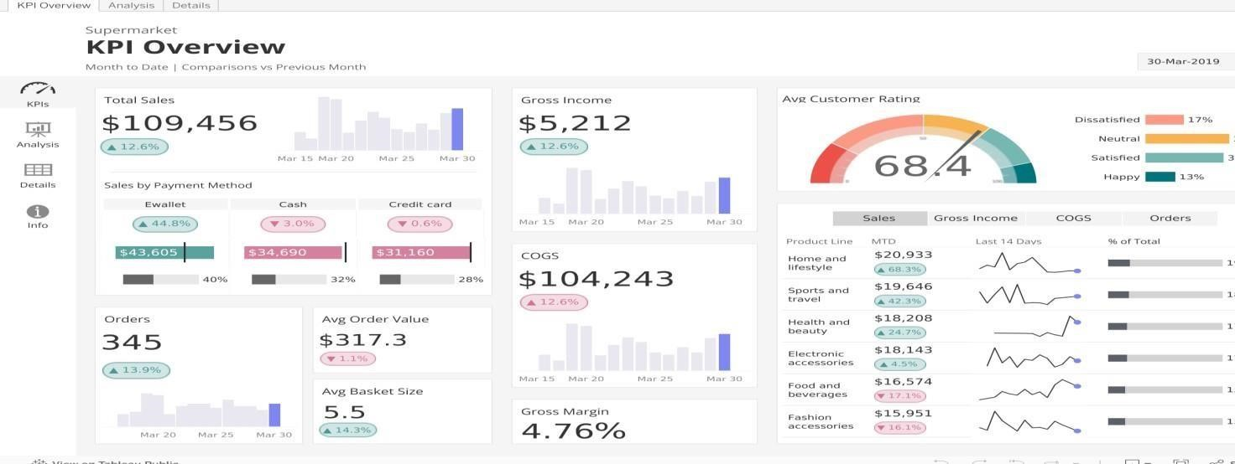

# #Z 2. Multi-Component Retail Dashboard

Combines area charts, bar charts, and filterable lists in a clean layout. Offers dynamic filtering by branch, category, or time period.

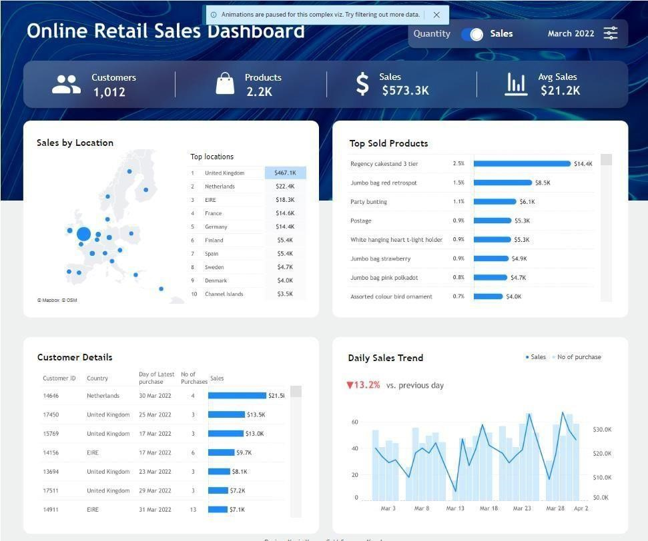

# _ª ]¸ 3. Time-Based Sales & Payments View

Includes monthly timelines with stacked bars and side panels for payment methods or product lines—ideal for trend and distribution analysis.

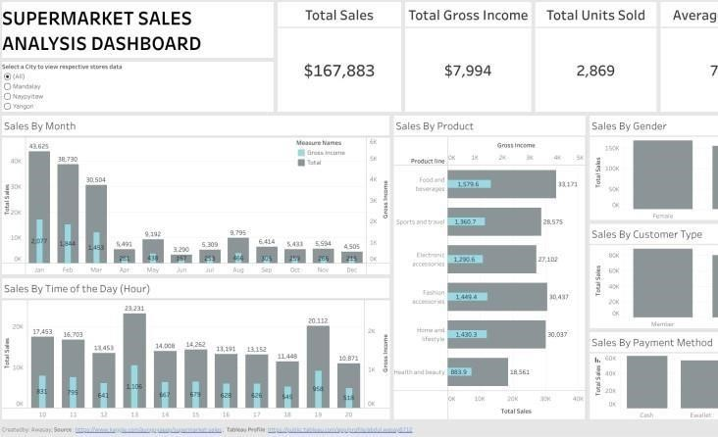

# ◉ ’● 4. Dark-Themed Executive Dashboard

Features slick aesthetics with bar trends, KPIs, and product-level insights—perfect for management reporting.

