- Setup local Postman MCP
Added Input prompt and Postman api mcp server
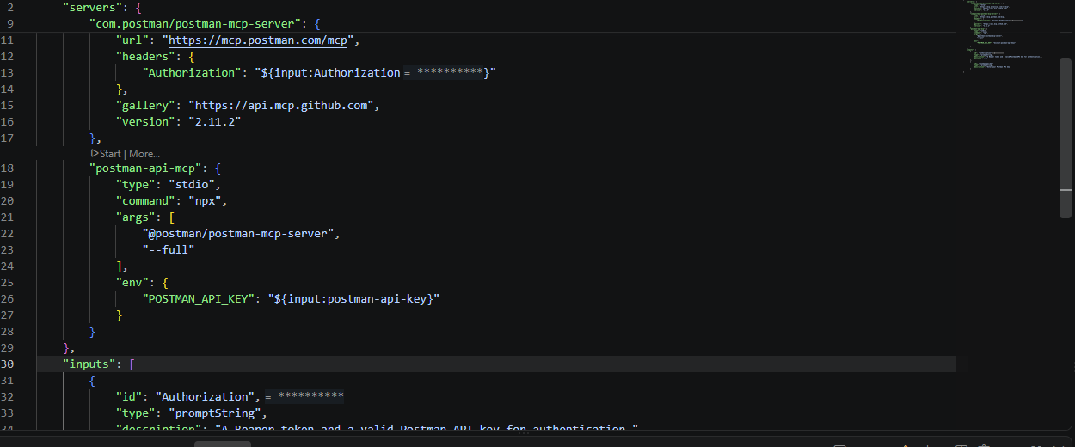
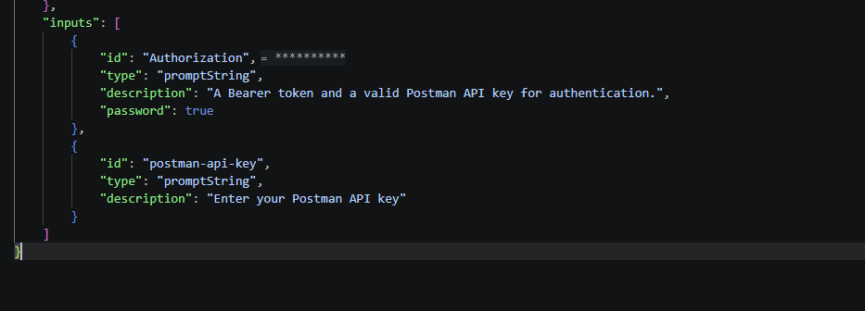
Start the server
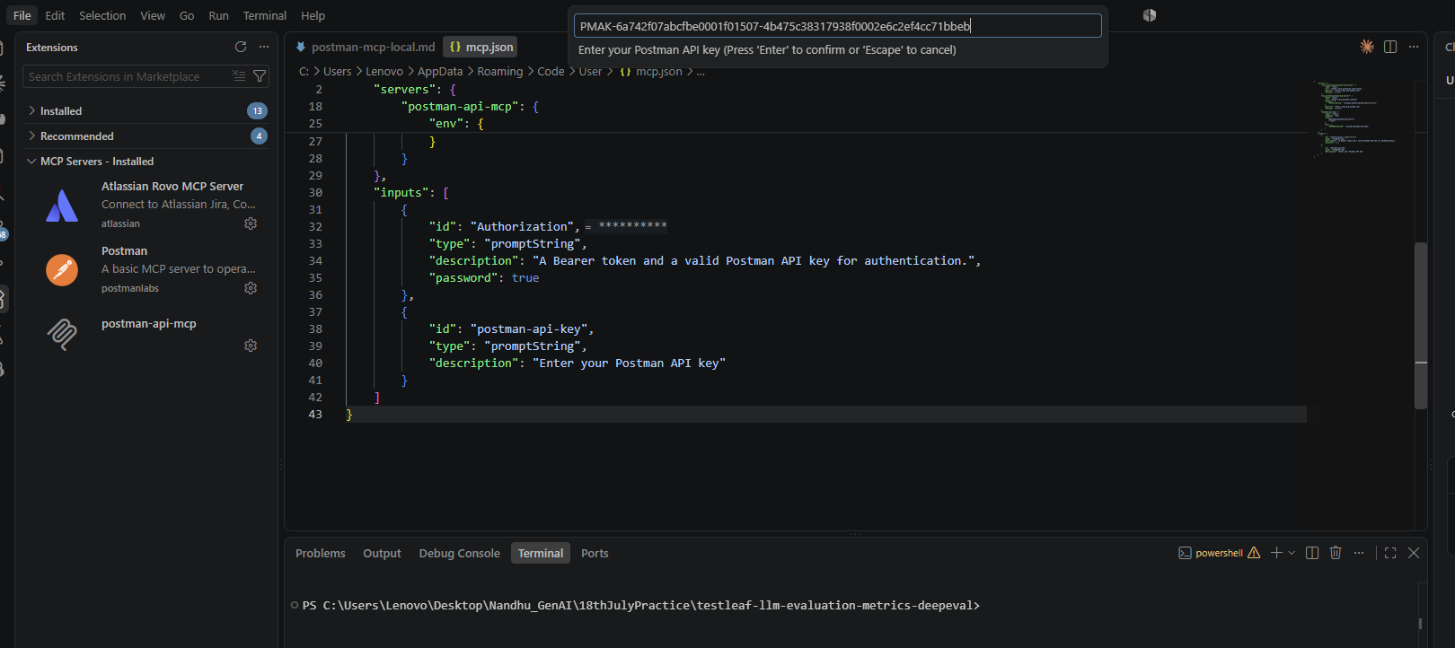
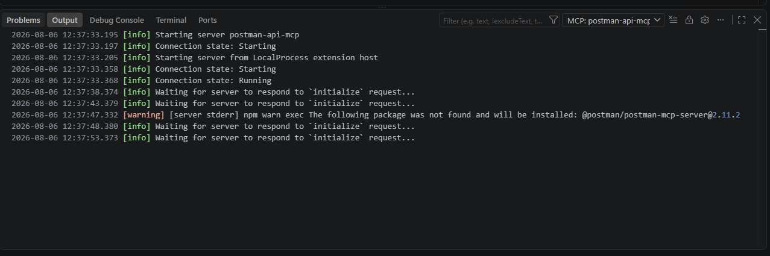
Added in Claude .json to enable in claude
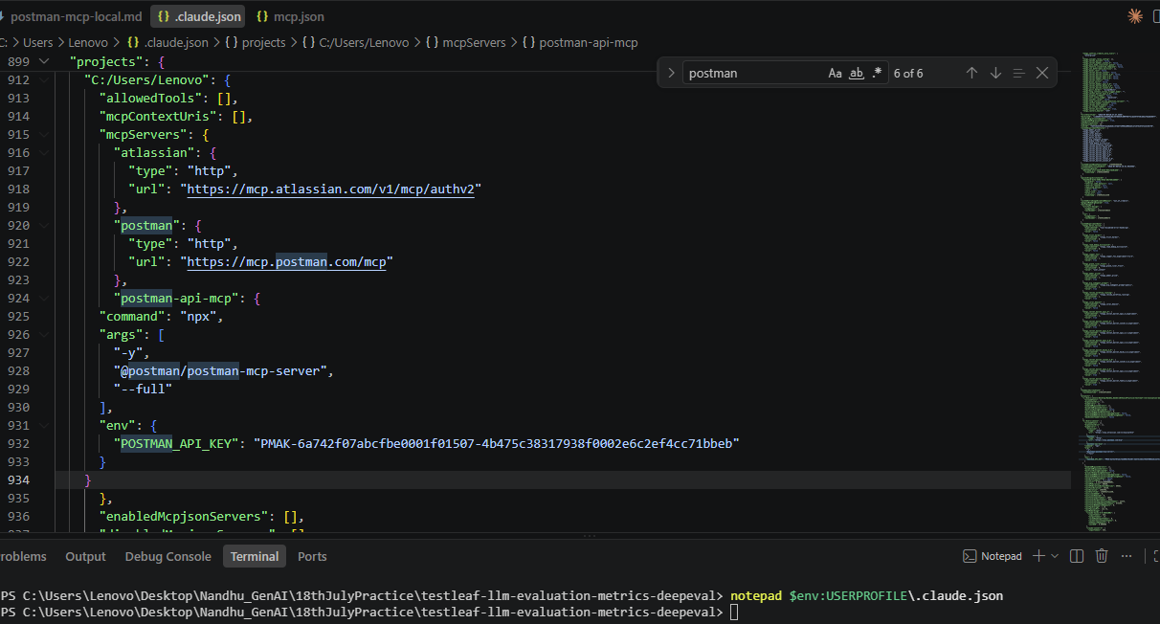

Connected to Claude
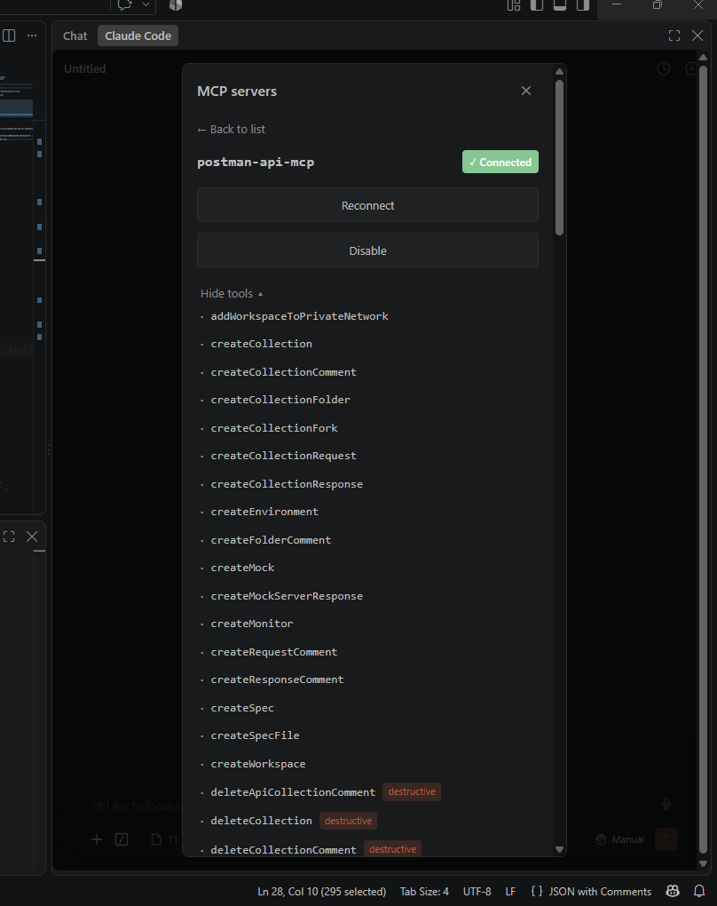
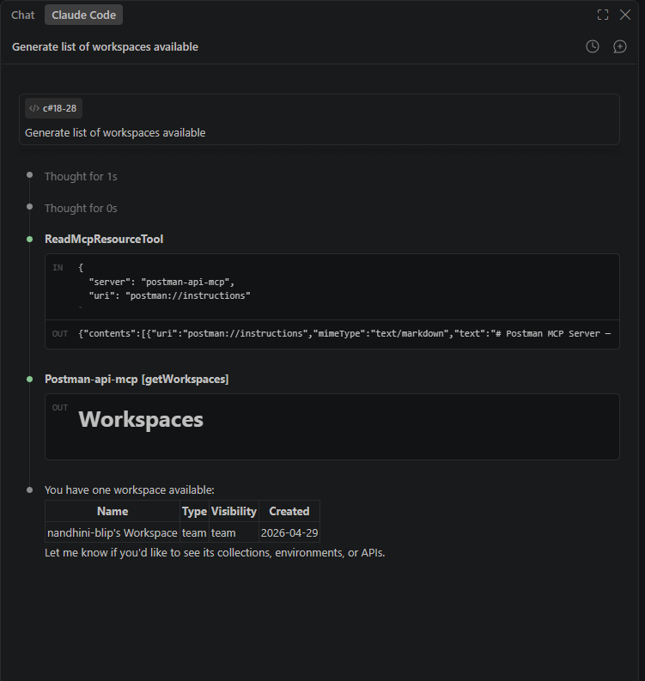
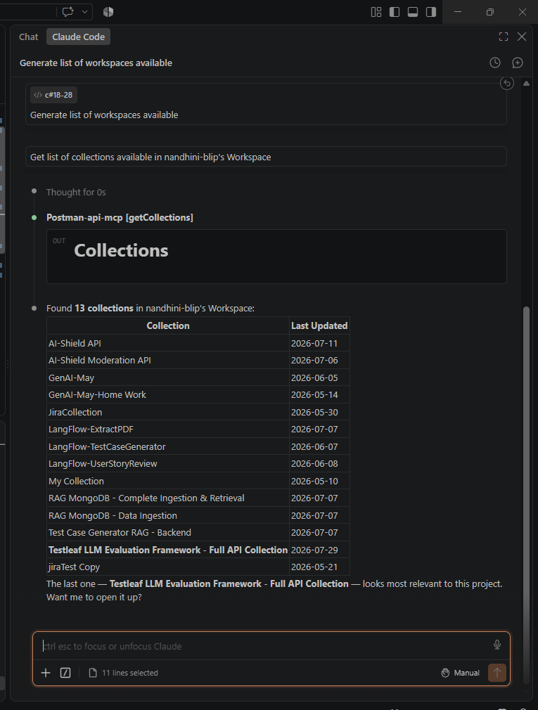
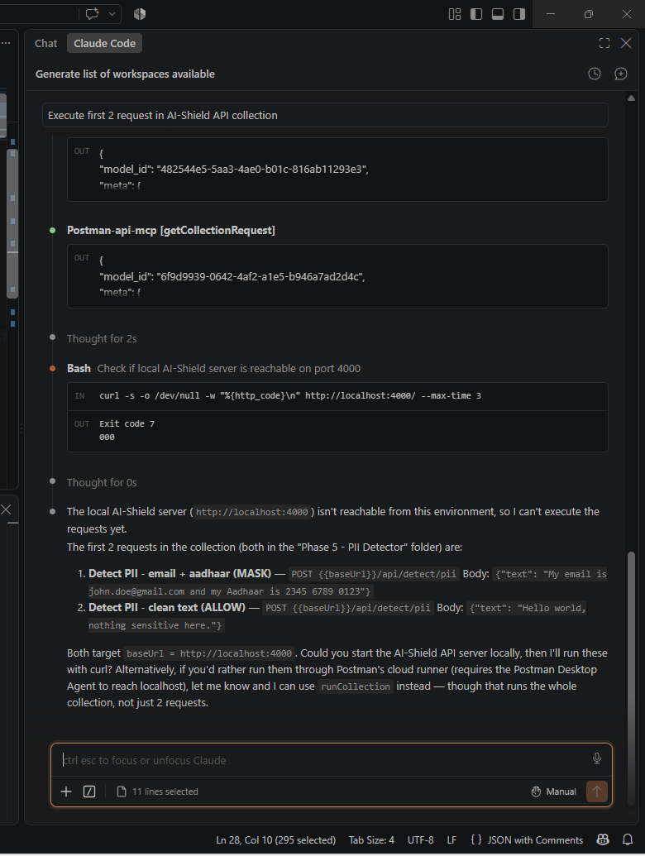

- Exploratory task --Explore different MCP servers and list down their purpose
MCP Server | Purpose
Filesystem | Generate and update test cases
GitHub | Create PRs, review automation code
Playwright | Execute UI tests
Browser | Verify application behavior
REST/OpenAPI | Test backend APIs
Jira | Create defects automatically
Confluence | Generate test documentation
Salesforce | Query and validate CRM data
PostgreSQL/SQL Server | Verify backend data
Docker | Run test environments
Kubernetes | Check deployment status
Slack | Send test execution summaries
Jenkins | Trigger automation suites
Git | Manage automation repositories
Memory | Long-term memory for agents
Filesystem | Knowledge base
Browser | Web browsing
GitHub | Code generation and review
Notion | Company knowledge
Slack | Team communication
Google Drive | Document retrieval
PostgreSQL | Structured data retrieval
Vector Database (Pinecone, Mongo DB,Weaviate, Qdrant, Chroma) | Retrieval-Augmented Generation (RAG)
OpenAPI | Connect to any REST service

