Analyze Binary Search performance when executed repeatedly on streaming data with periodic sorting. Record execution time for both sorting and searching phases. Interpret trade-offs between preprocessing cost and search efficiency. Justify the use of Binary Search in dynamic data streams.
Source Code:
import time
import random
import bisect

stream = []
stream_size = 10000

# Simulating streaming data
for i in range(stream_size):
stream.append(random.randint(1, 100000))

# Sorting Phase
start_sort = time.time()
stream.sort()
end_sort = time.time()

sort_time = end_sort - start_sort

# Searching Phase
key = random.choice(stream)

start_search = time.time()
index = bisect.bisect_left(stream, key)

if index < len(stream) and stream[index] == key:
result = "Element Found"
else:
result = "Element Not Found"

end_search = time.time()

search_time = end_search - start_search

print("Stream Size:", stream_size)
print("Search Key:", key)
print(result)
print("Sorting Time:", sort_time, "seconds")
print("Searching Time:", search_time, "seconds")
output:
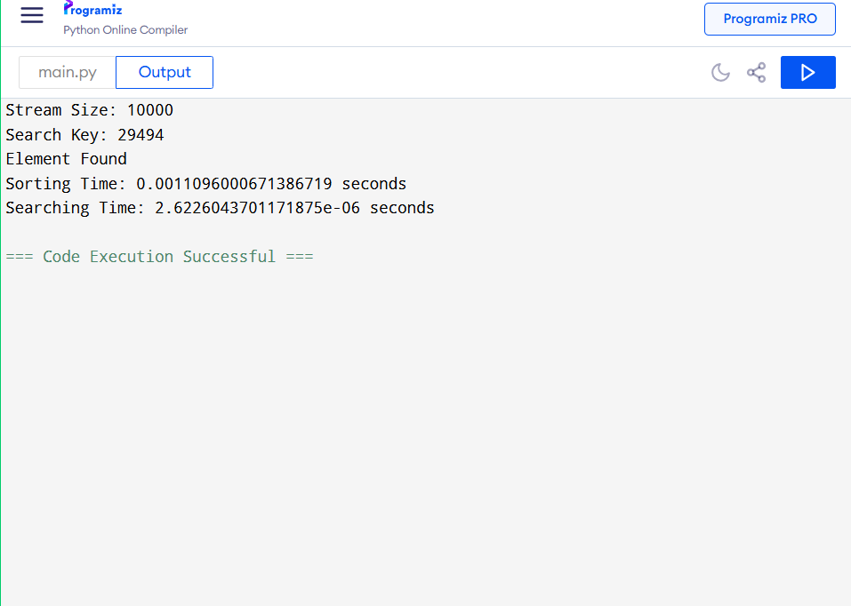
Aim
To analyze the performance of Binary Search when executed repeatedly on streaming data with periodic sorting, record the execution time of sorting and searching phases, and study the trade-off between preprocessing cost and search efficiency.
Algorithm
- Generate a stream of random data elements.
- Store the incoming elements in a list.
- Sort the list periodically using the built-in sorting method.
- Select a key element to search.
- Apply Binary Search to locate the key.
- Record the sorting time and searching time.
- Display the search result and execution times.

