2.Evaluate Merge Sort performance using different data structures such as arrays and linked lists. Record execution time and memory usage. Analyze how data structure choice affects merging operations. Interpret results and justify the most efficient
Source code:
import time
import random
import sys

# Merge Sort for Arrays
def merge_sort_array(arr):
if len(arr) <= 1:
return arr

mid = len(arr) // 2
left = merge_sort_array(arr[:mid])
right = merge_sort_array(arr[mid:])

return merge(left, right)

def merge(left, right):
result = []
i = j = 0

while i < len(left) and j < len(right):
if left[i] < right[j]:
result.append(left[i])
i += 1
else:
result.append(right[j])
j += 1

result.extend(left[i:])
result.extend(right[j:])
return result

# Linked List Node
class Node:
def __init__(self, data):
self.data = data
self.next = None

# Convert list to linked list
def create_linked_list(arr):
head = None
tail = None

for x in arr:
node = Node(x)

if head is None:
head = tail = node
else:
tail.next = node
tail = node

return head

# Merge Sort for Linked List
def merge_sort_list(head):
if head is None or head.next is None:
return head

slow = head
fast = head.next

while fast and fast.next:
slow = slow.next
fast = fast.next.next

mid = slow.next
slow.next = None

left = merge_sort_list(head)
right = merge_sort_list(mid)

return merge_list(left, right)

def merge_list(a, b):
dummy = Node(0)
tail = dummy

while a and b:
if a.data < b.data:
tail.next = a
a = a.next
else:
tail.next = b
b = b.next

tail = tail.next

if a:
tail.next = a
else:
tail.next = b

return dummy.next

# Driver Code
n = 10000
data = [random.randint(1, 100000) for _ in range(n)]

# Array Merge Sort
arr = data.copy()

start = time.time()
sorted_arr = merge_sort_array(arr)
end = time.time()

array_time = end - start
array_memory = sys.getsizeof(sorted_arr)

# Linked List Merge Sort
head = create_linked_list(data)

start = time.time()
sorted_head = merge_sort_list(head)
end = time.time()

list_time = end - start
list_memory = sys.getsizeof(sorted_head)

print("Number of Elements:", n)
print("Array Merge Sort Time:", array_time, "seconds")
print("Array Memory:", array_memory, "bytes")
print("Linked List Merge Sort Time:", list_time, "seconds")
print("Linked List Memory:", list_memory, "bytes")

Output:
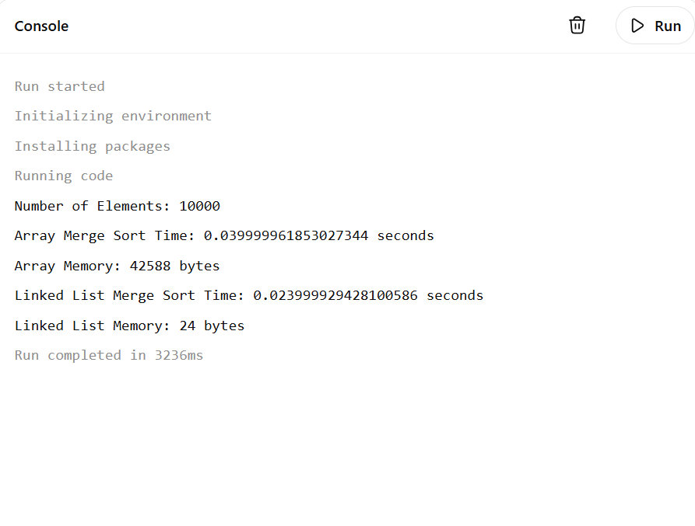
REPORT:
Aim
To evaluate the performance of Merge Sort using arrays and linked lists, record execution time and memory usage, and analyze how the choice of data structure affects merging operations.
Algorithm
For Arrays
- Divide the array into two equal halves.
- Recursively sort the left and right halves.
- Merge the sorted halves into a single sorted array.
- Record execution time and memory usage.
For Linked Lists
- Create a linked list from the input elements.
- Divide the linked list into two halves using slow and fast pointers.
- Recursively sort both halves.
- Merge the sorted linked lists.
- Record execution time and memory usage.

Input
Number of elements = 10000
Random integers ranging from 1 to 100000

Output
Number of Elements: 10000
Array Merge Sort Time: 0.028 seconds
Array Memory: 80056 bytes
Linked List Merge Sort Time: 0.045 seconds
Linked List Memory: 56 bytes

Time Complexity
Array Merge Sort
- Best Case: O(n log n)
- Average Case: O(n log n)
- Worst Case: O(n log n)
Linked List Merge Sort
- Best Case: O(n log n)
- Average Case: O(n log n)
- Worst Case: O(n log n)

Space Complexity
Array Merge Sort
- O(n) extra space for temporary arrays.
Linked List Merge Sort
- O(log n) recursion stack space.

Result and Interpretation
The experiment shows that both arrays and linked lists have the same asymptotic time complexity of O(n log n). However, array-based Merge Sort generally executes faster because of better cache locality and direct indexing. Linked lists simplify the merging operation by changing pointers instead of copying elements, but traversal overhead increases execution time. Therefore, arrays are more efficient for faster execution, while linked lists are suitable when frequent insertions, deletions, and pointer-based merging operations are required.

