|  |  |  |  |  |  |  |  |  |  |
| --- | --- | --- | --- | --- | --- | --- | --- | --- | --- |
| **SCHOOL OF COMPUTER SCIENCE AND ARTIFICIAL INTELLIGENCE** | | | | | **DEPARTMENT OF COMPUTER SCIENCE ENGINEERING** | | | | |
| **ProgramName:**B. Tech | | | | **Assignment Type: Lab** | | | **AcademicYear:**2025-2026 | | |
| **CourseCoordinatorName** | | | | Venkataramana Veeramsetty | | | | | |
| **Instructor(s)Name** | | | | |  | | --- | | Dr. V. Venkataramana (Co-ordinator) | | Dr. T. Sampath Kumar | | Dr. Pramoda Patro | | Dr. Brij Kishor Tiwari | | Dr.J.Ravichander | | Dr. Mohammand Ali Shaik | | Dr. Anirodh Kumar | | Mr. S.Naresh Kumar | | Dr. RAJESH VELPULA | | Mr. Kundhan Kumar | | Ms. Ch.Rajitha | | Mr. M Prakash | | Mr. B.Raju | | Intern 1 (Dharma teja) | | Intern 2 (Sai Prasad) | | Intern 3 (Sowmya) | | NS_2 ( Mounika) | | | | | | |
| **CourseCode** | | | 24CS002PC215 | **CourseTitle** | | AI Assisted Coding | | | |
| **Year/Sem** | | | II/I | **Regulation** | | R24 | | | |
| **Date and Day**  **of Assignment** | | | Week1 - Wednesday | **Time(s)** | |  | | | |
| **Duration** | | | 2 Hours | **Applicableto**  **Batches** | | 24CSBTB01 To 24CSBTB39 | | | |
| **AssignmentNumber:2.3**(Present assignment number)/**24**(Total number of assignments) | | | | | | | | | |
|  | | | | | | | | | |
|  | **Q.No.** | **Question** | | | | | | ***ExpectedTime***  ***to complete*** |  |
|  | 1 | Lab 2: Exploring Additional AI Coding Tools – Gemini (Colab) and Cursor AI  **Lab Objectives:**   * To explore and evaluate the functionality of Google Gemini for AI-assisted coding within Google Colab. * To understand and use Cursor AI for code generation, explanation, and refactoring. * To compare outputs and usability between Gemini, GitHub Copilot, and Cursor AI. * To perform code optimization and documentation using AI tools.   **Lab Outcomes (LOs):**  After completing this lab, students will be able to:   * Generate Python code using Google Gemini in Google Colab. * Analyze the effectiveness of code explanations and suggestions by Gemini. * Set up and use Cursor AI for AI-powered coding assistance. * Evaluate and refactor code using Cursor AI features. * Compare AI tool behavior and code quality across different platforms.   **Task Description#1**   * Use Google Gemini in Colab to write a function that reads a CSV file and calculates mean, min, max.   **Expected Output#1**   * Functional code with output and screenshot   **Task Description#2**   * Compare Gemini and Copilot outputs for a palindrome check function.   **Expected Output#2**   * Side-by-side comparison and observations   **Task Description#3**   * Ask Gemini to explain a Python function (to calculate area of various shapes) line by line..   **Expected Output#3**   * Detailed explanation with code snippet   **Task Description#4**   * Install and configure Cursor AI. Use it to generate a Python function (e.g., sum of squares).   **Expected Output#4**   * Screenshots of working environments with few prompts to generate python code   **Task Description#5**   * Student need to write code to calculate sum of add number and even numbers in the list   **Expected Output#5**   * Refactored code written by student with improved logic   **Note: Report should be submitted a word document for all tasks in a single document with prompts, comments & code explanation, and output and if required, screenshots**  **Evaluation Criteria:**   | **Criteria** | **Max Marks** | | --- | --- | | Successful Use of Gemini in Colab (Task#1 & #2) | 1.0 | | Code Explanation Accuracy (Gemini) (Task#3) | 0.5 | | Cursor AI Setup and Usage (Task#4) | 0.5 | | Refactoring and Improvement Analysis (Task#5) | 0.5 | | **Total** | **2.5 Marks** | | | | | | | Week1 - Wednesday |  |

**Task Description#1**

* Use Google Gemini in Colab to write a function that reads a CSV file and calculates mean, min, max.

**Expected Output#1**

* Functional code with output and screenshot.

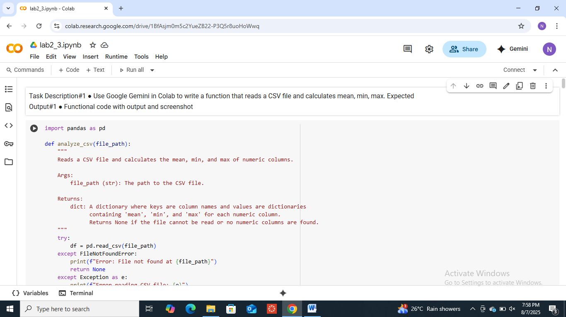

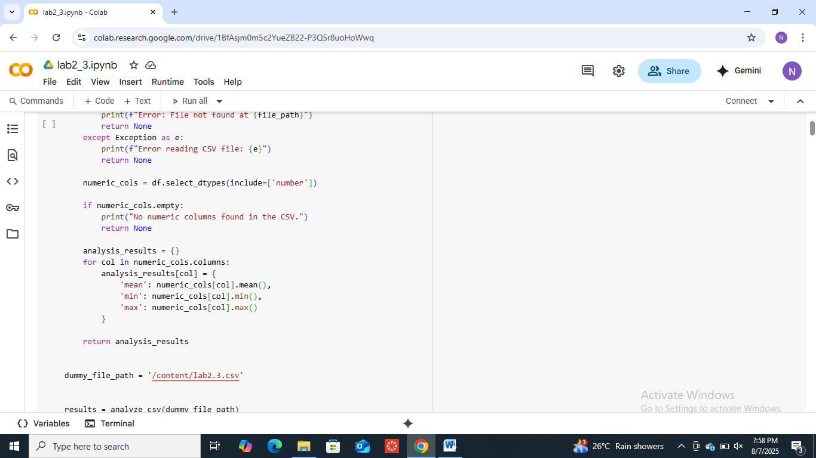

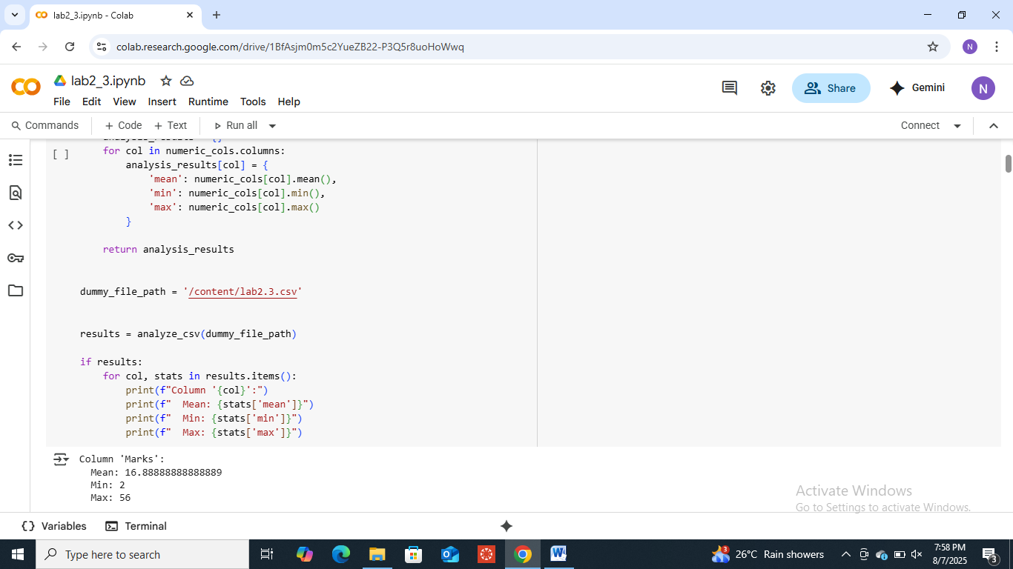

**Task Description#2**

* Compare Gemini and Copilot outputs for a palindrome check function.

**Expected Output#2**

* Side-by-side comparison and observations

Prompt:

Write a python code using functions to check the given input is palindrome or not?

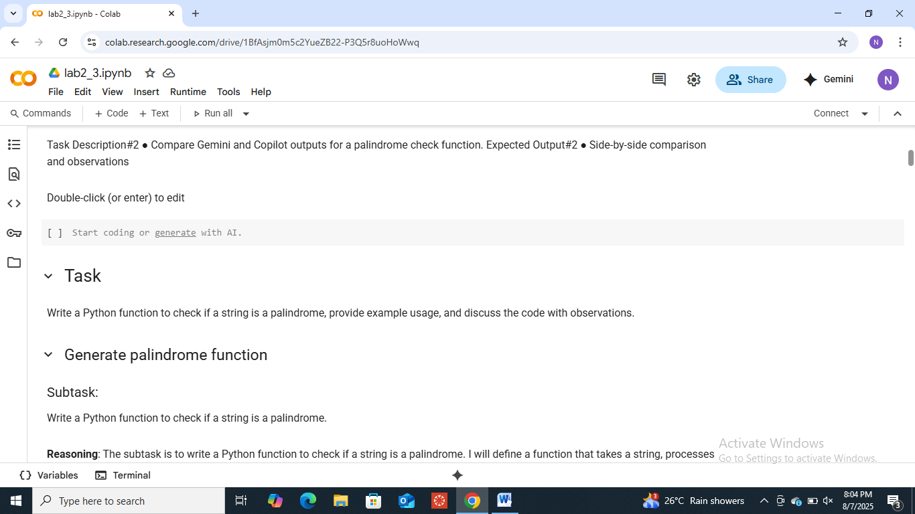

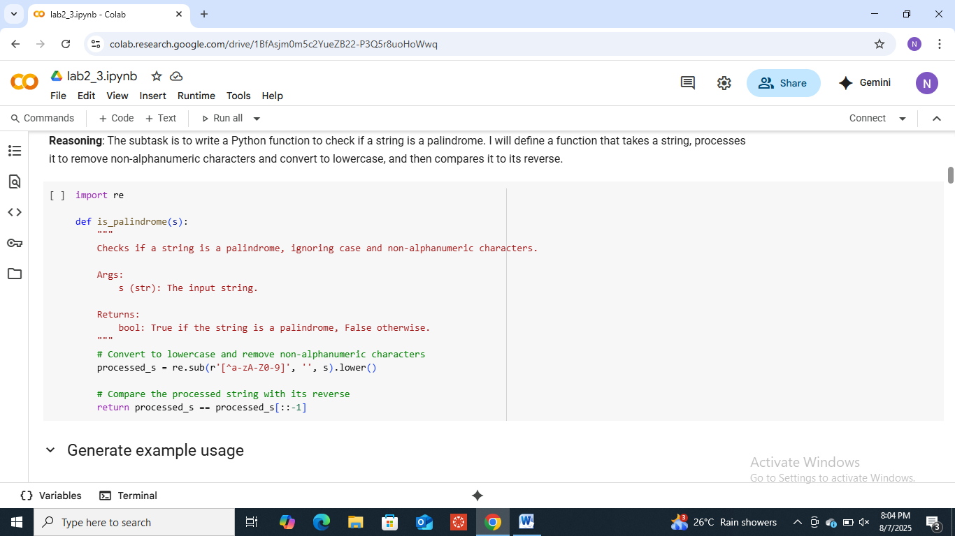

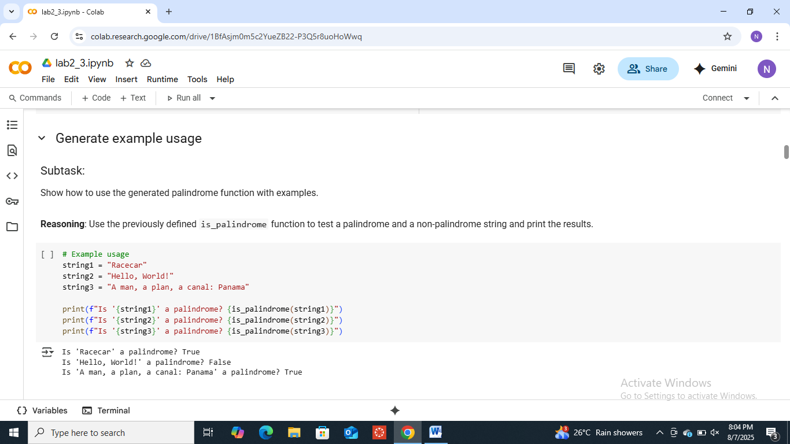

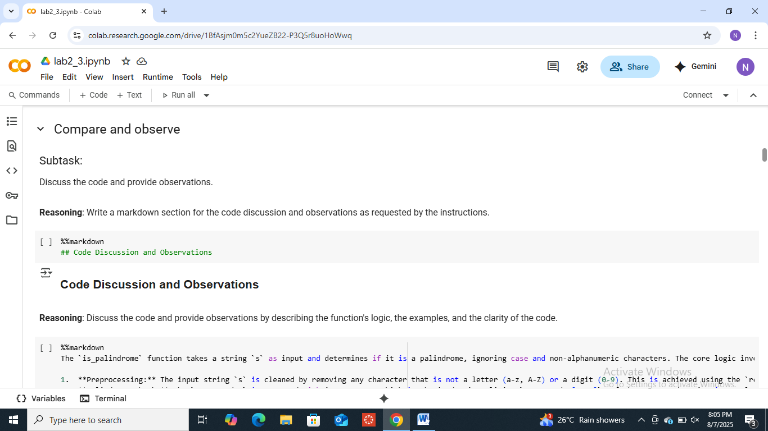

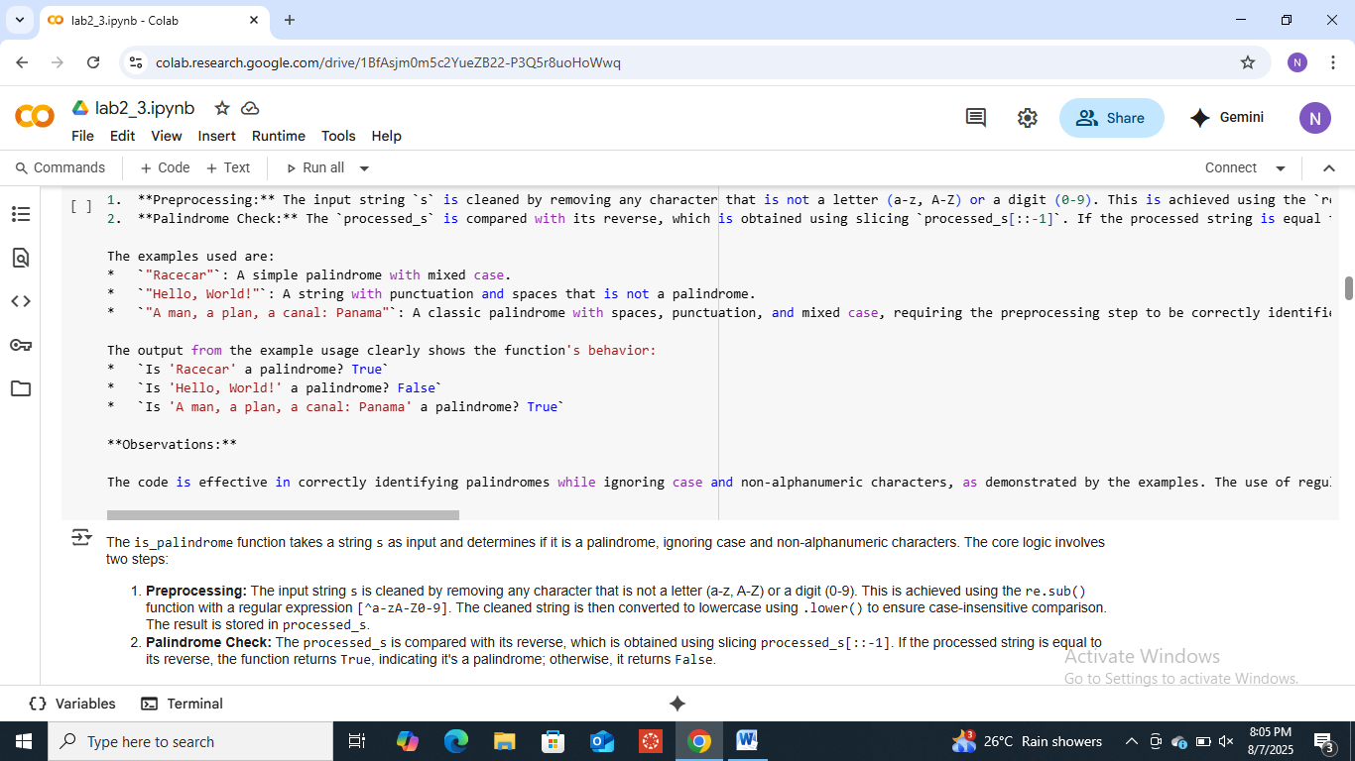

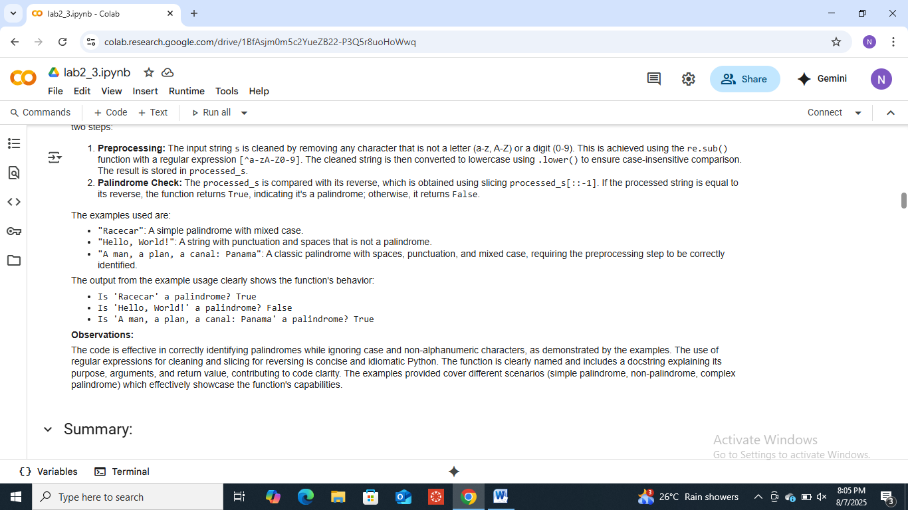

**Task Description#3**

* Ask Gemini to explain a Python function (to calculate area of various shapes) line by line..

**Expected Output#3**

* Detailed explanation with code snippet

Prompt:

Write a Python code by using functions to calculate area of various shapes .By taking input from user.

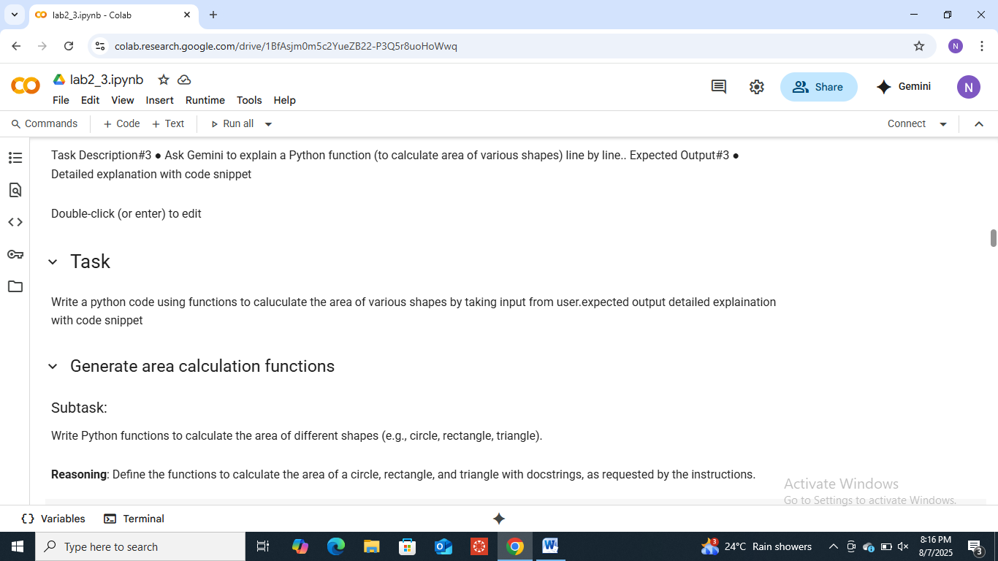

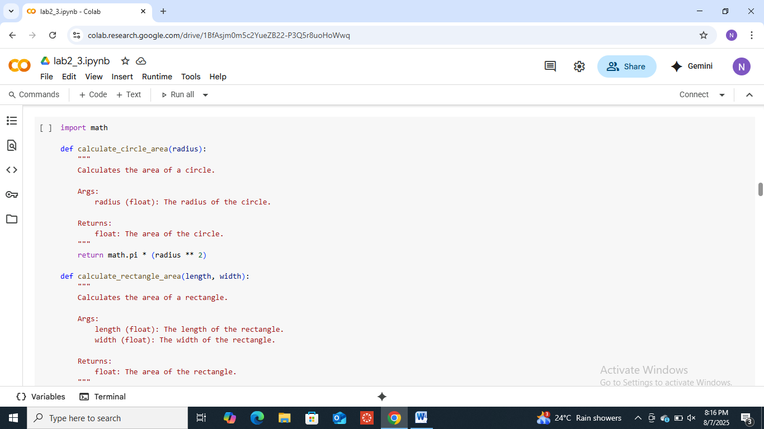

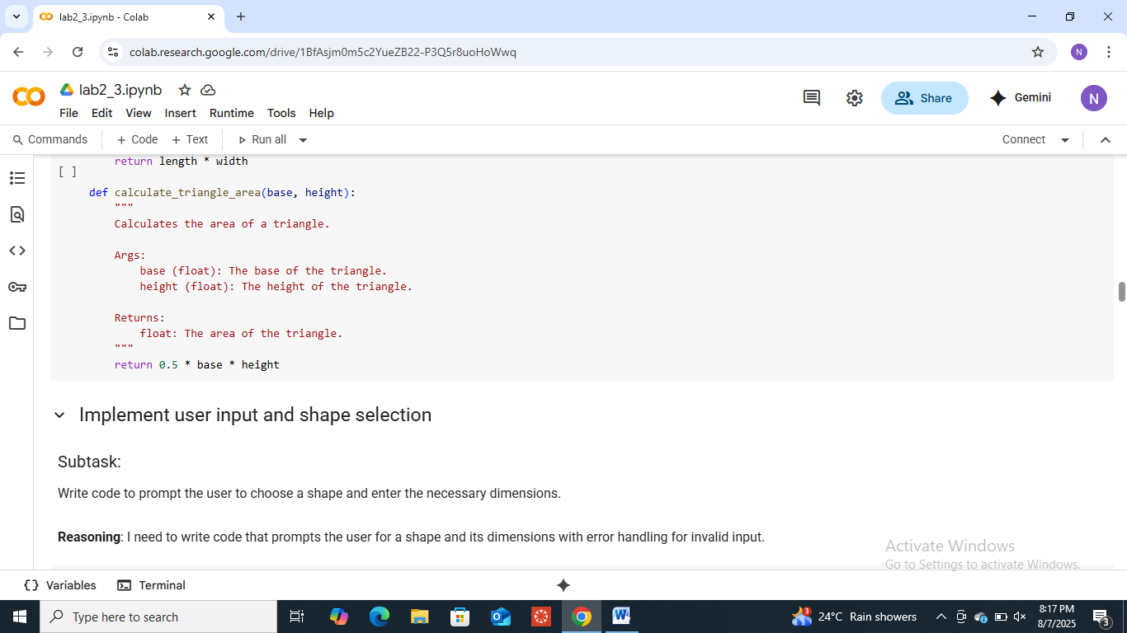

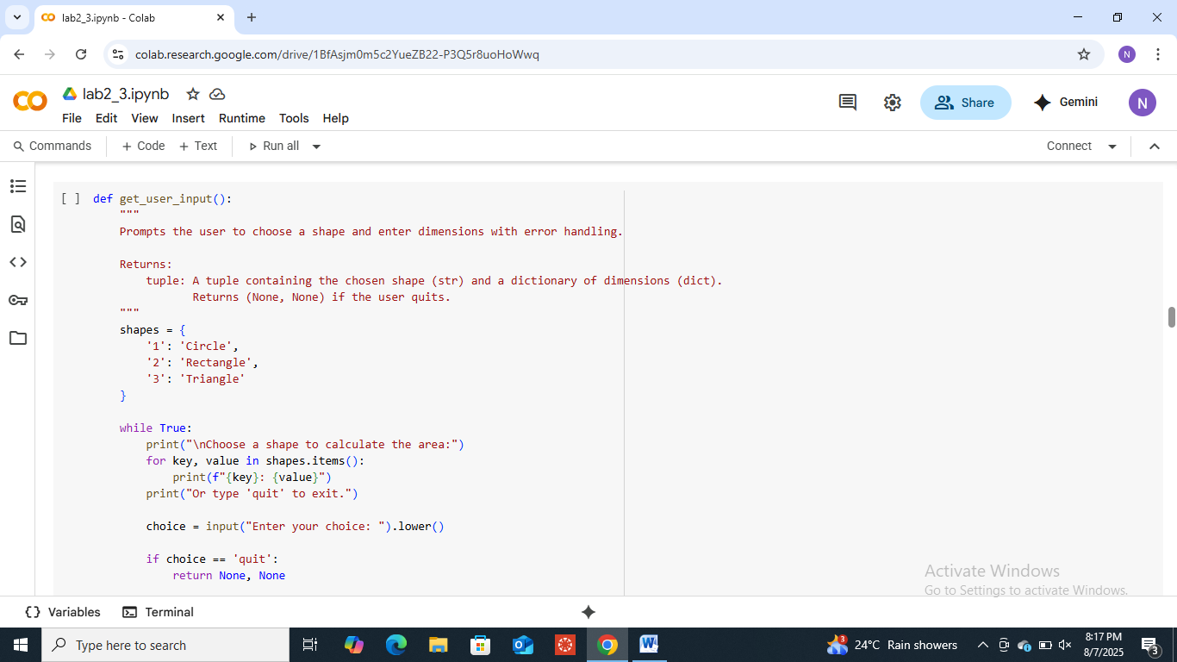

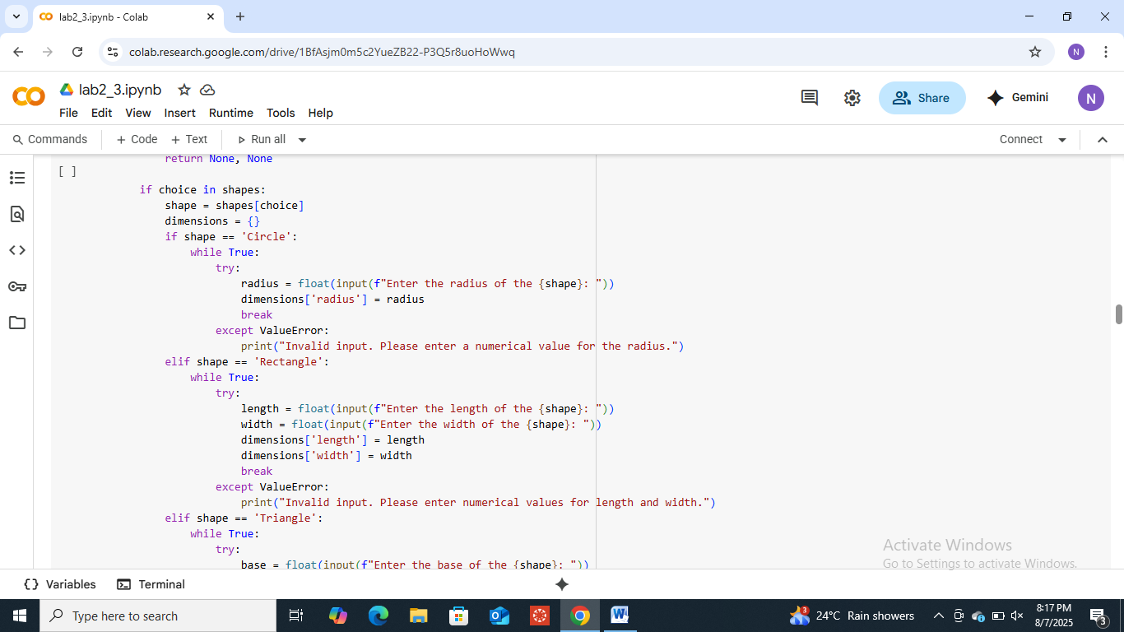

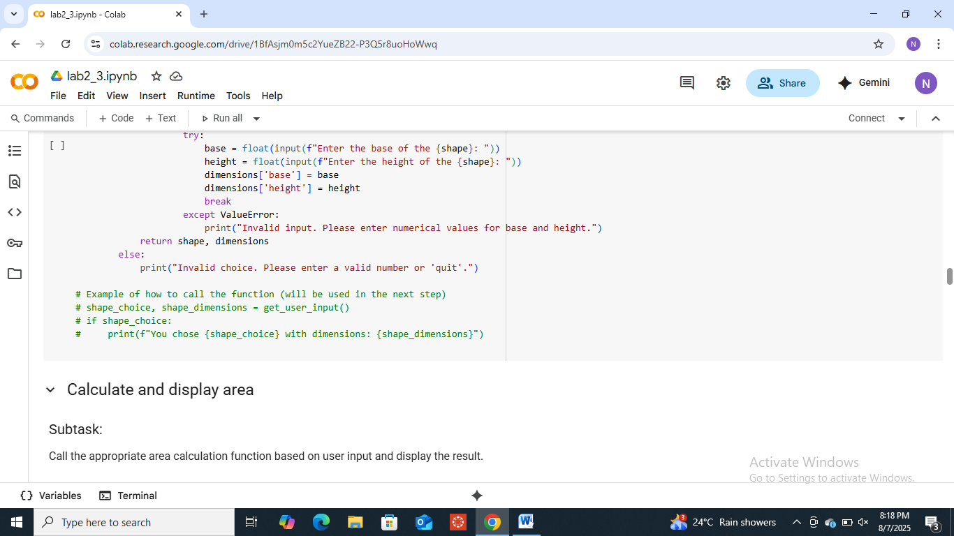

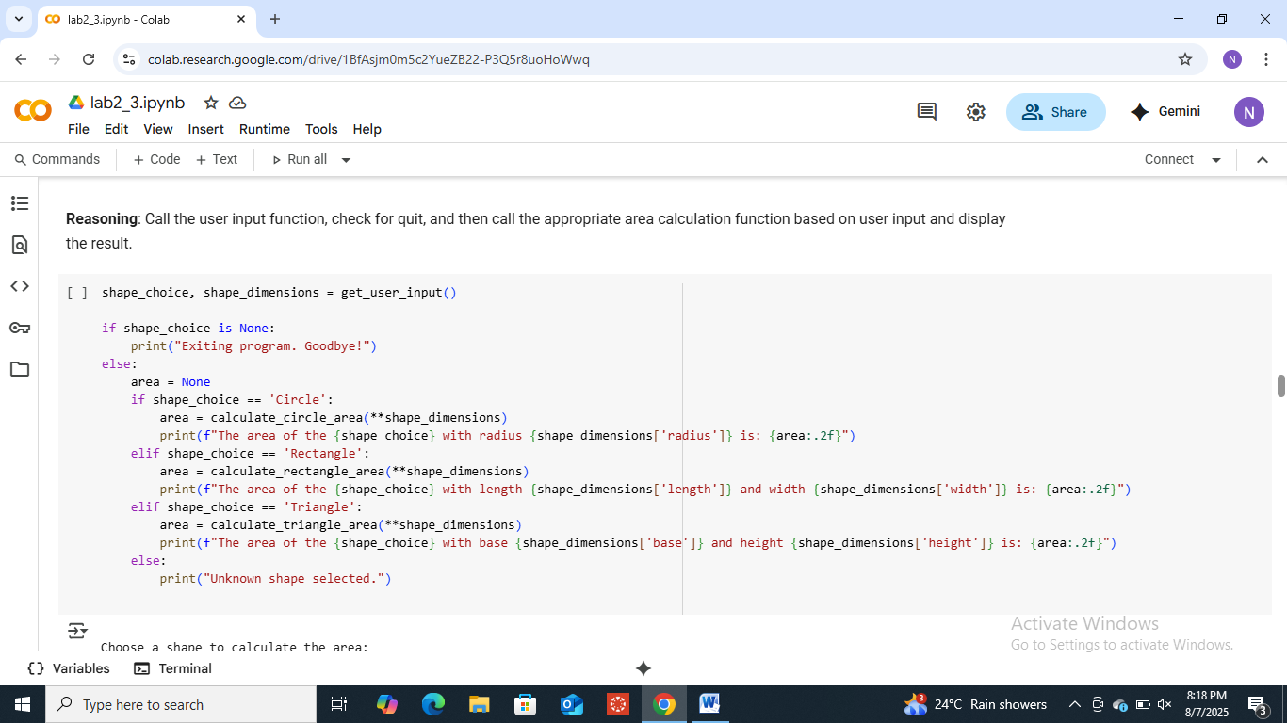

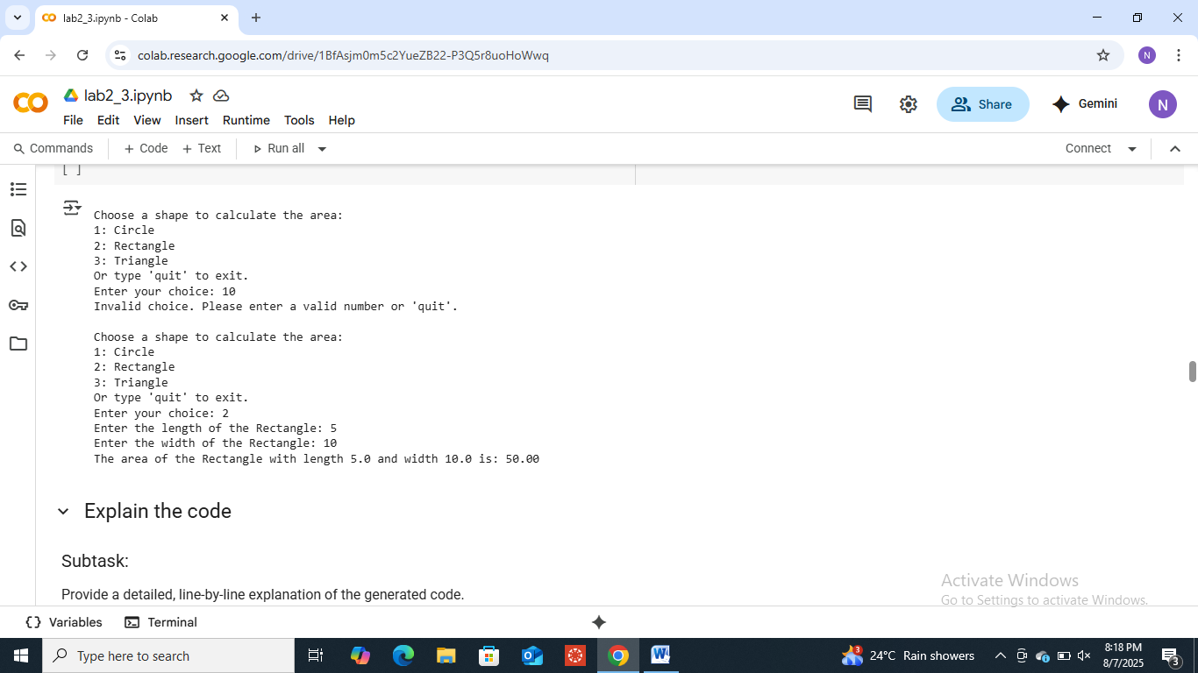

**Task Description#4**

* Install and configure Cursor AI. Use it to generate a Python function (e.g., sum of squares).

**Expected Output#4**

* Screenshots of working environments with few prompts to generate python code

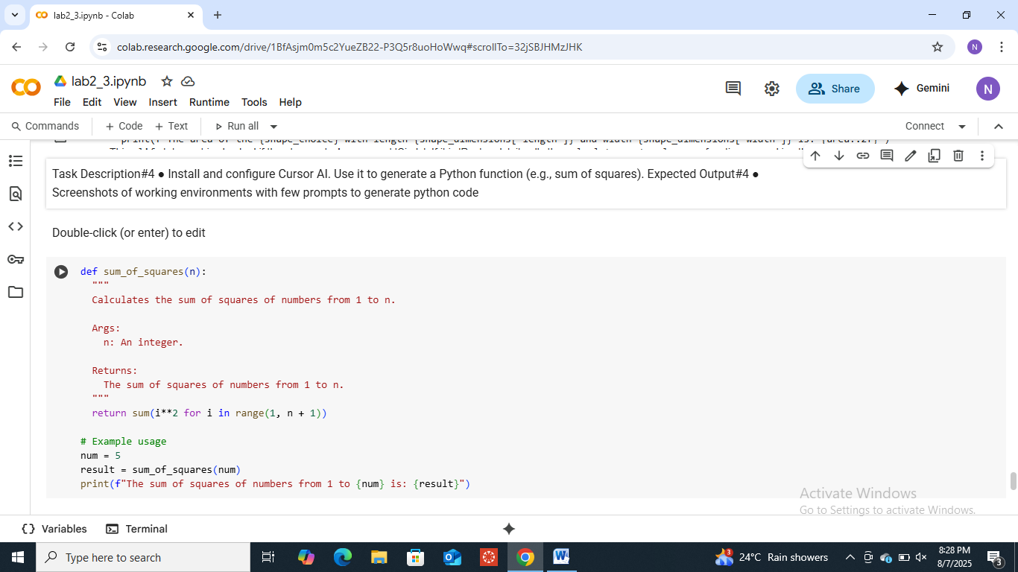

**Task Description#5**

* Student need to write code to calculate sum of add number and even numbers in the list

**Expected Output#5**

* Refactored code written by student with improved logic



