SR UNIVERSITY

Campus Warangal

Program: II - B.Tech (CS& AI)


Professor(a): Dr. Venkataramana Veeramsetty, Professor

Department: Computer Science and AI Semester: I

AI Assisted Coding - Lab Test 1 - Set A

Instructions:

1- Use AI Tools like VScode+Github Copilot and Cursor AI for code generation

2- This Assignment will be evaluated for 15 Marks (10 Marks for Tasks and 5 Marks for viva based on regular lab activities)

3- Students need to submit assignment through canvas before due date

4- Students who are absent for lab will receive 0 Marks

- Write a Python code to calculate the sum of odd and even numbers in a given list using GitHub Copilot along with VS Code. Use zero shot prompting

- Write a Python code for given a list of integers, remove duplicates and print the sorted result. GitHub Copilot along with VS Code. Use one shot prompting.

- Write a Python function that converts the temperature between Celsius, Fahrenheit, and Kelvin based on user choice. Use the Cursor AI tool. Use few shot prompting.

- Write a Python function to remove punctuation, convert to lowercase, and remove stop words from a given text. Use the Cursor AI tool. Use zero shot prompting.

Date: 2025-08-14

Question 1:
Write a Python code to calculate the sum of odd and even numbers in a given list using GitHub Copilot along with VS Code. Use zero shot prompting.
Prompt:
Write a python code to calculate the sum of odd and even numbers in a given list separately.This list is given by the user.

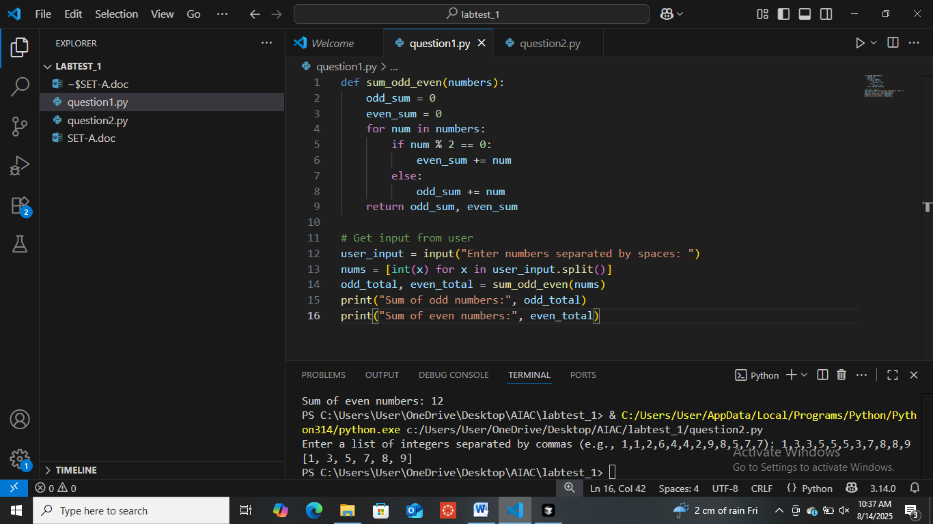

Question 2:

Write a Python code for given a list of integers, remove duplicates and print the sorted result.GitHub

Copilot along with VS Code. Use one shot prompting.

Prompt:

Write a python code taking the list of integers from user to remove duplicates and print the sorted
result.

Example:

Input:[1,1,2,6,4,4,2,9,8,5,7,7]

Output:[1,2,4,5,6,7,8,9]

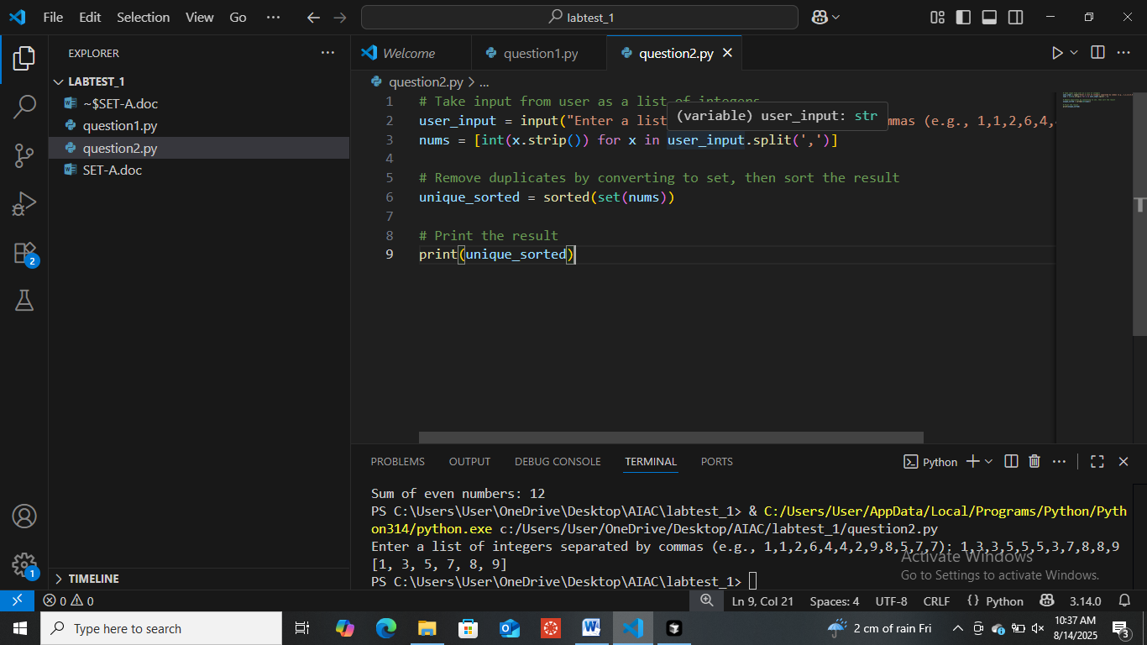

Question 3:
Write a Python function that converts the temperature between Celsius, Fahrenheit, and Kelvin based on user choice. Use the Cursor AI tool. Use few shot prompting.
Prompt:
Write a python code by using functions that converts the temperature based on the user choice.
Example 1:
Input:0 Celsius to Fahrenheit
Output:32 Fahrenheit

Example 2:
Input:32 Fahrenheit to Celsius
Output:0 Celcius

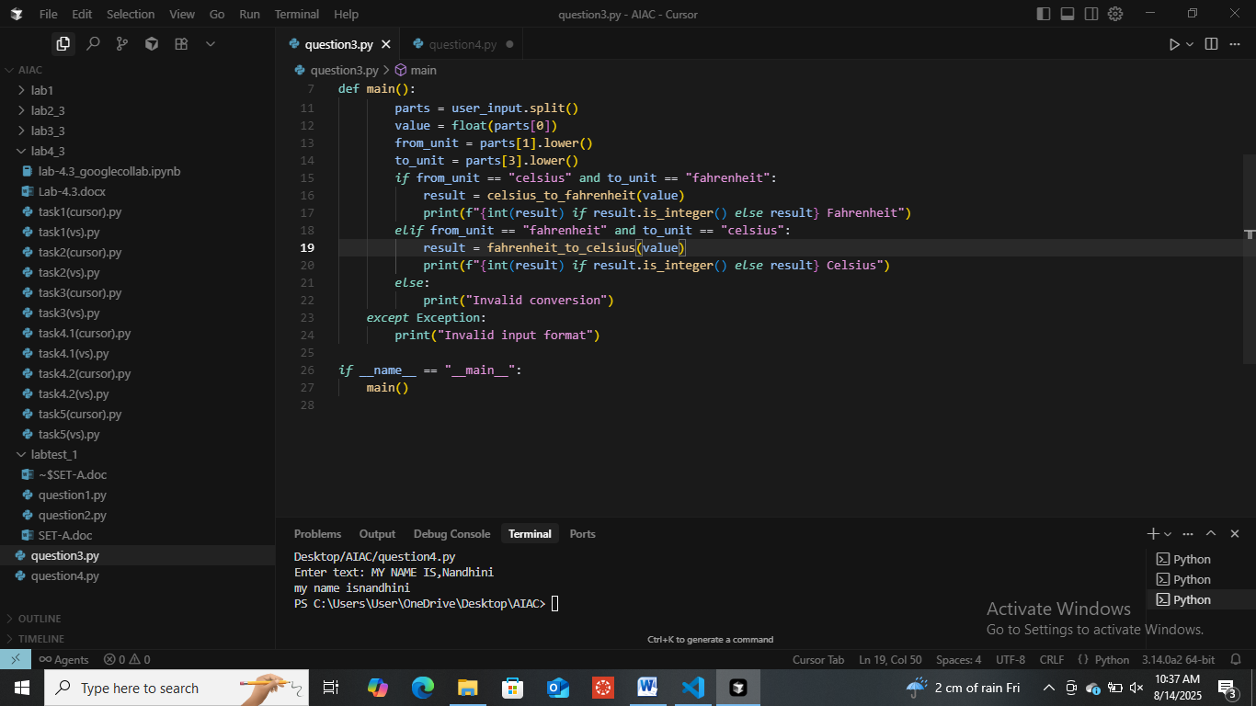

Question 4:

Write a Python function to remove punctuation, convert to lowercase, and remove stop words from a given text. Use the Cursor AI tool. Use zero shot prompting.
Prompt:
Write a python code by Using funct.ions to remove punctuation,converting to lower case,and removing the stop words from the text given by the user.

