RetailSense: A Random Forest-Based AI Framework for
Retail Intelligence

Dr Prabha B
Department of Artificial Intelligence and Machine Learning
Panimalar Engineering College,
Chennai, Tamil Nadu, India
jemi.prabha@gmail.com

Dr Suresh
Department of Artificial Intelligence and Machine Learning
Panimalar Engineering College,
Chennai, Tamil Nadu, India
drsureshkec@gmail.com

SasiKumar D
Department of Artificial Intelligence and Machine Learning
Panimalar Engineering College,
Chennai, Tamil Nadu, India
sasikumarme2004@gmail.com

Nandhini D
Department of Artificial Intelligence and Machine Learning
Panimalar Engineering College,
Chennai, Tamil Nadu, India
nandhinibkbabu21@gmail.com

Bhavana A
Department of Artificial Intelligence and Machine Learning
Panimalar Engineering College,
Chennai, Tamil Nadu, India
a.bhavana2006@gmail.com

Depshikha B
Department of Artificial Intelligence and Machine Learning
Panimalar Engineering College,
Chennai, Tamil Nadu, India
depshikha07@gmail.com

Abstract
The gap between the analytical capabilities of large retail enterprises and the intuition-driven decisions of small stores continues to widen. This paper presents a machine-learning-driven retail analytics system that integrates customer preference prediction, sales forecasting, and intelligent inventory management within a single cloud-synchronised boutique-management platform. Three supervised ensemble models form its core: a Random Forest classifier that predicts customer preferences from explicit style attributes and generates human-readable recommendation reasons; a Random Forest regressor that forecasts revenue across daily, weekly, monthly, and yearly horizons; and a second Random Forest regressor that predicts next-period demand to drive automated reorder quantities and low-stock alerts. Trained on domain-consistent datasets with an 80:20 split, the recommendation model attains 77.1% accuracy and a 65% F1-score, the forecaster attains R² = 0.816, and the demand model attains R² = 0.899, each outperforming a Linear Regression baseline. Beyond raw accuracy, the system translates predictions into an interpretable business-intelligence dashboard spanning revenue, sales, product, customer, and inventory analytics. The results show that ensemble learning offers a practical, low-cost route to enterprise-grade retail intelligence for resource-constrained retailers.
Keywords— Machine Learning, Business Intelligence & Analytics , Random Forest, Recommendation Systems, Sales Forecasting, Inventory Optimization.
I. Introduction
The fashion retail sector operates in a volatile demand environment shaped by shifting preferences, seasonal cycles, and short product life-spans [11], [12]. Large enterprises manage this volatility with sophisticated analytics and dedicated data-science teams, while small and medium retailers rely on manual ledgers, spreadsheets, or basic point-of-sale software that records transactions but offers no predictive intelligence [12]. This asymmetry costs independent retailers revenue through stock-outs, working capital through overstocking, and customers through non-personalised service [11], [14].
Machine learning has matured into a practical tool for extracting predictive value from ordinary transactional data [7]. Ensemble methods such as Random Forests are well suited to retail because they handle heterogeneous feature spaces extracting predictive value from ordinary transactional data. Ensemble methods such as Random Forests are well suited to retail because they handle heterogeneous feature spaces that mix categorical attributes (category, colour, occasion) with numeric quantities (price, historical sales), resist over-fitting, and require little tuning [1], [7]. Embedded in accessible software, such models can extend enterprise-grade analytics to the smallest stores [12].
This paper presents an AI-powered retail analytics platform designed for small clothing and fashion stores. It combines operational modules for customer, employee, product, and billing management with real-time multi-device synchronisation, and adds three machine-learning services: product recommendation, AI sales forecasting, and AI stock prediction [1], [2], [8]. A defining feature is its business-intelligence philosophy—predictions are surfaced not as opaque scores but as interpretable analytics that directly support day-to-day decisions [12], [13].
The main contributions are: (i) an integrated platform combining recommendation, forecasting, and demand prediction rather than isolated tasks [2], [8], [14]; (ii) an attribute-driven recommendation model that works under cold-start conditions and produces interpretable reasons [2], [3] ; (iii) a multi-horizon forecasting model with a data-sufficiency safeguard that avoids misleading predictions for new shops [5], [6], [20]; and (iv) an empirical evaluation of all three models against linear baselines [1], [8]. The paper is organised as follows: Section II reviews related work; Section III describes the proposed system; Section IV presents the methodology; Section
V defines the evaluation metrics; Section VI reports the results; and Section VII concludes.
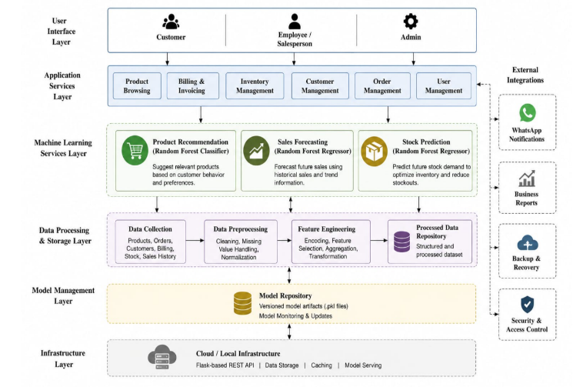
Fig. 1. A Machine Learning-Driven Retail
Analytics
II. Related Work
Retail machine learning has developed along three streams: recommendation systems, sales and demand forecasting, and inventory optimisation [2], [8], [12]. Early recommendation research was dominated by collaborative filtering [3], [15], which infers preferences from co-purchase patterns but suffers from the cold-start problem and depends on large interaction volumes that small retailers rarely have [3], [10]. Content-based and attribute-based approaches mitigate cold-start by modelling the intrinsic properties of items and users, making them better suited to boutique catalogues where explicit style attributes are available [2], [10], [16].
In sales forecasting, classical models such as ARIMA and exponential smoothing capture linear trend and seasonality but struggle with the non-linear interactions among calendar effects, festivals, and category dynamics that characterise fashion retail [5], [6] . Tree-based ensembles—Random Forests and gradient-boosted trees—consistently achieve higher accuracy because they model these interactions without manual specification and remain robust to noisy, heterogeneous inputs [1], [17], [20].
Inventory-optimisation research has traditionally used operations-research models such as the economic order quantity and newsvendor formulations, which assume known demand distributions [11]. Data-driven demand prediction relaxes this assumption by learning demand directly from historical sales and contextual features, enabling adaptive reorder policies [8], [14].
A recurring limitation is that these predictive components are rarely integrated into a single, retailer-facing system, and their outputs are seldom translated into intelligence a non-technical shop owner can act upon [12], [13]. The proposed system addresses this by embedding three complementary services within one deployable platform and evaluating them through the lens of business intelligence [1], [7], [12].
III. Proposed System
The proposed system treats boutique management as a continuous data-generating and data-consuming loop: every operational action contributes structured data to the analytical core, and every prediction is returned as actionable intelligence [12], [13]. It is implemented as a single-page web application backed by a Python (Flask) machine-learning micro-service and a real-time cloud datastore, running on commodity hardware and synchronising across devices[7].
A. System Modules :The platform integrates ten modules, summarised in Table I—operational modules for customer, employee, product, and billing management, real-time synchronisation, and WhatsApp integration, plus analytical modules comprising the dashboard and the three machine-learning services[12].
TABLE I. System Modules
Module | Function
Customer  Management | Registration, profiles, style attributes, session preferences
Employee Management | Staff records, performance attribution on orders
Product Management | Catalogue, categories, size-level stock tracking
Billing System | Three-step GST invoicing, payment capture, receipts
Real-Time Synchronisation | Multi-device cloud sync with offline cache
Analytics Dashboard | Revenue, sales, product, customer, payment analytics
WhatsApp Integration | Automated dispatch of bills and offers
Product Recommendation | Random Forest preference prediction with rationale
AI Sales Forecasting | Random Forest revenue prediction across four horizons
AI Stock Prediction | Random Forest demand prediction and reorder intelligence

B. Machine-Learning Core: The recommendation service predicts which products best satisfy a customer's stated preferences, applies a strict gender-to-category constraint, ranks candidates, and attaches a human-readable reason to each suggestion [2], [3], [10]. The forecasting service learns the shop's revenue dynamics and projects income across four horizons, anchoring predictions to the shop's actual revenue scale [5], [6], [20]. The stock-prediction service estimates next-period demand and derives reorder quantities and risk categories (Normal, Low, Critical) [8], [14]. A data-sufficiency safeguard suppresses forecasting for shops without adequate sales history, showing a transparent empty-state instead of an unreliable prediction [13], [18].
C. Architecture : The system uses a three-tier design: a presentation tier (single-page web client), an application tier (Flask REST micro-service exposing recommendation, forecasting, stock-prediction, and retraining endpoints that load pre-trained artefacts), and a persistence tier (real-time cloud datastore plus browser-local cache, with job lib-serialised model artefacts) [7]. This decouples the models from the interface, keeping inference latency low and allowing independent retraining [7], [12].
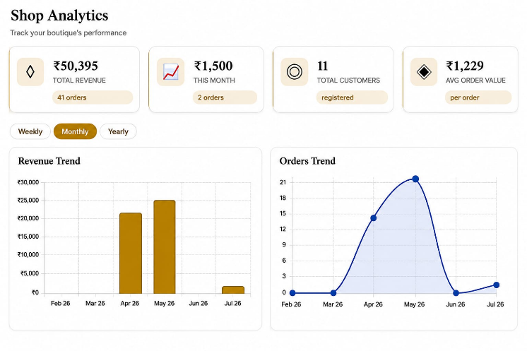
Fig. 2. Admin analytics dashboard
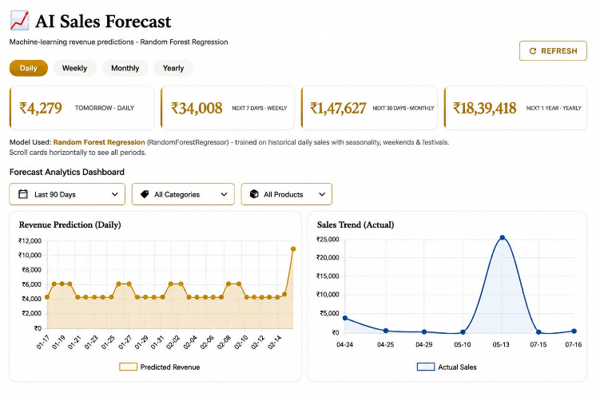 Fig 3 .AI-Based Sales Forecasting Using Random
Forest Regression
IV. Methodology
The methodology adopts a supervised learning paradigm across all three tasks, differing only in target formulation [7]. Preference prediction is binary classification (like / not-like) over customer–product attribute pairs; sales forecasting is regression of daily revenue on calendar features; stock prediction is regression of next-period demand on product, price, and seasonal features [2], [8], [14]. All three share a common scikit-learn pipeline backbone [7]. Random Forest was chosen for its robustness to mixed feature types, resistance to over-fitting, and strong performance without extensive tuning [1], [17].
A. Dataset Description :Three datasets support the three tasks: a recommendation dataset of 10,000 customer–product pairs with a binary preference label; a sales dataset of 730 days of daily revenue; and a stock dataset of 8,320 product-period records labelled with next-period units sold [2], [8], [14]. Table II summarises the principal features.
Feature | Type | Description
Gender | Categorical | Gender-constrained recommendation filtering
Skin Tone | Categorical | Mapped to flattering colour families
Favourite Colour | Categorical | Primary colour-matching signal
Occasion | Categorical | Intended usage context
Size | Categorical | Availability filtering and scoring
Product Category | Categorical | Women / Men / Kids / Newborn
Price | Numeric | Unit price (standard-scaled)
Day / Month / Day-of-Year | Numeric | Temporal features for forecasting
Weekend / Festival | Binary | Seasonality flags
Recent Units / 4-Week Average | Numeric | Rolling demand signals
TABLE II. Principal Dataset Features

B.Preprocessing and Feature Engineering :Data are collected passively during routine operation[12]. Preprocessing is implemented as a scikit-learn ColumnTransformer inside each pipeline so identical transformations apply at training and inference: missing categorical values are imputed with an "Unknown" token and numeric values with the column median, categorical features are one-hot encoded, and numeric features are standardised [7]. For forecasting, dates are decomposed into day-of-week, day-of-month, month, and day-of-year with weekend/festival flags and a trend index [5], [6], [20]. For stock prediction, rolling demand signals encode momentum [8],[14]. For recommendation, a skin-tone-to-colour knowledge base generates style-compatibility signals, and a strict gender-to-category constraint is applied before scoring [2], [10], [16].
C. Model Training and Setup: Each dataset uses an 80:20 train–test split with a fixed seed (stratified for classification) [7]. The recommendation classifier uses 200 trees, depth 14, and balanced class weights; the two regressors use 300 trees [1]. A Linear Regression baseline is trained for both regression tasks under identical conditions, and the model with the higher R² is retained—in both cases the Random Forest [1],[8]. Trained pipelines are serialised with job lib and served through the Flask micro-service [7]. Table III lists the deployed models.
TABLE III. Machine-Learning Models
Model | Algorithm | Learning Task
Recommendation | Random Forest  Classifier | Binary preference classification
Sales Forecast | Random Forest Regressor | Multi-horizon revenue regression
Stock Prediction | Random Forest Regressor | Next-period demand regression

V. Evaluation Metrics
The recommendation model is evaluated using *Accuracy, Precision, Recall, and F1-score*[7]. Accuracy measures overall prediction correctness, Precision evaluates the correctness of positive predictions, Recall measures the ability to identify actual positive instances, and the F1-score provides a balanced measure of Precision and Recall [7], [18].
The *sales forecasting* and *stock prediction* models are evaluated using *MAE, RMSE, and R²* [5], [6]. MAE measures the average prediction error, RMSE gives higher importance to larger errors, and R² indicates how well the model explains the variance in the target values, with values closer to 1 representing better performance [5], [6], [8].
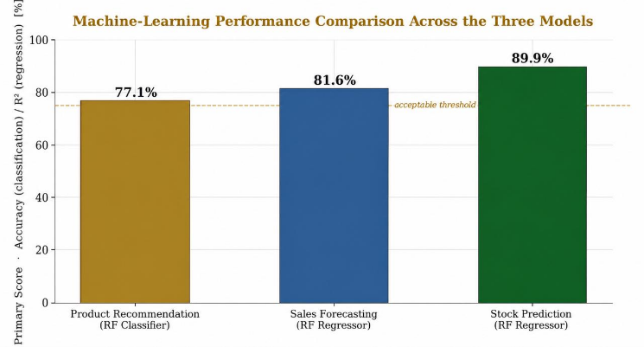
Fig 4 .Machine-learning performance
comparison across the three models.
VI. Results and Discussion
Table IV summarises the performance of the three models. The recommendation classifier attains 77.1% accuracy, 67% precision, 63% recall, and a 65% F1-score—roughly four of every five preference decisions correct, with a balanced precision–recall trade-off [1], [7]. As the model operates under cold-start conditions using only explicit style attributes, this confirms that attribute-driven classification is a viable strategy for boutique catalogues [2], [10], [16].
TABLE IV. Performance Metrics of the Three
Models
Model | Accuracy / R² | Precision | Recall | F1 | MAE | RMSE
Recommendation (RF Classifier) | 0.771 | 0.672 | 0.635 | 0.653 | — | —
Sales Forecast (RF Regressor) | 0.816 | — | — | — | 503.72 | 641.53
Stock Prediction (RF Regressor) | 0.899 | — | — | — | 0.96 | 1.44
The forecaster achieves R² = 0.816, explaining ~82% of daily revenue variance (MAE 503.72, RMSE 641.53), capturing weekly rhythm, festival spikes, and the growth trend while anchoring forecasts to the shop's real revenue scale [5], [6], [8]. The demand model is the strongest performer, with R² = 0.899, MAE below one unit (0.96), and RMSE 1.44—predicting per-product weekly demand to within roughly a single unit, which is directly actionable for reordering [8], [14].
Compared against a Linear Regression baseline under identical conditions (Table V), the Random Forest forecaster (0.816) clearly exceeds the linear model (0.769), and the demand model (0.899) substantially exceeds its counterpart (0.791), with lower MAE and RMSE [1], [8]. These margins confirm that the non-linear interactions among calendar, price, and seasonal features—captured by the tree ensemble but invisible to a linear model—are material to retail accuracy[1], [17].

TABLE V. Comparative Analysis: Random Forest
vs. Linear Regression
Ask / Model | R² | MAE | RMSE
Forecast – Random Forest | 0.816 | 503.72 | 641.53
Forecast – Linear Regression | 0.769 | 556.05 | 717.48
Stock – Random Forest | 0.899 | 0.96 | 1.44
Stock – Linear Regression | 0.791 | 1.41 | 2.06

The system's practical value lies in translating predictions into business intelligence [12], [13]. The dashboard consolidates key indicators—revenue, order volume, customers, average order value—with category and payment-mix breakdowns [12]. Revenue analytics separate growth from volatility; forecast analytics contrast recent actuals with projections to support cash-flow and purchasing; and inventory intelligence contrasts predicted demand with current stock to flag items needing reorder [12], [14]. The recommendation model further improves the customer experience by surfacing a few highly relevant, justified suggestions[2], [10]. Finally, by suppressing forecasts for shops without sufficient history and showing a transparent empty-state, the platform avoids acting on predictions extrapolated from non-existent data—a responsible-AI stance appropriate to decision support [13], [18].
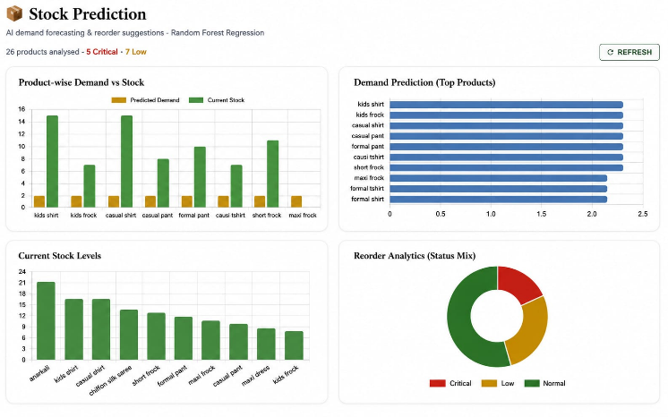
Fig. 5 . AI-Based Stock Prediction Using Random
Forest Regression
VII. Conclusion
This paper presented a machine-learning-driven retail analytics system unifying customer preference prediction, sales forecasting, and intelligent inventory management for small fashion retailers. Three Random Forest models—a preference classifier, a revenue forecaster, and a demand predictor—were trained, evaluated, and deployed as a cohesive decision-support platform, attaining 77.1% recommendation accuracy, R² = 0.816 for forecasting, and R² = 0.899 for demand prediction, each surpassing a Linear Regression baseline. Beyond accuracy, its principal contribution is the translation of model outputs into interpretable business intelligence delivered through an accessible, cloud-synchronised platform. The results show that ensemble learning offers a practical, low-cost route to enterprise-grade retail intelligence, and that responsible handling of data scarcity is essential to trustworthy deployment. Future work will incorporate behavioural signals to strengthen recommendation, explore gradient-boosted and probabilistic forecasting, couple demand prediction with formal inventory-optimisation policies, and add scheduled retraining to keep the models aligned with evolving preferences.
References:

[1] L. Breiman, "Random forests," Machine Learning, vol. 45, no. 1, pp. 5–32, 2001.

[2] F. Ricci, L. Rokach, and B. Shapira, Recommender Systems Handbook, 2nd ed. New York, NY, USA: Springer, 2015.

[3] G. Adomavicius and A. Tuzhilin, "Toward the next generation of recommender systems," IEEE Trans. Knowledge and Data Engineering, vol. 17, no. 6, pp. 734–749, 2005.

[4] T. Chen and C. Guestrin, "XGBoost: A scalable tree boosting system," in Proc. 22nd ACM SIGKDD Int. Conf. KDD, 2016, pp. 785–794.

[5] S. Makridakis, E. Spiliotis, and V. Assimakopoulos, "The M4 competition: Results, findings and way forward," Int. J. Forecasting, vol. 34, no. 4, pp. 802–808, 2018.

[6] R. J. Hyndman and G. Athanasopoulos, Forecasting: Principles and Practice, 3rd ed. Melbourne, Australia: OTexts, 2021.

[7] F. Pedregosa et al., "Scikit-learn: Machine learning in Python," J. Machine Learning Research, vol. 12, pp. 2825–2830, 2011.

[8] H. C. Pham and N. Ahmad, "Machine learning approaches for demand forecasting in retail: A review," Int. J. Production Economics, vol. 231, p. 107886, 2021.

[9] A. Gupta and R. Pathak, "Sales prediction for retail using ensemble learning techniques," in Proc. Int. Conf. Computing and Communication, 2020, pp. 1–6.

[10] C. C. Aggarwal, Recommender Systems: The Textbook. Cham, Switzerland: Springer, 2016.

[11] S. Chopra and P. Meindl, Supply Chain Management: Strategy, Planning, and Operation, 7th ed. Harlow, U.K.: Pearson, 2019.

[12] A. Krishnan and V. Ravi, "Business intelligence and analytics in retail: A systematic review," Decision Support Systems, vol. 145, p. 113537, 2021.

[13] D. Bertsimas and N. Kallus, "From predictive to prescriptive analytics," Management Science, vol. 66, no. 3, pp. 1025–1044, 2020.

[14] K. Bharathi and P. Sudha, "Inventory management using predictive analytics," Int. J. Advanced Computer Science and Applications, vol. 12, no. 5, pp. 210–217, 2021.

[15] B. Sarwar, G. Karypis, J. Konstan, and J. Riedl, "Item-based collaborative filtering recommendation algorithms," in Proc. 10th Int. Conf. World Wide Web (WWW), 2001, pp. 285–295.
16] X. He, L. Liao, H. Zhang, L. Nie, X. Hu, and T.-S. Chua, "Neural collaborative filtering," in Proc. 26th Int. Conf. World Wide Web (WWW), 2017, pp. 173–182.
[17] G. Ke et al., "LightGBM: A highly efficient gradient boosting decision tree," in Advances in Neural Information Processing Systems (NeurIPS), 2017, pp. 3146–3154.
[18] S. M. Lundberg and S.-I. Lee, "A unified approach to interpreting model predictions," in Advances in Neural Information Processing Systems (NeurIPS), 2017, pp. 4765–4774.
[19] R. Agrawal and R. Srikant, "Fast algorithms for mining association rules," in Proc. 20th Int. Conf. Very Large Data Bases (VLDB), 1994, pp. 487–499.
[20] G. Bontempi, S. Ben Taieb, and Y.-A. Le Borgne, "Machine learning strategies for time series forecasting," in Business Intelligence, Lecture Notes in Business Information Processing, vol. 138. Berlin, Germany: Springer, 2013, pp. 62–77.

