SOFTWARE TESTING & PLAYWRIGHT AUTOMATION
MODULE-END ASSIGNMENT 2
JavaScript – OOP, Inheritance, Modules & Debugging
Name: Nandhini G
Note: The questions are written in simple form, followed by the JavaScript statement/code, expected output, and a short explanation.

Task 1: Class, Object, Constructor and Method

Question: Create a TestResult class. Store the test name and status using a constructor. Create a showResult() method and display the results of Login Test and Checkout Test.
JavaScript Statement / Code:
class TestResult {
constructor(testName, status) {
this.testName = testName;
this.status = status;
}
showResult() {
console.log("Test Name:", this.testName);
console.log("Status:", this.status);
console.log("");
}
}
const login = new TestResult("Login Test", "Passed");
const checkout = new TestResult("Checkout Test", "Failed");
login.showResult();
checkout.showResult();
Expected Output:
Test Name: Login Test
Status: Passed
Test Name: Checkout Test
Status: Failed
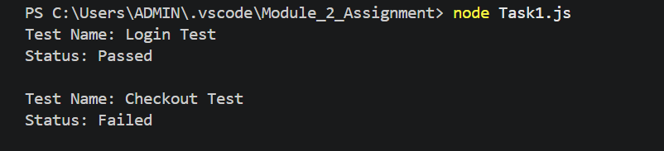

Explanation: The class stores the test name and status. The constructor sets the values. The showResult() method displays them. Two objects are created for two test cases.

Task 2: Inheritance and Method Overriding
Question: Create an Animal parent class with makeSound(). Create Dog and Cat child classes using extends. Override makeSound() and display each animal sound.
JavaScript Statement / Code:
class Animal {
makeSound() {
console.log("Animal makes a sound");
}
}
class Dog extends Animal {
makeSound() {
console.log("Dog says: Woof Woof");
}
}
class Cat extends Animal {
makeSound() {
console.log("Cat says: Meow Meow");
}
}
const dog = new Dog();
const cat = new Cat();
dog.makeSound();
cat.makeSound();
Expected Output:
Dog says: Woof Woof
Cat says: Meow Meow

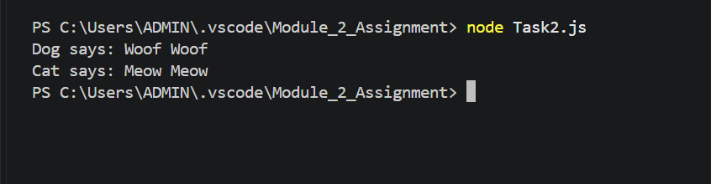

Explanation: Dog and Cat inherit from Animal using extends. Both child classes have their own makeSound() method. This is called method overriding.

Task 3: Private Property and Encapsulation
Question: Create an Employee class with public name and department properties and a private #salary property. Use a constructor and displaySalary() method.
JavaScript Statement / Code:
class Employee {
#salary;
constructor(name, department, salary) {
this.name = name;
this.department = department;
this.#salary = salary;
}
displaySalary() {
console.log("Salary:", this.#salary);
}
}
const employee = new Employee("Arun", "Automation", 45000);
console.log("Employee Name:", employee.name);
console.log("Department:", employee.department);
employee.displaySalary();
Expected Output:
Employee Name: Arun
Department: Automation
Salary: 45000
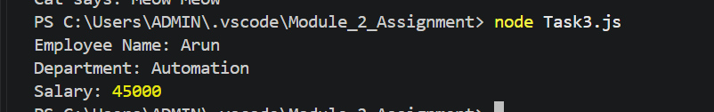

Explanation: Name and department are public properties. #salary is private and cannot be accessed directly outside the class. displaySalary() reads the private salary inside the class.

Task 4: JavaScript Modules – Export and Import
Question: : Create testData.js with a generateTestUser(name) function that returns the name in the format “Test User: name”. Export the function. In testRunner.js, import the function, call it with Arun, Meera and Rahul, and display the results.
JavaScript Code:
File 1: testData.js
export function generateTestUser(name) {
return "Test User: " + name;
}
File 2: testRunner.js
import { generateTestUser } from "./testData.js";
console.log(generateTestUser("Arun"));
console.log(generateTestUser("Meera"));
console.log(generateTestUser("Rahul"));
Expected Output:
Test User: Arun
Test User: Meera
Test User: Rahul
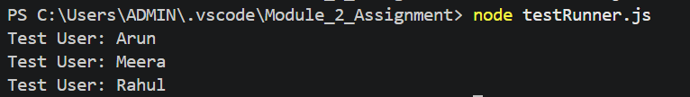
Explanation: testData.js contains and exports the reusable function. testRunner.js imports the function and calls it with three names. export and import allow code to be shared between files.

Task 5: Debugging a JavaScript Class
Question: Find and correct the property-name mismatch so the LoginTest program displays the username admin.
JavaScript Statement / Code:
class LoginTest {
constructor(username) {
this.username = username;
}
displayUser() {
console.log("Login User:", this.username);
}
}
const test = new LoginTest("admin");
test.displayUser();
Expected Output:
Login User: admin
Explanation: The original code saved the value as this.userName but tried to display this.username. JavaScript treats these as different names. Both places now use this.username.

