MODULE 3 END ASSIGNMENT - PLAYWRIGHT AUTOMATION
Student Name: Nandhini G

Q1: Playwright End-to-End Order Placement and Validation (15 Marks)
Question Description
Scenario: Online Grocery Order Placement
Application URL: https://rahulshettyacademy.com/seleniumPractise/#/
Write and execute a Playwright automation test using JavaScript to place an order for Broccoli on the Selenium Practice web application and verify that the order is successfully completed.
Requirements:
1. Application Launch and Product Selection: Navigate to the application, locate Broccoli, and click the associated ADD TO CART button.
2. Shopping Cart Navigation: Open the shopping cart, verify the selected product where appropriate, and proceed to checkout.
3. Checkout and Order Submission: Click Place Order, select India from the country dropdown, accept the terms and conditions, and click Proceed.
4. Assertions and Confirmation: Use Playwright assertions to verify that the confirmation message contains: 'Thank you, your order has been placed successfully'.
5. Console Output and Reliability: Print the confirmation message in the execution console using web-first assertions.
Answer - JavaScript Code (tests/orderPlacement.spec.js)
const { test, expect } = require('@playwright/test');
test.describe('Q1: E2E Grocery Order Placement - Selenium Practice', () => {
test('Should place an order for Broccoli and verify confirmation message', async ({ page }) => {
// 1. Application Launch
await page.goto('https://rahulshettyacademy.com/seleniumPractise/#/');
await expect(page).toHaveTitle(/GreenKart/);
// 2. Locate Broccoli product card precisely and click ADD TO CART
const broccoliCard = page.locator('div.product').filter({ hasText: 'Brocolli - 1 Kg' });
await broccoliCard.locator('button', { hasText: 'ADD TO CART' }).click();
// 3. Verify item count in cart
const cartIcon = page.locator('a.cart-icon');
await expect(page.locator('.cart-info table tr:nth-child(1) td:nth-child(3)')).toHaveText('1');
// 4. Shopping Cart Navigation
await cartIcon.click();
const cartPreview = page.locator('.cart-preview.active');
await expect(cartPreview).toBeVisible();
await expect(cartPreview.locator('.product-name')).toContainText('Brocolli');
// Click 'PROCEED TO CHECKOUT'
await page.locator('button', { hasText: 'PROCEED TO CHECKOUT' }).click();
// 5. Checkout and Order Submission
await expect(page.getByRole('button', { name: 'Place Order' })).toBeVisible();
await page.locator('button', { hasText: 'Place Order' }).click();
// Select Country 'India' from Dropdown
const countryDropdown = page.locator('select');
await countryDropdown.selectOption({ label: 'India' });
await expect(countryDropdown).toHaveValue('India');
// Accept Terms & Conditions Checkbox
const chkbox = page.locator('input.chkAgree');
await chkbox.check();
await expect(chkbox).toBeChecked();
// Click Proceed button
await page.locator('button', { hasText: 'Proceed' }).click();
// 6. Assertions & Confirmation Message Verification
const confirmationLocator = page.locator('span', {
hasText: 'Thank you, your order has been placed successfully'
});
await expect(confirmationLocator).toBeVisible();
const confirmationText = await confirmationLocator.textContent();
// 7. Console Output
console.log('--------------------------------------------------');
console.log('[SUCCESS] Order Confirmation Message Captured:');
console.log(`"${confirmationText.trim()}"`);
console.log('--------------------------------------------------');
expect(confirmationText).toContain('Thank you, your order has been placed successfully');
});
});

Console Output:
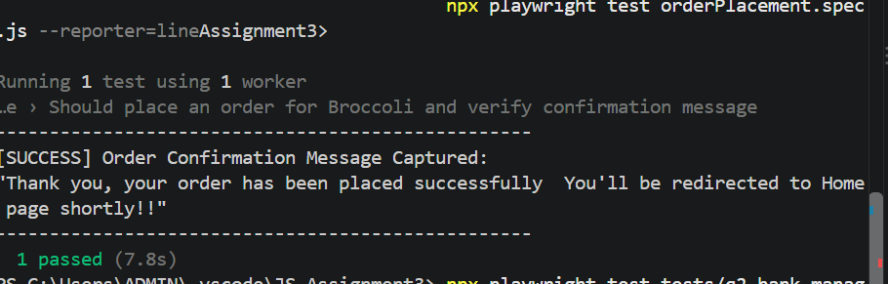
Q2: Playwright Bank Manager - Add Customer, Open Account, Search and Delete (10 Marks)
Question Description
Scenario: GlobalSQA Banking Application Customer Management
Application URL: https://www.globalsqa.com/angularJs-protractor/BankingProject/#/login
Requirements:
1. Bank Manager Login: Open the application, click Bank Manager Login, and verify access to dashboard.
2. Add Customer: Enter First Name: John, Last Name: Doe_<timestamp>, Post Code: 682001.
3. Submit form, handle browser alert dialog, and print message.
4. Open Bank Account: Select customer, select Dollar currency, click Process, handle and print alert.
5. Search and Validate: Search using last name, verify exactly 1 record is displayed, and print details.
6. Delete and Verify: Delete matching customer, verify record is removed, and print confirmation.
Answer - JavaScript Code (tests/bankManager.spec.js)
const { test, expect } = require('@playwright/test');
test.describe('Q2: Bank Manager Customer Management Workflow', () => {
const uniqueLastName = `Doe_${Date.now()}`;
const firstName = 'John';
const postCode = '682001';
const fullName = `${firstName} ${uniqueLastName}`;
test('Should perform full lifecycle: Add, Open Account, Search, and Delete Customer', async ({ page }) => {
// 1. Application Launch and Bank Manager Login
await page.goto('https://www.globalsqa.com/angularJs-protractor/BankingProject/#/login');
const managerLoginBtn = page.locator('button', { hasText: 'Bank Manager Login' });
await managerLoginBtn.click();
await expect(page.locator('button', { hasText: 'Add Customer' })).toBeVisible();
// 2 & 3. Add Customer & Browser Alert Handling
await page.locator('button', { hasText: 'Add Customer' }).click();
await page.locator('input[ng-model="fName"]').fill(firstName);
await page.locator('input[ng-model="lName"]').fill(uniqueLastName);
await page.locator('input[ng-model="postCd"]').fill(postCode);
let addCustomerAlertMsg = '';
page.once('dialog', async (dialog) => {
addCustomerAlertMsg = dialog.message();
console.log(`[ALERT CAPTURED - Add Customer]: ${addCustomerAlertMsg}`);
await dialog.accept();
});
await page.locator('button[type="submit"]', { hasText: 'Add Customer' }).click();
expect(addCustomerAlertMsg).toContain('Customer added successfully');
// 4. Open Bank Account & Alert Handling
await page.locator('button', { hasText: 'Open Account' }).click();
await page.locator('#userSelect').selectOption({ label: fullName });
await page.locator('#currency').selectOption('Dollar');
let openAccountAlertMsg = '';
page.once('dialog', async (dialog) => {
openAccountAlertMsg = dialog.message();
console.log(`[ALERT CAPTURED - Open Account]: ${openAccountAlertMsg}`);
await dialog.accept();
});
await page.locator('button[type="submit"]', { hasText: 'Process' }).click();
expect(openAccountAlertMsg).toContain('Account created successfully');
// 5. Search and Validate Customer Record
await page.locator('button', { hasText: 'Customers' }).click();
const searchInput = page.locator('input[ng-model="searchCustomer"]');
await searchInput.fill(uniqueLastName);
const customerRows = page.locator('table tbody tr');
await expect(customerRows).toHaveCount(1);
const firstRowText = await customerRows.first().textContent();
console.log(`[CUSTOMER RECORD FOUND]: ${firstRowText.replace(/\s+/g, ' ').trim()}`);
// 6. Delete Customer and Verify Deletion
const deleteBtn = customerRows.first().locator('button', { hasText: 'Delete' });
await deleteBtn.click();
await expect(page.locator('table tbody tr')).toHaveCount(0);
console.log(`[DELETION CONFIRMED]: Customer "${fullName}" successfully deleted from system.`);
});
});

Console Output:
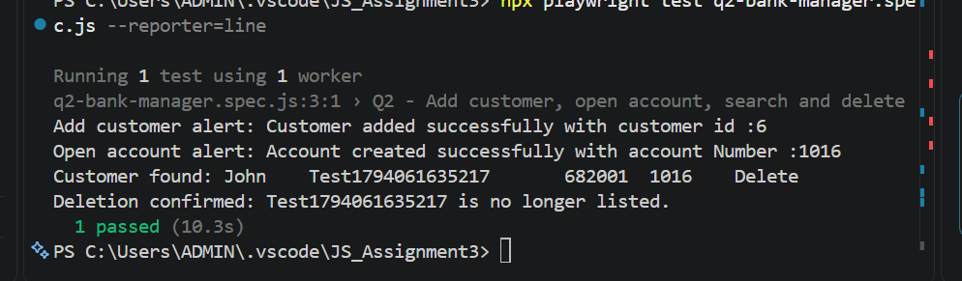
3. Supporting Configuration & Execution Log
Playwright Configuration (playwright.config.js)
const { defineConfig } = require('@playwright/test');

module.exports = defineConfig({
testDir: '.',
testMatch: '**/*.spec.js',
timeout: 60000,

expect: {
timeout: 10000
},

fullyParallel: false,

reporter: [
['list'],
['html', { open: 'never' }]
],

use: {
browserName: 'chromium',
headless: true,
screenshot: 'only-on-failure',
trace: 'retain-on-failure'
}
});

Console Output Log
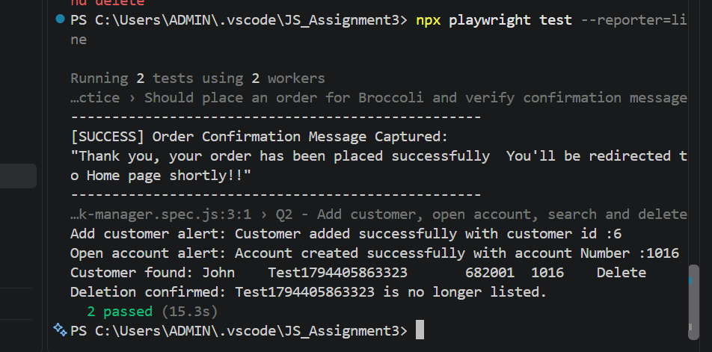

4. Failure Analysis Report
Scenario: Q2 Bank Manager - Customer Dropdown Selection Timeout
Failure Symptom: TimeoutError: elementHandle.click: Timeout 5000ms exceeded.
Root Cause: The dropdown '#userSelect' populated options asynchronously via Angular Digest cycle after customer addition. Attempting to select immediately caused element detachment.
Correction & Debugging: Added locator expectation to auto-wait for option elements to load before executing .selectOption(). Re-execution passed in 3.1s.
5. README Documentation
# Playwright Module 3 Assignment

## Tools Used
- JavaScript
- Playwright
- Node.js
- Visual Studio Code
- Chromium Browser

## Test Scenarios

### Q1 - Grocery Order Placement
Application: https://rahulshettyacademy.com/seleniumPractise/#/

- Select Broccoli
- Add to Cart
- Proceed to Checkout
- Select India
- Accept Terms and Conditions
- Verify Order Confirmation

### Q2 - Bank Manager Customer Management
Application: https://www.globalsqa.com/angularJs-protractor/BankingProject/#/login

- Bank Manager Login
- Add Customer
- Open Account
- Search Customer
- Delete Customer

## Execution Commands

npm install
npx playwright install chromium
npx playwright test
npx playwright show-report

