WEBSITE TRAFFIC ANALYSIS PHASE 3

# PHASE 3: DEVELOPMENT PART -1 IBM COGNOS

IBM Cognos is a powerful business intelligence and analytics platform developed by IBM. It's designed to help businesses and organizations make informed decisions by providing a comprehensive suite of tools for data visualization, reporting, dashboard creation, and more.

# STEP BY STEP PROCESS

STEP 1: Creating IBM Cognos Account

# We have created an IBM cognos account.

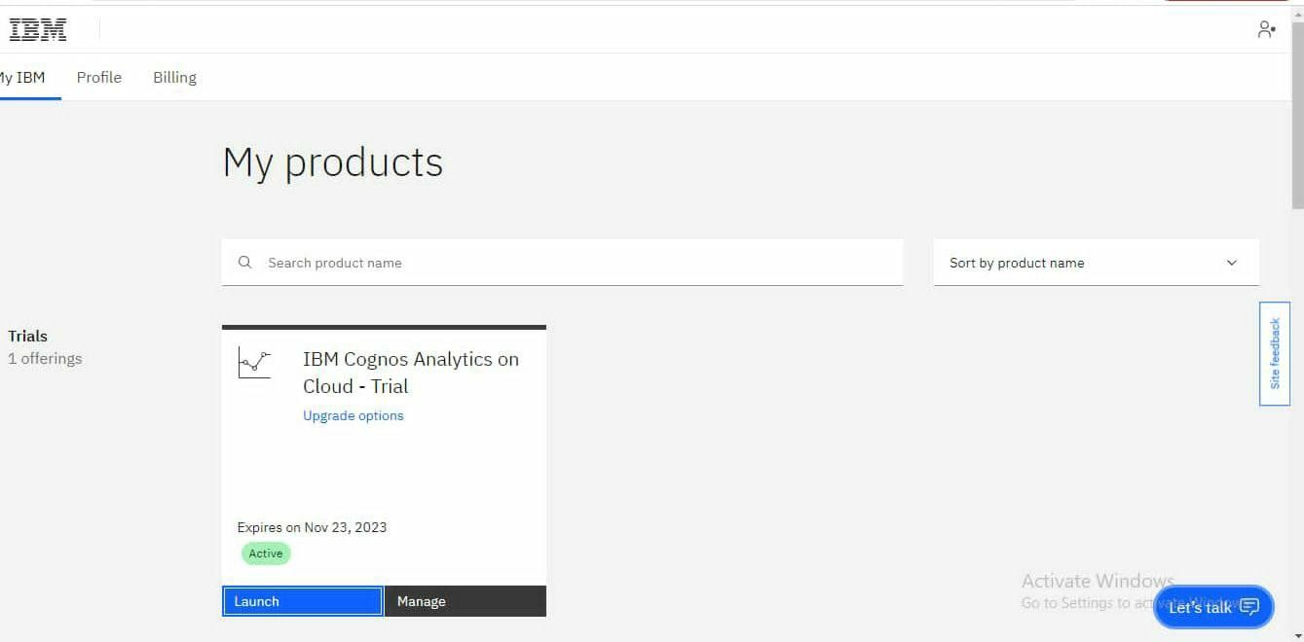

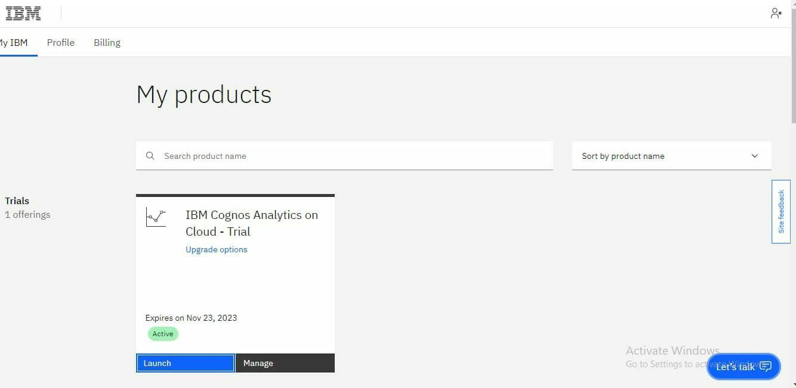

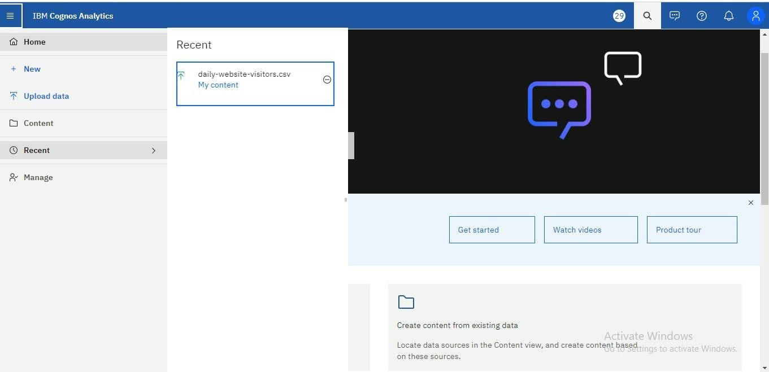

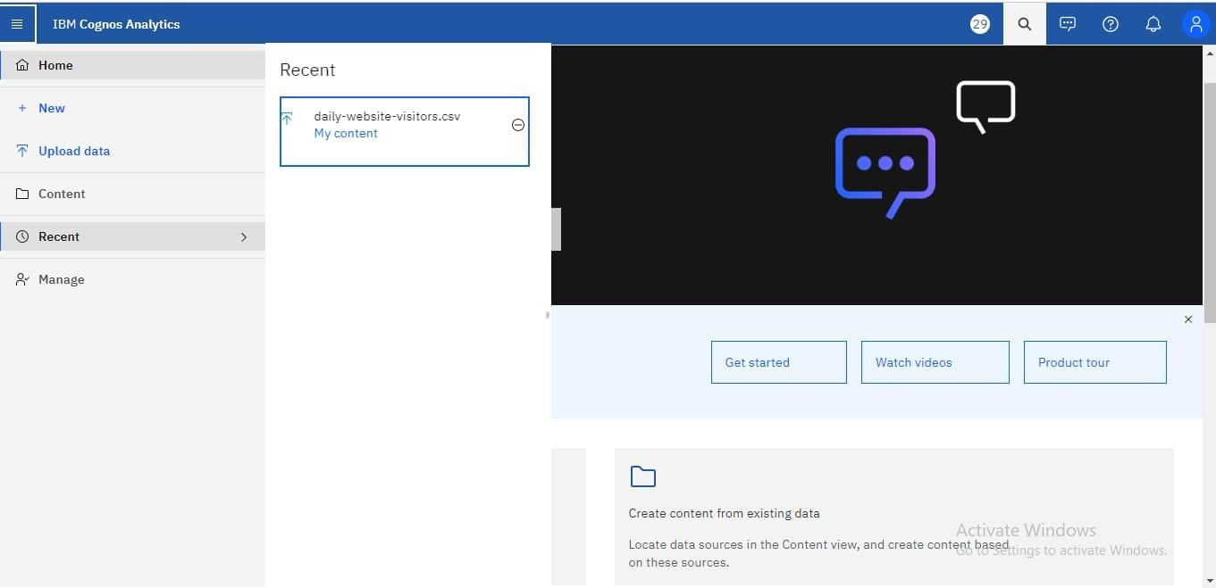

STEP 2: Virtualization

Creating the dashboard with dataset.



