Computer Vision Without Vision: Recognition Assistance for Visually Impaired in a Workplace

Paste the appropriate copyright/license statement here. ACM now supports three different publication options:

• ACM copyright: ACM holds the copyright on the work. This is the historical approach.

• License: The author(s) retain copyright, but ACM receives an exclusive publication license.

• Open Access: The author(s) wish to pay for the work to be open access. The additional fee must be paid to ACM.

This text field is large enough to hold the appropriate release statement assuming it is single-spaced in Verdana 7 point font. Please do not change the size of this text box.

Each submission will be assigned a unique DOI string to be included here.

# Abstract

Abhinandan Sampathkumar

asampath@iu.edu

Jaidev Yekkar Dinesh

jyekkard@iu.edu

Nandini Ramanan

nramanan@iu.edu

Vinita Boolchandani

vinitab@iu.edu

Indiana University

Bloomington, IN 47408, USA

Our prototype is an assistive application for visually impaired in workplace. Based on our initial study of literature, we came across several significant problems a visually impaired person faces in his/her environment, especially in workplace every day**.** Two of the most common problems were to identify people who are new in the workplace and the awkwardness experienced when the visually impaired person responds to another person who did not intend to address the visually impaired person. Our prototype resolves these two issues. It has a Mobile application to control the camera and a bone conduction device to give clear and concise audio feedback to the user who is visually impaired. The user clicks the button in the mobile application whenever he needs to capture the image of a person to be identified. The application will send the audio feedback through the bone conduction device with details of the person if the person is identified or an appropriate message otherwise. Thus, addressing the first problem of identifying a person of interest (POI). Our application also performs activity recognition if a person is using his phone and addresses the second problem of experiencing awkward situations.

# Author Keywords

Visually impaired; workplace; camera; bone conduction device; identifying POI, awkward situations.

# ACM Classification Keywords

H.5.m. Information interfaces and presentation (e.g., HCI): Miscellaneous;

# Introduction

World Health Organization estimates state that around 285 million people worldwide are visually impaired, of which 39 are blind and 246 have low vision or convergence issues [2]. It is estimated that there are 34 million students and 75 million employees who have visual disabilities in the whole wide world and these numbers are predicted to increase every year [7]. In case of visually impaired persons, they usually have a good sense of orientation only in their immediate neighborhood which includes the places they visit often but for the rest of the world, they highly seek assistance from someone around. The low rate of visually impaired people in work places or in schools, speaks for itself.

Based on our initial study of literature, we came across several significant problems a visually impaired person faces in his/her environment and the existing tools they use to help improve their everyday, some of which are mentioned here. Visually impaired people face a lot of social challenges, which leads to low self-esteem, especially in workplaces, where they cannot perform certain activities which others with vision can easily do. They have this constant pressure of proving equal to their sighted colleagues in the office. This disability of theirs has a great impact on the employment opportunities, where a lot of employers don’t want to hire them [4]. Most of the office work is still on papers and employers find it an extra burden to translate the formal papers into Braille as well as into audio / spoken media. Inside an office building where they meet a new person almost every day, challenges are even more. We believe that our solution which is encouraged by ubiquitous computing can help improve the perception of the surrounding reality for the visually impaired in a workplace setup. Same goes on with the visually impaired students in schools. These students have great difficulties meeting people outside school, for say sports or gaming, which certainly limits their interaction with the environment around them [5].

Based on expert advice we have narrowed down to the problem of identifying individuals in the office community and responding to the conversations that are directed towards. This problem is of great interest to us because it would help the visually impaired individual build good relationship with their peers, and at the same time build their confidence. This helps them initiate conversations with people in their surroundings, which according to us is a sign of a healthy community.



Figure 1: In this image, the first problem of identifying the person who is new to the office is visualized.

# Goals

# Our goal is to develop an assistive application for visually impaired in an office setup which should perform the following:

# Help identify people in office.

# Help avoid awkward situations, by informing them if a question was directed to them.

# Help user control the camera through mobile application.

# Provide Concise/ clear audio feedback to the user.

# Ensure privacy protocols are maintained in the application.



Figure 2: In this image, the second problem of experiencing awkward situation is visualized.

# Methodology

We began our work by listing the problems that visually impaired people face at their workplace. These included diverse scenarios that we thought were a major concern according to our initial research. This was followed by multiple brainstorming sessions that helped us to narrow down to two specific problem scenarios. These problem scenarios led us to several ideas that could be feasible solutions. We conducted four interviews, out of which, three were with the completely visually impaired people and one with the partially visually impaired person. We learnt about the problems faced by the visually impaired through our interviews. The most common problems were related to knowing who is approaching them, whether the person talking near the visually impaired is making a conversation to them or someone else and who are the people around them. An analysis was done for each idea against the feedback from our interviews with the target population which led to a refined needs assessment.

With the help of the experts and brainstorming we narrowed down the problem space to two most specific ideas of identifying individuals in the office community and responding to the conversations that are directed towards them. This problem is of great interest to us because it would help the visually impaired individual build good relationships with their peers, and at the same time build their confidence. An in-depth validation of these designs was done using storyboards and personae. Additionally, we conducted a survey to further refine and improvise designs. To summarize, based on the data we collected from the interviews and a survey, we clearly defined our problem space and finalized the design.

# Design

The design consists of a mobile app and a bone conduction headphone. The mobile app is used to capture the image of the person of interest and upload the image to the server. The image is discarded at the application level once it is uploaded to the server, hence addressing the privacy issue. The bone conduction headphone is used to hear the details of the person as a voice message.

**Mobile app:**

The mobile app has a button to capture image. The captured image will be displayed on the screen. The upload button will send the image to the server where the image matching algorithm is run.

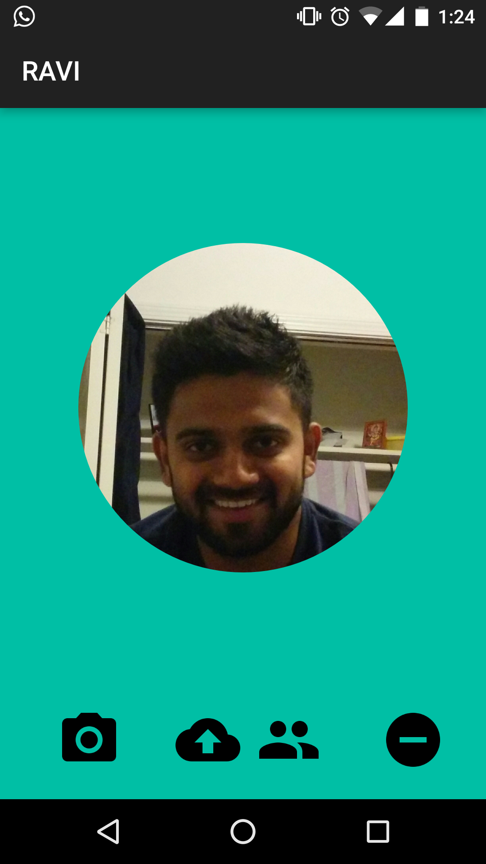

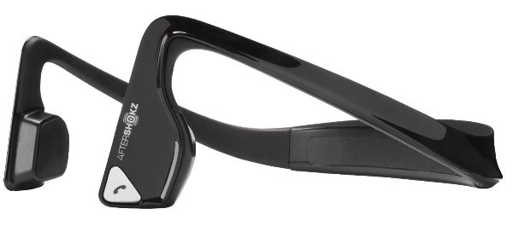

**Conclusion**

We made an attempt to help the visually impaired people at workplace in identifying the person of interest and avoid awkward situation by creating a prototype. Our prototype informs the visually impaired user about surrounding employees’ identity. It informs the user if a conversation is not directed to him/her and helps avoid awkward situations. It does not violate any privacy rights of people around the user as none of the captured images are stored. We do not overwhelm the user with too many details in the audio. We believe that our application would help the visually impaired individuals build good relationships with their peers, and at the same time build their confidence by helping them initiate conversations with people in their surroundings, thus resulting in a healthy community.

**Future Work**

We intend to incorporate emotion recognition into our application. The camera functionality is envisioned to be upgraded to perform a wide-angle image capture. Our prototype can be extended to give user feedback on how many people are in his sight at any instance. We also intend to incorporate gaze detection to identify if an individual is talking to the user.

**Acknowledgements**

We would like to thank Professor Kay Connelly for her valuable guidance and support through each phase, and Tousif Ahmed, our expert, who helped us narrow down to our problem statement and reach out to the target population.

# References

1. Ahmetovic, Dragan, et al. "NavCog: a navigational cognitive assistant for the blind." Proceedings of the 18th International Conference on Human-Computer Interaction with Mobile Devices and Services. ACM, 2016.
2. Visual impairment and blindness. (2017). [online] World Health Organization. Available at: http://www.who.int/mediacentre/factsheets/fs282/en/ [Accessed 17 Feb. 2017].
3. Asakawa, C. (2017). *How new technology helps blind people explore the world*. [online] Ted.com. Available at: https://www.ted.com/talks/chieko_asakawa_how_new_technology_helps_blind_people_explore_the_world [Accessed 17 Feb. 2017].
4. www.globalrepresentation.com, J. (2017). *What Problems Do People with Disabilities Have?* [online] Codi.tamucc.edu. Available at: http://codi.tamucc.edu/archives/computing/.making/.part2.htm [Accessed 17 Feb. 2017].
5. Beck, K. and Beck, K. (2010). *Challenges That Blind People Face*. [online] LIVESTRONG.COM. Available at: http://www.livestrong.com/article/241936-challenges-that-blind-people-face/ [Accessed 17 Feb. 2017].
6. The Challenges of Blind Internet Users. (2017). [online] Evengrounds.com. Available at: http://evengrounds.com/blog/challenges-of-blind-internet-users [Accessed 17 Feb. 2017].
7. Anon, (2017). [online] Gesta.org. Available at: http://www.gesta.org/estudos/statistics0402.pdf [Accessed 17 Feb. 2017].