* Sigmoid/Logit function [f(z)] = 1 / (1+ e ^ -z)
  + where e = Euler’s number ~ 2.71
  + Z is an integer
* 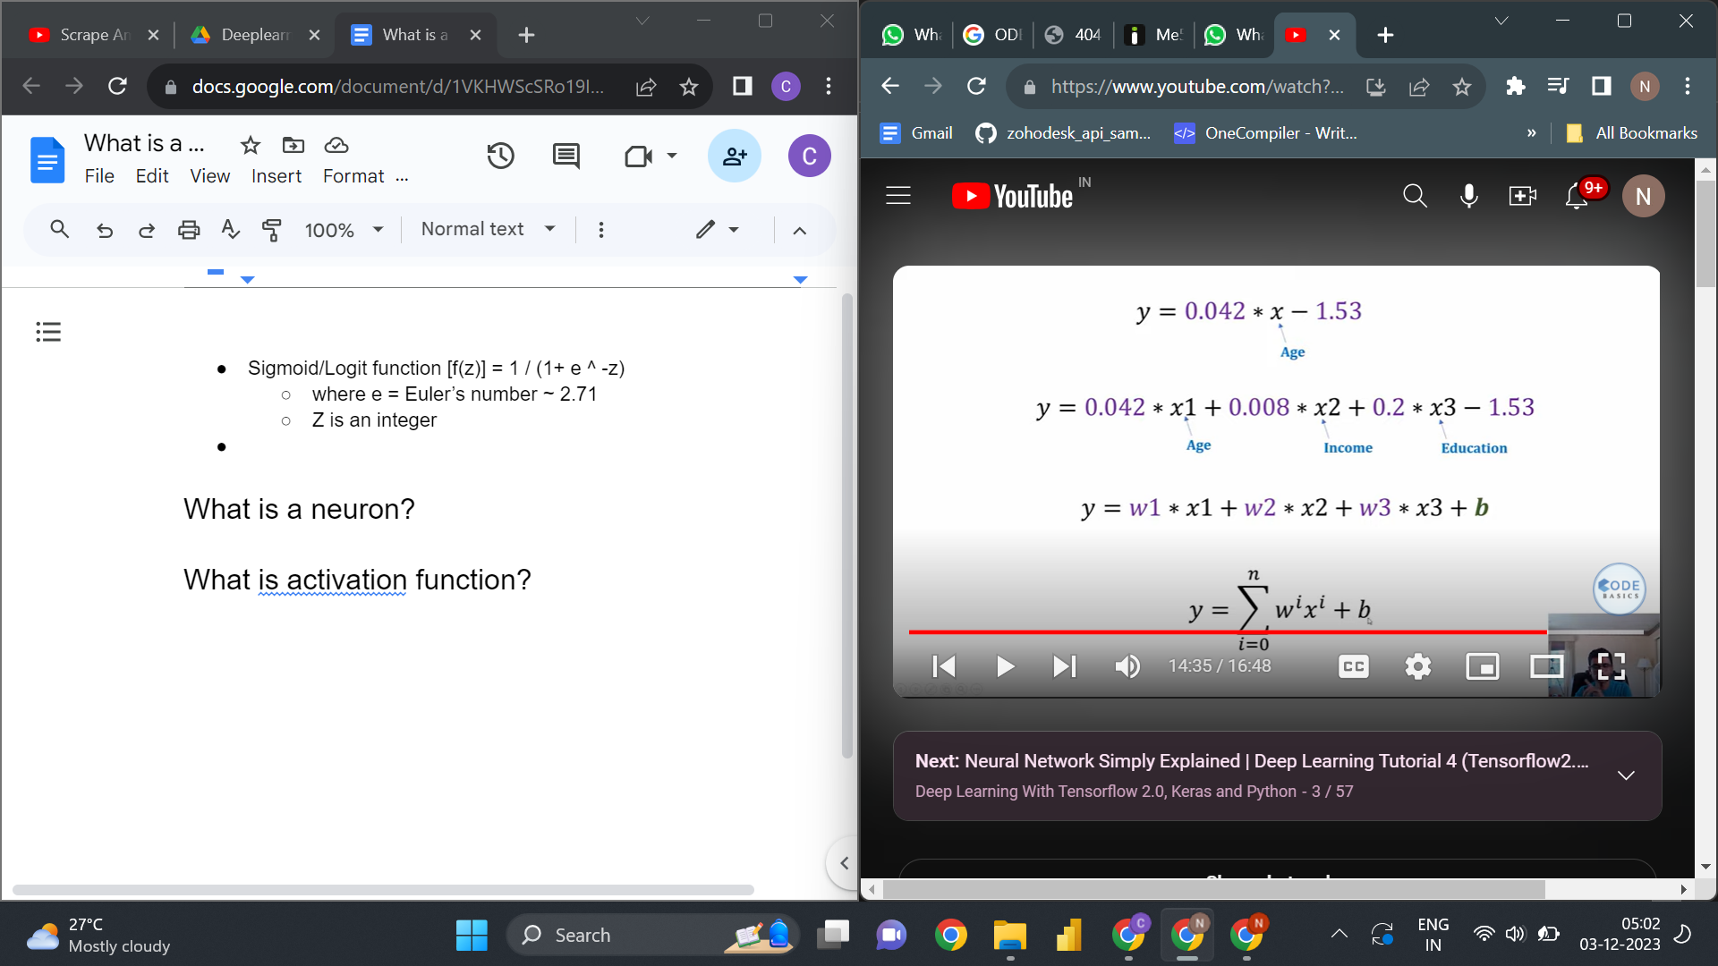
* The above image shows ML representation of Logistic Regression
* 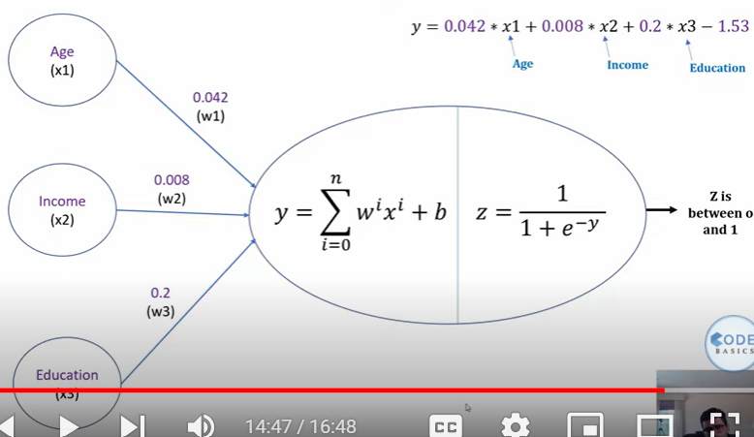
* The above image show Neural network representation
* Where z is sigmoid/Logit function that converts the value of ‘y’ between to 1
* And the sigmoid function acts as an activation function for the Logistic Regression

## What is a neuron?

## What is activation function?

## What is Neural Network?



## What is Backward Error Propagation?

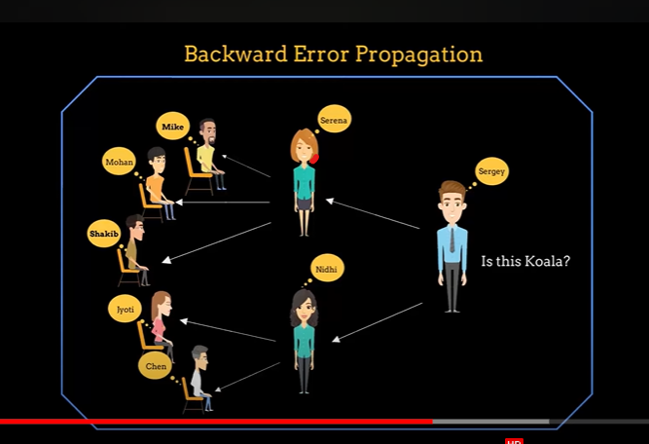

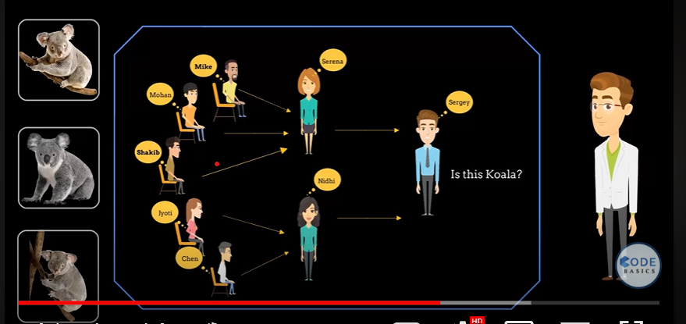

***Note: The most interesting part of neural networks is that each neuron knows what subtask they are working on and they train themselves efficiently with users intervention. In complex data set we do not which features to use but neural network will figure out what subtask they work on***