EcoPackAI – AI-Powered Sustainable Packaging Recommendation System

Module 5

Flask Backend API

Introduction
Module 5 focuses on the design and implementation of the backend layer of the AI Packaging Recommendation System using the Flask web framework. This module plays a critical role in transforming user inputs into intelligent, data-driven outputs by integrating machine learning models, environmental logic, and database operations.
The backend acts as the central decision-making engine of the system. It receives product details such as weight and fragility from the frontend, retrieves suitable packaging material data from the PostgreSQL database, applies AI-based prediction models, and computes sustainability metrics before returning well-structured JSON responses.
This module ensures that the system is scalable, modular, secure, and capable of real-world deployment.

Objectives of the Module
The primary objectives of Module 5 are:
- To design and implement RESTful APIs using Flask
- To accept and validate product input data from users
- To generate AI-based packaging material recommendations
- To compute environmental sustainability scores
- To establish connectivity with a PostgreSQL database
- To return structured JSON responses
- To follow secure and scalable backend development practices

Technologies Used
Component | Technology
Backend Framework | Flask (Python)
Database | PostgreSQL
Database Access | SQLAlchemy
Machine Learning | Random Forest, XGBoost
Model Loading | Joblib
Data Format | JSON
Frontend Integration | HTML, CSS, JavaScript

Backend Architecture Overview
The backend architecture of this module follows a layered and modular approach to ensure maintainability and scalability.

API Layer
This layer is implemented using Flask routes. It handles incoming HTTP requests, validates input data, and returns appropriate HTTP responses in JSON format.

Business Logic Layer
This layer applies domain-specific logic such as:
- Comparing product weight with material weight capacity
- Matching product fragility with material strength
- Applying penalties for unsuitable material-product combinations

Machine Learning Layer
This layer integrates trained machine learning models to:
- Predict packaging cost using a Random Forest model
- Predict CO₂ emissions using an XGBoost model

Database Layer
This layer communicates with the PostgreSQL database using SQLAlchemy to fetch material properties required for prediction and scoring.

Response Layer
This layer formats the final output into clean, consistent JSON responses suitable for frontend consumption.

Flask Application Setup
The Flask application is initialized with template and static folder configurations to support frontend integration. The root route (/) serves the main user interface.

Database Integration
The Flask backend is connected to a PostgreSQL database using SQLAlchemy, which provides a secure and efficient way to execute SQL queries.

Database Table
The primary table used in this module is target_material_data. Each row in this table represents a packaging material with multiple attributes.

Stored Attributes
The table contains the following important fields:
- Weight capacity of the material
- Structural strength of the material
- Biodegradability score
- Recyclability score
- One-hot encoded material type columns

Purpose of Database Integration
The database acts as the knowledge base of the system. All AI predictions and environmental evaluations depend on accurate and well-structured material data stored in this table.

Machine Learning Model Integration
Two pre-trained machine learning models are loaded during application startup:
- Random Forest Model – Predicts packaging cost
- XGBoost Model – Predicts CO₂ emissions
These models use engineered numerical features derived from both material properties and user inputs.

Feature Engineering
The feature engineering process converts raw database values and user inputs into a structured numerical format compatible with the trained models. This ensures consistency between training and inference phases.

API Endpoints Description
This module exposes RESTful APIs that directly implement the business logic defined in the Flask backend code. The logic combines rule-based calculations with machine learning predictions to produce accurate and environmentally responsible recommendations.

Material Recommendation API (/recommend)
- HTTP Method: POST
- Purpose: Recommend the top 10 most suitable packaging materials based on product requirements, cost efficiency, and environmental impact.

Input Handling Logic
The API accepts the following inputs from the frontend:
- Weight (kg): Physical weight of the product
- Fragility (1–5): Sensitivity of the product to damage
These inputs define the constraints that packaging materials must satisfy.

Database Interaction Logic
- All records are fetched from the target_material_data table in PostgreSQL.
- Each record represents a candidate packaging material with physical, economic, and environmental attributes.

Capacity vs Weight Logic
- If the product weight exceeds the material’s weight capacity, the material becomes less suitable.
Formula Used:
Capacity Ratio = Product Weight / Material Capacity
Capacity Penalty = max(0, Capacity Ratio − 1)
This penalty increases cost and CO₂ impact for materials that cannot safely support the product.

Fragility vs Strength Logic
- Fragile products require materials with higher structural strength.
Formula Used:
Strength Requirement = Fragility / 5
Strength Penalty = max(0, Strength Requirement − (Material Strength / 5))
Materials with insufficient strength receive a penalty.

Effective Feature Adjustment Logic
To reflect real-world behavior, penalties are injected into the feature set:
- Effective Weight = Weight × (1 + Capacity Penalty)
- Effective Fragility = Fragility × (1 + Strength Penalty)
These adjusted values ensure that the ML models account for physical mismatches.

Machine Learning Prediction Logic
- A Random Forest model predicts packaging cost.
- An XGBoost model predicts CO₂ emissions.
Raw predictions are adjusted using the calculated penalties:
- Adjusted Cost = Cost × (1 + Capacity Penalty + Strength Penalty)
- Adjusted CO₂ = CO₂ × (1 + Capacity Penalty)
Predicted values are scaled to real-world units:
- Cost → Indian Rupees (₹)
- CO₂ → Percentage (%)

Material Ranking Logic
A combined score is calculated to rank materials:
Final Score Formula:
Score = (0.6 × Adjusted CO₂) + (0.4 × Adjusted Cost)
Lower scores indicate better material suitability.

Response Logic
- Materials are sorted based on the final score.
- The top 10 materials are returned as a JSON response containing:
  - Material type
  - Predicted cost (₹)
  - CO₂ impact (%)
  - Overall ranking score

Environmental Score API (/environment-score)
- HTTP Method: POST
- Purpose: Evaluate the environmental sustainability of packaging materials based on product constraints.

Input Handling Logic
- Accepts product weight and fragility from the frontend.

Penalty Computation Logic
- Capacity and strength penalties are computed using the same logic as the recommendation API.

Dynamic Eco Adjustment Logic
Environmental properties are dynamically adjusted:
- Biodegradability decreases with capacity penalty
- Recyclability decreases with strength penalty
Eco Penalty Formula:
Eco Penalty = (0.6 × Capacity Penalty) + (0.4 × Strength Penalty)

CO₂ Impact Index Logic
Effective product conditions are recalculated:
- Effective Weight = Weight × (1 + Capacity Penalty)
- Effective Fragility = Fragility × (1 + Strength Penalty)
CO₂ percentage is computed using weighted normalization and capped at 100%.

Material Suitability Logic
- Eco benefit is calculated using biodegradability and recyclability.
- CO₂ impact index is adjusted using eco benefit.
Material Suitability Score:
Material Suitability = 100 − CO₂ Impact Index
Higher values indicate more environmentally sustainable materials.

Response Logic
- Materials are sorted in descending order of suitability score.
- The best-performing material is returned as a JSON response.

JSON Response Structure
All API responses follow a standardized JSON format for consistency and frontend compatibility:
- Clear key naming
- Rounded numerical values for readability
- HTTP status codes for error handling

Security and Validation
- Input values are type-validated to ensure correctness
- SQLAlchemy prevents SQL injection attacks
- Backend logic is isolated from the frontend
- Debug mode is enabled only for development purposes

Scalability and Future Enhancements
The backend design supports future improvements such as:
- User authentication and authorization
- Role-based access control
- API rate limiting
- Docker-based deployment
- Cloud hosting and CI/CD integration

System Architecture:
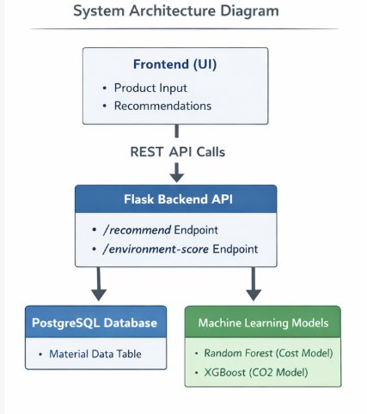

Data Flow Diagram:
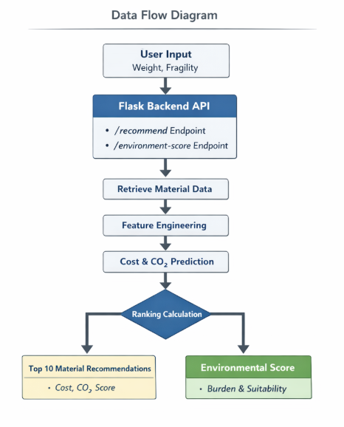

Conclusion
Module 5 delivers a comprehensive and intelligent Flask-based backend system that successfully integrates artificial intelligence, database management, and environmental sustainability logic. By combining machine learning predictions with real-world material constraints, the module provides accurate, reliable, and environmentally responsible packaging recommendations.
This backend module serves as the core intelligence layer of the AI Packaging Recommendation System and lays a strong foundation for future enhancements such as authentication, cloud deployment, and large-scale industrial adoption.

