EcoPackAI – AI-Powered Sustainable Packaging Recommendation System

Module 6

Frontend UI Development

Introduction
Module 6 focuses on the design and implementation of the Frontend User Interface (UI) for the AI Packaging Recommendation System. This module provides an interactive, user-friendly web interface that allows users to input product parameters and view AI-generated material recommendations along with environmental impact metrics.
The frontend acts as the communication layer between the user and the Flask backend APIs, ensuring smooth data flow, real-time updates, and clear visualization of results.

Objectives of Module 6
The main objectives of this module are:
- To build a responsive and intuitive user interface
- To collect product input parameters from users
- To communicate with Flask REST APIs
- To display AI-based material recommendations
- To present ranking and comparison metrics clearly
- To enhance user experience using Bootstrap styling

Technologies Used

Component | Technology
Markup Language | HTML5
Styling | CSS3
UI Framework | Bootstrap 5
Client-side Logic | JavaScript (Fetch API)
Backend Integration | Flask REST APIs

Frontend Architecture Overview
The frontend follows a simple and modular structure:
- Input Section – Collects product details from the user
- Recommendation Display Section – Shows AI-recommended materials
- Environmental Score Section – Displays sustainability metrics
- JavaScript Logic Layer – Handles API communication and DOM updates

User Interface Design

Page Layout
The UI is built using Bootstrap’s grid system to ensure:
- Responsive design across devices
- Clean alignment and spacing
- Consistent visual appearance
The main page includes:
- Page title
- Product input form
- Recommendation table
- Environmental score card

Product Input Form
The input form allows users to enter the following product parameters:
- Product Category – Text input for product type
- Weight (kg) – Numeric input with decimal support
- Fragility (1–5) – Numeric input defining product sensitivity
Form validation is handled using HTML attributes such as required, min, and max to prevent invalid input submission.

Backend API Integration
The frontend communicates with the Flask backend using the Fetch API and JSON payloads.

Material Recommendation API Integration
- Endpoint: /recommend
- Method: POST

Logic Flow:
- Collect input values from the form
- Convert input data into JSON format
- Send request to the recommendation API
- Receive AI-generated material recommendations
- Dynamically populate the recommendation table
Each recommendation includes:
- Rank
- Material name
- Predicted cost (₹)
- CO₂ impact (%)

Environmental Score API Integration
- Endpoint: /environment-score
- Method: POST

Logic Flow:
- Reuse weight and fragility inputs
- Send request to environmental score API
- Receive sustainability metrics
- Display results in a dedicated score card
Displayed metrics include:
- Biodegradability percentage
- Recyclability percentage
- CO₂ impact index
- Material suitability score

Dynamic Content Rendering
JavaScript is used to dynamically update the webpage without reloading:
- Recommendation table rows are generated at runtime
- Environmental score values are updated in real-time
- UI sections are shown or hidden using Bootstrap utility classes
This ensures a smooth and interactive user experience.

Error Handling and User Feedback
- Network or backend errors are logged in the browser console
- Users are notified using alert messages in case of failures
- Default placeholders are shown when no data is available

UI Styling and Responsiveness
- Bootstrap cards and tables provide a clean visual structure
- Shadows and spacing enhance readability
- Responsive grid layout ensures compatibility with different screen sizes

Security and Input Validation
- Client-side validation prevents invalid inputs
- JSON-based communication ensures data consistency
- Backend handles final validation and security checks

Scalability and Enhancements
The frontend design allows future enhancements such as:
- Dropdown-based product categories
- Charts for visual comparison
- User authentication and profiles
- Theme customization

Screenshot of UI

Initially:
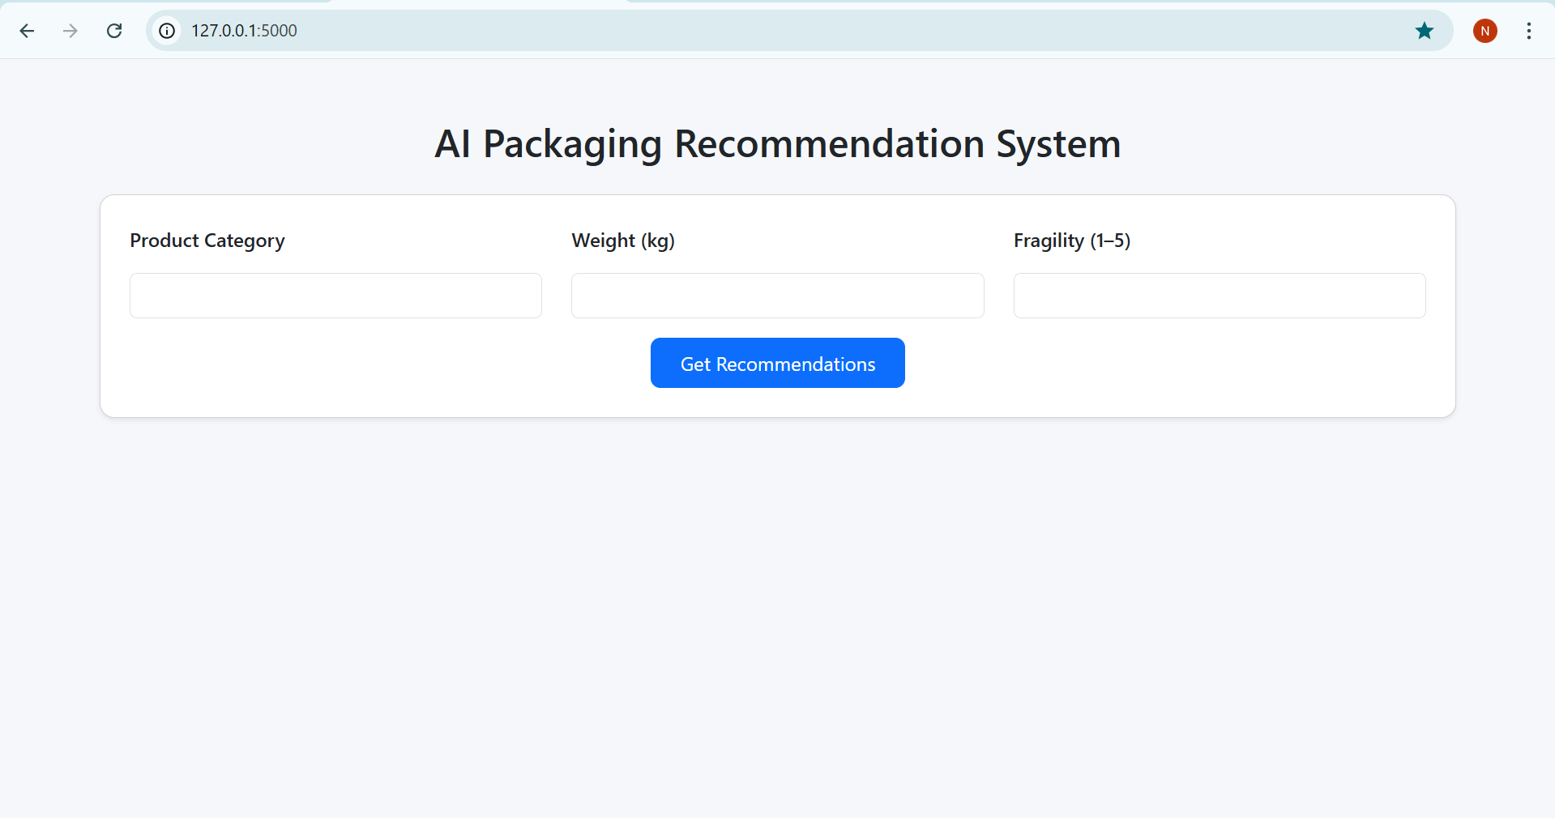

After the recommendation button is clicked

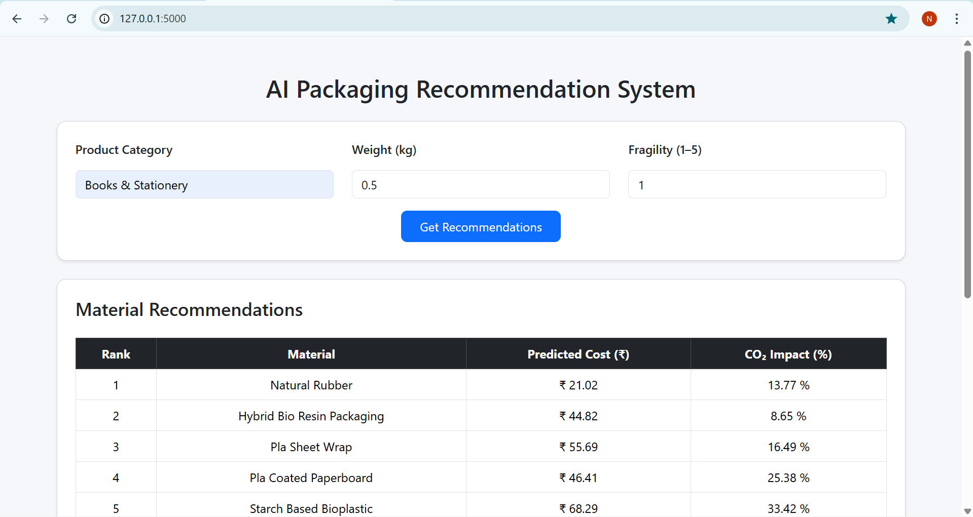

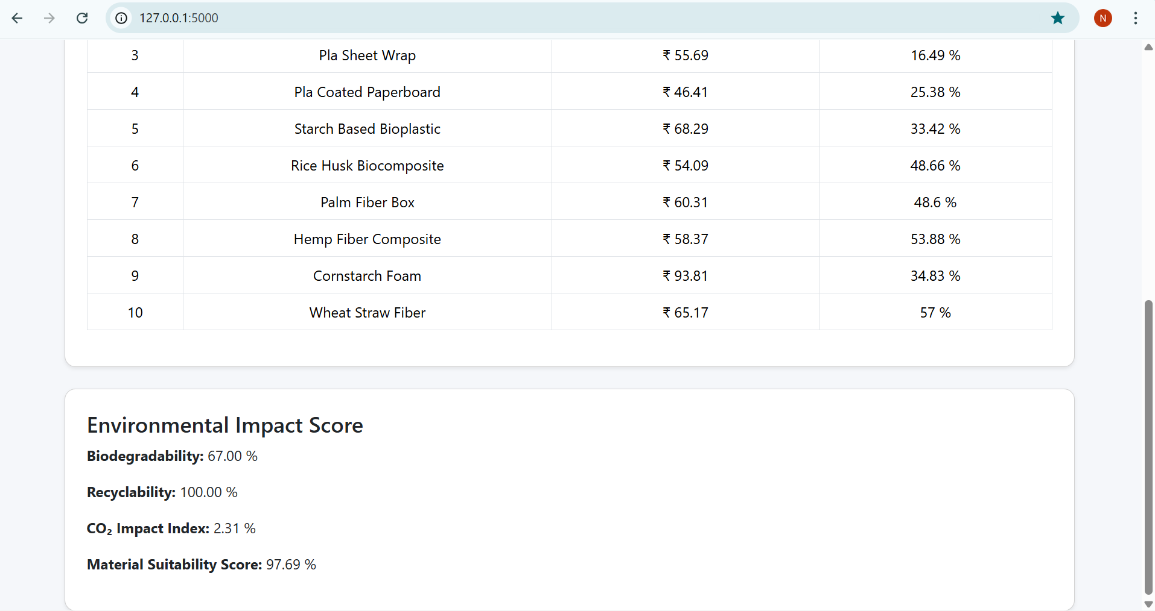

Conclusion
Module 6 successfully delivers a clean, responsive, and interactive frontend interface for the AI Packaging Recommendation System. By effectively integrating with Flask backend APIs, this module enables users to obtain intelligent packaging recommendations and environmental insights in a simple and intuitive manner.
The frontend plays a crucial role in improving usability and making AI-driven decisions accessible to end users.

