(6115)-MAHENDRA INSTITUTE OF ENGINEERING AND TECHNOLOGY

PUBLIC TRANSPORTATION OPTIMIZATION

PHASE: 3

* **introduction:**

Public transportation optimization refers to the process of improving the efficiency, reliability, and effectiveness of public transportation systems. This involves utilizing various strategies, technologies, and data analysis to enhance the overall performance of public transit services. The goal is to ensure that public transportation meets the demands of the population while minimizing costs, reducing congestion, and promoting sustainability.

* Scheduling Optimization
* Resource Allocation and Management
* Fare Optimization and Revenue Management
* Passenger Experience Enhancement
* Integration and Intermodality
* Environmental Sustainability

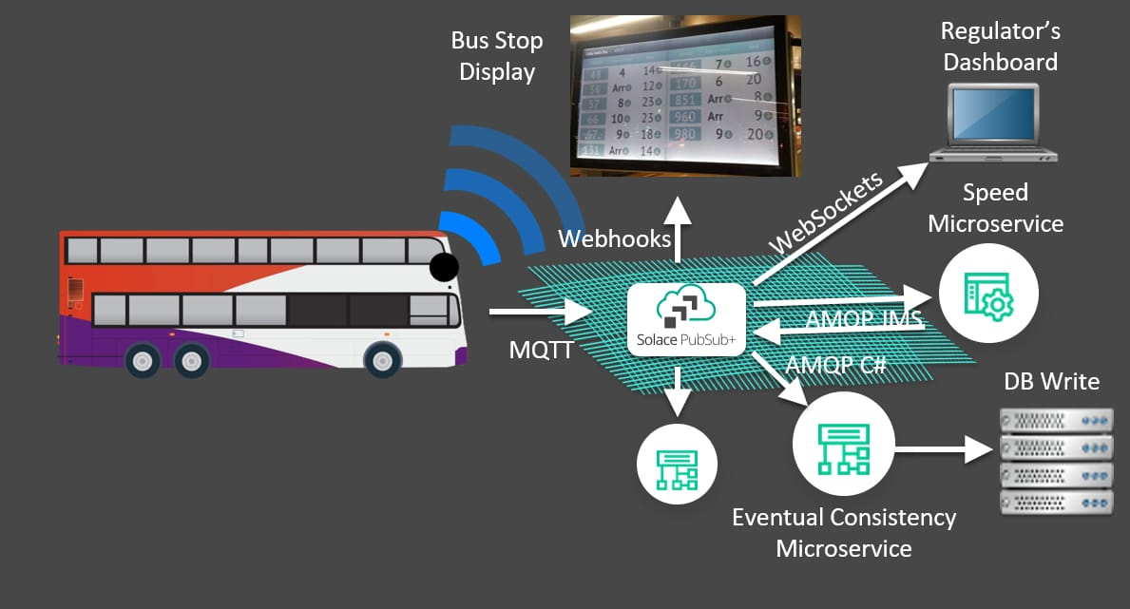

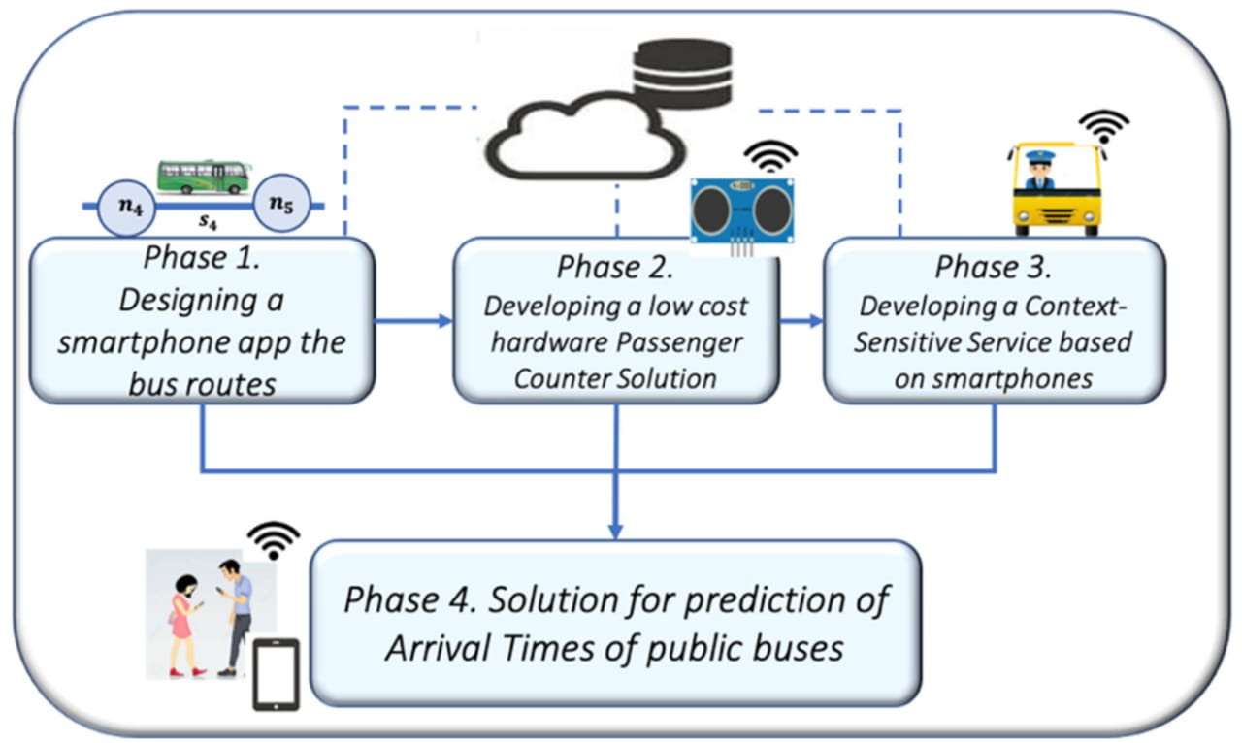

* **Installation:**

**Arduino IDE 1 Installation (Windows)**

This document explains how to install the Arduino Software (IDE) on Windows machines.

* **Download the Arduino Software (IDE)**

Get the latest version from the [download page](https://www.arduino.cc/en/Main/Software). You can choose between the Installer (.exe) and the Zip packages. We suggest you use the first one that installs directly everything you need to use the Arduino Software (IDE), including the drivers. With the Zip package you need to install the drivers manually. The Zip file is also useful if you want to create a [portable installation](https://arduino.cc/en/Guide/PortableIDE).

When the download finishes, proceed with the installation and please allow the driver installation process when you get a warning from the operating system.

[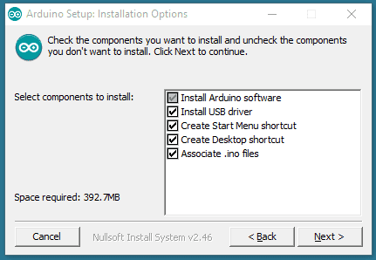](https://docs.arduino.cc/static/33f20406f68c5707052471d78a90a5c6/9cb4e/DRV_Capture1.png)

Choose the components to install.

[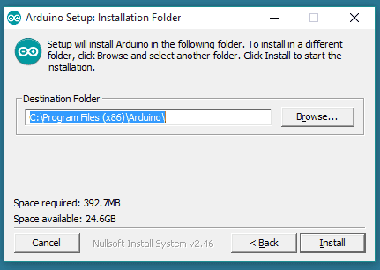](https://docs.arduino.cc/static/12311f50263afe3f12349d932fdeb3f5/9cb4e/DRV_Capture2.png)

Choose the installation directory.

[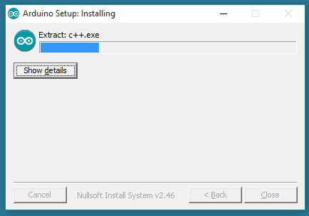](https://docs.arduino.cc/static/02501558f5cba4564376f0bb8adfcf01/ade6e/DRV_Capture3.png)

Installation in progress.

* **SENSORS:**

**1.ULTRASONIC SENSORS**

**2.GPS**

**3.IR PHOTO DIODE(IR LASER)**

**4.LED TV**

**5.ESP 32**

**6.ARDUINO BOARD**

* **PLANING:**

**1. Define Objectives: Determine the specific goals of optimization, such as reducing congestion, improving efficiency, or increasing ridership.**

**2. Data Collection: Gather data on current routes, schedules, ridership, and other relevant factors. This data will serve as the foundation for your optimization efforts.**

**3. Stakeholder Engagement: Involve relevant stakeholders, including transportation authorities, passengers, and local communities, to understand their needs and concerns.**

**4. Technology: Consider using transportation management software and data analytics tools to process and analyze the collected data.**

**5. Route Planning: Utilize optimization algorithms to design more efficient routes and schedules based on demand and resource constraints.**

**6. Pricing and Fare Structure: Optimize ticket pricing and fare structures to encourage ridership and cover operating costs.**

**7. Sustainability: Integrate eco-friendly options, like electric buses or cycling lanes, to promote sustainability and reduce emissions.**

**8. Monitoring and Adjustments: Continuously monitor performance and gather feedback to make necessary adjustments and improvements to the system.**

**9. Public Communication: Keep passengers and the public informed about changes and improvements in the public transportation system.**

**10. Simulation and Testing: Simulate the proposed changes to ensure they meet your optimization objectives without causing negative impacts.**

* ***EXECUTION :***

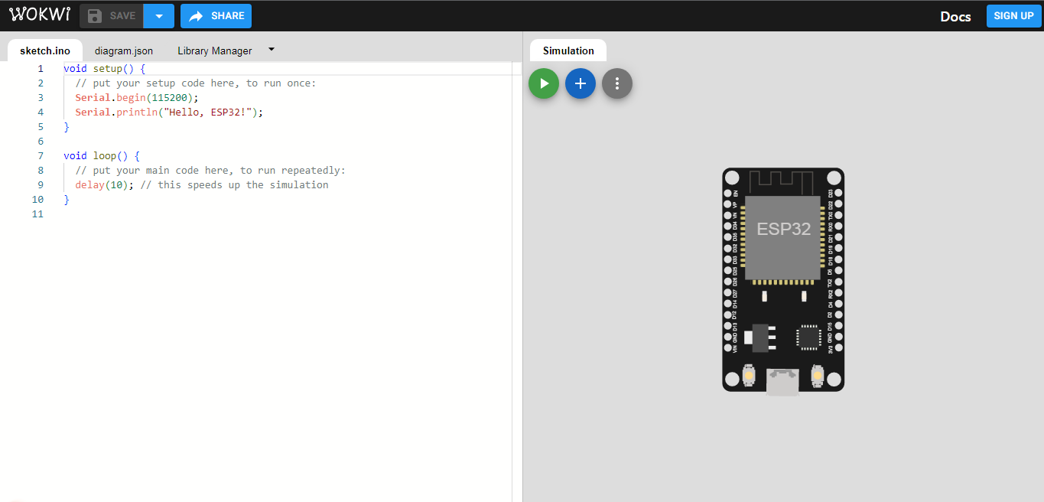

***Controlling:***

1. ***Route Planning and Scheduling Software: Utilizing software to plan the most efficient routes, schedules, and stops for buses, trams, or trains.***
2. ***Real-Time Tracking and GPS: Implementing GPS and real-time tracking systems to monitor vehicle locations and adjust routes dynamically.***
3. ***Passenger Information Systems: Providing real-time information to passengers through apps, websites, or digital displays at stations.***
4. ***Fare Collection and Payment Systems: Managing electronic ticketing, contactless payment, and fare collection systems.***
5. ***Maintenance and Fleet Management: Using software to schedule and track maintenance of vehicles and infrastructure.***
6. ***Traffic Management and Signal Priority: Coordinating with traffic signals to give public transport vehicles priority at intersections.***
7. ***Data Analytics and Predictive Maintenance: Analyzing data to predict maintenance needs, optimize routes, and improve overall efficiency.***
8. ***Demand-Responsive Transportation: Implementing on-demand services that adapt to passenger requests using software algorithms.***

***9.Integration with Other Modes of Transportation: Ensuring seamless connections with other forms of transit, like bike-sharing or ride-sharing.***

***10. Emergency and Incident Management:***

***Using software to respond to incidents and adjust services during emergencies or disruptions.***

***\*\*\*THANK YOU\*\*\****