***MAHENDRA INSTITUE OF ENGINEERING AND TECHNOLOGY-(6115)***

# Project Title: *Public Transport Optimization*

**Project Implementation:**

Public transportation optimization refers to the process of improving the efficiency, reliability, and effectiveness of public transportation systems. This involves utilizing various strategies, technologies, and data analysis to enhance the overall performance of public transit services. The goal is to ensure that public transportation meets the demands of the population while minimizing costs, reducing congestion, and promoting sustainability.

* Scheduling Optimization
* Resource Allocation and Management
* Fare Optimization and Revenue Management
* Passenger Experience Enhancement
* Integration and Intermodality
* Environmental Sustainability

**Features Of Engineering:**

1. Define Objectives: Determine the specific goals of optimization, such as reducing congestion, improving efficiency, or increasing ridership.

2. Data Collection: Gather data on current routes, schedules, ridership, and other relevant factors. This data will serve as the foundation for your optimization efforts.

3. Stakeholder Engagement: Involve relevant stakeholders, including transportation authorities, passengers, and local communities, to understand their needs and concerns.

4. Technology: Consider using transportation management software and data analytics tools to process and analyze the collected data.

5. Route Planning: Utilize optimization algorithms to design more efficient routes and schedules based on demand and resource constraints.

6. Pricing and Fare Structure: Optimize ticket pricing and fare structures to encourage ridership and cover operating costs.

7. Sustainability: Integrate eco-friendly options, like electric buses or cycling lanes, to promote sustainability and reduce emissions.

8. Monitoring and Adjustments: Continuously monitor performance and gather feedback to make necessary adjustments and improvements to the system.

9. Public Communication: Keep passengers and the public informed about changes and improvements in the public transportation system.

10. Simulation and Testing: Simulate the proposed changes to ensure they meet your optimization objectives without causing negative impacts.

**SENSORS:**

**1.ULTRASONIC SENSORS**

**2.GPS**

**3.IR PHOTO DIODE(IR LASER)**

**4.LED TV**

**5.ESP 32**

**6.ARDUINO BOARD**

**Model Training:**

Due to short period of time for the projects our team has prepared limited dataset are model to training the dataset for the implementation of Public transport optimization.

**Data set:**

{

  "version": 1,

  "author": "MANOJ S",

  "editor": "wokwi",

  "parts": [

    { "type": "wokwi-esp32-devkit-v1", "id": "esp", "top": -12.8, "left": 180.8, "attrs": {} },

    {

      "type": "wokwi-hc-sr04",

      "id": "ultrasonic1",

      "top": -31.94,

      "left": -1.1,

      "attrs": { "distance": "240" }

    },

    {

      "type": "wokwi-hc-sr04",

      "id": "ultrasonic2",

      "top": -32.14,

      "left": -184.37,

      "attrs": { "distance": "104" }

    },

    {

      "type": "wokwi-led",

      "id": "led1",

      "top": 196.6,

      "left": 95.24,

      "attrs": { "color": "red" }

    }

  ],

  "connections": [

    [ "esp:TX0", "$serialMonitor:RX", "", [] ],

    [ "esp:RX0", "$serialMonitor:TX", "", [] ],

    [ "ultrasonic1:VCC", "esp:VIN", "red", [ "v0" ] ],

    [ "ultrasonic1:GND", "esp:GND.2", "black", [ "v0" ] ],

    [ "ultrasonic1:TRIG", "esp:D13", "green", [ "v0" ] ],

    [ "ultrasonic1:ECHO", "esp:D12", "green", [ "v0" ] ],

    [ "ultrasonic2:GND", "esp:GND.2", "black", [ "v93.61", "h255.99", "v-19.13", "h1.42" ] ],

    [ "ultrasonic2:VCC", "esp:VIN", "red", [ "v111.32", "h288.11", "v-26.93" ] ],

    [ "ultrasonic2:ECHO", "esp:D14", "green", [ "v97.15", "h262.44", "v-53.14" ] ],

    [ "ultrasonic2:TRIG", "esp:D15", "green", [ "v102.11", "h397.16", "v-36.14" ] ],

    [ "led1:C", "esp:GND.1", "black", [ "v7.36", "h195.18", "v-106.29" ] ],

    [ "led1:A", "esp:D22", "green", [ "v0.98", "h178.81", "v-149.51" ] ]

  ],

  "dependencies": {}

}

**Evaluation:**

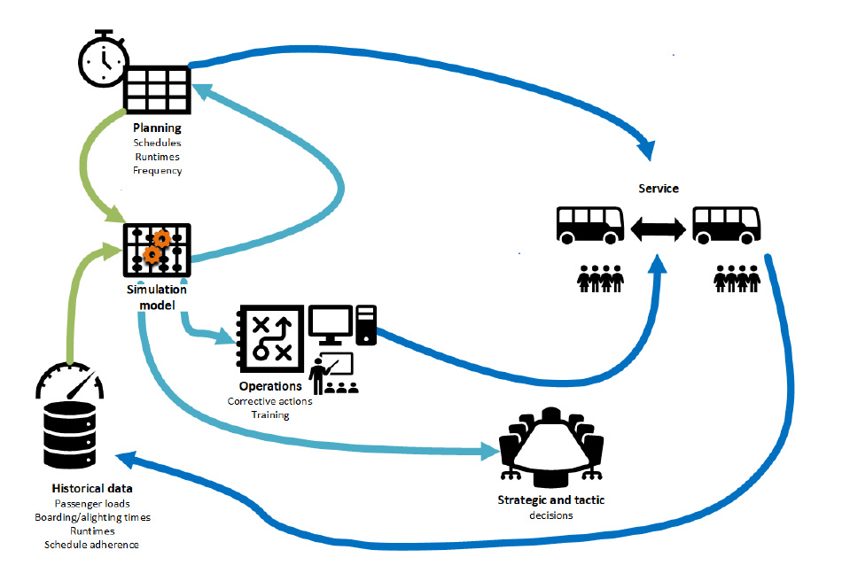

Evaluating the effectiveness of public transport optimization is crucial to determine whether the implemented strategies and technologies are achieving their intended goals. Evaluation can help identify areas for improvement and ensure that public transport services meet the needs of passengers and the community. Here are some key aspects to consider when evaluating public transport optimization:

**1. Ridership and Usage Metrics:**

- Measure changes in ridership, such as an increase in the number of passengers using public transport.

- Track passenger boarding and alighting data to assess which routes and stops are most popular.

- Analyze ticketing and payment data to understand patterns of usage.

**2. On-time Performance:**

- Monitor the punctuality of public transport services. This includes tracking the percentage of buses, trains, or trams that depart and arrive on schedule.

- Evaluate the impact of optimization strategies on reducing delays and minimizing wait times.

**3. Service Reliability:**

- Assess the reliability of public transport services, including the frequency and consistency of schedules.

- Measure the incidence of service interruptions, breakdowns, or disruptions and the time it takes to recover from them.

**4. Efficiency and Cost-effectiveness:**

- Evaluate the operational efficiency of public transport systems, considering factors like fuel consumption, maintenance costs, and labor efficiency.

- Compare the costs of optimization strategies to the benefits, such as increased ridership or reduced congestion.

**5. Accessibility and Inclusivity:**

- Examine the accessibility of public transport services for people with disabilities and those with limited mobility.

- Ensure that optimization efforts promote inclusivity and are accessible to all members of the community.

**6. Environmental Impact**:

- Measure the environmental impact of public transport optimization, including reductions in carbon emissions, air quality improvements, and the use of clean energy sources.

**7. Customer Satisfaction Surveys:**

- Conduct regular surveys or collect feedback from passengers to gauge their satisfaction with public transport services.

- Assess passenger perceptions of safety, cleanliness, convenience, and overall experience.

**8. Safety and Security:**

- Evaluate the safety and security of passengers and staff, including measures taken to prevent accidents, mitigate security risks, and respond to emergencies.

**9. Economic Impact:**

- Analyze the economic impact of public transport optimization on the local economy, considering factors like job creation, increased property values, and reduced traffic congestion.

**10. Data-driven Decision-making:**

- Assess whether optimization efforts are informed by data-driven decisions and whether data analytics are used to improve services and make adjustments.

**11. Traffic Congestion Reduction:**

- Evaluate the impact of public transport optimization on reducing traffic congestion in urban areas, leading to improved traffic flow for all road users.

**12. Environmental and Energy Efficiency:**

- Measure the reduction in greenhouse gas emissions, energy consumption, and environmental benefits resulting from public transport optimization.

**13. Social and Equity Considerations:**

- Ensure that optimization efforts consider social equity by addressing the needs of underserved or marginalized communities and promoting affordable and accessible transportation for all.

**14. Long-term Sustainability:**

- Assess whether the optimization strategies are sustainable in the long term and adaptable to changing urban environments, technology advancements, and population growth.

**15. Cost-benefit Analysis:**

- Perform a cost-benefit analysis to determine the overall economic feasibility of the optimization efforts, considering the costs of implementation and the benefits accrued over time.

Evaluating public transport optimization requires a multidimensional approach, considering various factors such as ridership, efficiency, environmental impact, safety, and user satisfaction. Regular evaluation and feedback are essential for continually improving public transport services and ensuring they meet the evolving needs of communities.

**Deployment And Integration:**

The simulations have been made to estimate what effect different parameters have on the attractiveness and efficiency of the integrated service. The parameters that are assessed to be the most interesting when planning an integrated service, and that also are possible to test in LITRES-2, are the following:

• The number of demand responsive vehicles

• The capacity of demand responsive vehicles

• The number of transfer nodes

• Acceptable size of time windows for customers

• Acceptable travel factor of the demand responsive vehicles

• Pricing alternatives

**Future Improvements:**

**Transit Frequency:** Transit frequency optimization models can determine the optimal time interval between subsequent buses for a set of public transportation lines given by their itineraries, i.e., sequences of stops and street sections, that reaches a pre-specified goal such as minimization of passengers’ overall travel time (walking, on-board and waiting). These models consider origin-destination demand constraints, constraints on the available fleet of buses, and other infrastructure and policy constraints.

**Stop/Terminal Location:** Decision-makers can use facility location optimization models to determine the optimal locations of stops or terminals from a given set of candidate locations based on a pre-determined objective such as maximization of the population covered by the facilities.

**Vehicle Routing:**Vehicle routing optimization models identify the best routes for vehicles (e.g., buses) that travel over a region to serve the maximum possible demand, minimize the transportation cost, or minimize passengers’ waiting time.

**Delay Management:** When a delay occurs, two alternatives are available: 1) A connection bus waits and causes a delay for both customers on the bus and those who wish to get on the bus later on; 2) A connection bus departs on time and delayed passengers should be waiting for the next bus. Bi-objective delay optimization models can simultaneously consider two competing objectives, i.e., minimizing the delay of all vehicles and minimizing passengers’ total waiting time, to find efficient solutions with respect to the trade-off of both objectives.

**Maintenance Scheduling:** Maintenance scheduling optimization models determine when and where should roadway or vehicle maintenance be scheduled to minimize the consequences of non-working assets on the efficiency of the public transportation system.

**Driver Scheduling:** Resource allocation and scheduling optimization models work seamlessly together to assign available drivers to vehicles and shifts in order to maximize driver’s job satisfaction, resource utilization, and service level by generating fair and efficient driver schedules.

**Output Reference:**

<https://wokwi.com/projects/378905581521445889>

If Any Error Occured In The Above Hyperlink Please Copy Link And Paste It In Your Browser.

🡪**THANK YOU**🡨