# 6115-MAHENDRA INSTITUTE OF ENGINEERING AND TECHNOLOGY

MALLASAMUDRAM, NAMAKKAL-637503

# PUBLIC TRANSPORTATION OPTIMIZATION

**ABSTRACT:**

Public transportation optimization refers to the process of improving the efficiency, reliability, and effectiveness of public transportation systems. This involves utilizing various strategies, technologies, and data analysis to enhance the overall performance of public transit services. The goal is to ensure that public transportation meets the demands of the population while minimizing costs, reducing congestion, and promoting sustainability.

* Scheduling Optimization
* Resource Allocation and Management
* Fare Optimization and Revenue Management
* Passenger Experience Enhancement
* Integration and Intermodality
* Environmental Sustainability

**INTRODUCTION :**

Public transportation is a critical component of urban and regional mobility, providing an essential means of transportation for a significant portion of the population. However, as cities grow, the demand for efficient and reliable public transportation continues to increase, necessitating the optimization of these systems. Public transportation optimization involves employing various strategies and methodologies to enhance the performance, efficiency, accessibility, and sustainability of transit networks.

The primary objectives of public transportation optimization are to improve the overall effectiveness of the system, minimize operational costs, reduce travel times, enhance passenger experience, and mitigate environmental impacts. Achieving these goals requires careful planning, data analysis, technological advancements, and strategic decision-making.

**Key Aspects of Public Transportation Optimization:**

* **Route Planning and Optimization:** Optimal route planning ensures that transit routes cover high-demand areas, minimize travel distances, and provide convenient access to keydestinations. Utilizing data analytics and geographic information systems (GIS), transit agencies can design efficient routes that serve the needs of diverse passenger populations.
* **Scheduling Efficiency:** Efficient scheduling involves creating timetables that align with demand patterns, particularly during peak hours. Balancing frequency, reducing waiting times, and maintaining reliability are essential considerations in scheduling optimization.

**Resource Allocation and Management:** Effectively managing resources such as vehicles, drivers, fuel, and maintenance is vital to optimize operational costs and improve service quality. Smart resource allocation ensures that the right amount of resources is allocated to meet demand.

* **Demand Forecasting and Capacity Planning:** Accurate demand forecasting allows transit agencies to adjust service levels and allocate resources based on anticipated passenger loads. Capacity planning ensures that vehicles and routes can accommodate expected demand.
* **Fare Optimization and Revenue Management:** Optimizing fare structures and implementing efficient fare collection systems help generate revenue while encouraging ridership. Dynamic pricing and integrated fare systems enhance user convenience.
* **Technology Integration:** Leveraging technology, such as real-time tracking, predictive analytics, and mobile applications, can significantly enhance the passenger experience by providing up-to-date information and improving overall service reliability.
* **Intermodal Integration:** Coordinating different modes of transportation, including buses, trains, subways, and other forms of public transit, ensures seamless intermodal travel experiences for passengers and encourages the use of public transportation.
* **Sustainability and Environmental Considerations:** Prioritizing sustainability by incorporating eco-friendly vehicles, promoting active transportation, and implementing green initiatives helps reduce the carbon footprint and contribute to a more sustainable future.

# HARDWARE:

Hardware refers to the physical components of a computer or electronic device. These are tangible, physical entities that you can touch and see. Hardware includes:

* **Central Processing Unit (CPU):** The CPU is the "brain" of the computer, responsible for executing instructions and performing calculations.
* **Memory (RAM and Storage):** RAM (Random Access Memory) provides temporary storage for data and programs that are being actively used. Storage (e.g., hard drives, solid-state drives) stores data permanently.
* **Motherboard:** The main circuit board that houses the CPU, memory, and other essential components. It provides the connections and interfaces for these components to communicate.
* **Input Devices:** Devices like keyboards, mice, scanners, and touchscreens that allow users to input data into the computer.
* **Output Devices:** Devices like monitors, printers, and speakers that display or produce the results of computations.
* **Peripherals:** Additional devices connected to the computer, such as printers, external drives, and USB devices.
* **Graphics Processing Unit (GPU):** Dedicated hardware for processing graphics and accelerating tasks related to visuals, important for gaming, video editing, and more.

**Networking Hardware:** Components like network adapters, routers, switches, and cables that enable communication and connectivity within a network.

* **Power Supply Unit (PSU):** Provides electrical power to the computer components.
* **Cooling Systems:** Fans, heat sinks, and liquid cooling systems to regulate the temperature of the components, especially the CPU and GPU.

# SOFTWARE:

Software comprises the programs, applications, and instructions that tell the hardware how to function. It's intangible, consisting of code and data that run on the hardware. Types of software include:

* **Operating Systems (OS):** The primary software that manages the computer hardware and provides services for computer programs. Examples include Windows, macOS, Linux, iOS, and Android.
* **Applications:** Programs designed to perform specific tasks or functions, such as word processors (e.g., Microsoft Word), web browsers (e.g., Google Chrome), and games.
* **Utilities:** Tools and programs that help manage and maintain the computer system, like antivirus software, disk cleanup tools, and file compression utilities.
* **Programming Languages and Compilers:** Tools used to write, compile, and run software code in various programming languages like Python, Java, C++, etc.
* **Device Drivers:** Software that allows the operating system to communicate with and control hardware devices, ensuring proper functionality.
* **Firmware:** Low-level software stored in hardware (e.g., BIOS/UEFI) that initializes and controls the hardware during the boot process.
* **Middleware:** Software that acts as an intermediary between different software applications, facilitating communication and data exchange.
* **System Software:** Software that manages and supports the computer system and its components, including OS, device drivers, and utilities.

# MODULES:

"Public modules" could refer to modular components or units of a public software system or platform that are accessible to users or developers for integration, customization, or extension. These modules typically encapsulate specific functionalities, features, or services, allowing for easier management, reusability, and scalability of the software system. The term "module" suggests a level of modularity and organization within the software architecture.

Here are some common characteristics and examples of public modules:

**Characteristics of Public Modules:**

**Modularity:** Public modules are designed as separate, self-contained units, making it easier to manage, update, and maintain specific functionalities.

* **Reusability:** Modules can be reused across different parts of an application or even in other projects, promoting efficient development practices.
* **Encapsulation:** Each module encapsulates related functionalities, data, or services, hiding the internal details and providing a clear interface for interaction.
* **Interoperability:** Modules are often designed to work seamlessly with other modules or
* components within the system, promoting interoperability.

**Examples of Public Modules:**

* **Authentication Module:** Manages user authentication, login, and authorization processes, providing secure access to the application.
* **Payment Processing Module:** Handles payment transactions, integrating with payment gateways and ensuring secure and reliable payment processing.
* **Notification Module:** Manages notifications and alerts to users, allowing for various notification types and delivery methods.
* **File Upload Module:** Provides functionality for uploading, storing, and managing files, supporting various file formats and sizes.
* **Data Processing Module:** Offers functionalities for data manipulation, transformation, and analysis, supporting data processing needs within the application.
* **Localization Module:** Supports multilingual capabilities, allowing the application to be localized for different languages and regions.
* **Search Module:** Implements a robust search functionality within the application, facilitating efficient data retrieval and search queries.
* **Reporting Module:** Enables the generation and viewing of reports based on data collected within the application.
* **The Importance of Public Transportation :**

1.Cost-effective:

**Public transportation can be more affordable than driving or taking a taxi.**

**2**.Reduced traffic congestion:

**When more people use public transportation, there are fewer cars on the road, leading to less traffic and pollution.**

**3.**Accessibility :

**Public transportation provides an accessible means of travel for those who may not be able to afford a car or are unable**

# Existing system :

**Optimizing public transportation systems typically involves various strategies and technologies to improve efficiency, accessibility, and sustainability. Some existing approaches include:**

* Real-time Tracking:

**Implementing GPS and tracking systems to monitor vehicles in real-time, helping passengers know when their ride will arrive.**

* Data Analytics:

**Analyzing passenger data to optimize routes, schedules, and capacity to meet demand more effectively.**

* Multimodal Integration**:**

**Integrating different modes of transportation (e.g., buses, trains, subways, and rideshares) to create a seamless network.**

* Smart Ticketing:

**Using contactless payment methods and mobile apps for ticketing to reduce boarding times and streamline fare collection.**

**Designating dedicated lanes for public transit to reduce congestion and improve travel times.**

* Electric and Sustainable Vehicles:

**Transitioning to electric or hybrid vehicles to reduce emissions and environmental impact.**

* Accessibility Improvements**:**

**Ensuring that public transportation is accessible to people with disabilities and those with limited mobility.**

* Public-Private Partnerships:

**Collaborating with private companies for innovative solutions and funding.**

* Demand-Responsive Transit:

**Implementing on-demand services in areas with variable ridership patterns.**

* Public Engagement:

**Involving the community in the decision-making process and gathering feedback to make informed improvements.**

**These strategies can vary depending on the specific needs and challenges of a particular public transportation syste**

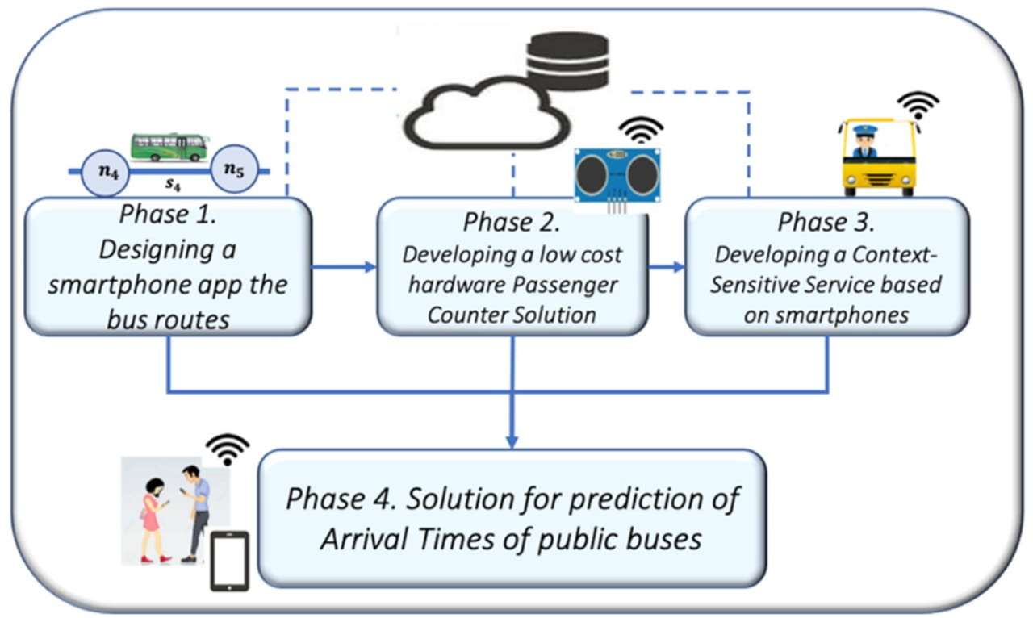

* **proposed system**

**Designing a proposed system for optimizing public transportation involves considering various factors to enhance efficiency, accessibility, and sustainability. Here's a high-level overview of a potential system**

**Implement a centralized system that collects and analyzes real-time data from buses, trains, subways, and other transit modes. This data should include passenger counts, vehicle locations, and traffic condition.**

* Passenger Information Systems**:**

**Develop a mobile app and digital signage at stops/stations to provide passengers with real-time updates on arrival times, delays, and service disruptions. Include trip planning features for multimodal journeys.**

* Fare Integration:

**Implement a unified fare payment system that allows passengers to use a single payment method (e.g., contactless cards, mobile apps) across all transit modes, reducing boarding times and administrative costs.**

* Transit Priority Infrastructure:

**Create dedicated bus lanes, transit signal priority systems, and bus rapid transit (BRT) routes to ensure that public transit moves efficiently through traffic.**

* Electric and Sustainable Fleet:

**Transition to electric and low-emission vehicles to reduce environmental impact. Consider investing in renewable energy sources for charging infrastructure.**

* Accessibility Focus:

**Ensure that all transit stations, vehicles, and information systems are accessible to people with disabilities. This includes ramps, elevators, and Braille signage.**

* Community Engagement:

**Involve the community in the planning and decision-making process. Collect feedback through surveys, town hall meetings, and digital platforms to address specific needs.**

* Dynamic Pricing:

**Implement dynamic pricing models that adjust fares based on demand, time of day, and occupancy** rates to encourage off-peak travel and optimize revenue.

* Public-Private Partnerships:

**Collaborate with private companies to enhance services, such as integrating rideshare and bike-sharing options into the transit system.**

* Environmental Sustainability:

**Invest in eco-friendly practices such as energy-efficient stations, green infrastructure, and renewable energy sources to reduce the system's carbon footprint**

* Safety and Security:

**Enhance security measures on public transit, including surveillance cameras, emergency call buttons, and personnel presence to ensure passenger safety.**

* Maintenance and Upkeep:

**Establish a rigorous maintenance schedule for vehicles and infrastructure to minimize downtime and ensure the system operates reliably.**

* Data Analytics for Predictive Maintenance:

**Use predictive analytics to identify maintenance needs in advance, reducing unplanned service interruptions.**

* Scalability and Flexibility**:**

**Design** the system with scalability in mind to accommodate future growth and changes in demand.

* Promotion and Education:

**Launch marketing campaigns to promote public transit use and educate the public about the benefits of the optimized system.**

**Implementing such a system requires collaboration among government agencies, transit authorities, technology providers, and the community.**

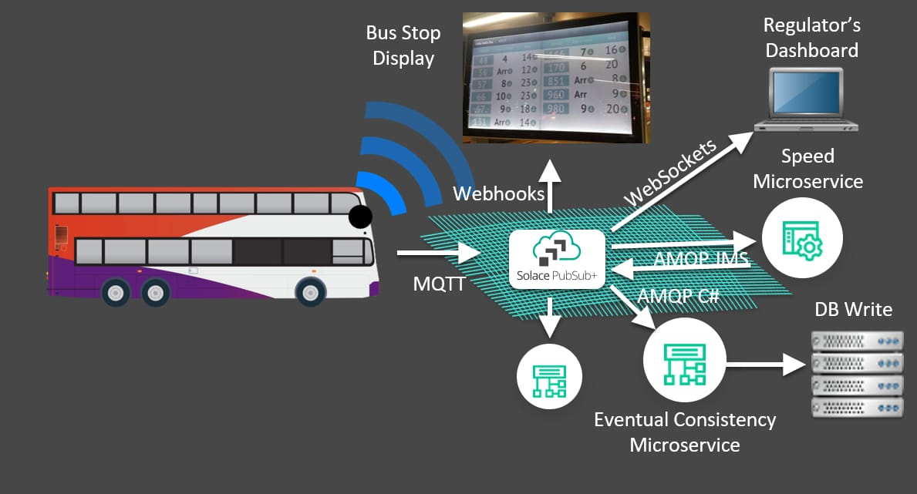

* **Public transportation optimization in proposed system design**
* Route Planning:

**Design efficient routes that serve high-demand areas, reduce travel time, and minimize congestion.**

* Scheduling:

**Develop timetables that balance frequency and capacity during peak and off-peak hours.**

* Fleet Management:

**Optimize the number and types of vehicles based on demand, fuel efficiency, and environmental impact.**

* Safety:

**Enhanced security measures can make public transportation safer for passengers, reducing crime and accidents.**

* Ticketing and Payment Systems**:**

**Implement digital payment methods to streamline fare collection and reduce boarding time.**

* Integration**:**

**Ensure seamless connections with other modes of transportation (e.g., buses, trains, subways) to provide a holistic transit system.**

* Accessibility:

**Design stations and vehicles to be accessible to people with disabilities.**

* Information Systems:

**Provide real-time information to passengers about arrival times and service disruptions through mobile apps and displays at stops.**

* Environmental Sustainability:

**Incorporate eco-friendly technologies like electric buses and renewable energy sources.**

* Data Analytics**:**

**Utilize data analysis to monitor performance, identify bottlenecks, and make data-driven improvements.**

* Safety and Security:

**Implement measures to ensure passenger safety and reduce crime on public transportation.**

* **Installation:**

**Arduino IDE 1 Installation (Windows)**

This document explains how to install the Arduino Software (IDE) on Windows machines.

* **Download the Arduino Software (IDE)**

Get the latest version from the [download page](https://www.arduino.cc/en/Main/Software). You can choose between the Installer (.exe) and the Zip packages. We suggest you use the first one that installs directly everything you need to use the Arduino Software (IDE), including the drivers. With the Zip package you need to install the drivers manually. The Zip file is also useful if you want to create a [portable installation](https://arduino.cc/en/Guide/PortableIDE).

When the download finishes, proceed with the installation and please allow the driver installation process when you get a warning from the operating system.

[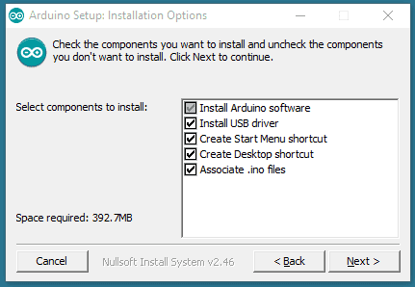](https://docs.arduino.cc/static/33f20406f68c5707052471d78a90a5c6/9cb4e/DRV_Capture1.png)

Choose the components to install.

[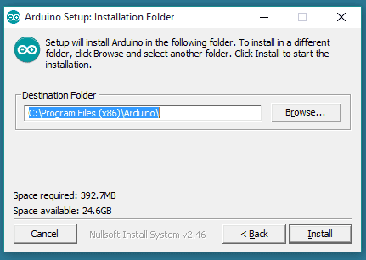](https://docs.arduino.cc/static/12311f50263afe3f12349d932fdeb3f5/9cb4e/DRV_Capture2.png)

Choose the installation directory.

[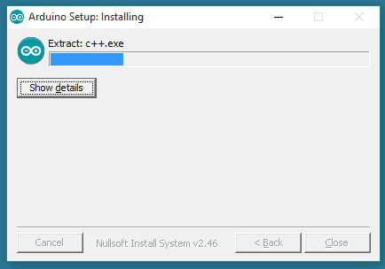](https://docs.arduino.cc/static/02501558f5cba4564376f0bb8adfcf01/ade6e/DRV_Capture3.png)

Installation in progress.

* **SENSORS:**

**1.ULTRASONIC SENSORS**

**2.GPS**

**3.IR PHOTO DIODE(IR LASER)**

**4.LED TV**

**5.ESP 32**

**6.ARDUINO BOARD**

* **PLANING:**

*1. Define Objectives: Determine the specific goals of optimization, such as reducing congestion, improving efficiency, or increasing ridership.*

*2. Data Collection: Gather data on current routes, schedules, ridership, and other relevant factors. This data will serve as the foundation for your optimization efforts.*

*3. Stakeholder Engagement: Involve relevant stakeholders, including transportation authorities, passengers, and local communities, to understand their needs and concerns.*

*4. Technology: Consider using transportation management software and data analytics tools to process and analyze the collected data.*

*5. Route Planning: Utilize optimization algorithms to design more efficient routes and schedules based on demand and resource constraints.*

*6. Pricing and Fare Structure: Optimize ticket pricing and fare structures to encourage ridership and cover operating costs.*

*7. Sustainability: Integrate eco-friendly options, like electric buses or cycling lanes, to promote sustainability and reduce emissions.*

*8. Monitoring and Adjustments: Continuously monitor performance and gather feedback to make necessary adjustments and improvements to the system.*

*9. Public Communication: Keep passengers and the public informed about changes and improvements in the public transportation system.*

*10. Simulation and Testing: Simulate the proposed changes to ensure they meet your optimization objectives without causing negative impacts.*

* *EXECUTION :*

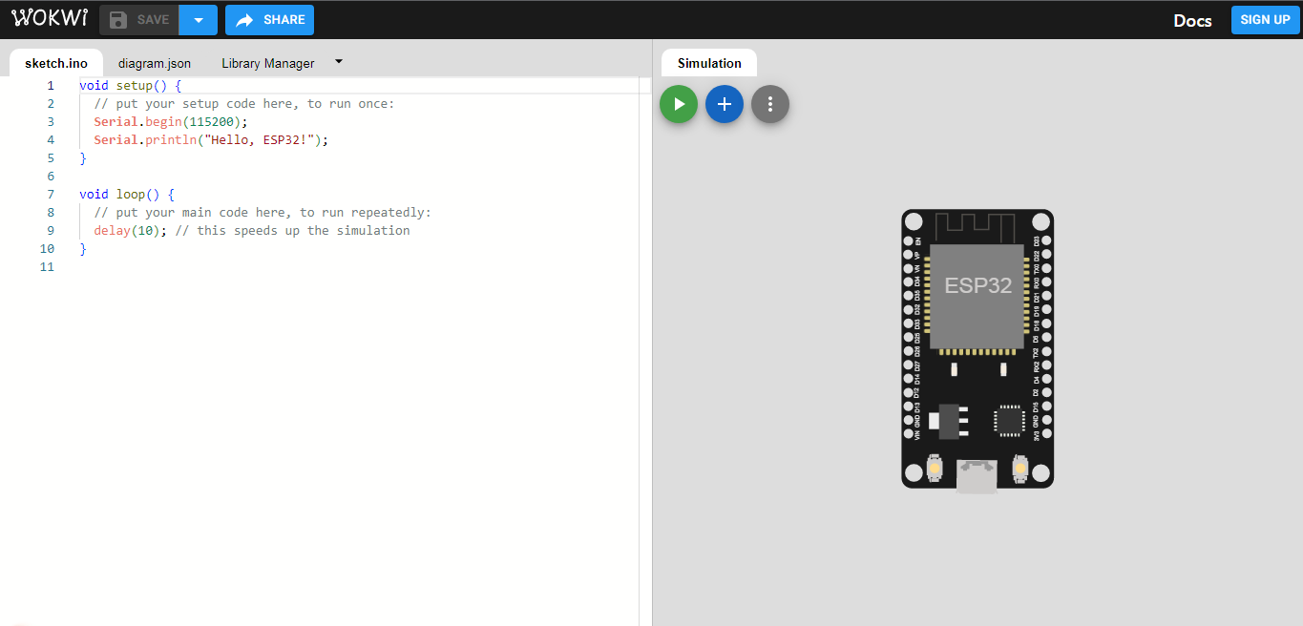

*Controlling:*

*1.Route Planning and Scheduling Software: Utilizing software to plan the most efficient routes, schedules, and stops for buses, trams, or trains.*

*2.Real-Time Tracking and GPS: Implementing GPS and real-time tracking systems to monitor vehicle locations and adjust routes dynamically.*

*3.Passenger Information Systems: Providing real-time information to passengers through apps, websites, or digital displays at stations.*

*4.Fare Collection and Payment Systems: Managing electronic ticketing, contactless payment, and fare collection systems.*

*5.Maintenance and Fleet Management: Using software to schedule and track maintenance of vehicles and infrastructure.*

*6.Traffic Management and Signal Priority: Coordinating with traffic signals to give public transport vehicles priority at intersections.*

*7.Data Analytics and Predictive Maintenance: Analyzing data to predict maintenance needs, optimize routes, and improve overall efficiency.*

*8.Demand-Responsive Transportation: Implementing on-demand services that adapt to passenger requests using software algorithms.*

*9.Integration with Other Modes of Transportation:Ensuring seamless connections with other forms of transit, like bike-sharing or ride-sharing.*

*10.Emergency and Incident Management:*

*Using software to respond to incidents and adjust services during emergencies or disruptions.*

*Project Implementation:*

Public transportation optimization refers to the process of improving the efficiency, reliability, and effectiveness of public transportation systems. This involves utilizing various strategies, technologies, and data analysis to enhance the overall performance of public transit services. The goal is to ensure that public transportation meets the demands of the population while minimizing costs, reducing congestion, and promoting sustainability.

* Scheduling Optimization
* Resource Allocation and Management
* Fare Optimization and Revenue Management
* Passenger Experience Enhancement
* Integration and Intermodality
* Environmental Sustainability

**Features Of Engineering:**

1. Define Objectives: Determine the specific goals of optimization, such as reducing congestion, improving efficiency, or increasing ridership.

2. Data Collection: Gather data on current routes, schedules, ridership, and other relevant factors. This data will serve as the foundation for your optimization efforts.

3. Stakeholder Engagement: Involve relevant stakeholders, including transportation authorities, passengers, and local communities, to understand their needs and concerns.

4. Technology: Consider using transportation management software and data analytics tools to process and analyze the collected data.

5. Route Planning: Utilize optimization algorithms to design more efficient routes and schedules based on demand and resource constraints.

6. Pricing and Fare Structure: Optimize ticket pricing and fare structures to encourage ridership and cover operating costs.

7. Sustainability: Integrate eco-friendly options, like electric buses or cycling lanes, to promote sustainability and reduce emissions.

8. Monitoring and Adjustments: Continuously monitor performance and gather feedback to make necessary adjustments and improvements to the system.

9. Public Communication: Keep passengers and the public informed about changes and improvements in the public transportation system.

10. Simulation and Testing: Simulate the proposed changes to ensure they meet your optimization objectives without causing negative impacts.

**SENSORS:**

**1.ULTRASONIC SENSORS**

**2.GPS**

**3.IR PHOTO DIODE(IR LASER)**

**4.LED TV**

**5.ESP 32**

**6.ARDUINO BOARD**

**Model Training:**

Due to short period of time for the projects our team has prepared limited dataset are model to training the dataset for the implementation of Public transport optimization.

**Data set:**

{

  "version": 1,

  "author": "MANOJ S",

  "editor": "wokwi",

  "parts": [

    { "type": "wokwi-esp32-devkit-v1", "id": "esp", "top": -12.8, "left": 180.8, "attrs": {} },

    {

      "type": "wokwi-hc-sr04",

      "id": "ultrasonic1",

      "top": -31.94,

      "left": -1.1,

      "attrs": { "distance": "240" }

    },

    {

      "type": "wokwi-hc-sr04",

      "id": "ultrasonic2",

      "top": -32.14,

      "left": -184.37,

      "attrs": { "distance": "104" }

    },

    {

      "type": "wokwi-led",

      "id": "led1",

      "top": 196.6,

      "left": 95.24,

      "attrs": { "color": "red" }

    }

  ],

  "connections": [

    [ "esp:TX0", "$serialMonitor:RX", "", [] ],

    [ "esp:RX0", "$serialMonitor:TX", "", [] ],

    [ "ultrasonic1:VCC", "esp:VIN", "red", [ "v0" ] ],

    [ "ultrasonic1:GND", "esp:GND.2", "black", [ "v0" ] ],

    [ "ultrasonic1:TRIG", "esp:D13", "green", [ "v0" ] ],

    [ "ultrasonic1:ECHO", "esp:D12", "green", [ "v0" ] ],

    [ "ultrasonic2:GND", "esp:GND.2", "black", [ "v93.61", "h255.99", "v-19.13", "h1.42" ] ],

    [ "ultrasonic2:VCC", "esp:VIN", "red", [ "v111.32", "h288.11", "v-26.93" ] ],

    [ "ultrasonic2:ECHO", "esp:D14", "green", [ "v97.15", "h262.44", "v-53.14" ] ],

    [ "ultrasonic2:TRIG", "esp:D15", "green", [ "v102.11", "h397.16", "v-36.14" ] ],

    [ "led1:C", "esp:GND.1", "black", [ "v7.36", "h195.18", "v-106.29" ] ],

    [ "led1:A", "esp:D22", "green", [ "v0.98", "h178.81", "v-149.51" ] ]

  ],

  "dependencies": {}

}

**Evaluation:**

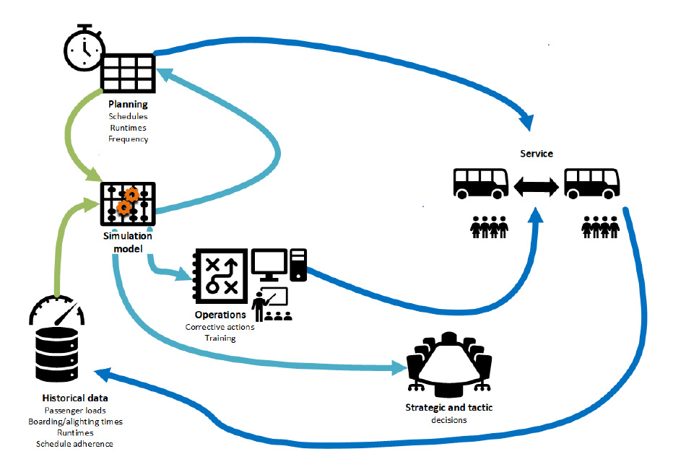

Evaluating the effectiveness of public transport optimization is crucial to determine whether the implemented strategies and technologies are achieving their intended goals. Evaluation can help identify areas for improvement and ensure that public transport services meet the needs of passengers and the community. Here are some key aspects to consider when evaluating public transport optimization:

**1. Ridership and Usage Metrics:**

- Measure changes in ridership, such as an increase in the number of passengers using public transport.

- Track passenger boarding and alighting data to assess which routes and stops are most popular.

- Analyze ticketing and payment data to understand patterns of usage.

**2. On-time Performance:**

- Monitor the punctuality of public transport services. This includes tracking the percentage of buses, trains, or trams that depart and arrive on schedule.

- Evaluate the impact of optimization strategies on reducing delays and minimizing wait times.

**3. Service Reliability:**

- Assess the reliability of public transport services, including the frequency and consistency of schedules.

- Measure the incidence of service interruptions, breakdowns, or disruptions and the time it takes to recover from them.

**4. Efficiency and Cost-effectiveness:**

- Evaluate the operational efficiency of public transport systems, considering factors like fuel consumption, maintenance costs, and labor efficiency.

- Compare the costs of optimization strategies to the benefits, such as increased ridership or reduced congestion.

**5. Accessibility and Inclusivity:**

- Examine the accessibility of public transport services for people with disabilities and those with limited mobility.

- Ensure that optimization efforts promote inclusivity and are accessible to all members of the community.

**6. Environmental Impact**:

- Measure the environmental impact of public transport optimization, including reductions in carbon emissions, air quality improvements, and the use of clean energy sources.

**7. Customer Satisfaction Surveys:**

- Conduct regular surveys or collect feedback from passengers to gauge their satisfaction with public transport services.

- Assess passenger perceptions of safety, cleanliness, convenience, and overall experience.

**8. Safety and Security:**

- Evaluate the safety and security of passengers and staff, including measures taken to prevent accidents, mitigate security risks, and respond to emergencies.

**9. Economic Impact:**

- Analyze the economic impact of public transport optimization on the local economy, considering factors like job creation, increased property values, and reduced traffic congestion.

**10. Data-driven Decision-making:**

- Assess whether optimization efforts are informed by data-driven decisions and whether data analytics are used to improve services and make adjustments.

**11. Traffic Congestion Reduction:**

- Evaluate the impact of public transport optimization on reducing traffic congestion in urban areas, leading to improved traffic flow for all road users.

**12. Environmental and Energy Efficiency:**

- Measure the reduction in greenhouse gas emissions, energy consumption, and environmental benefits resulting from public transport optimization.

**13. Social and Equity Considerations:**

- Ensure that optimization efforts consider social equity by addressing the needs of underserved or marginalized communities and promoting affordable and accessible transportation for all.

**14. Long-term Sustainability:**

- Assess whether the optimization strategies are sustainable in the long term and adaptable to changing urban environments, technology advancements, and population growth.

**15. Cost-benefit Analysis:**

- Perform a cost-benefit analysis to determine the overall economic feasibility of the optimization efforts, considering the costs of implementation and the benefits accrued over time.

Evaluating public transport optimization requires a multidimensional approach, considering various factors such as ridership, efficiency, environmental impact, safety, and user satisfaction. Regular evaluation and feedback are essential for continually improving public transport services and ensuring they meet the evolving needs of communities.

**Deployment And Integration:**

The simulations have been made to estimate what effect different parameters have on the attractiveness and efficiency of the integrated service. The parameters that are assessed to be the most interesting when planning an integrated service, and that also are possible to test in LITRES-2, are the following:

• The number of demand responsive vehicles

• The capacity of demand responsive vehicles

• The number of transfer nodes

• Acceptable size of time windows for customers

• Acceptable travel factor of the demand responsive vehicles

• Pricing alternatives

**Future Improvements:**

**Transit Frequency:** Transit frequency optimization models can determine the optimal time interval between subsequent buses for a set of public transportation lines given by their itineraries, i.e., sequences of stops and street sections, that reaches a pre-specified goal such as minimization of passengers’ overall travel time (walking, on-board and waiting). These models consider origin-destination demand constraints, constraints on the available fleet of buses, and other infrastructure and policy constraints.

**Stop/Terminal Location:** Decision-makers can use facility location optimization models to determine the optimal locations of stops or terminals from a given set of candidate locations based on a pre-determined objective such as maximization of the population covered by the facilities.

**Vehicle Routing:**Vehicle routing optimization models identify the best routes for vehicles (e.g., buses) that travel over a region to serve the maximum possible demand, minimize the transportation cost, or minimize passengers’ waiting time.

**Delay Management:** When a delay occurs, two alternatives are available: 1) A connection bus waits and causes a delay for both customers on the bus and those who wish to get on the bus later on; 2) A connection bus departs on time and delayed passengers should be waiting for the next bus. Bi-objective delay optimization models can simultaneously consider two competing objectives, i.e., minimizing the delay of all vehicles and minimizing passengers’ total waiting time, to find efficient solutions with respect to the trade-off of both objectives.

**Maintenance Scheduling:** Maintenance scheduling optimization models determine when and where should roadway or vehicle maintenance be scheduled to minimize the consequences of non-working assets on the efficiency of the public transportation system.

**Driver Scheduling:** Resource allocation and scheduling optimization models work seamlessly together to assign available drivers to vehicles and shifts in order to maximize driver’s job satisfaction, resource utilization, and service level by generating fair and efficient driver schedules.

**Output Reference:**

<https://wokwi.com/projects/378905581521445889>

If Any Error Occured In The Above Hyperlink Please Copy Link And Paste It In Your Browser.

🡪**THANK YOU**🡨