PROJECT DOCUMENT
Mini Sales Data Pipeline using Azure

1. Objective
The objective of this project is to build a simple end-to-end data pipeline using cloud services to store, process, and analyze sales data.

2. Technologies Used
- Azure Storage – Data storage
- Azure Data Factory – Data movement (ETL)
- Azure Synapse Analytics – Data analysis using SQL

3. Architecture
CSV File → Azure Storage → Data Factory → Processed Storage → Synapse → SQL Analysis
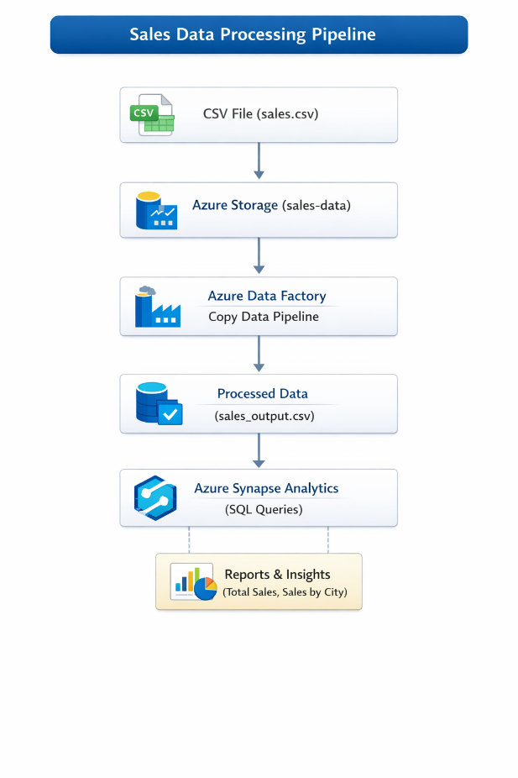

Steps :
1.Storage Account:
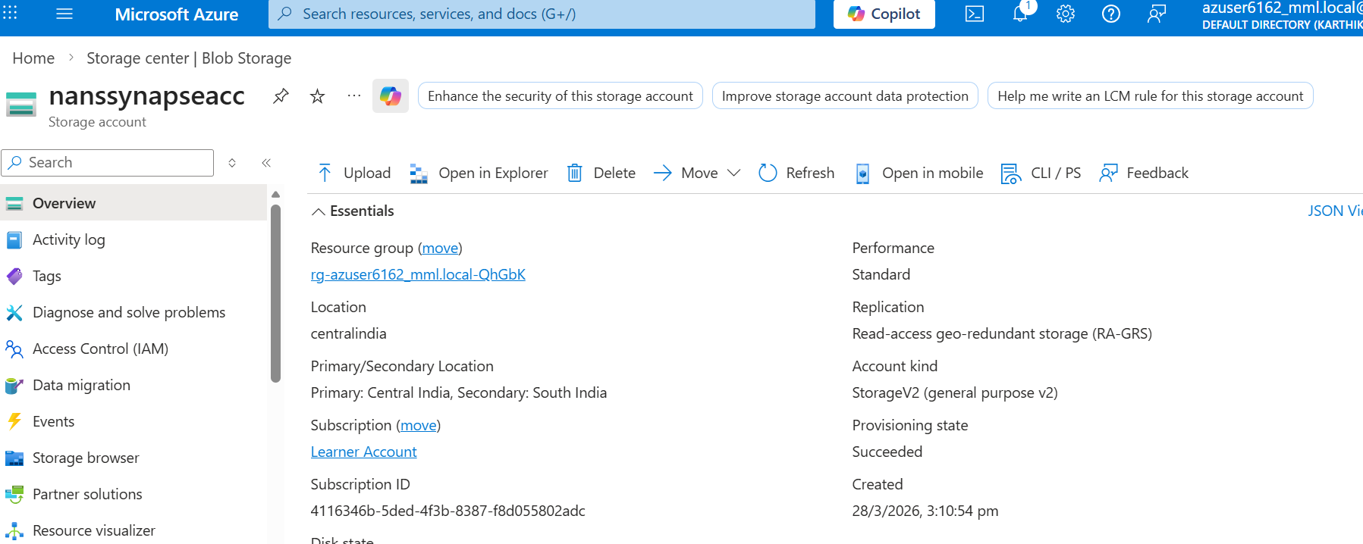

2.Azure Data Factory Setup:
a. Source Dataset (DelimitedText1)
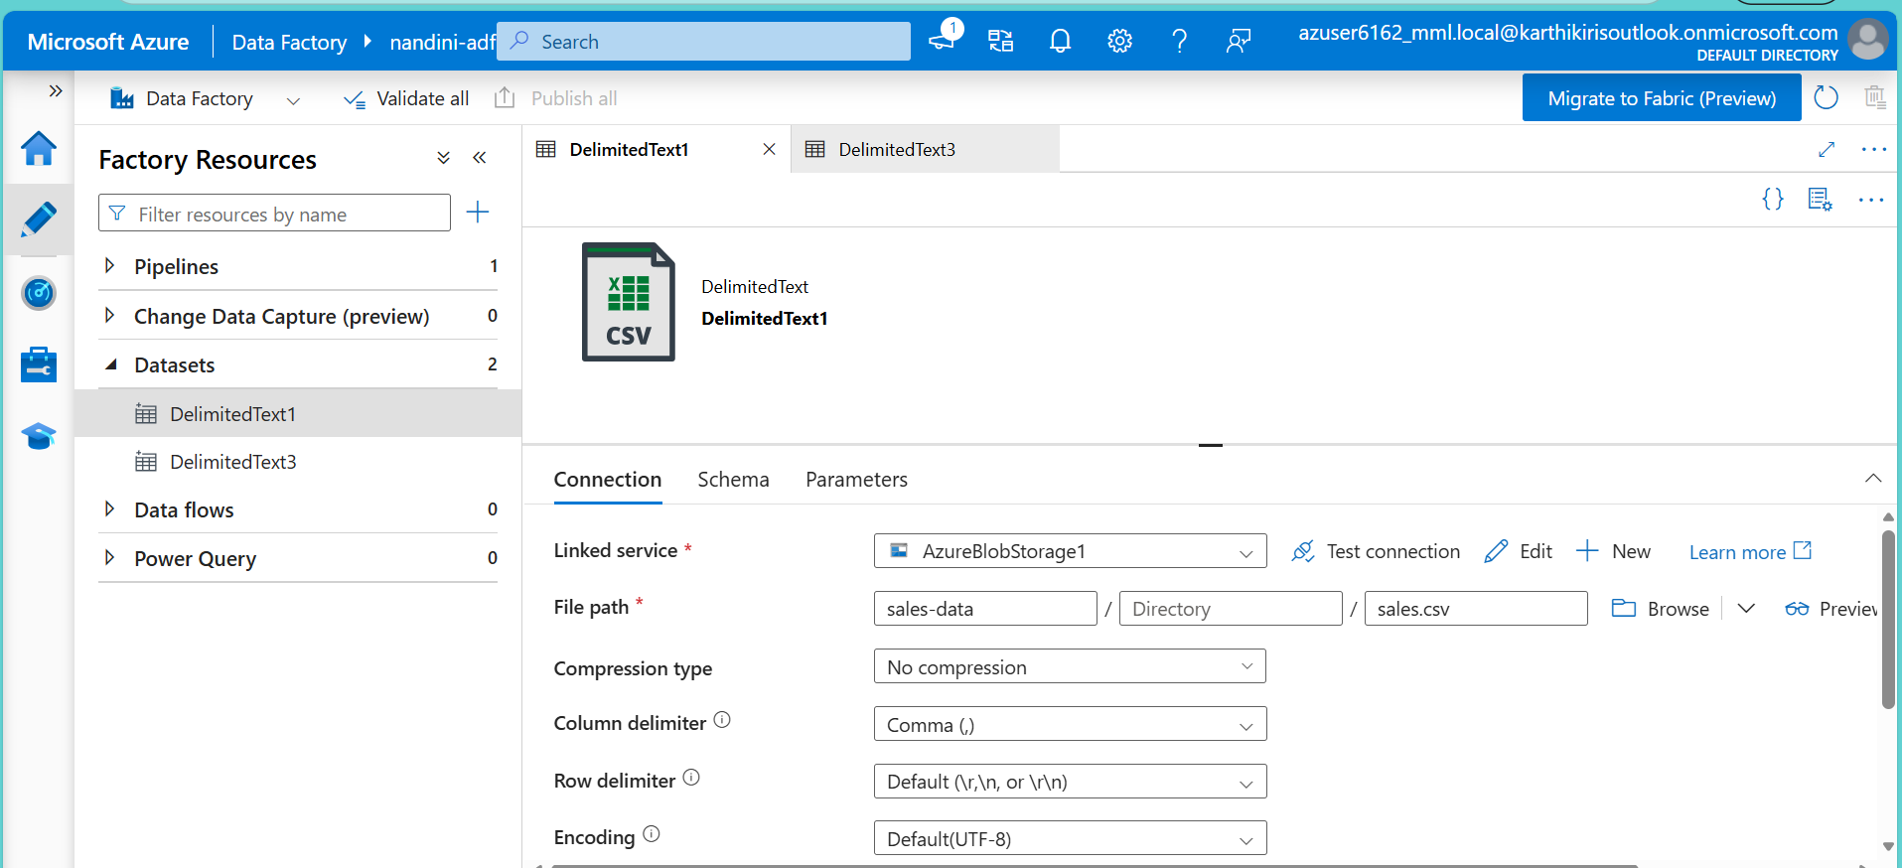

b. Sink Dataset (DelimitedText3):
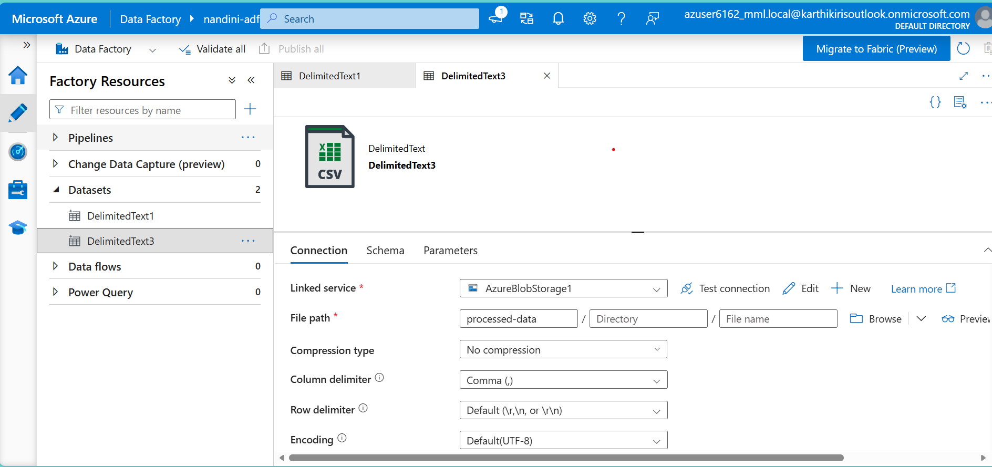

3.Pipeline Canva:
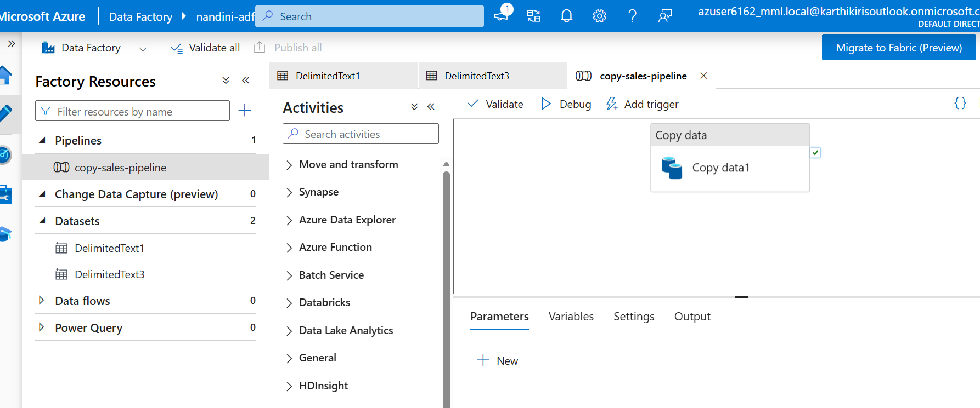

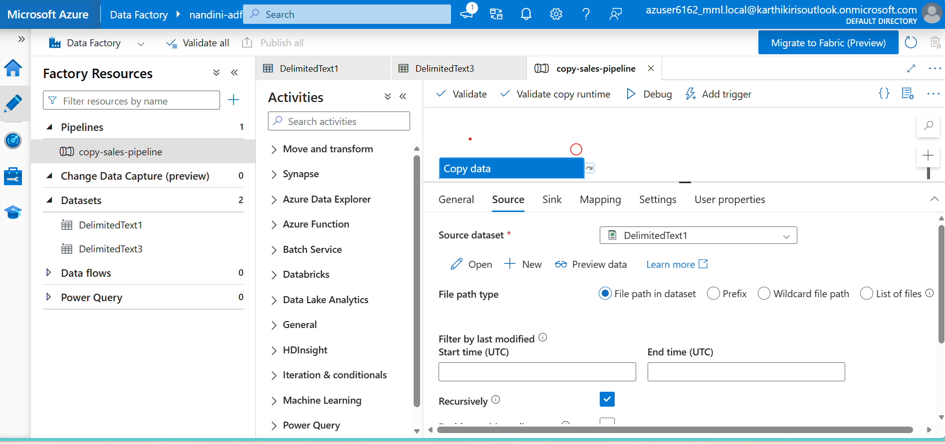

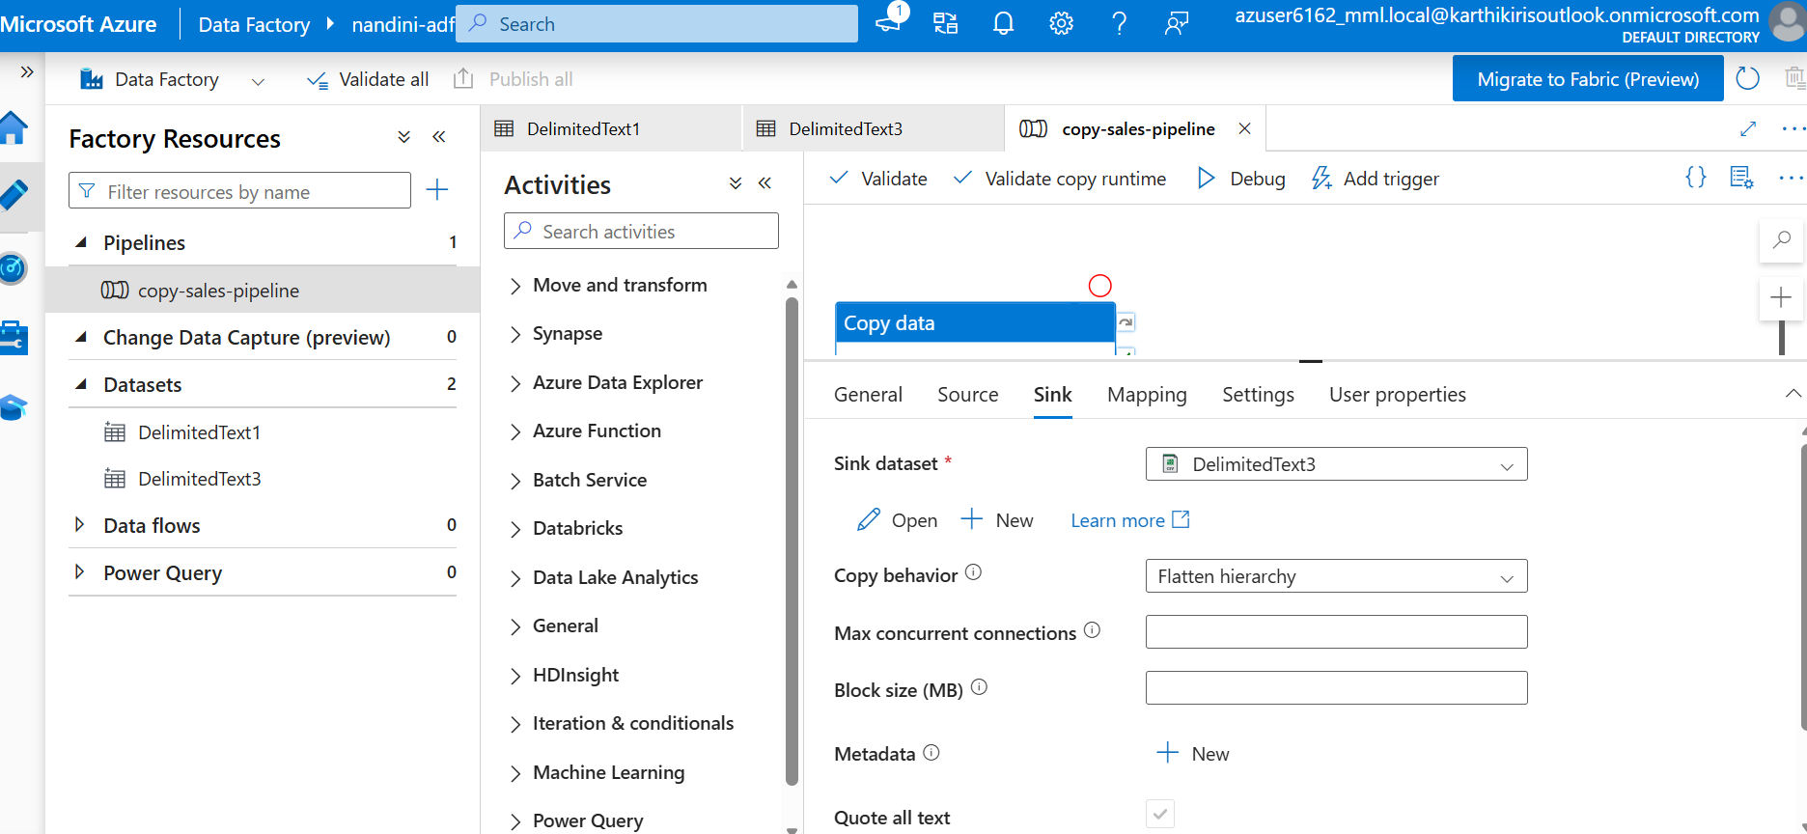

3. Azure Synapse

