- Write an Apache Spark GraphX program to construct a graph and find the shortest path from vertex 1 to all other vertices using ShortestPath algorithm.

Importing the required functions

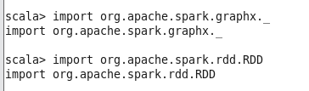

Defining the vertices and edges
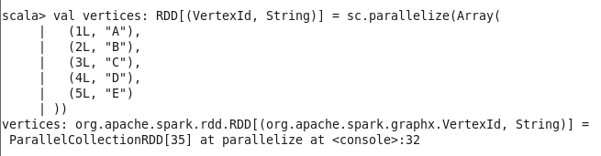

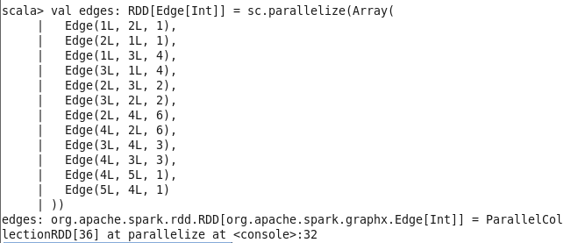

Building a graph

Shortest Path algorithm

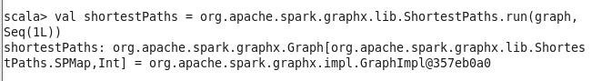

Output:
