**PE 08 - SQL EXTENSIONS #1**

**1.a) Summarize the Earnings by Year, Quarter and Month**

**i) ROLL-UP**

SELECT d.year , d.Quarter, d.Month , SUM(ef.earnings) AS TOTAL_EARNINGS

FROM PE_Earnings.earningsfact ef

JOIN PE_Earnings.datedim d ON ef.dateKey = d.dateKey

GROUP BY year, Quarter, Month WITH ROLLUP;

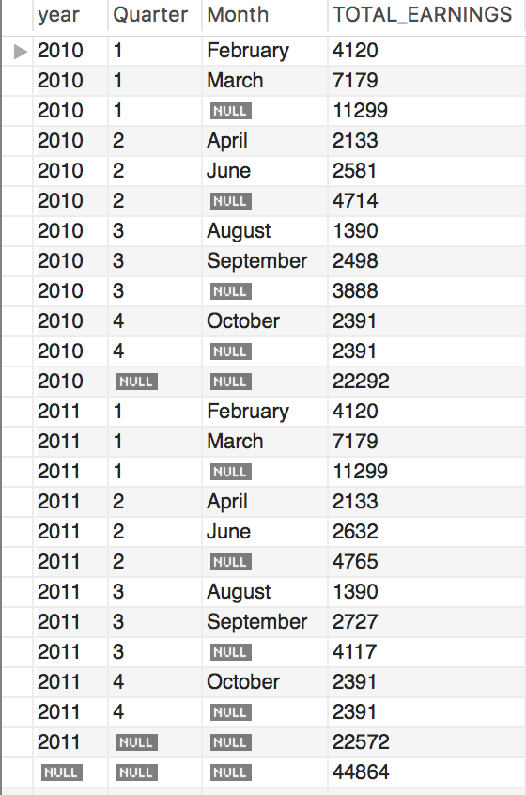

Roll up gives all possible subtotals only in the order of the columns specified in group by. In this query we are rolling up by month i.e we are aggregating the earnings by month and grouping by year, quarter and month. TOTAL_EARNINGS will give the subtotal of earnings made each month for every quarter of each year. We are joining earningsfact table with datedim table using the common field dateKey.

**ii) CUBE**

SELECT d.year , d.Quarter, d.Month , SUM(ef.earnings) AS TOTAL_EARNINGS

FROM PE_Earnings.earningsfact ef

JOIN PE_Earnings.datedim d ON ef.dateKey = d.dateKey

GROUP BY d.year, d.Quarter, d.Month WITH ROLLUP

UNION

SELECT d.year , d.Quarter, d.Month , SUM(ef.earnings) AS TOTAL_EARNINGS

FROM PE_Earnings.earningsfact ef

JOIN PE_Earnings.datedim d ON ef.dateKey = d.dateKey

GROUP BY d.year, d.Quarter WITH ROLLUP

UNION

SELECT d.year , d.Quarter, d.Month , SUM(ef.earnings) AS TOTAL_EARNINGS

FROM PE_Earnings.earningsfact ef

JOIN PE_Earnings.datedim d ON ef.dateKey = d.dateKey

GROUP BY d.year, d.Month WITH ROLLUP

UNION

SELECT d.year , d.Quarter, d.Month , SUM(ef.earnings) AS TOTAL_EARNINGS

FROM PE_Earnings.earningsfact ef

JOIN PE_Earnings.datedim d ON ef.dateKey = d.dateKey

GROUP BY d.Quarter, d.Month WITH ROLLUP

UNION

SELECT d.year , d.Quarter, d.Month , SUM(ef.earnings) AS TOTAL_EARNINGS

FROM PE_Earnings.earningsfact ef

JOIN PE_Earnings.datedim d ON ef.dateKey = d.dateKey

GROUP BY d.year WITH ROLLUP

UNION

SELECT d.year , d.Quarter, d.Month , SUM(ef.earnings) AS TOTAL_EARNINGS

FROM PE_Earnings.earningsfact ef

JOIN PE_Earnings.datedim d ON ef.dateKey = d.dateKey

GROUP BY d.Quarter WITH ROLLUP

UNION

SELECT d.year , d.Quarter, d.Month , SUM(ef.earnings) AS TOTAL_EARNINGS

FROM PE_Earnings.earningsfact ef

JOIN PE_Earnings.datedim d ON ef.dateKey = d.dateKey

GROUP BY d.Month WITH ROLLUP

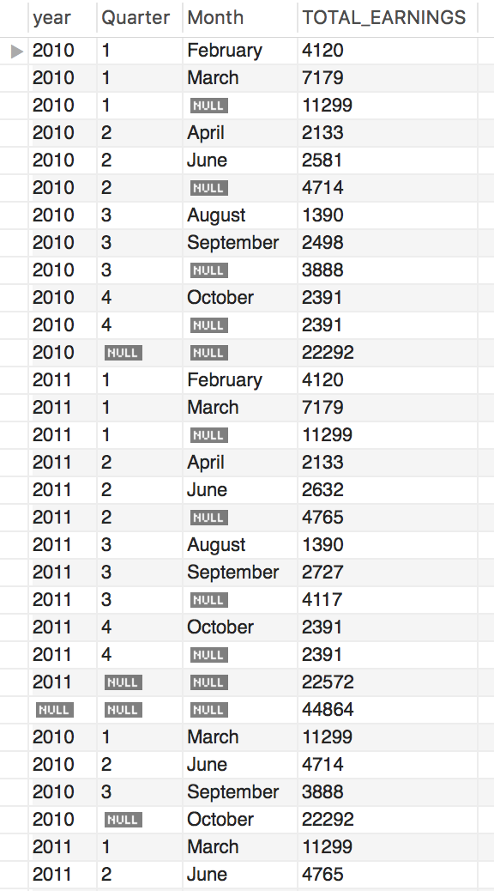

Cube gives all possible combinations of subtotal by doing a combination of select statements and unions. In this query we can get the total earnings of each month by quarter and year by doing select statements for all possible combinations of columns in group by and doing a union of all.

**1.b) Summarize the Earnings by Region, District and State for 2010 earnings only.**

**i) ROLL-UP**

SELECT c.regionName , c.districtName, c.state , SUM(ef.earnings) AS TOTAL_EARNINGS

FROM PE_Earnings.earningsfact ef

JOIN PE_Earnings.customerdim c ON ef.customerKey = c.customerKey

JOIN PE_Earnings.datedim d ON ef.dateKey = d.dateKey

WHERE d.year = '2010'

GROUP BY c.regionName , c.districtName, c.state WITH ROLLUP;

Roll up gives all possible subtotals only in the order of the columns specified in group by. In this query we are rolling up by state i.e we are aggregating the earnings by state and grouping by region, district and state. TOTAL_EARNINGS will give the subtotal of earnings made in each state by district and region for the year 2010. We are joining earningsfact table with datedim table using the common field dateKey.

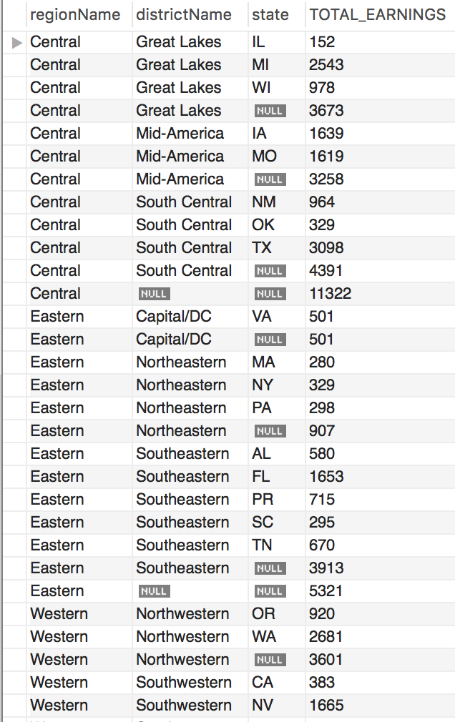

**ii) CUBE**

SELECT c.regionName , c.districtName, c.state , SUM(ef.earnings) AS TOTAL_EARNINGS

FROM PE_Earnings.earningsfact ef

JOIN PE_Earnings.customerdim c ON ef.customerKey = c.customerKey

JOIN PE_Earnings.datedim d ON ef.dateKey = d.dateKey

WHERE d.year = '2010'

GROUP BY c.regionName , c.districtName, c.state WITH ROLLUP

UNION

SELECT c.regionName , c.districtName, c.state , SUM(ef.earnings) AS TOTAL_EARNINGS

FROM PE_Earnings.earningsfact ef

JOIN PE_Earnings.customerdim c ON ef.customerKey = c.customerKey

JOIN PE_Earnings.datedim d ON ef.dateKey = d.dateKey

WHERE d.year = '2010'

GROUP BY c.regionName , c.districtName WITH ROLLUP

UNION

SELECT c.regionName , c.districtName, c.state , SUM(ef.earnings) AS TOTAL_EARNINGS

FROM PE_Earnings.earningsfact ef

JOIN PE_Earnings.customerdim c ON ef.customerKey = c.customerKey

JOIN PE_Earnings.datedim d ON ef.dateKey = d.dateKey

WHERE d.year = '2010'

GROUP BY c.regionName, c.state WITH ROLLUP

UNION

SELECT c.regionName , c.districtName, c.state , SUM(ef.earnings) AS TOTAL_EARNINGS

FROM PE_Earnings.earningsfact ef

JOIN PE_Earnings.customerdim c ON ef.customerKey = c.customerKey

JOIN PE_Earnings.datedim d ON ef.dateKey = d.dateKey

WHERE d.year = '2010'

GROUP BY c.districtName, c.state WITH ROLLUP

UNION

SELECT c.regionName , c.districtName, c.state , SUM(ef.earnings) AS TOTAL_EARNINGS

FROM PE_Earnings.earningsfact ef

JOIN PE_Earnings.customerdim c ON ef.customerKey = c.customerKey

JOIN PE_Earnings.datedim d ON ef.dateKey = d.dateKey

WHERE d.year = '2010'

GROUP BY c.regionName WITH ROLLUP

UNION

SELECT c.regionName , c.districtName, c.state , SUM(ef.earnings) AS TOTAL_EARNINGS

FROM PE_Earnings.earningsfact ef

JOIN PE_Earnings.customerdim c ON ef.customerKey = c.customerKey

JOIN PE_Earnings.datedim d ON ef.dateKey = d.dateKey

WHERE d.year = '2010'

GROUP BY c.districtName WITH ROLLUP

UNION

SELECT c.regionName , c.districtName, c.state , SUM(ef.earnings) AS TOTAL_EARNINGS

FROM PE_Earnings.earningsfact ef

JOIN PE_Earnings.customerdim c ON ef.customerKey = c.customerKey

JOIN PE_Earnings.datedim d ON ef.dateKey = d.dateKey

WHERE d.year = '2010'

GROUP BY c.state WITH ROLLUP;

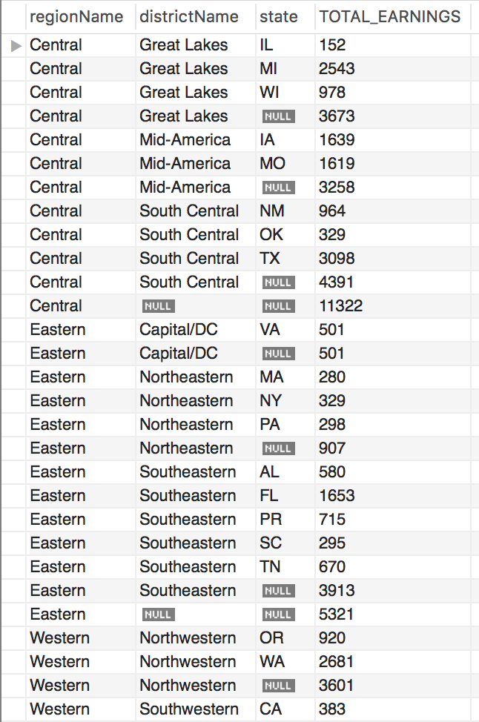

Cube gives all possible combinations of subtotal by doing a combination of select statements and unions. In this query we can get the total earnings of every state by district and region by doing select statements for all possible combinations of columns in group by and doing a union of all for the year 2010.

2) Use the ROLLUP example from question 1.b. but only show States with total earnings above 1000.

SELECT d.year, c.state , SUM(ef.earnings) AS TOTAL_EARNINGS

FROM PE_Earnings.earningsfact ef

JOIN PE_Earnings.customerdim c ON ef.customerKey = c.customerKey

JOIN PE_Earnings.datedim d ON ef.dateKey = d.dateKey

GROUP BY c.state WITH ROLLUP

HAVING d.year = '2010' and TOTAL_EARNINGS > 1000;

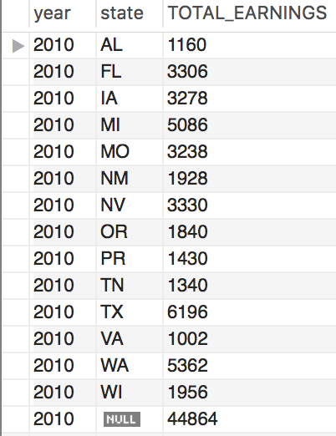

Here we are rolling up by state for the year 2010 and total earnings greater than 1000.