OUTPUTS:-
2.
customerID | gender | MultipleLines | InternetService | OnlineSecurity | DeviceProtection | TechSupport | StreamingTV | StreamingMovies | PaymentMethod | MonthlyCharges | TotalCharges | Churn
0 | 7590-VHVEG | Female | No phone service | DSL | No | No | No | No | No | Electronic check | 29.85 | 29.85 | No
1 | 5575-GNVDE | Male | No | DSL | Yes | Yes | No | No | No | Mailed check | 56.95 | 1889.50 | No
2 | 3668-QPYBK | Male | No | DSL | Yes | No | No | No | No | Mailed check | 53.85 | 108.15 | Yes
3 | 7795-CFOCW | Male | No phone service | DSL | Yes | Yes | Yes | No | No | Bank transfer (automatic) | 42.30 | 1840.75 | No
4 | 9237-HQITU | Female | No | Fiber optic | No | No | No | No | No | Electronic check | 70.70 | 151.65 | Yes
3.Shape: (99, 13)
<class 'pandas.core.frame.DataFrame'>
RangeIndex: 99 entries, 0 to 98
Data columns (total 13 columns):
# Column Non-Null Count Dtype
--- ------ -------------- -----
0 customerID 99 non-null object
1 gender 99 non-null object
2 MultipleLines 99 non-null object
3 InternetService 99 non-null object
4 OnlineSecurity 99 non-null object
5 DeviceProtection 99 non-null object
6 TechSupport 99 non-null object
7 StreamingTV 99 non-null object
8 StreamingMovies 99 non-null object
9 PaymentMethod 99 non-null object
10 MonthlyCharges 99 non-null float64
11 TotalCharges 99 non-null float64
12 Churn 99 non-null object
dtypes: float64(2), object(11)
memory usage: 10.2+ KB

MonthlyCharges | TotalCharges
count | 99.000000 | 99.000000
mean | 67.917677 | 2424.697475
std | 29.163910 | 2340.836332
min | 18.950000 | 20.150000
25% | 49.150000 | 512.625000
50% | 74.700000 | 1426.400000
75% | 94.925000 | 4062.250000
max | 113.250000 | 7895.150000
4.customerID 0
gender 0
MultipleLines 0
InternetService 0
OnlineSecurity 0
DeviceProtection 0
TechSupport 0
StreamingTV 0
StreamingMovies 0
PaymentMethod 0
MonthlyCharges 0
TotalCharges 0
Churn 0
dtype: int64

66666666666666666666
7. 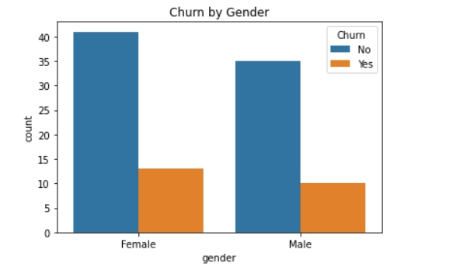8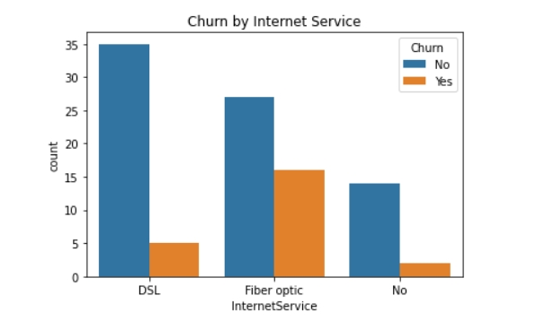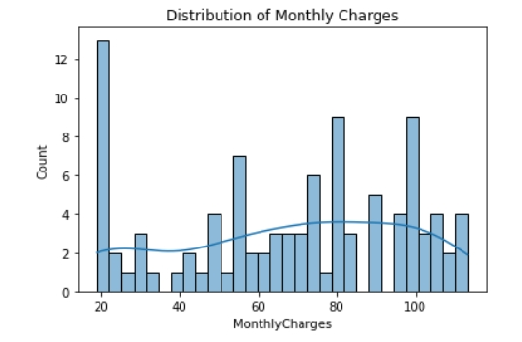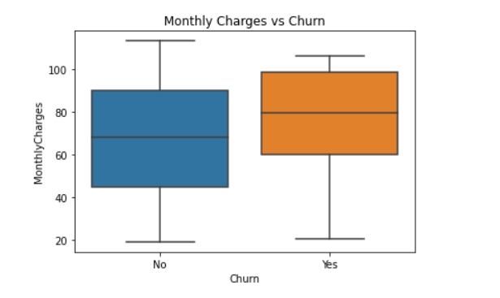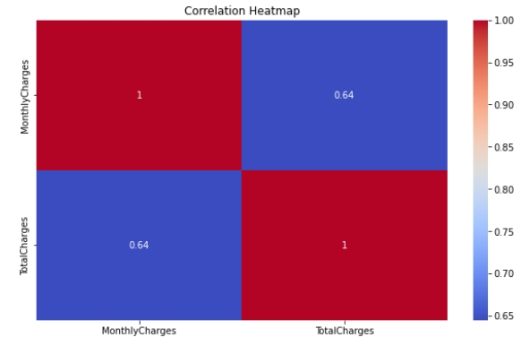11111111111111111111111
<class 'pandas.core.frame.DataFrame'>
RangeIndex: 99 entries, 0 to 98
Data columns (total 13 columns):
# Column Non-Null Count Dtype
--- ------ -------------- -----
0 customerID 99 non-null object
1 gender 99 non-null object
2 MultipleLines 99 non-null object
3 InternetService 99 non-null object
4 OnlineSecurity 99 non-null object
5 DeviceProtection 99 non-null object
6 TechSupport 99 non-null object
7 StreamingTV 99 non-null object
8 StreamingMovies 99 non-null object
9 PaymentMethod 99 non-null object
10 MonthlyCharges 99 non-null float64
11 TotalCharges 99 non-null float64
12 Churn 99 non-null object
dtypes: float64(2), object(11)
memory usage: 10.2+ KB

121212121212121212121212
MonthlyCharges | TotalCharges | Churn | customerID_0278-YXOOG | customerID_0280-XJGEX | customerID_0318-ZOPWS | customerID_0434-CSFON | customerID_0526-SXDJP | customerID_0557-ASKVU | customerID_0731-EBJQB | ... | InternetService_Fiber optic | InternetService_No | OnlineSecurity_Yes | DeviceProtection_Yes | TechSupport_Yes | StreamingTV_Yes | StreamingMovies_Yes | PaymentMethod_Credit card (automatic) | PaymentMethod_Electronic check | PaymentMethod_Mailed check
0 | 29.85 | 29.85 | 0 | 0 | 0 | 0 | 0 | 0 | 0 | 0 | ... | 0 | 0 | 0 | 0 | 0 | 0 | 0 | 0 | 1 | 0
1 | 56.95 | 1889.50 | 0 | 0 | 0 | 0 | 0 | 0 | 0 | 0 | ... | 0 | 0 | 1 | 1 | 0 | 0 | 0 | 0 | 0 | 1
2 | 53.85 | 108.15 | 1 | 0 | 0 | 0 | 0 | 0 | 0 | 0 | ... | 0 | 0 | 1 | 0 | 0 | 0 | 0 | 0 | 0 | 1
3 | 42.30 | 1840.75 | 0 | 0 | 0 | 0 | 0 | 0 | 0 | 0 | ... | 0 | 0 | 1 | 1 | 1 | 0 | 0 | 0 | 0 | 0
4 | 70.70 | 151.65 | 1 | 0 | 0 | 0 | 0 | 0 | 0 | 0 | ... | 1 | 0 | 0 | 0 | 0 | 0 | 0 | 0 | 1 | 0
1313131313131313131313

Accuracy: 0.7
Confusion Matrix:
[[11 1]
[ 5 3]]
Classification Report:
precision recall f1-score support

0 0.69 0.92 0.79 12
1 0.75 0.38 0.50 8

accuracy 0.70 20
macro avg 0.72 0.65 0.64 20
weighted avg 0.71 0.70 0.67 20

5555555555555555555

