**GIT**

**After installation of git check status of GIT**

**Git status**

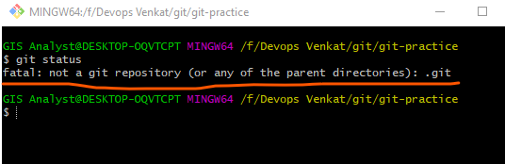

**First we need to initialize the git**

**Git init**

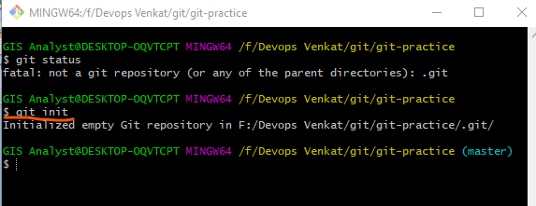

**Created .git folder in our git-practice folder**

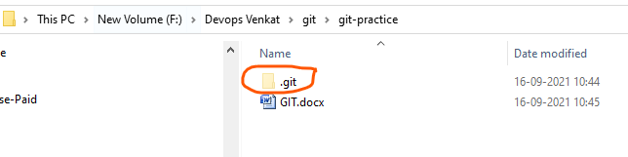

**Now check with git status**

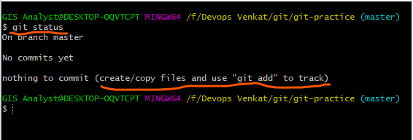

**Configure user name and email id**

git config --global user.name "nandikatti"



git config --global user.email “[nandikattilakshmi@outlook.com](mailto:nandikattilakshmi@outlook.com)”



**After init the git then we have three stages as below:**

**Workspace area** --- untracked files (which we are created files/modified)

**Staging/index area** ---------- intermediate

**Local repo** area ------- tracked files which we can push to central repository

We find this stage of areas only through commands in git

Git status

**To create file in git folder use below command:**

Touch <filename>

Touch file1

To list the files use ls

Ls

Check in which are is in file with command git status

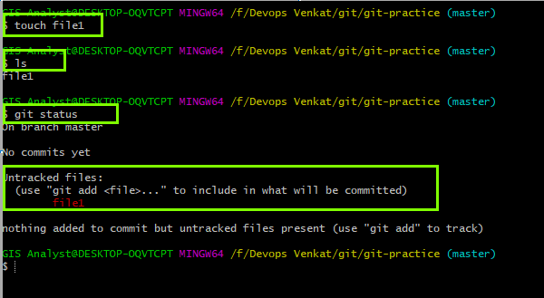

Now we need to add to staging

Git add file1

Now check with git status

It is in staging area

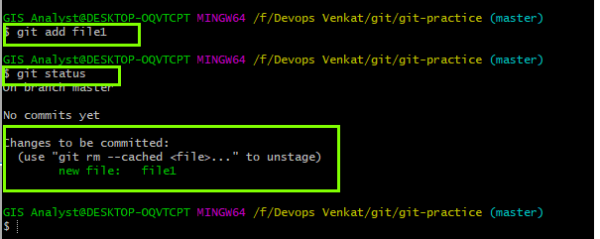

To add in local repo give below command

Git commit –m “sample commit” filename

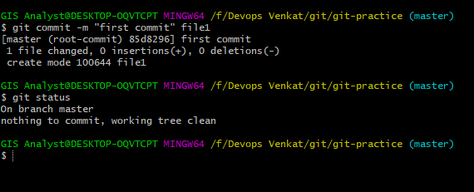

Check with git log

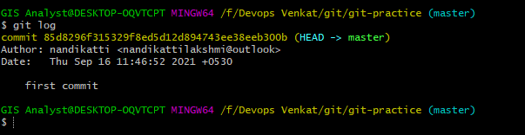

**Commands list:**

Git init

Git config –-global user.name “nandikatti”

Git config –global user.email “nandikattilakshmi”

Git config –list

Touch file

Git status

Git add file1

Git status

Git commit –m “first commit” file1

Git log

Git show cid

Add multiple files

Touch file2 file3 file4

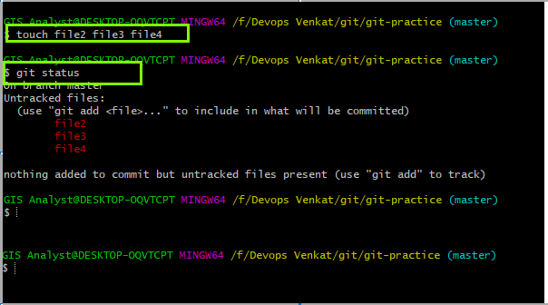

Add to staging

Git add .

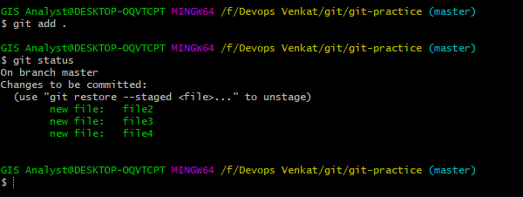

Add to local repo

Git commit –m “second commit” fiel2 file3

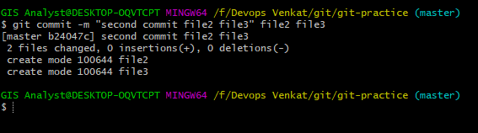

Add all files to local repo without giving file names

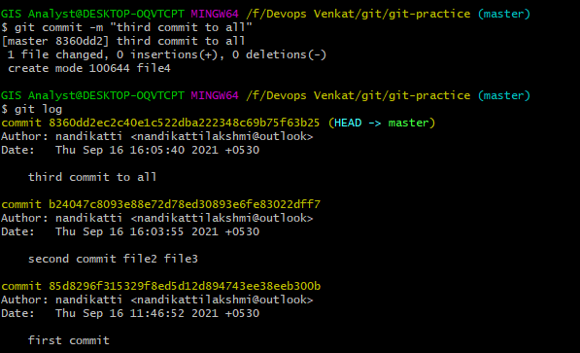

**If we need to remove from staging to workspace and local to workspace:**

**Staging to workspace**

**Git git reset Head <filename>**

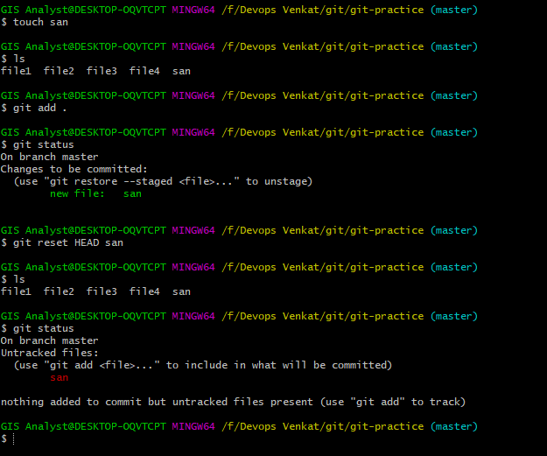

**From local repo to staging**

**Use n-1 cid**

**Git reset –soft cid**

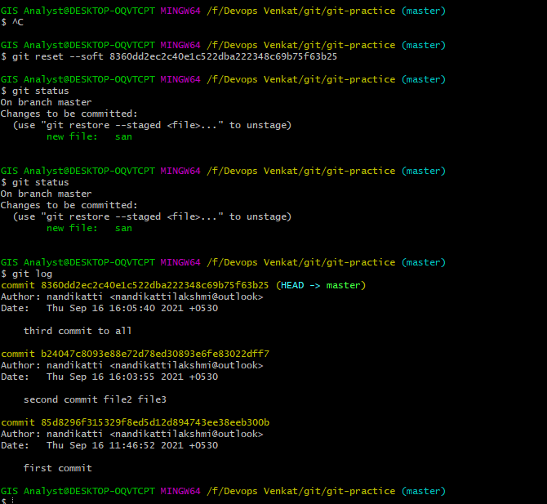

**For only modified files we can commit direct to local repo**

**Go to file and do some modification and give below command**

**Git commit –m “message” <file name>**

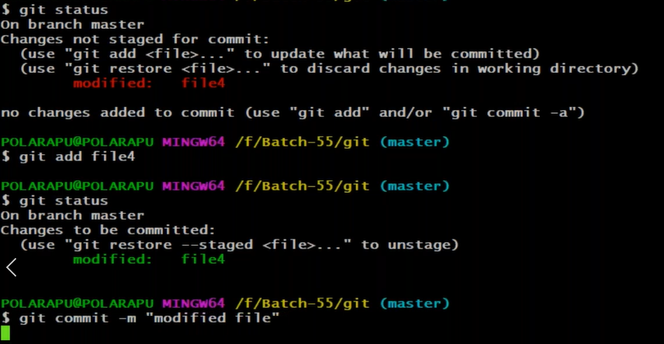

**Clone from central repo to local repo**

**Git clone and git hub link**

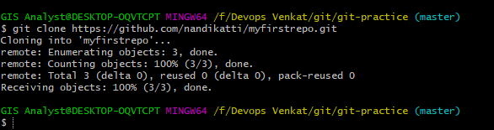

**Now go to the repository path of git and use git push command to push the file into central repo**

**Git push**

**If any authorization is required and give through website**

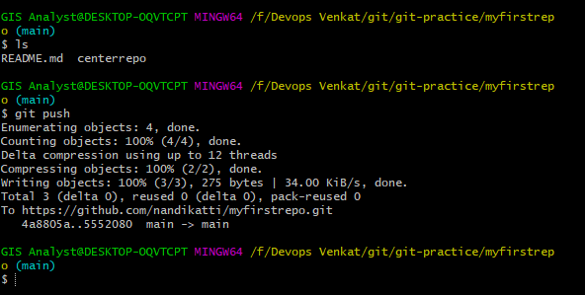

**Command list:**

**git clone** [**https://github.com/nandikatti/myfirstrepo.git**](https://github.com/nandikatti/myfirstrepo.git)

**check in git bash**

**ls**

**create file touch centerrepo**

**git status**

**git add centerrepo**

**git commit –m “test commit”**

**git log**

**git push**

**cd ..**