**Assignment – 3**

**Give a LAN and WAN Diagram. Explain about the same in simple words and with an example.**

**Local Area Network (LAN):**

LAN is a network that connects devices within a limited geographical area, typically a single building or campus. It allows devices to share resources like files, printers, and internet access. Common examples include home networks, office networks, and school networks

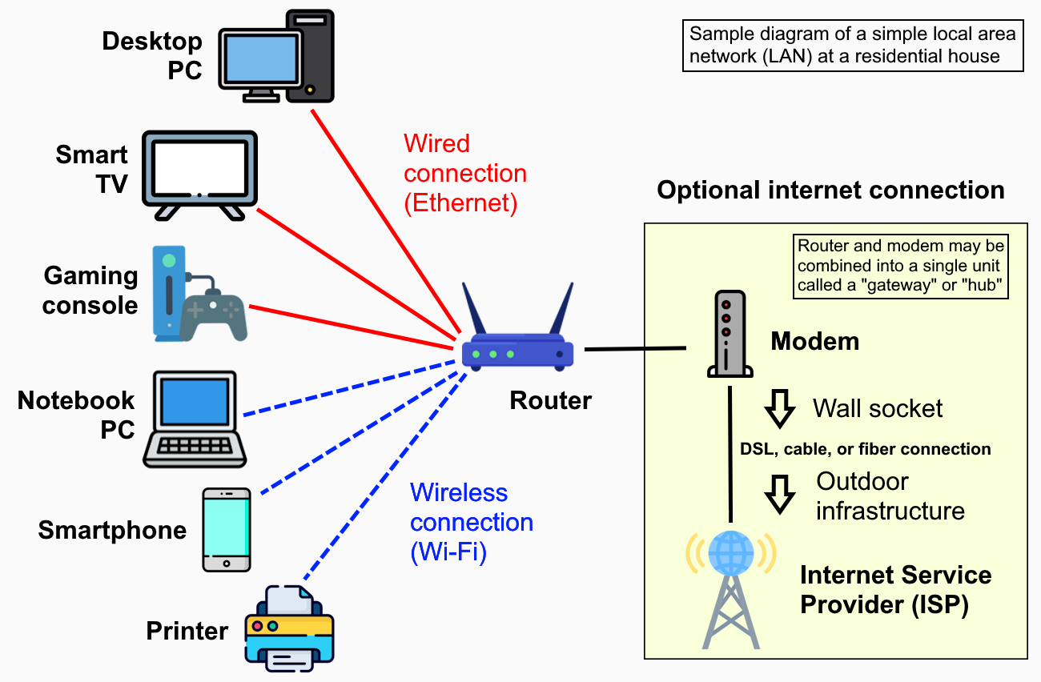

Key Characteristics:

* Limited Geographic Area:

LANs are defined by their small size, typically confined to a single building or campus.

* Resource Sharing:

LANs enable devices to share resources like files, printers, and internet connections.

* High Speed:

LANs typically offer fast communication speeds due to the limited distance and fewer devices involved.

* Various Components:

LANs consist of various components like routers, switches, cables, and access points.

**WAN - Wide Area Network:**

LAN is a computer network that spans a large geographical area, typically connecting multiple local area networks (LANs). It allows devices and networks in different locations to communicate and share information over long distances. Essentially, a WAN is a network of networks.

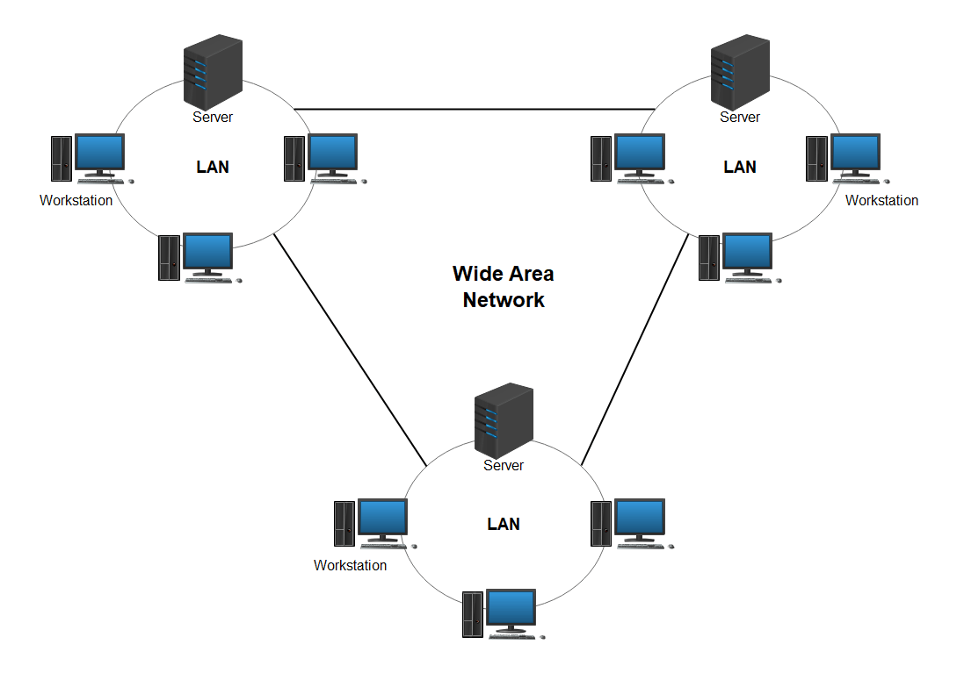

Here's a more detailed breakdown:

* Scope:

WANs are not confined to a single building or campus; they extend across cities, countries, or even the globe.

* Purpose:

WANs enable businesses to connect their branch offices, data centers, and cloud applications, facilitating communication and resource sharing.

* Examples:

The internet is the largest WAN, and businesses often use WANs to connect their various locations.

* Types:

WANs can be private (owned by a single organization) or public (like the internet), and they use various technologies like leased lines, fiber optics, and wireless connections.

* How it works:

WANs use networking technologies to create a virtual network that allows different LANs to communicate, often using routers or other devices to connect to the WAN.