**Assignment-1**

**Write a brief summary on SDLC, Explain each phase.**

The software development lifecycle (SDLC) is the cost-effective and time-efficient process that development teams use to design and build high-quality software. The goal of SDLC is to minimize project risks through forward planning so that software meets customer expectations during production and beyond.

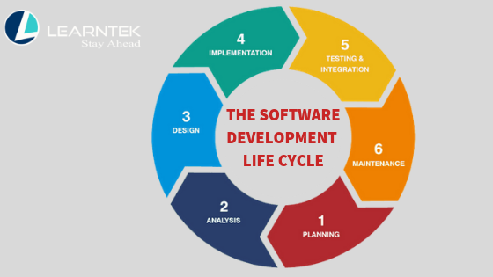

1. **Planning:**

The planning phase establishes the goals and scope of a software development project. During the project planning stage, the software development team brainstorms basic, high-level ideas about the project. These ideas include the problem or use case it will solve, who will use it and how the software might interact with other applications and systems.

1. **Analysis:**

Analysis phase is where you deeply understand the problem, gather requirements, and design a solution that which language should be selected to solve the problem . It's about translating high-level goals into a concrete plan, including defining system functions, identifying potential risks, and making sure the final product meets the user's needs.

1. **Design:**

The design phase is where developers create a blueprint or plan for how the software will be built. This includes deciding on the software's structure, user interface, database design, and how different parts will interact. It's like sketching out the plan for a house before it's built.

1. **Implementation:**

In this where the softwares comes into the picture.  This phase includes coding the software, integrating components, and ensuring security measures are in place. It's the point where the abstract design blueprints become a functional system.

1. **Testing & Integration:**

The testing phase in the Software Development Life Cycle (SDLC) is a crucial stage where developers and testers identify and fix defects in the software to ensure it meets requirements and functions as expected. This phase involves various types of testing.

1. **Maintenance:**

This is the phase where the live debugs will come. This phase focuses on fixing bugs, making enhancements, and adapting the software to evolving user needs and environments.