**Brief summary of differences on Agile and Waterfall.**

**Agile Methodology:**

Agile Methodology is a way to manage projects by breaking them into smaller parts. It focuses on working together and making constant improvements. Teams plan, work on the project, and then review how things are going in a repeating cycle.

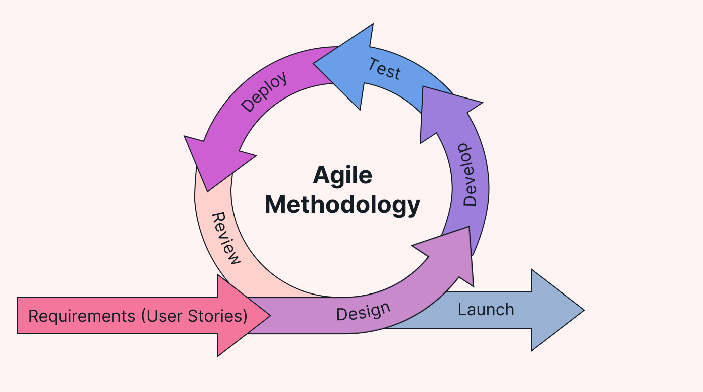

**Waterfall model:**

The Waterfall model is a linear, sequential software development process where each phase (requirements, design, implementation, testing, maintenance) must be completed before the next begins. It's a structured, step-by-step approach, often used when requirements are well-defined and stable. Waterfall model will not accept the user requirements once it starts the process.

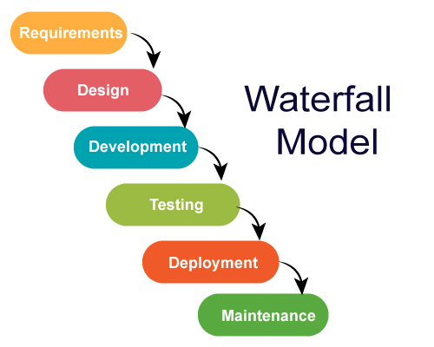

**Differences between Agile and Waterfall methodologies:**

**Agile** is an iterative approach to software development, emphasizing flexibility and collaboration among cross-functional teams. It focuses on delivering small, incremental releases, adapting to changes throughout the development process.

Where the **Waterfall** is a linear and sequential approach, where each phase must be completed before moving to the next. Changes are difficult to incorporate once a phase is completed. Agile promotes adaptability and customer feedback, while Waterfall provides a structured plan but may struggle with accommodating changes late in the development cycle