**Assignment**

Kanban and Lean Principles are both agile methodologies aimed at improving workflow efficiency, reducing waste, and ensuring that teams can deliver value faster.

**Kanban :**

Kanban is a visual management system that helps teams track and manage their work. The core idea is to visualize the workflow to improve efficiency and manage work in progress (WIP).

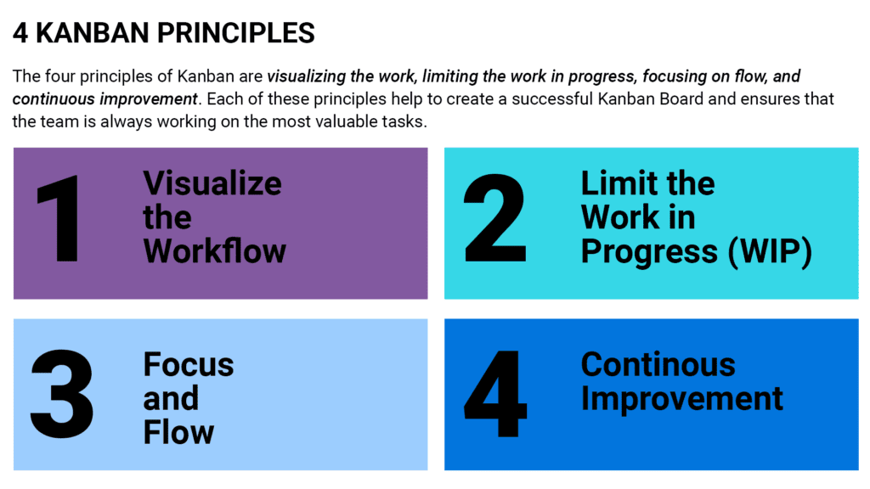

1. Visualizing Work: Kanban boards display tasks in columns (e.g., "To Do," "In Progress," "Done"). This helps teams see what needs to be done, what’s being worked on, and what’s completed.

•2. Limiting Work in Progress (WIP): Kanban limits the number of tasks that can be in progress at any one time, preventing bottlenecks and overloading the team.

3.Flow Management: By focusing on completing tasks and moving them to the "Done" column, teams can improve the flow of work and deliver value continuously.

4. Continuous Improvement: Kanban encourages regular reviews and adjustments to improve the process over time.

**Lean Principles :**

Lean principles focus on maximizing value for the customer while minimizing waste. The goal is to create more value with fewer resources.

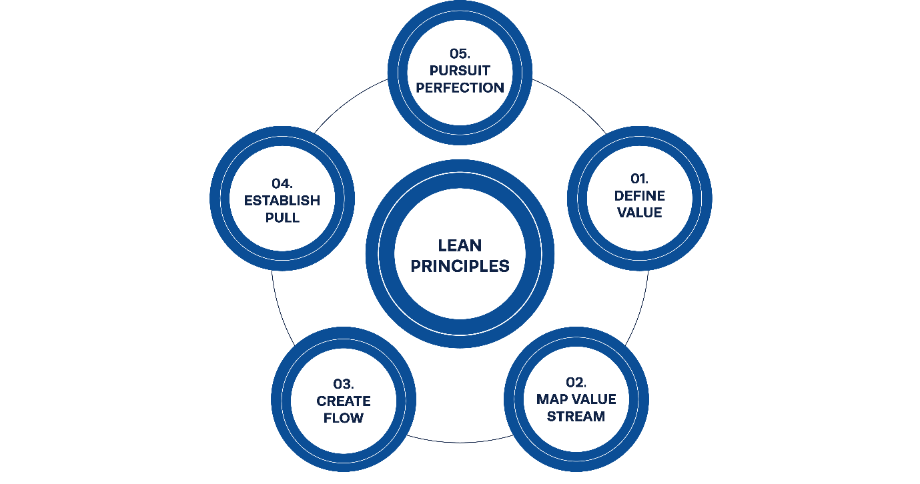

1. Value: Identify what is valuable to the customer and focus on delivering that.
2. Value Stream: Map out the entire process of delivering a product or service to the customer. Look for waste (steps that don’t add value) and eliminate them.
3. Flow: Ensure that work flows smoothly through the process without delays or bottlenecks. This helps in faster delivery.
4. Pull: Work is done only when needed, based on customer demand. This prevents overproduction and reduces unnecessary work.
5. Perfection: Continuously improve the process, aiming for perfection by reducing waste and improving quality over time.

Summary of Differences:

* Kanban is a visual system for managing work that focuses on flow and limiting work in progress (WIP).
* Lean Principles are broader guidelines aimed at eliminating waste, improving efficiency, and delivering value to the customer.

Both frameworks aim for continuous improvement, but Kanban focuses more on visualizing work and managing workflow, while Lean focuses on optimizing the overall system and eliminating waste.

Top of Form

Bottom of Form