# Includes Navigation Bar (clickable) , Heading ,Paragraph:

# Includes: links , lists and images aligned using padding concept of css

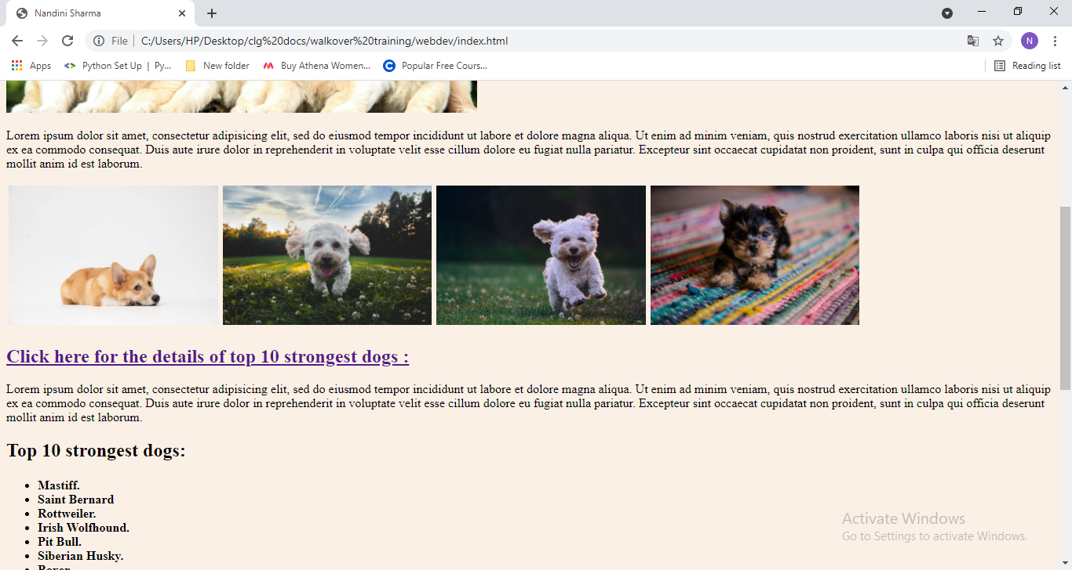

# Includes: Form ,links

