MACHINE LEARNING CASE STUDY
Customer Retention
Risk Model
An explainable framework for predicting cancellation risk and prioritizing timely retention outreach.
PROJECT THESIS
Predict earlier. Intervene thoughtfully.
A transparent logistic-regression pipeline turns pre-outcome customer signals into human-reviewed retention priorities.
"The goal is not to automate customer decisions. It is to help retention teams focus attention where it may matter most."
Public portfolio edition | Synthetic data only

EXECUTIVE OVERVIEW

From cancellation history to an action queue
The original prototype explored whether multiple customer, contract and service variables could predict a binary cancellation outcome. This public project retains that modeling logic while replacing all company-specific data, mappings and identities with synthetic examples.
BUSINESS VALUE
Rank risk before the outcome occurs.
Probability scores support targeted outreach, consistent review thresholds and measurable retention experiments.

Project at a glance
Layer | Public implementation | Decision supported
Data | Synthetic customer-level records | Safe reproduction and testing
Model | Logistic regression pipeline | Account-level cancellation probability
Operations | Risk bands and intervention threshold | Prioritized retention review
Governance | Leakage, fairness and drift checks | Responsible production use
Public metrics are illustrative and are not company performance results.

MODEL DESIGN

A reproducible, leakage-aware pipeline
The model uses only fields intended to exist before the cancellation decision. Categorical variables are encoded inside the pipeline, numerical variables are standardized and the outcome is evaluated on a held-out stratified sample.
01 Define the scoring moment
Document exactly when a score is produced and exclude fields created afterward.
02 Prepare features
Impute missing values, one-hot encode categories and scale numerical inputs.
03 Estimate risk
Fit logistic regression and return calibrated cancellation probabilities.
04 Connect to action
Translate probability into low, medium and high review bands.

Feature groups
Group | Examples | Control
Acquisition | Lead channel, region group | Review proxy and segment effects
Contract | Term length, plan index | Use values known at scoring time
Delivery | Installation delay, completion | Prevent downstream outcome leakage
Engagement | Support touchpoints, account age | Monitor distribution drift

RISK LANDSCAPE

Scores create a portfolio view, not a verdict
The synthetic distribution below demonstrates how a retention team can combine risk ranking with capacity planning. The threshold should reflect the cost of missed cancellations, the cost of outreach and the team's available review capacity.
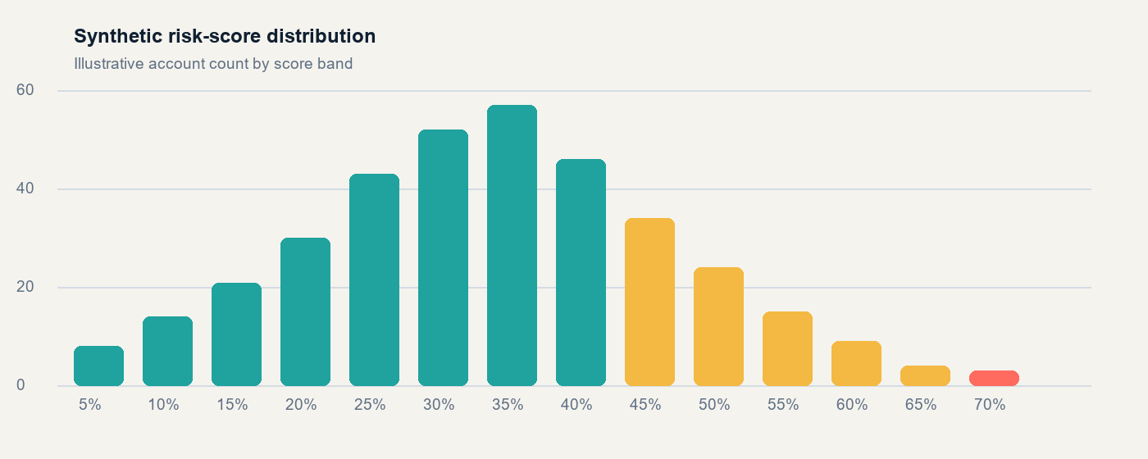
Figure 1. Synthetic risk-score distribution. Values are illustrative and not derived from company records.
THRESHOLD PRINCIPLE
A lower threshold catches more potential cancellations but creates a larger review queue.
Choose the operating point with precision-recall trade-offs, intervention capacity and customer experience in view.

VALIDATION

Accuracy alone is not enough
The source prototype reported a very high initial accuracy. A production-ready assessment should challenge that result before celebrating it: verify the split strategy, check for duplicate customers, test feature availability and compare against the majority-class baseline.

Evaluation scorecard
Measure | Why it matters | Failure signal
ROC-AUC | Ranking quality across thresholds | Near-random separation
Recall | Share of cancellations identified | Too many missed at-risk accounts
Precision | Quality of the outreach queue | Review effort wasted
Calibration | Whether probabilities match outcomes | Scores overstate or understate risk
Segment recall | Consistency across customer groups | Unequal error rates

LEAKAGE CHECK
Do not train on the answer in disguise.
Cancellation status, post-cancellation monitoring states and fields updated after the scoring moment must be excluded from production features.

OPERATING MODEL

Turn probability into the next best action
Risk band | Illustrative range | Recommended action | Service level
High | 70-100% | Human review; diagnose friction; prioritized outreach | Within 1 business day
Medium | 45-69% | Targeted nurture; confirm installation and service health | Within 3 business days
Low | 0-44% | Standard lifecycle communication; monitor for change | Routine cadence
Risk bands are operational examples. Final thresholds require validation against real intervention outcomes.

Closed-loop learning
Score: Create a timestamped probability using approved pre-outcome features.
Review: Show the leading drivers and let a trained owner confirm the outreach plan.
Intervene: Record the action, channel, timing and customer response.
Learn: Measure incremental retention lift, calibration and segment-level outcomes.

PRIVACY + GOVERNANCE

Designed for responsible public sharing
This case study was rebuilt rather than visually redacted. That prevents names, internal encodings, raw account records, notebook identifiers and screenshot metadata from surviving in hidden document parts or embedded images.

Public-release controls
Control | Implementation
De-identification | Company, product and employee identities removed
Synthetic replacement | Public dataset generated independently from source records
Metadata scrub | Creator, revision identity and custom metadata removed
Reproducibility | Training script, model card and dashboard included
Human oversight | Scores support review and do not automate adverse decisions

RELEASE RULE
Raw company records remain outside the repository.
Only synthetic data, anonymized documentation and generic feature categories are included in the public project.

Next production steps
Run temporal validation, probability calibration, feature-availability tests, duplicate-account checks, fairness review and a controlled retention experiment before deployment.

