CASE STUDY
Digital Lending Bureau Risk
and Lender Partnership Dashboard
A MySQL-to-Tableau decision system for originations, portfolio risk and partner governance
600  Applications | 312  Funded loans | 62.3%  PAR 30

Prepared as a portfolio analytics demonstration
Reporting cut-off: 31 July 2026 | Synthetic data | MySQL 8.0 + Tableau

Executive summary
PORTFOLIO CONCLUSION
The demonstration portfolio converts 64.0% of applications to approval and 81.2% of approvals to disbursal. Current PAR 30 is 62.3% and FPD is 23.1%, making partner selection and early collections the two highest-value management levers.

This case study demonstrates how a digital lender can bring bureau, application, partner and repayment data into one governed risk cockpit. The solution is intentionally decision-oriented: it allows executives to compare lenders, credit teams to inspect risk mix, and collections teams to prioritize accounts before delinquency becomes loss.

What the dashboard answers
- Which lender partners deliver the best combination of conversion and portfolio quality?
- Where does the application funnel lose eligible borrowers?
- How concentrated is bureau stress across utilization, enquiries and prior delinquency?
- Are newer vintages deteriorating faster at comparable months on book?
- Which accounts require action now, and what intervention is recommended?

Headline findings
Area | Observed result | Management implication
Originations | 600 applications; 384 approvals; 312 disbursals | Track conversion with risk-adjusted partner quality.
Current risk | 30+/60+/90+ account rates: 57.8% / 27.3% / 12.4% | Use exposure-weighted PAR for capital and collections prioritization.
First payment | FPD rate: 23.1% | Escalate first-cycle misses because they often signal affordability, process or fraud risk.
Early warning | 41 critical, 59 high, 12 watch accounts | Route accounts into differentiated treatment queues.
Note: All observed results in this report are generated from deterministic synthetic data and illustrate the analytical method rather than actual lender performance.

1. Business context and problem statement
Digital lending performance can look healthy at origination while deteriorating after disbursal. Application conversion, bureau quality, lender economics and repayment outcomes are often managed in separate systems. That fragmentation makes it difficult to distinguish productive growth from risk-heavy growth and delays intervention on accounts beginning to roll forward.

Business objective
Build a single MySQL analytical layer and Tableau dashboard that connects customer bureau behavior, the application funnel, lender-partner performance and repayment risk at an auditable grain.

Primary stakeholders
Stakeholder | Decision enabled
Executive / CRO | Risk-adjusted growth, lender comparison, PAR and vintage direction
Credit policy | Bureau-risk mix, approval outcomes and threshold review
Partnerships | Conversion, turnaround and quality by lender
Collections | DPD movement, FPD, roll rates and prioritized action queues
Data / BI | Metric governance, refresh reliability and reconciliation

Success criteria
- One governed definition for approval, disbursal, DPD, FPD, vintage, roll rate and PAR.
- Partner comparisons that balance conversion with downstream risk.
- Early-warning segmentation that explains each trigger and recommended treatment.
- Tableau sources separated by grain to prevent duplicate measures.
- Reconciliation checks that fail visibly before dashboard publication.

2. Solution architecture
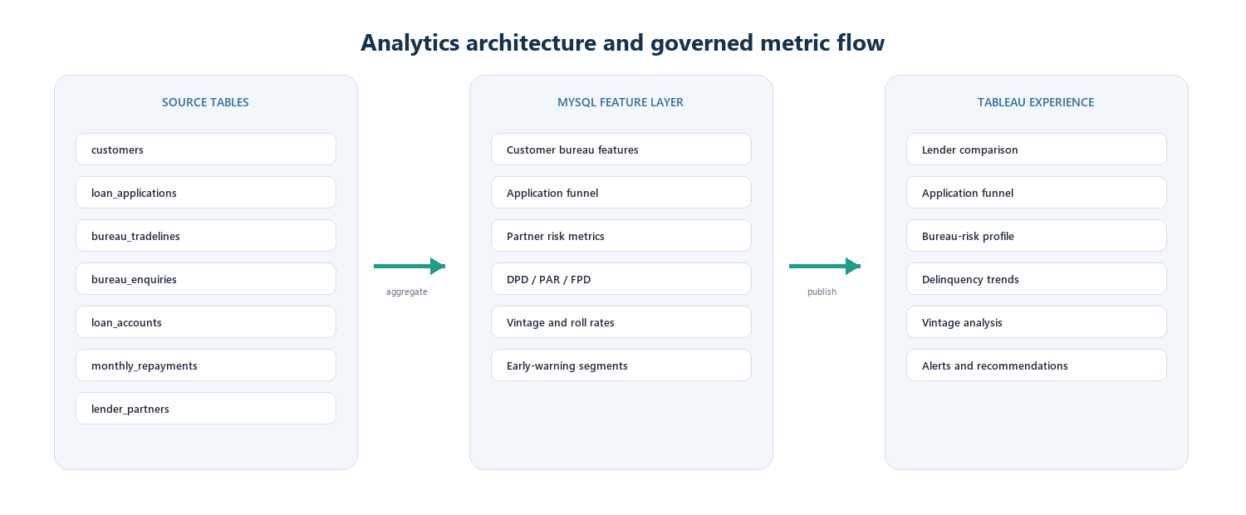
Figure 1. MySQL feature layer and Tableau consumption model
Seven normalized source tables preserve operational grain. Twelve MySQL views aggregate those tables into purpose-built Tableau sources. Each dashboard sheet connects to the view matching its analytical grain; views are not physically joined in Tableau, avoiding fan-out and double counting.

3. Data model
Table | Grain | Role
customers | Customer | Demographics, employment and income
loan_applications | Application | Requested terms, funnel status and decision dates
bureau_tradelines | Tradeline | Balances, limits, overdue, security and DPD
bureau_enquiries | Enquiry | Recent credit-seeking behavior
loan_accounts | Funded loan | Disbursal, pricing, tenure and account status
monthly_repayments | Installment | Contractual due, paid amount, DPD and outstanding
lender_partners | Partner | Partner type, risk share and target APR

Analytical views
- Customer bureau features: utilization, balance-to-income, enquiries, delinquency history and risk band.
- Application funnel: submitted, bureau processed, approved, rejected and disbursed flags with cycle times.
- Partner risk: approval, conversion, account DPD, exposure-weighted PAR and FPD.
- Behavioral risk: delinquency trend, vintage/MOB, roll-rate matrix and current portfolio-at-risk.
- Early warning: interpretable flags, severity segment, warning score and recommended action.
LEAKAGE CONTROL
The demo bureau report is dated immediately before each application. Enquiries are bounded to the report date, preventing post-decision data from leaking into the application risk profile.

4. Metric framework
Metric | Definition | Grain
Approval rate | Approved applications / submitted applications | Application
Approval-to-disbursal | Disbursed applications / approved applications | Application
30+/60+/90+ rate | Accounts at or beyond threshold / reporting accounts | Current account snapshot
PAR 30/60/90 | Outstanding principal at or beyond threshold / total outstanding | Current account snapshot
FPD | Loans with first installment 30+ / matured first installments | Funded loan
Vintage curve | PAR or DPD by origination month and MOB | Vintage x MOB
Roll rate | Accounts moving bucket A to B / accounts starting in A | Month x transition
DPD buckets are CURRENT, 1-29, 30-59, 60-89 and 90+. Future NOT_DUE installments are excluded from matured performance denominators.
WHY BOTH ACCOUNT RATE AND PAR MATTER
Account rates measure incidence. PAR measures capital exposure. A lender can have many small delinquent accounts but limited balance risk, or few large delinquent accounts with material exposure.

5. Dashboard - lender comparison and funnel
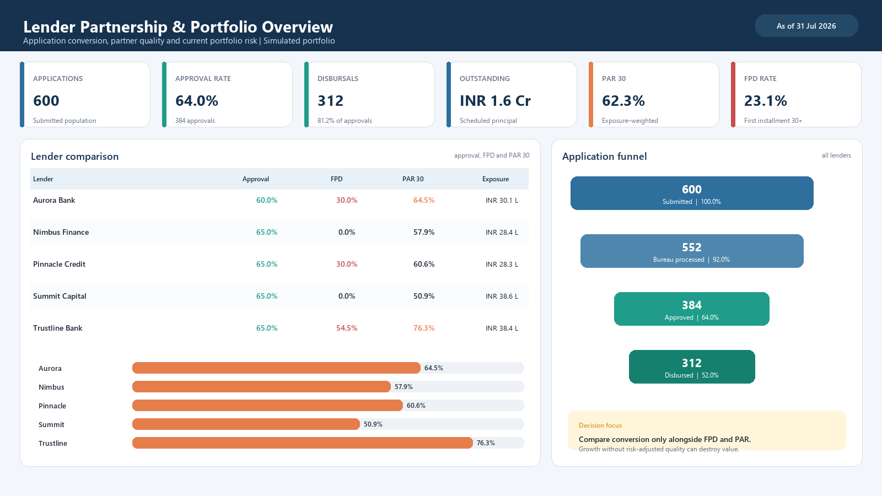
Figure 2. Executive lender and portfolio overview
The opening dashboard places conversion and risk on the same screen. Partner ranking is deliberately not based on approval rate alone; it also exposes FPD, PAR 30 and outstanding exposure.
DECISION INSIGHT
Summit Capital has the strongest risk position in the simulated comparison at 50.9% PAR 30, while Trustline Bank requires the closest joint review at 76.3% PAR 30. Commercial allocation should use a conversion-plus-risk scorecard, not funnel volume alone.

6. Dashboard - bureau-risk profile
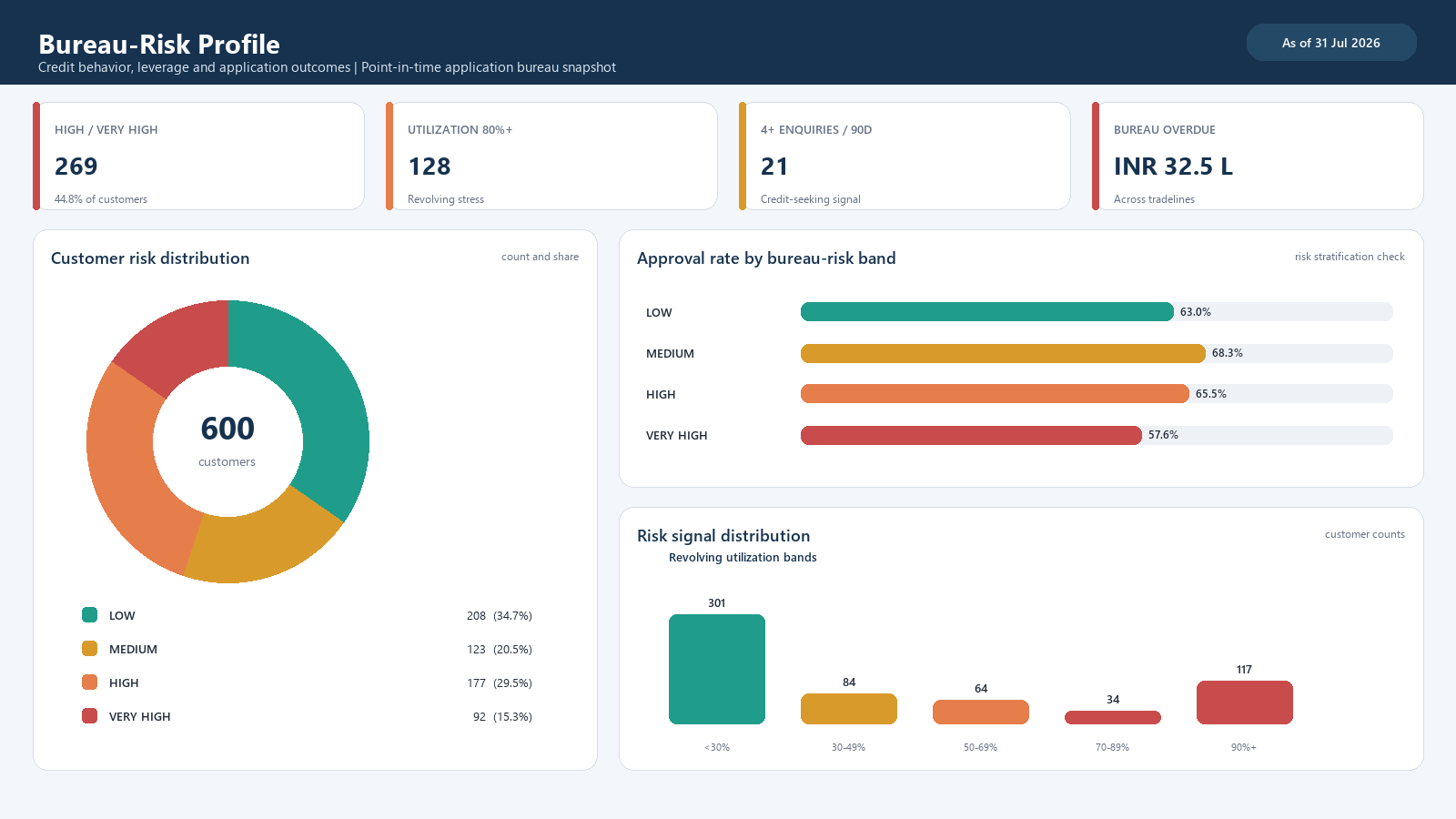
Figure 3. Bureau-risk profile and approval stratification
The bureau profile segments the applicant population before performance outcomes are considered. 269 of 600 customers fall into HIGH or VERY HIGH risk based on prior DPD, write-off indicators or high utilization.
POLICY INSIGHT
Approval rates should decrease as bureau risk rises. Any inversion by partner, product or channel is a prompt to examine override policy, bureau timing, affordability and fraud controls.

7. Dashboard - delinquency and vintage
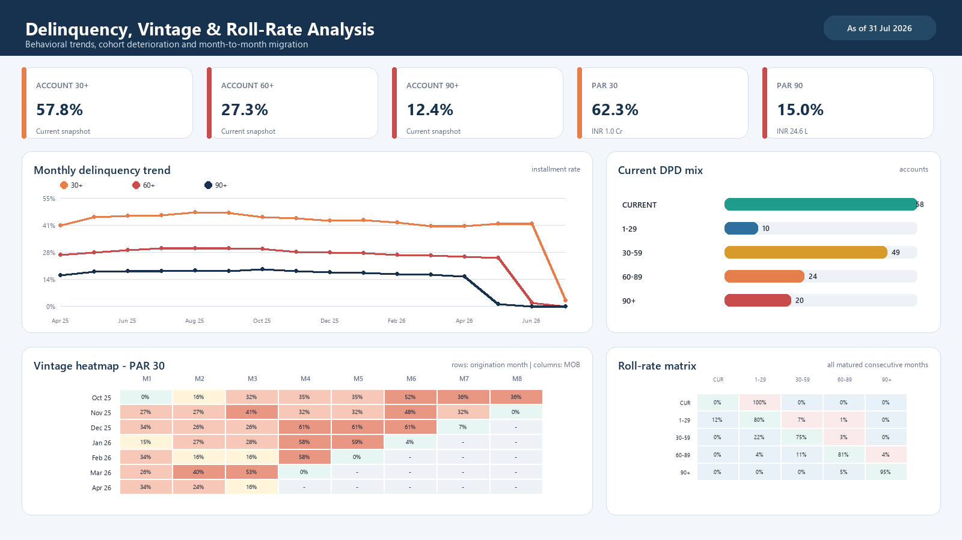
Figure 4. Delinquency trend, vintage heatmap and roll-rate matrix
The trend view shows portfolio direction, while the vintage heatmap compares cohorts at the same age. The roll-rate matrix separates stable accounts, cures and forward migration, which is more actionable than a single delinquency total.
COLLECTIONS INSIGHT
Current account 30+ is 57.8% and exposure-weighted PAR 30 is 62.3%. The gap indicates whether delinquency is concentrated in larger or smaller accounts and should influence queue priority.

8. Dashboard - alerts and recommendations
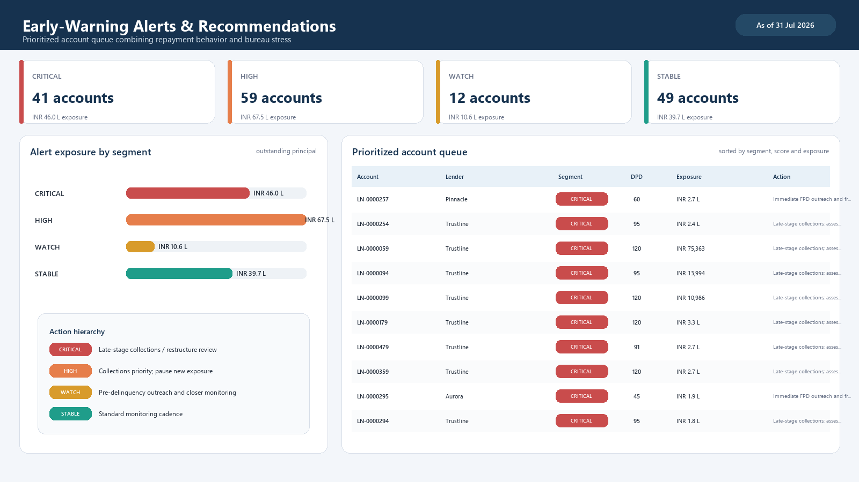
Figure 5. Early-warning exposure and prioritized account queue
The alert queue translates risk signals into operating actions. Severity uses current DPD, FPD, repeat shortfalls, worsening DPD, bureau utilization and enquiry intensity. The score is a sorting aid, not an automated credit decision.
ACTION INSIGHT
The current queue contains 41 critical and 59 high-risk accounts. Treatment should begin with the highest exposure inside each severity segment, with overrides recorded for auditability.

9. Findings and recommendations

Finding 1 - Conversion must be risk adjusted
Approval rate and disbursal volume are incomplete partner KPIs. The lender comparison shows how similar origination volumes can produce different FPD and PAR outcomes.
- Adopt a quarterly partner scorecard combining approval, approval-to-disbursal, FPD, PAR 30, PAR 90 and vintage deterioration.
- Move incremental allocation only after controlling for product, ticket size, bureau band and cohort age.

Finding 2 - First-cycle performance is an operational control point
The simulated FPD rate is 23.1%. First-installment failure can indicate affordability stress, mandate failure, onboarding defects or fraud and therefore merits a separate intervention path.
- Trigger outreach before and immediately after the first due date; monitor auto-debit setup and failed mandates.
- Review FPD by partner, channel and risk band before changing underwriting thresholds.

Finding 3 - Early warning should be treatment-oriented
A warning score is useful only when it leads to a clear action. The dashboard pairs each account with a segment and recommended response, allowing collections managers to manage capacity and monitor outcomes.
- Critical: late-stage collections and restructuring assessment.
- High: priority outreach, hardship/payment-date review, and pause new exposure.
- Watch: reminder, bureau refresh where appropriate, and increased monitoring frequency.

Finding 4 - Vintage and roll rates detect deterioration earlier
Static PAR answers where the book stands today. Vintage and roll-rate views explain whether new cohorts are worsening faster and where accounts migrate, enabling policy or collections changes before aggregate PAR fully reflects the shift.

10. Operating model
Cadence | Dataset / decision | Owner | Control
Daily | Applications, decisions, disbursals, payments | Data Engineering | Row counts, freshness, orphan checks
Weekly | Early-warning and collections queue | Collections Risk | Queue coverage, contact outcome, cures
Monthly | DPD, PAR, FPD, vintage and roll rates | Portfolio Risk | Ledger reconciliation and cohort sign-off
Quarterly | Partner scorecard and allocation | Risk + Partnerships | Risk-adjusted economics and policy actions

Tableau interaction model
- Partner selection filters every main sheet using partner name.
- Bureau-risk selection highlights the corresponding application population.
- Delinquency trend navigates to the roll-rate drill-through.
- Risk alerts sort by severity, warning score and exposure.
- Reset controls restore the portfolio view and the subtitle displays data freshness.

Refresh pattern
Load operational tables into MySQL, run data-quality gates, refresh or materialize the analytical views, then refresh Tableau extracts. Production should use an enterprise reporting-date control rather than a hard-coded demo cut-off.

11. Governance, limitations and next steps

Governance requirements
- Tokenize customer identifiers and restrict bureau attributes using least privilege.
- Retain bureau consent, purpose and permissible-use evidence.
- Version metric definitions and threshold changes; record manual overrides.
- Reconcile funded principal and outstanding exposure to finance and servicing ledgers.
- Test fairness, drift and stability before any early-warning signal influences a credit decision.

Case-study limitations
This report uses a deterministic synthetic portfolio designed to exercise every metric and dashboard state. It does not estimate expected credit loss, profitability, fraud probability or causal partner performance. DPD behavior is generated at contractual installment grain, and the alert rules are interpretable examples rather than validated predictive models.

Recommended production extensions
Phase | Extension | Outcome
Phase 1 | Operationalize reporting-date snapshots and reconciliations | Trusted recurring dashboard
Phase 2 | Add product, geography, channel and risk-adjusted margin | Allocation and pricing decisions
Phase 3 | Add cure, promise-to-pay, contact and collections outcome data | Treatment optimization
Phase 4 | Validate predictive early-warning model with monitoring and reason codes | Prioritized intervention at scale
RECOMMENDED NEXT DECISION
Pilot the partner scorecard and alert queue for one monthly cycle. Require metric reconciliation, named owners and documented actions before using results for allocation or policy changes.

Appendix A - Deliverables and reproducibility
The companion project contains the complete MySQL schema, deterministic seed procedure, twelve analytical views, quality checks, Tableau connection template, calculated fields and dashboard build instructions.
Artifact | Purpose
01_schema.sql | Seven source tables, keys, constraints and indexes
02_seed_demo_data.sql | 600-customer deterministic portfolio generator
03_analytics_views.sql | Feature, funnel, risk, DPD, FPD, vintage, roll, PAR and alert views
04_quality_checks.sql | Orphan, timeline, repayment and rate reconciliation tests
Tableau guide | Six dashboard sections plus roll-rate drill-through

Appendix B - Acceptance checklist
- All quality-check failed-row counts equal zero.
- Applications, approvals, disbursals, principal and outstanding reconcile.
- 30+ is greater than or equal to 60+, which is greater than or equal to 90+.
- FPD numerator never exceeds the matured first-payment denominator.
- Future NOT_DUE installments are excluded.
- Tableau percentage fields ending in _pct are not multiplied by 100 again.
- Equivalent filters are applied across independent Tableau data sources.
End of report

