nn269@phoenix28:/phoenix/S7/nn269/MS_Thesis$ python3 train.py [28/270]

Files already downloaded and verified

Finished Training vgg

Testing vgg

Accuracy of the network on the 10000 test images: 41 %

Accuracy of plane : 3 %

Accuracy of car : 92 %

Accuracy of bird : 27 %

Accuracy of cat : 52 %

Accuracy of deer : 37 %

Accuracy of dog : 0 %

Accuracy of frog : 27 %

Accuracy of horse : 76 %

Accuracy of ship : 81 %

Accuracy of truck : 12 %

Finished Training lenet

Testing lenet

Accuracy of the network on the 10000 test images: 30 %

Accuracy of plane : 0 %

Accuracy of car : 82 %

Accuracy of bird : 6 %

Accuracy of cat : 32 %

Accuracy of deer : 14 %

Accuracy of dog : 0 %

Accuracy of frog : 13 %

Accuracy of horse : 76 %

Accuracy of ship : 90 %

Accuracy of truck : 0 %

Finished Training resnet

Testing resnet

Accuracy of the network on the 10000 test images: 35 %

Accuracy of plane : 0 %

Accuracy of car : 100 %

Accuracy of bird : 9 %

Accuracy of cat : 50 %

Accuracy of deer : 33 %

Accuracy of dog : 0 %

Accuracy of frog : 13 %

Accuracy of horse : 64 %

Accuracy of ship : 81 %

Accuracy of truck : 12 %

-------------- Training and Testing using Original DS --------------

Finished Training vgg

Testing vgg

Accuracy of the network on the 10000 test images: 82 %

Accuracy of plane : 86 %

Accuracy of car : 96 %

Accuracy of bird : 72 %

Accuracy of cat : 70 %

Accuracy of deer : 85 %

Accuracy of dog : 69 %

Accuracy of frog : 83 %

Accuracy of horse : 84 %

Accuracy of ship : 90 %

Accuracy of truck : 94 %

Finished Training lenet

Testing lenet

Accuracy of the network on the 10000 test images: 54 %

Accuracy of plane : 41 %

Accuracy of car : 89 %

Accuracy of bird : 39 %

Accuracy of cat : 38 %

Accuracy of deer : 25 %

Accuracy of dog : 42 %

Accuracy of frog : 72 %

Accuracy of horse : 56 %

Accuracy of ship : 81 %

Accuracy of truck : 46 %

Finished Training resnet

Testing resnet

Accuracy of the network on the 10000 test images: 82 %

Accuracy of plane : 82 %

Accuracy of car : 92 %

Accuracy of bird : 72 %

Accuracy of cat : 73 %

Accuracy of deer : 74 %

Accuracy of dog : 69 %

Accuracy of frog : 80 %

Accuracy of horse : 88 %

Accuracy of ship : 93 %

Accuracy of truck : 89 %

_________________________________________________________

Finished Training vgg

Testing vgg

Accuracy of the network on the 10000 test images: 51 %

Accuracy of plane : 41 %

Accuracy of car : 39 %

Accuracy of bird : 42 %

Accuracy of cat : 35 %

Accuracy of deer : 81 %

Accuracy of dog : 60 %

Accuracy of frog : 2 %

Accuracy of horse : 88 %

Accuracy of ship : 62 %

Accuracy of truck : 76 %

Finished Training lenet

Testing lenet

Accuracy of the network on the 10000 test images: 28 %

Accuracy of plane : 0 %

Accuracy of car : 0 %

Accuracy of bird : 3 %

Accuracy of cat : 35 %

Accuracy of deer : 22 %

Accuracy of dog : 30 %

Accuracy of frog : 0 %

Accuracy of horse : 72 %

Accuracy of ship : 62 %

Accuracy of truck : 48 %

Finished Training resnet

Testing resnet

Accuracy of the network on the 10000 test images: 46 %

Accuracy of plane : 13 %

Accuracy of car : 25 %

Accuracy of bird : 27 %

Accuracy of cat : 52 %

Accuracy of deer : 74 %

Accuracy of dog : 57 %

Accuracy of frog : 0 %

Accuracy of horse : 84 %

Accuracy of ship : 75 %

Accuracy of truck : 66 %

-------------- Training and Testing using Original DS --------------

Finished Training vgg

Testing vgg

Accuracy of the network on the 10000 test images: 82 %

Accuracy of plane : 86 %

Accuracy of car : 85 %

Accuracy of bird : 78 %

Accuracy of cat : 55 %

Accuracy of deer : 92 %

Accuracy of dog : 72 %

Accuracy of frog : 86 %

Accuracy of horse : 84 %

Accuracy of ship : 93 %

Accuracy of truck : 84 %

Finished Training lenet

Testing lenet

Accuracy of the network on the 10000 test images: 53 %

Accuracy of plane : 41 %

Accuracy of car : 67 %

Accuracy of bird : 30 %

Accuracy of cat : 23 %

Accuracy of deer : 29 %

Accuracy of dog : 42 %

Accuracy of frog : 63 %

Accuracy of horse : 60 %

Accuracy of ship : 68 %

Accuracy of truck : 41 %

Finished Training resnet

Testing resnet

Accuracy of the network on the 10000 test images: 83 %

Accuracy of plane : 79 %

Accuracy of car : 85 %

Accuracy of bird : 78 %

Accuracy of cat : 70 %

Accuracy of deer : 85 %

Accuracy of dog : 60 %

Accuracy of frog : 77 %

Accuracy of horse : 92 %

Accuracy of ship : 93 %

Accuracy of truck : 89 %

_______________________________________________

30 epochs

Finished Training vgg

Testing vgg

Accuracy of the network on the 10000 test images: 54 %

Accuracy of plane : 44 %

Accuracy of car : 39 %

Accuracy of bird : 39 %

Accuracy of cat : 44 %

Accuracy of deer : 70 %

Accuracy of dog : 63 %

Accuracy of frog : 5 %

Accuracy of horse : 92 %

Accuracy of ship : 71 %

Accuracy of truck : 76 %

Finished Training lenet

Testing lenet

Accuracy of the network on the 10000 test images: 31 %

Accuracy of plane : 6 %

Accuracy of car : 7 %

Accuracy of bird : 3 %

Accuracy of cat : 29 %

Accuracy of deer : 44 %

Accuracy of dog : 30 %

Accuracy of frog : 0 %

Accuracy of horse : 80 %

Accuracy of ship : 53 %

Accuracy of truck : 64 %

Finished Training resnet

Testing resnet

Accuracy of the network on the 10000 test images: 48 %

Accuracy of plane : 31 %

Accuracy of car : 39 %

Accuracy of bird : 21 %

Accuracy of cat : 47 %

Accuracy of deer : 77 %

Accuracy of dog : 57 %

Accuracy of frog : 0 %

Accuracy of horse : 80 %

Accuracy of ship : 75 %

Accuracy of truck : 64 %

-------------- Training and Testing using Original DS --------------

Finished Training vgg

Testing vgg

Accuracy of the network on the 10000 test images: 83 %

1. Accuracy of plane : 86 %
2. Accuracy of car : 92 %
3. Accuracy of bird : 81 %
4. Accuracy of cat : 61 %
5. Accuracy of deer : 96 %
6. Accuracy of dog : 66 %
7. Accuracy of frog : 72 %
8. Accuracy of horse : 84 %
9. Accuracy of ship : 96 %
10. Accuracy of truck : 92 %

Finished Training lenet

Testing lenet

Accuracy of the network on the 10000 test images: 58 %

1. Accuracy of plane : 58 %
2. Accuracy of car : 75 %
3. Accuracy of bird : 33 %
4. Accuracy of cat : 38 %
5. Accuracy of deer : 25 %
6. Accuracy of dog : 48 %
7. Accuracy of frog : 72 %
8. Accuracy of horse : 52 %
9. Accuracy of ship : 75 %
10. Accuracy of truck : 58 %

Finished Training resnet

Testing resnet

Accuracy of the network on the 10000 test images: 84 %

1. Accuracy of plane : 89 %
2. Accuracy of car : 82 %
3. Accuracy of bird : 75 %
4. Accuracy of cat : 73 %
5. Accuracy of deer : 77 %
6. Accuracy of dog : 66 %
7. Accuracy of frog : 83 %
8. Accuracy of horse : 92 %
9. Accuracy of ship : 96 %
10. Accuracy of truck : 92 %
11. Counter({7: 500})
12. Counter({5: 500})
13. Counter({5: 500})

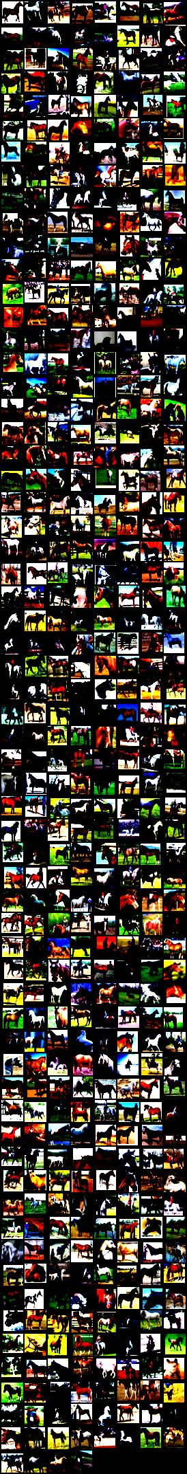 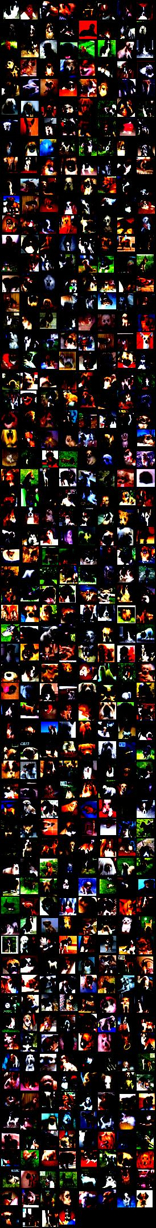 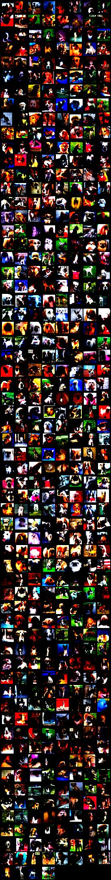

Figure: Horse, dog and dog (left to right)

1. Counter({4: 500})
2. Counter({3: 500})
3. Counter({3: 500})
4. Counter({4: 500})
5. Counter({3: 500})
6. Counter({7: 500})
7. Counter({4: 500})

Distilled datasets – teacher student networks

Try random stuff

Don’t just use the set hallO

1. Counter({7: 375, 5: 77, 6: 44, 9: 4})
2. Counter({1: 250, 7: 96, 4: 78, 2: 48, 5: 12, 0: 12, 6: 4})
3. Counter({1: 157, 7: 134, 4: 127, 5: 40, 2: 29, 6: 10, 0: 2, 9: 1})
4. Counter({9: 440, 7: 59, 4: 1})
5. Counter({2: 285, 3: 137, 8: 31, 4: 30, 0: 9, 9: 7, 5: 1})
6. Counter({9: 287, 3: 84, 8: 48, 4: 39, 2: 33, 1: 6, 0: 3})
7. Counter({8: 305, 5: 131, 0: 34, 7: 19, 3: 7, 2: 4})
8. Counter({9: 253, 4: 174, 8: 36, 2: 24, 3: 13})
9. Counter({7: 239, 5: 188, 9: 65, 6: 7, 4: 1})
10. Counter({8: 497, 5: 1, 9: 1, 0: 1})
11. Counter({4: 306, 0: 193, 7: 1})
12. Counter({5: 500})
13. Counter({5: 491, 6: 8, 2: 1})
14. Counter({3: 500})
15. Counter({7: 500})
16. Counter({2: 268, 7: 232})
17. Counter({7: 500})
18. Counter({7: 400, 2: 100})
19. Counter({7: 498, 4: 2})

# Counter({7: 500})

Aws, azure

Oracle

Bloomberg

Microsoft

Google

Cost-wise table

What datasets are there

Johnson school library!!