**Demo-PPM**

Hi Every one,

Earlier we were devoloped six type of Reports like

* Login
* Membership
* Transaction
* Subscription
* Coupons
* Upgrades & Downgradees
* RFM Analysis

As a visitor or a customer going to search a website for buying a product or a plan ,if that customer may or may not login the site ,

If he login the site if he may or maynot the member ,if he takes the membership for plan all the transactions details are stored in the Transaction report , after completion of transactions all the subscription details are strored in the Subscription table only at that time of subscription he may have some coupons available if he apply coupons all the coupons details are stored in the Coupons report.

These are the after login the website and takes subscription plans details.

Now we were devoloped the Before Login Page as the Customers were before taking the subscriptions if he may or may not searching the website ,if he directly taking the plans and if don’t know about the plan details he search the website and he taking the plans.

Ex: some of the friends or coleagues were using the health insurance plan he satisfied that plan and he suggests that plan as his friend or coleagues so that, they were directly going to take the plan subscription without searching the plan or any product.

Here we were explains as the who are the with search customers / without search customers of Total Visits Customers.

How many Transaction were done based on with search transactions and without search transactions of Total transactions.

How much Revenue will get the with search revenue and without search Revenue of Total Revenue.

This is the total Detail reports of the before login page.

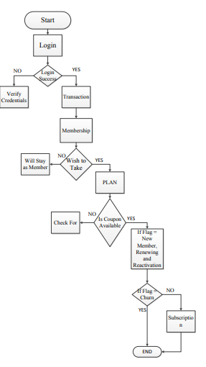

Here we were devoloped the Before Login page explains as the Health Insurance plans we were compares to our reports, in this dashboard given a quize whatever the requirement of the customer he choose that plan which plan can suits his he will decide that based on the requirement.

It will display as the Top Most plan and top revenue of that plan why this is Top Most plan means Customer Satisfaction is high, plan flexibility,plan publicity based upon that this is the top most plan compare to other companies this is the best plan whatever he takes the quize based upon the requirement it will display the top most plan.

Here we can give a option to the customers ,If he don’t like this this company he want move the next top most companies which ever available companies in our list.

**Before Login Page:**

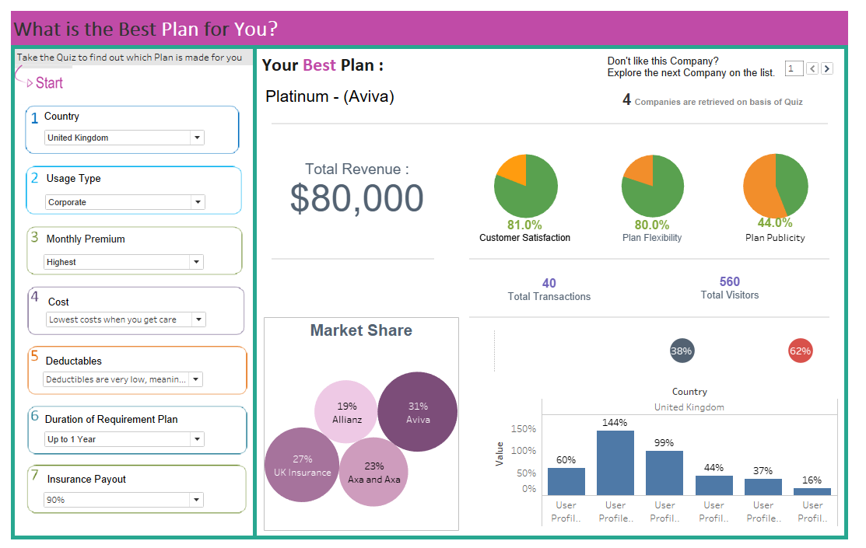

Here we gave the quiz questions were

Which country like

1. Uk
2. India

Usage type:

1. Corporate
2. Personal or Individual

Monthly Premium:

1. Higest
2. High
3. Lowest
4. Moderate

Cost & Deductables were based on the Monthly Premium these options were selected.

Duration of the Plan:

1. Up to 1 year
2. Up to 9 months
3. Up to 6 months
4. Up to 3 months.

Insurance Payout:

1. 60%
2. 70%
3. 80%
4. 90%

These were the questions required to take the quiz of the customers before taking the plan subscription.

Here we were explains the gender percentages as female % and male % shown as the circles.

Age group were devided as the bar chart it displays as the age group take as

13-19

20-29

30-39

40-49

60+

Like that we were taking the age group wise percentages.

Market share as explains the total country wise company wise percentages.