**Chat Bot**

**Chat Bot:**

A chatbot is a program simulates a conversation between a user and a computer.

How it works:

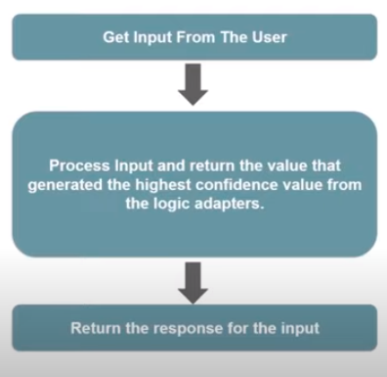

Import the needed libraries for chatbot:

#import the library

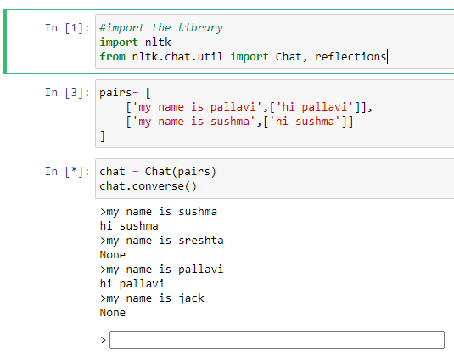

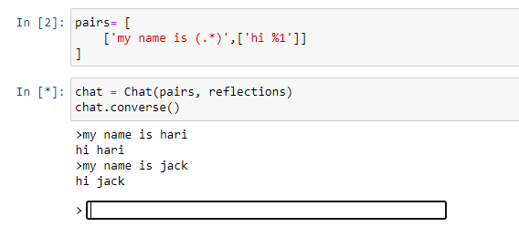

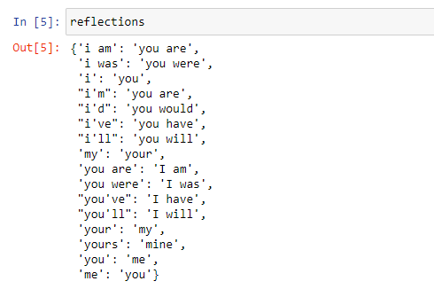

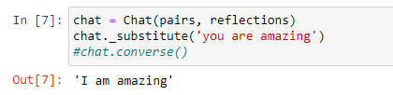

It gives you the matched substitues.

Replace with your own reflections:

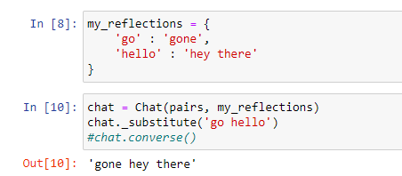

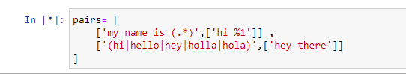

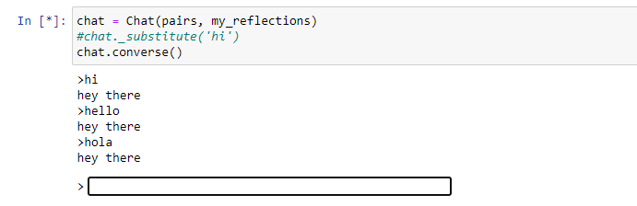

To get the multiple outputs:

