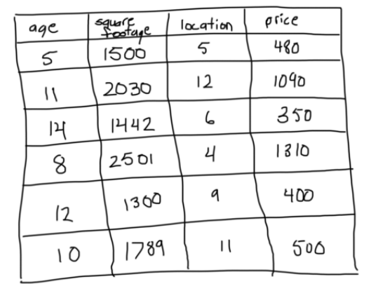

**Step 1: Calculate the average of the target label**

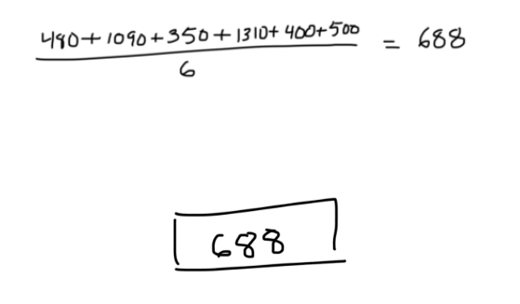

## Step 2: Calculate the residuals

residual = actual value – predicted value

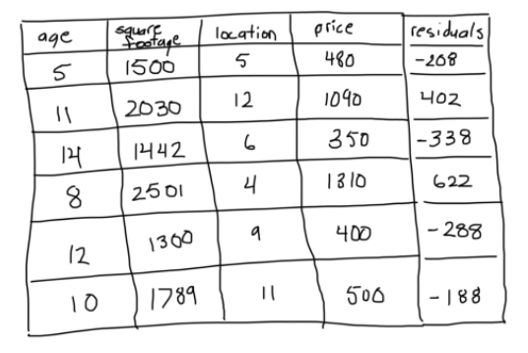

## Step 3: Construct a decision tree

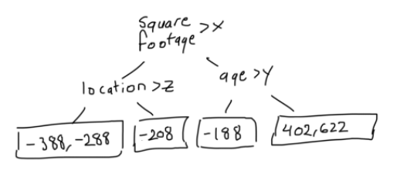

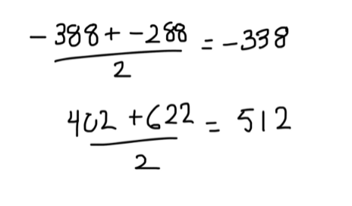

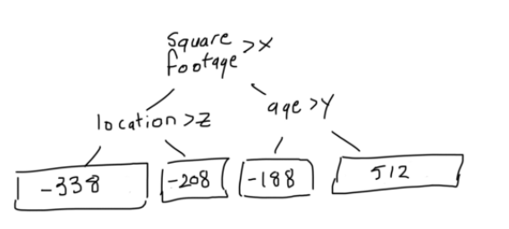

## Step 4: Predict the target label using all of the trees within the ensemble

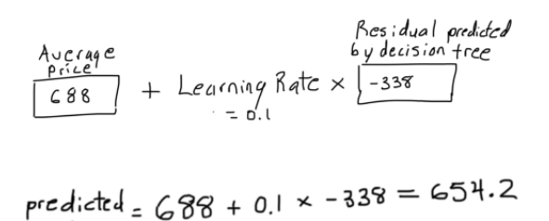

## Step 5: Compute the new residuals

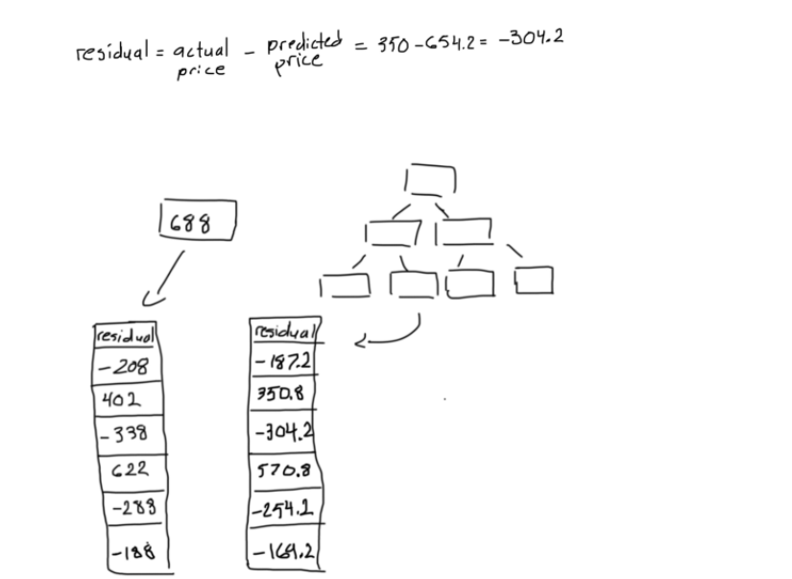

## Step 6: Repeat steps 3 to 5 until the number of iterations matches the number specified by the hyperparameter (i.e. number of estimators)

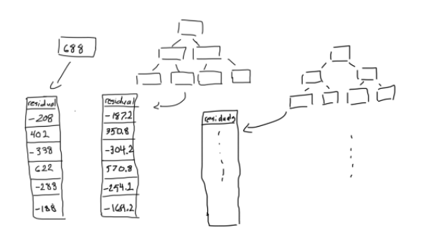

## Step 7: Once trained, use all of the trees in the ensemble to make a final prediction as to the value of the target variable

