**OCT-Task1**

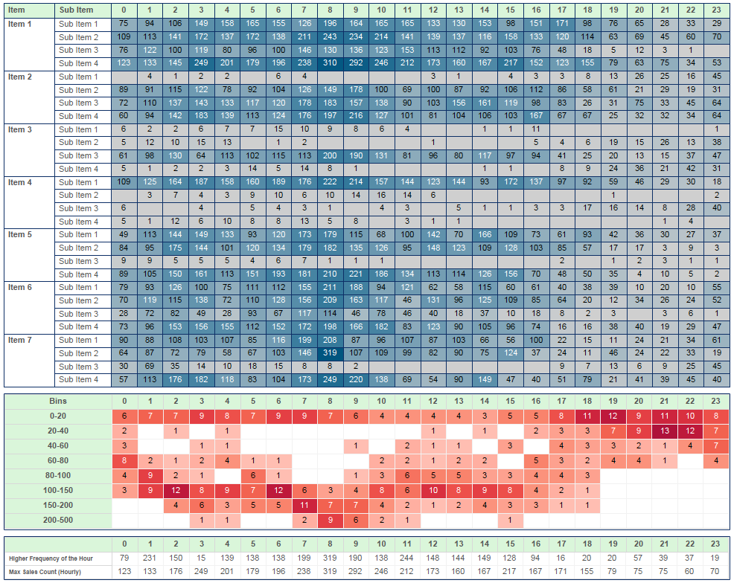

**Report—1**

Hour in Columns

Item, Sub Item in Rows.

Sales Count in Color, Text

**Report--2**

Hour in Columns

Bins in Rows.

Here we need to create Calculation on Bins.

IF [Sale Count]>=0 AND [Sale Count]<=20 THEN "0-20"

ELSEIF [Sale Count] >=20 AND [Sale Count]<=40 THEN "20-40"

ELSEIF [Sale Count] >=40 AND [Sale Count]<=60 THEN "40-60"

ELSEIF [Sale Count] >=60 AND [Sale Count]<=80 THEN "60-80"

ELSEIF [Sale Count] >=80 AND [Sale Count]<=100 THEN "80-100"

ELSEIF [Sale Count] >=100 AND [Sale Count]<=150 THEN "100-150"

ELSEIF [Sale Count] >=150 AND [Sale Count]<=200 THEN "150-200"

ELSE "200-500"

END

Sales Count in Color, Text take it as Text.

**Report---3**

Hour is in Columns.

Higher Frequency is in Text

Max Sale Count is in Text.

{FIXED [Hour] :max([Sale Count])}--------Max Sale Count

{ FIXED [Bins],[Hour]: SUM([Number of Records])}--Higher frequency-1

{EXCLUDE [Bins]:MAX({fixed [Bins],[Hour]:SUM([Number of Records])})}---Higher frequency-2

{ FIXED [Bins],[Hour]:MAX([Sale Count])}----higher frequency--3

if [Higher frequency -1] = [Hgher frequency - 2] then [Higher Frequency - 3] end------higher frequency

**For 3rd Report .** (Another Cal:

WINDOW_MAX(IF WINDOW_MAX(COUNT([Number of Records])) =

COUNT([Number of Records]) THEN MAX([Sale Count]) END)

🡪 compute using –Bins

-->In detail Bins,

Last()=1 it is in filter 🡪 compute using Bins.)

**For 3rd Report .** (Another Cal:

{ INCLUDE [Hour],[Bins]:SUM([Number of Records])}

RANK_UNIQUE(MAX([No.of count]),'desc')=1---compute using—bins ( in filter)

In Detail---Bins