**Server**

As a Tableau Desktop user, you will be able to create workbooks and views, dashboards, and data sources in Tableau Desktop, and then publish this content to your Server.

As a Tableau Server user, you will be able to access up-to-date content and gain quick insights without relying on static distributed content.

As a Tableau Server administrator you will control who has access to server content to help protect sensitive data. Administrators can set user permissions on projects, workbooks, views, and data sources.

User Experience

* Navigating the Tableau Server
* Web Authoring
* Managing subscriptions
* Publishing
* Leveraging the Data Server
* Embedding Views

Server Administration

* Navigating the Tableau Server
* Web Authoring
* Managing subscriptions
* Publishing
* Leveraging the Data Server
* Embedding Views

# Sign in to the Tableau Server Admin Area

Server administrator on Tableau Server, you can access admin settings to configure sites, users, projects, and to do other content-related tasks.

Here’s how to sign in to the tableau server admin pages:

1. Open our browser and enter URL.
2. <https://nano:8850/>
3. Tableau server displays a page where you can enter a user name and password.

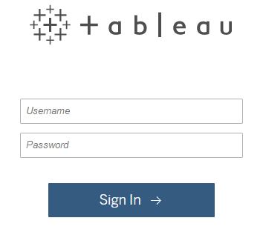

1. Enter the credentials for the server administrator that you created when you finished installing Tableau Server.

You're then taken to the main page of the **Default** site, and you're ready to create users, sites, and manage content.

## Server administrator tasks

Server administrators (available with Tableau Server Enterprise only) can do the following:

* Monitor server status and activity.
* Generate log files.
* Add sites and edit site settings. Only server administrators can add sites to the server.
* Add users to the server, and assign users to sites.
* Add and manage site groups.

To manage settings only for a specific site, you must first navigate to the site. Within each site, you can do the following:

* Administer content: Create projects, move content from one project to another, assign permissions, change ownership of a content resource, and so on.
* Manage schedules for extract refreshes and subscriptions.
* Monitor site activity and record workbook performance metrics.
* Manage storage space limits for content published by users.
* Allow web authoring.
* Enable revision history.
* Allow site administrators to add and remove users.
* Allow users to subscribe to workbooks and views, and allow content owners to subscribe others to workbooks and views.
* Enable offline snapshots for favorites (iOS only)

## Site administrator tasks

A site administrator on Tableau Online or Tableau Server can do the following tasks:

* Administer content: Create projects, move content from one project to another, assign permissions, change ownership of a content resource, and so on.
* View, manage, and manually run schedules for extract refreshes and subscriptions.
* Add and manage site users
* Add and manage site groups.
* Monitor site activity.

### Site administrator

|  |  |
| --- | --- |
| If you are a site administrator for Tableau Online or Tableau Server, and you have access to multiple sites, you’ll get menus for selecting which site to manage, and for managing that site’s content, users, groups, schedules, and tasks, and for monitoring its status.  The site selector displays the name of the current site. To go to another site, select the site menu, and then select the site name.  If you have access to only one site, the site selector does not appear, but all other menus are the same. | https://help.tableau.com/current/server/en-us/Img/gs_ms_siteadmin_contentpage.png |

# Configure SMTP Setup:

Tableau Server can email server administrators about system failures, and email server users about subscribed views and data-driven alerts. First, however, you need to configure the SMTP server that Tableau Server uses to send email. After configuring SMTP, complete the steps to configure notifications ([Configure Server Event Notification](https://help.tableau.com/current/server/en-us/email.htm)), then when you start or restart the server, it will trigger an email notification, which confirms that you have set up notifications correctly.

Encrypted SMTP connections are not supported for notifications or subscriptions.

Configuring SMTP requires that you restart Tableau Server services.

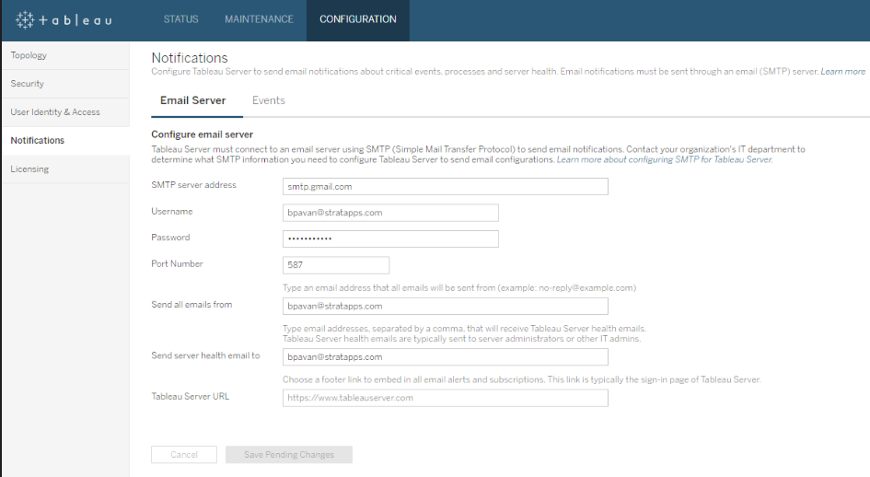

6. Then apply changes and restart

# Configure Server Event Notification:

You can configure the following server notifications on the following events:

* Content updates
  + Extract failures
  + Subscription views for users
  + Flow run failures
* Server health monitoring
  + Server status changes
  + License reporting
* Drive space
  + Recording usage history
  + Email alerts when space crosses or remains below pre-configured thresholds

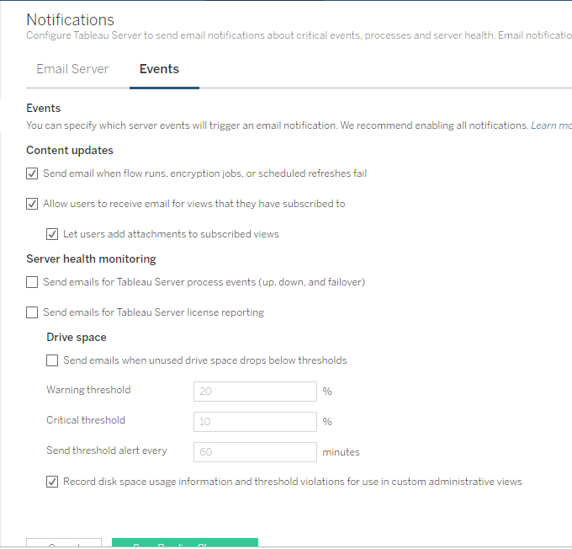

**Add Users from Server:**

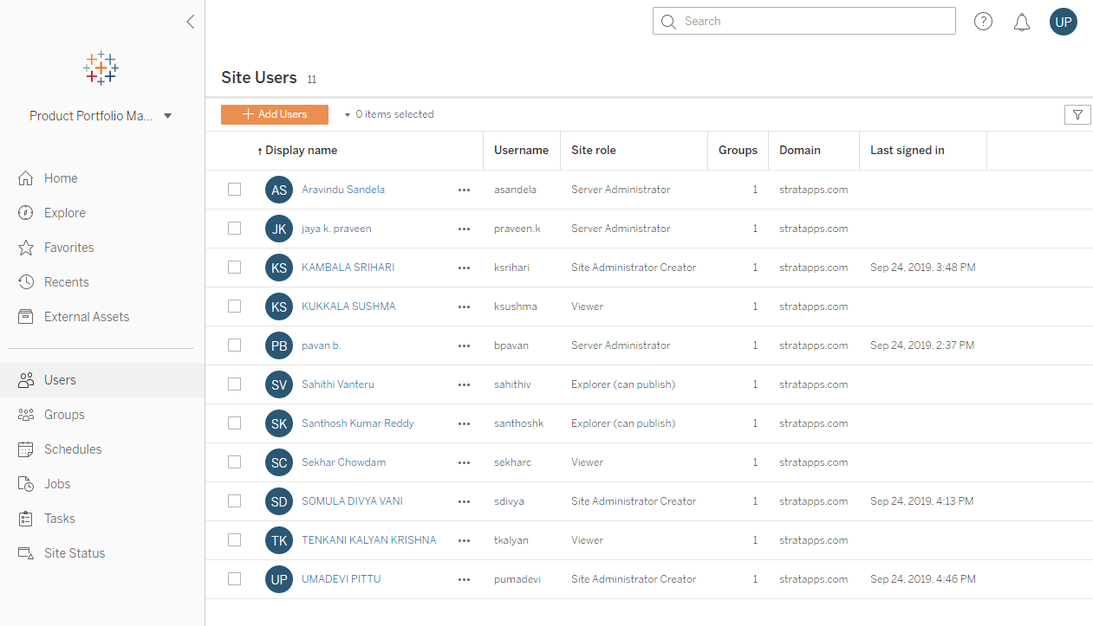

Select Add Users option then it will open one popup:

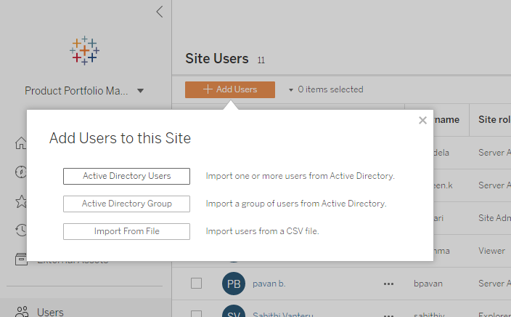

User name and then select site roles from explore (or) Viewer (or) creator:

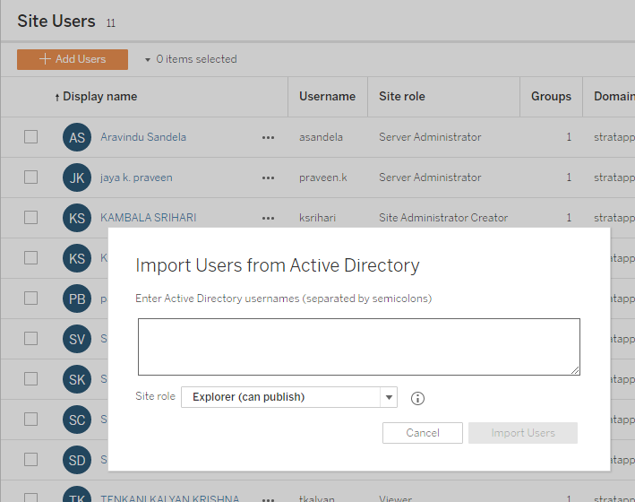

Change site role:

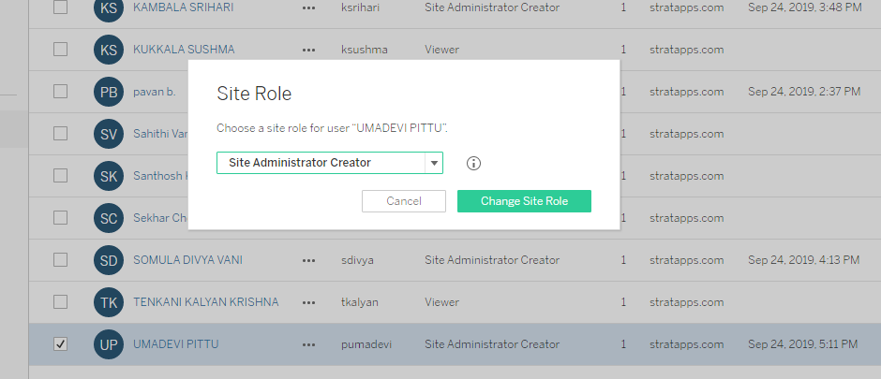

Site roles:

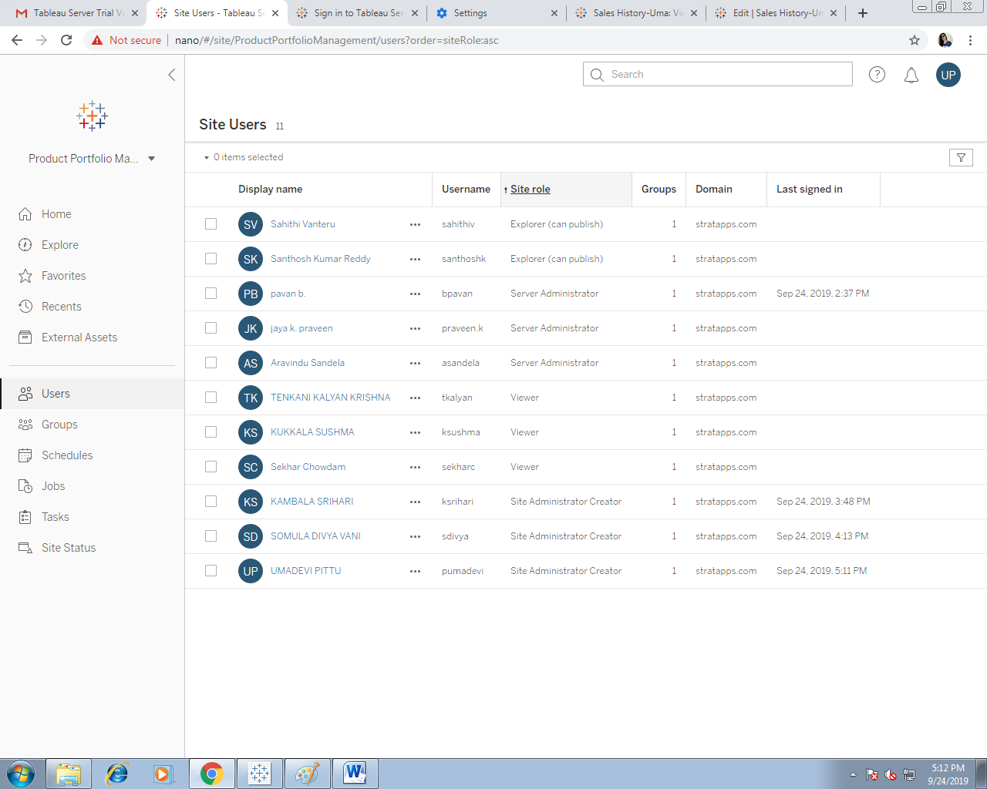

Schedules:

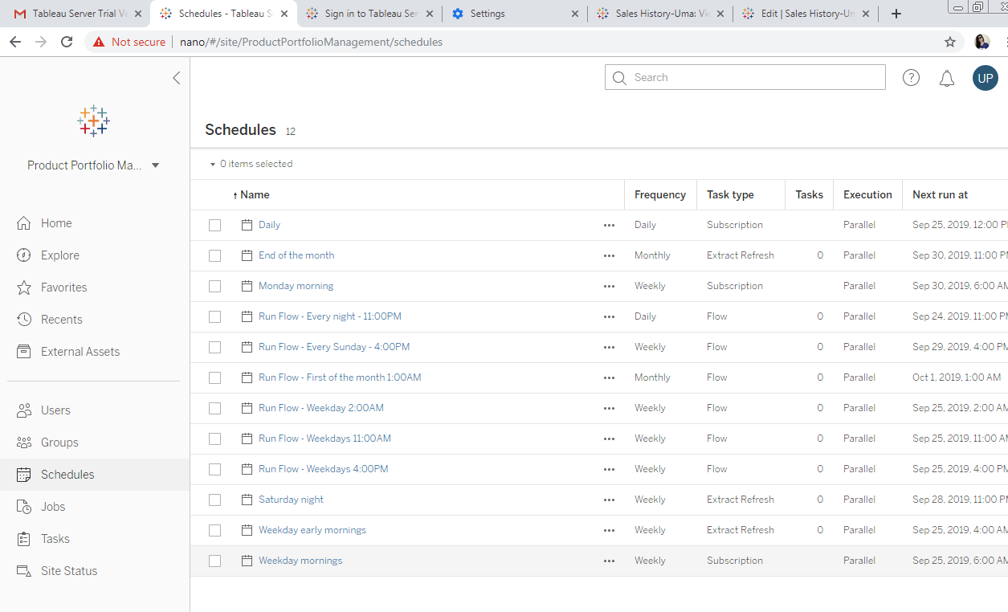

## To create a new schedule

1. In a site, click **Schedules**.
2. Click **New Schedule**.

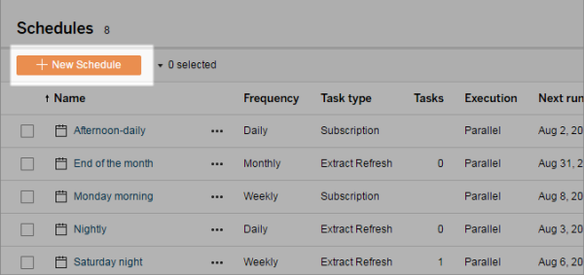

1. Specify a descriptive **Name** for the schedule. For example, End of week.
2. Select a **Task type** the schedule will handle—refreshing extracts, running flows, or delivering subscriptions.
3. Optionally you can define a **Default Priority** from 1 to 100, where 1 is the highest priority. This is the priority that will be assigned to the tasks by default. If two tasks are pending in the queue, the one with the higher priority runs first.
4. Choose whether a schedule will run in parallel or serially. Schedules that run in parallel run on all available backgrounder processes so that they can complete faster.
5. Finish defining the schedule. You can define an hourly, daily, weekly, or monthly schedule.

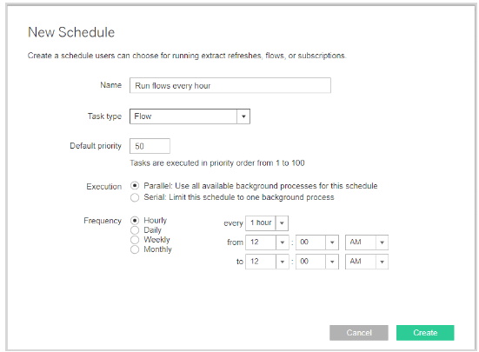

## To modify an existing schedule

1. Navigate to the Schedules page.
2. Select an existing schedule, click the Actions drop-down arrow, and then select **Edit Settings**.

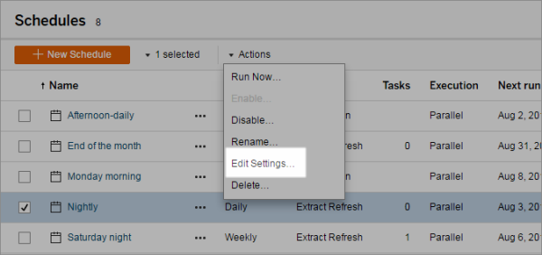

1. Finish editing the schedule, and click **Save**.

Change Schedules:

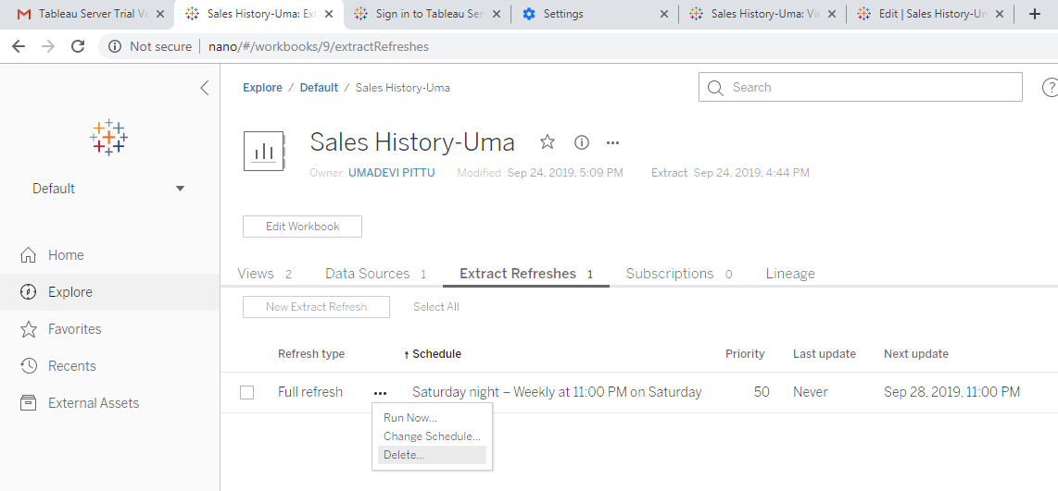

# Manage Refresh Tasks

Administrators can change the priority of scheduled extract refreshes relative to other server tasks, manually refresh extracts, or delete their schedules.

1. Sign in to the site that has the schedules you want to manage, and then click **Tasks**.
2. Select one or more scheduled extract refreshes.
3. From the **Actions** menu, do any of the following:
   * Select **Change Schedule**, and choose a new schedule from the list.
   * Select **Run Now** to refresh manually.

**Note:** If an extract does not have a scheduled refresh, you can refresh it on demand from the Data Connections page.

* + Select **Change Priority**, and enter a number between 1 and 100 to move the extract up or down in the priority list.

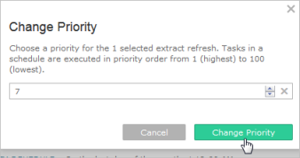

* + Select **Delete** to completely remove the schedule for the selected data sources.

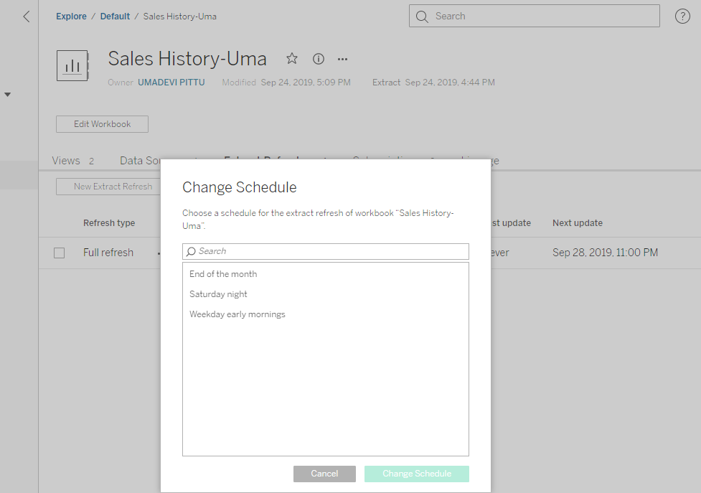

Here Inherit the Permission for the server.

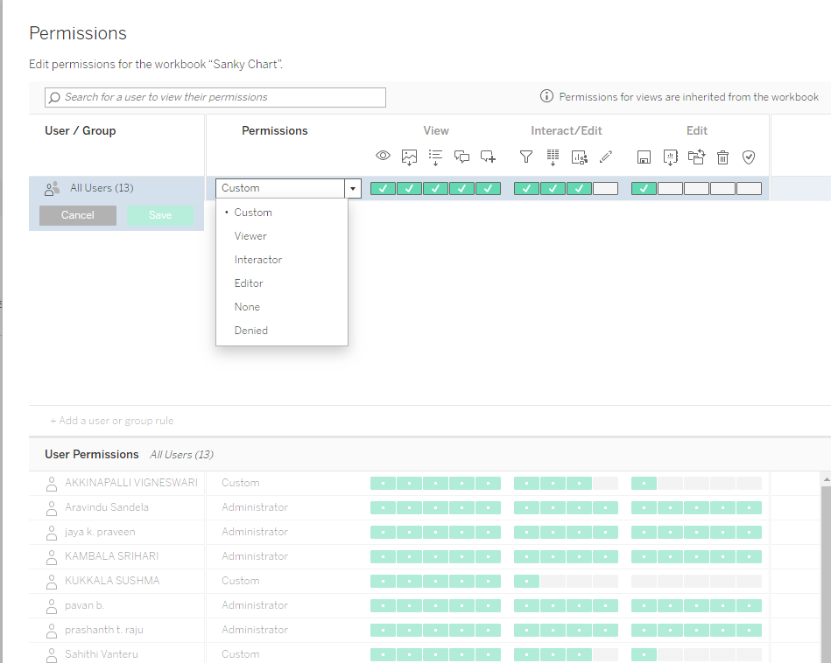

Edit The Workbook in Server Level:

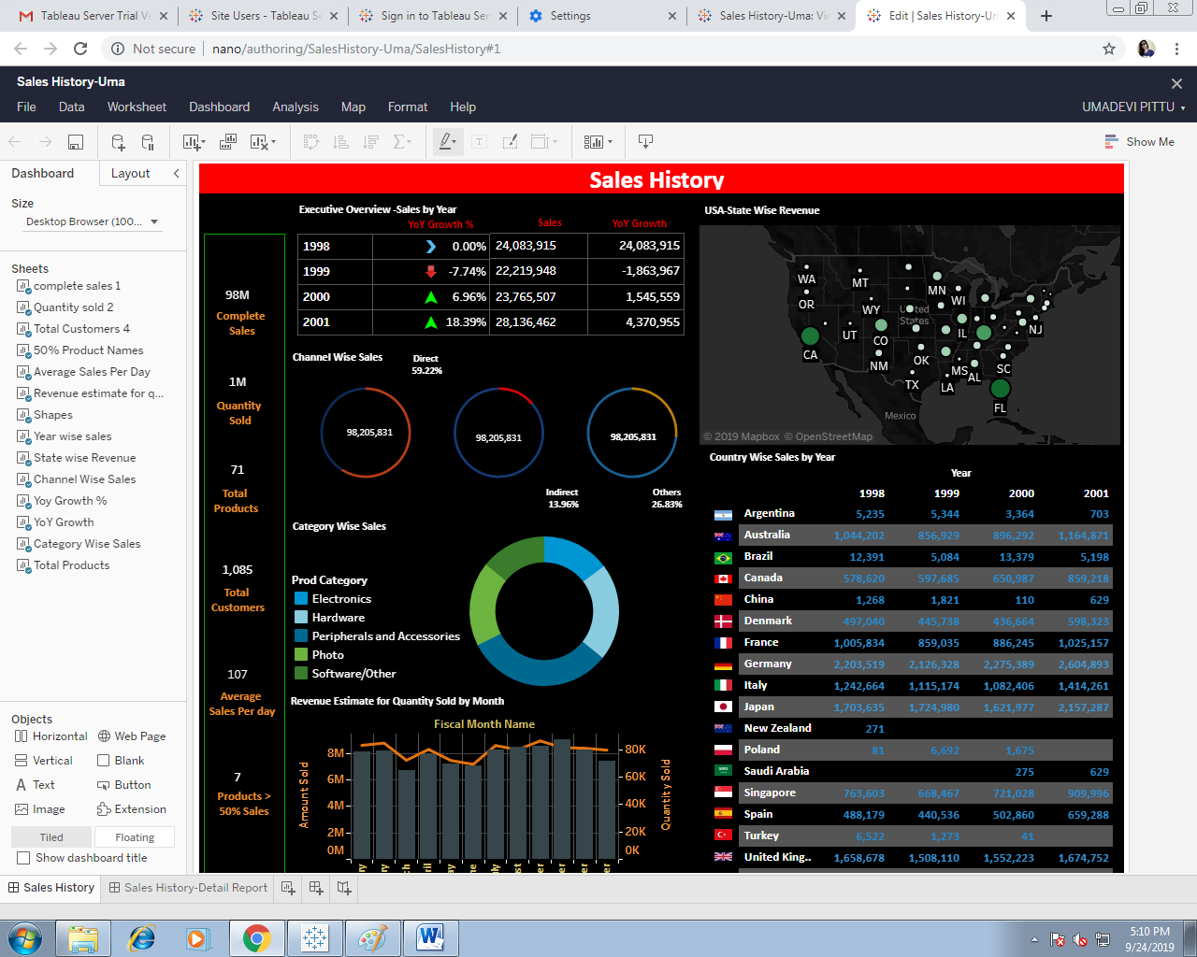

Here Workbook level Permissions:

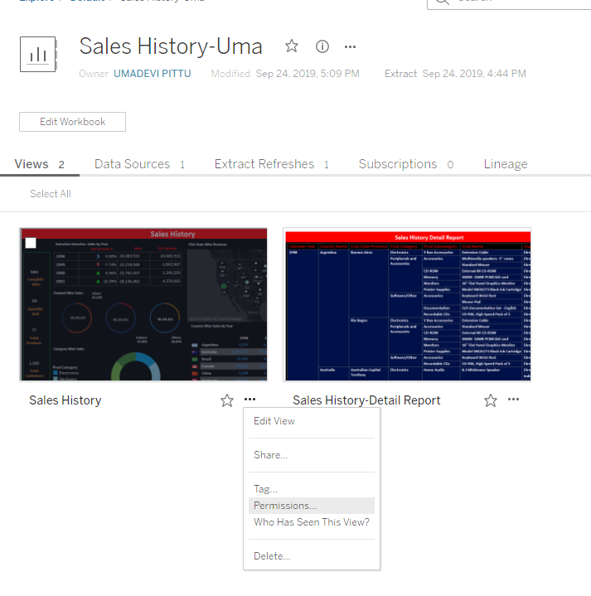

After that it will open new window it will show User/Group and Permissions

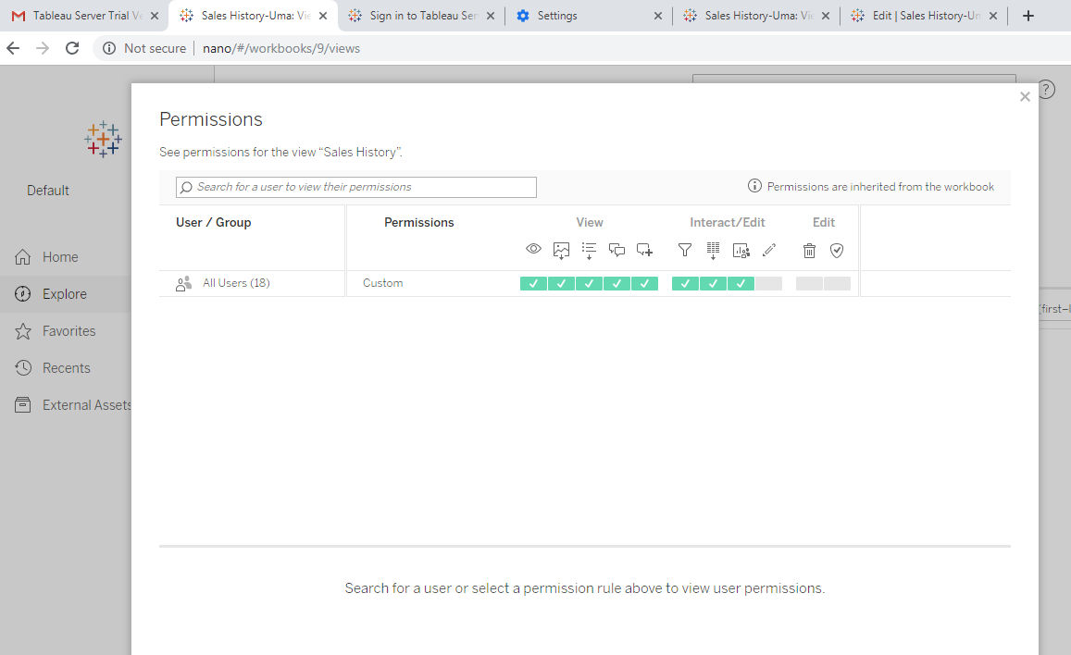

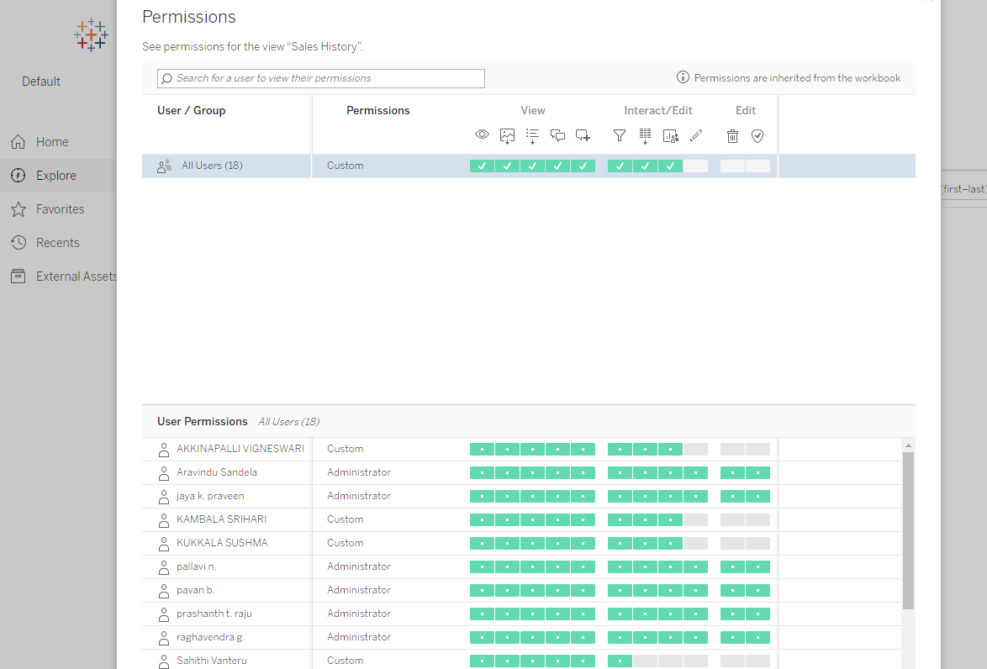

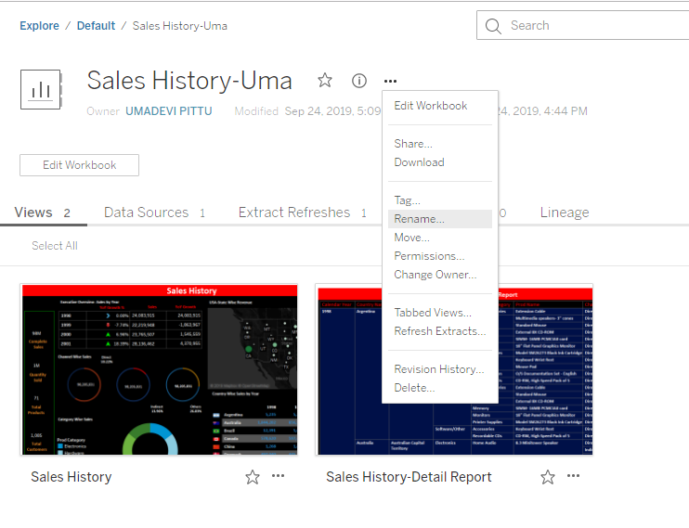

Here also we can edit the Permissions, Rename, Refresh Extracts, Edit the Workbook.

Revision History:

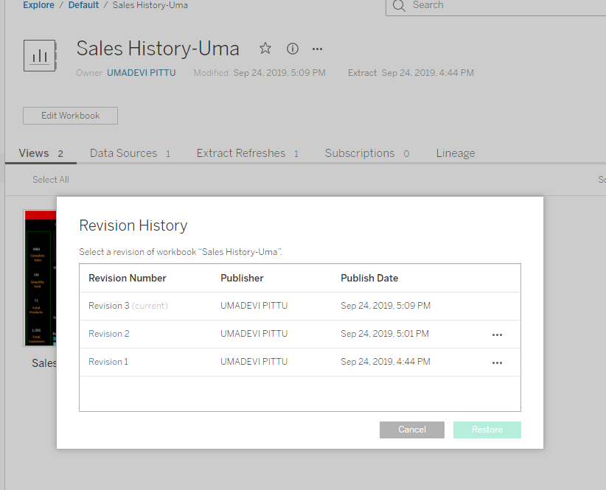

Publish To Workbook on the Server:

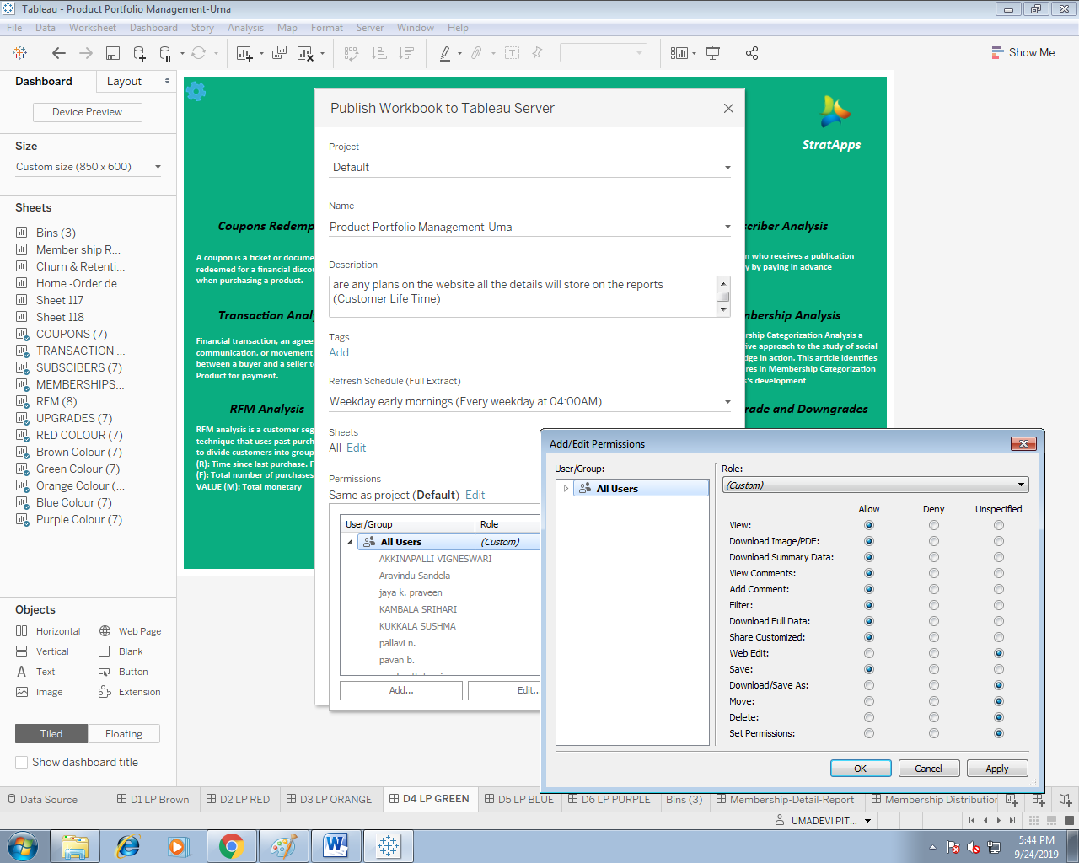

Change Permissions for workbook level:

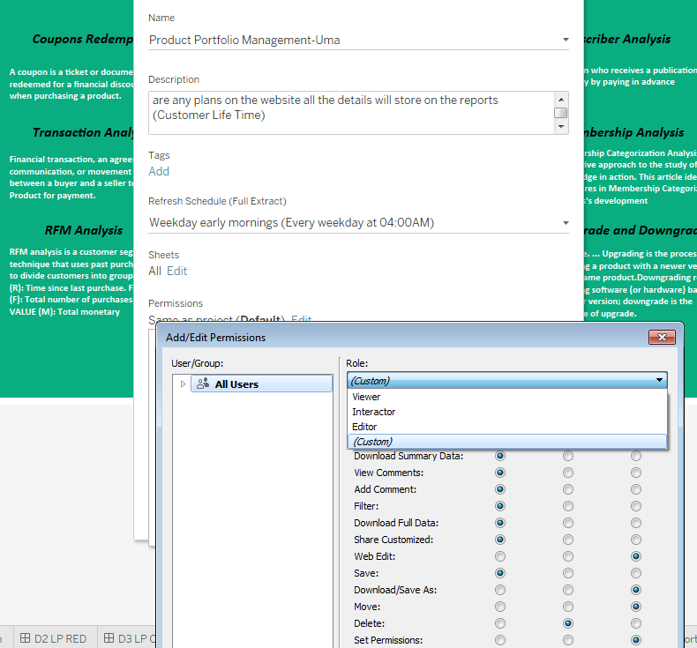

These are all Embedded Workbooks no need to ask Password for every time

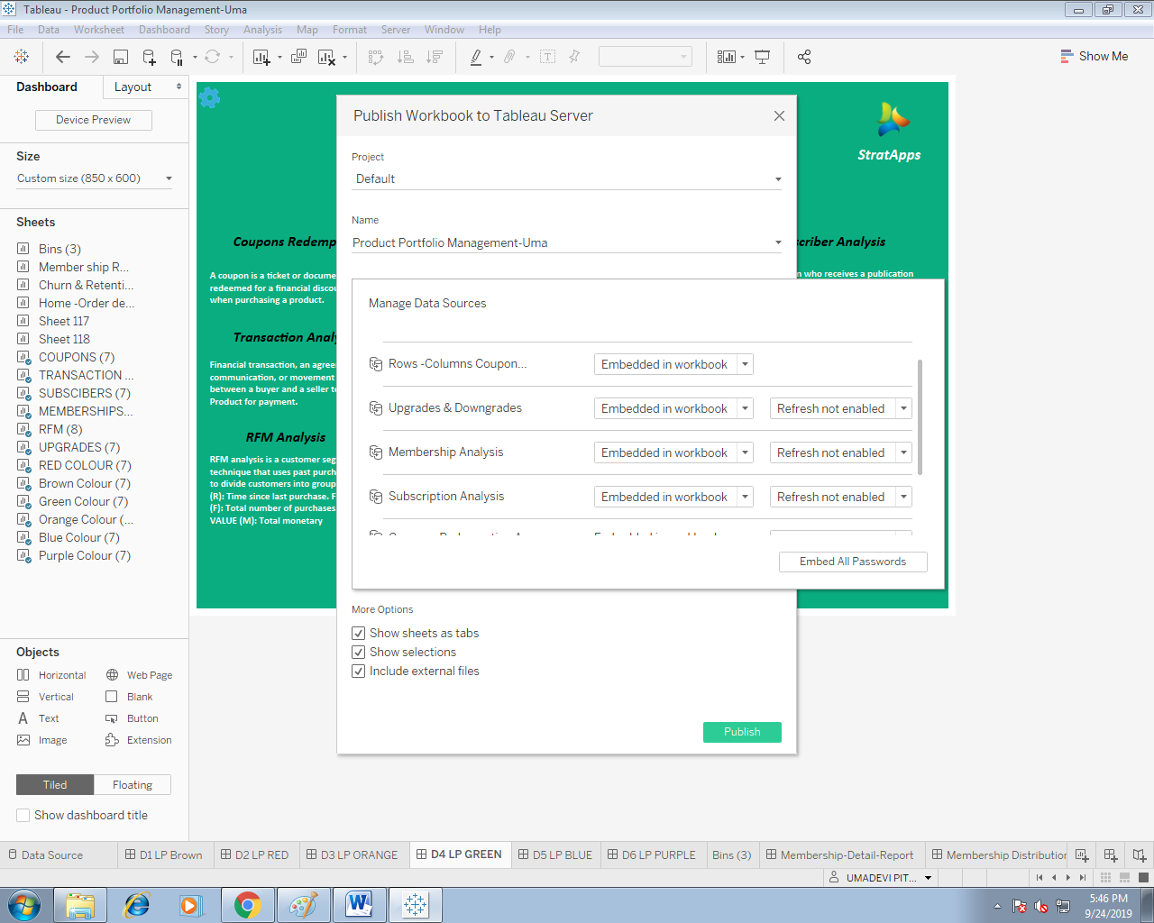

Here we can Publish Workbook:

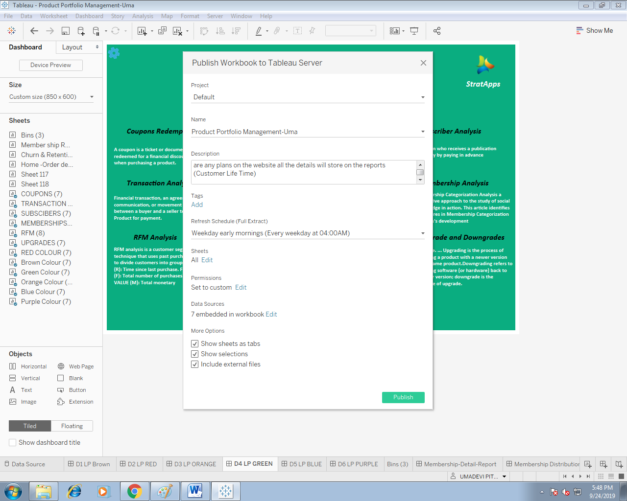

After selecting Publish then it will show:

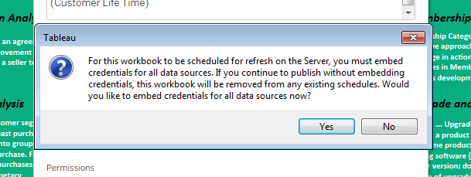

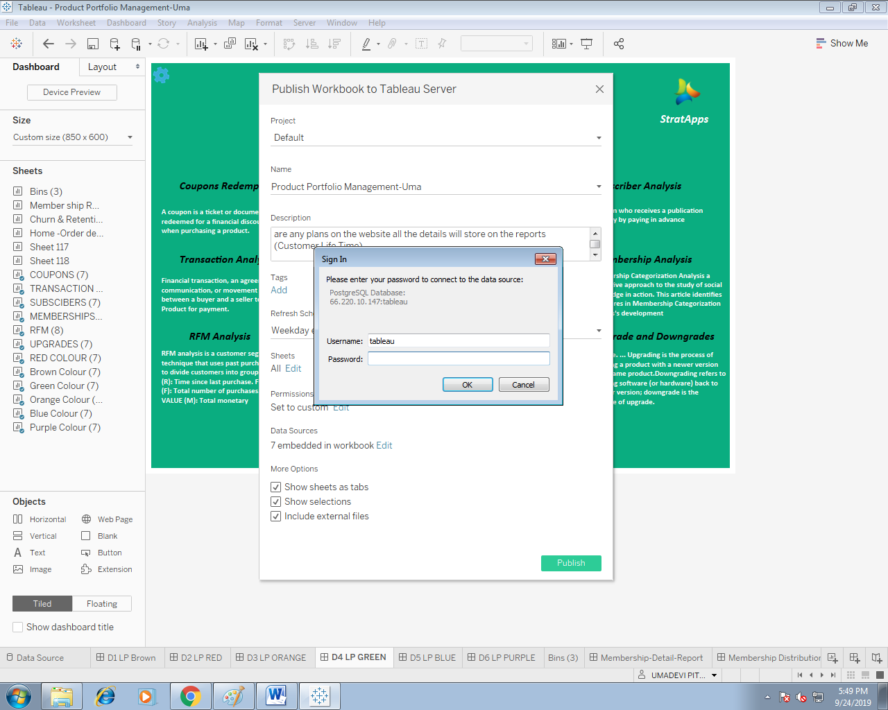

Here asking for tableau Credential Pwd enter PWD then OK

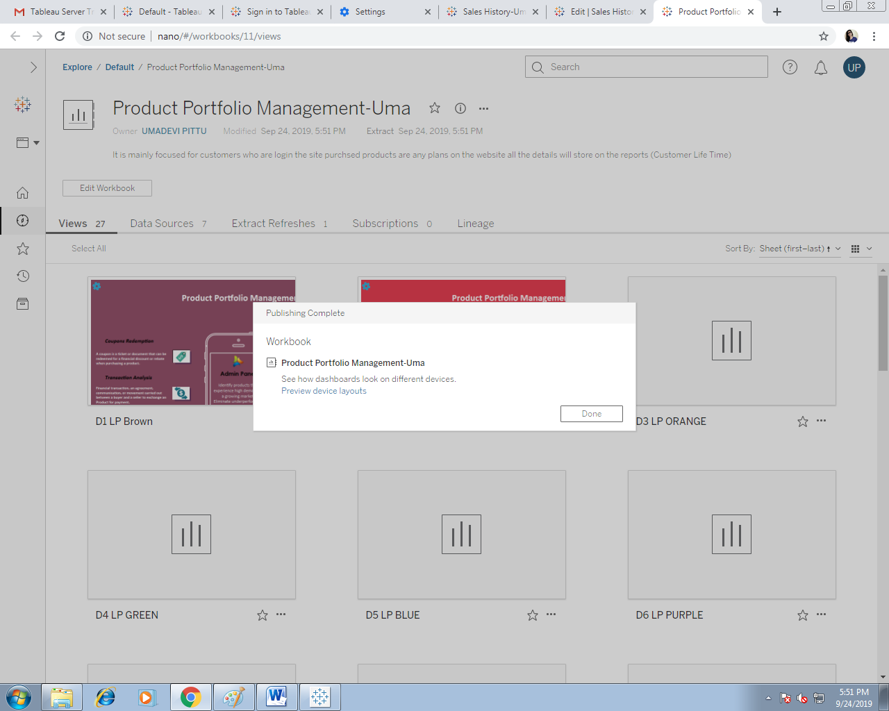

Add Groups from server:

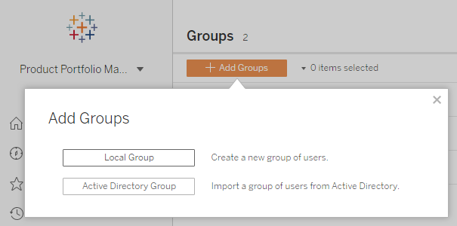

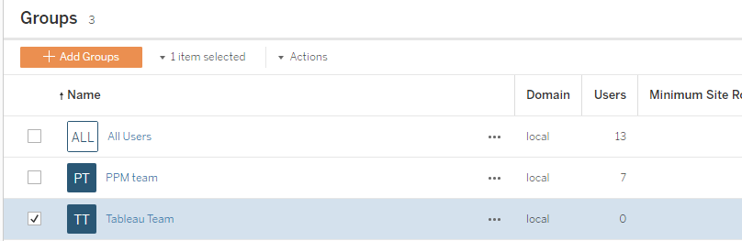

Here creating the group name as Tableau Team after that adding members from that group then select group name and add members from that group.

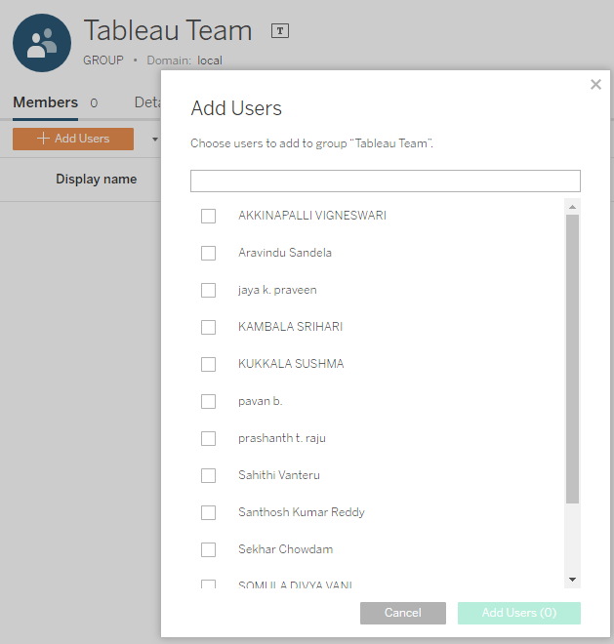

Here one user can assign how many groups we can easily checking the group membership.

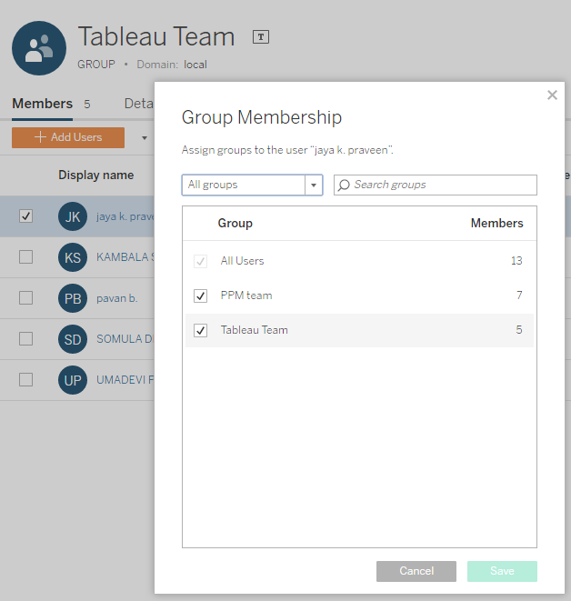

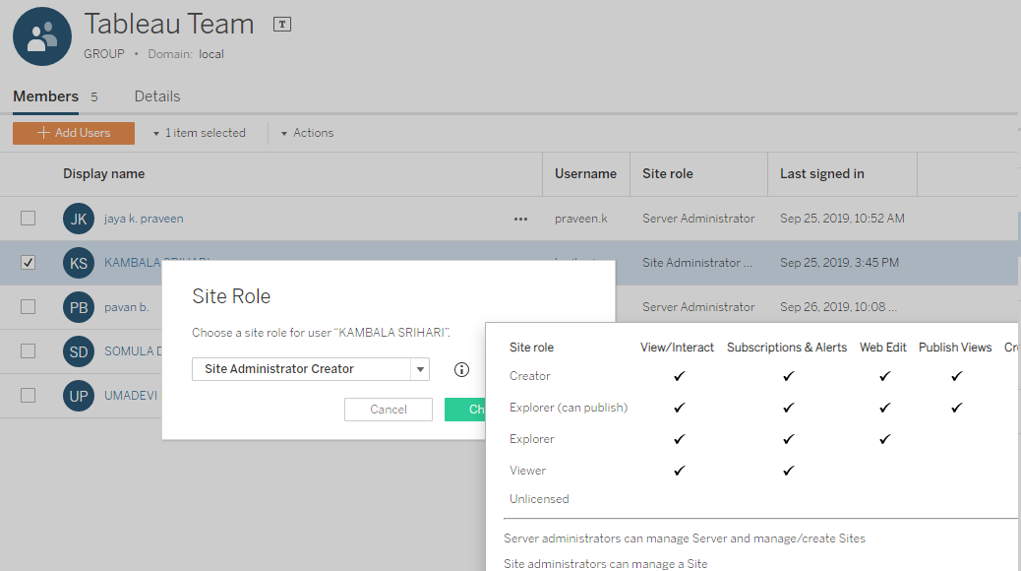

Here also we can change the site roles of users after creating the group, adding members from the group, can change the site roles.