**ASSIGNMENT-6**

1. Write a query to display the name (first name and last name) for those employees who get more salary than the employee whose ID is 163?

Ans: select first_name,last_name from employees where salary>(select salary from employees where employee_id=163);

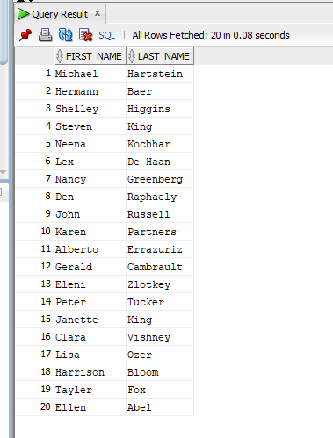

1. Write a query to display the name (first name and last name), salary, department id for those employees who earn such an amount of salary which is the smallest salary of any of the departments.

Ans: select first_name,last_name,salary,department_id from employees where salary in(select min(salary) from employees group by department_id);

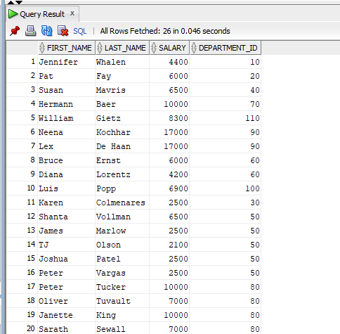

1. Write a query to display the department number, name (first name and last name), job_id and department name for all employees in the Finance department.

Ans: select e.department_id, e.first_name,e.last_name,e.job_id,d.dname from employees e,dept d where e.department_id=d.deptno and d.dname='Finance';

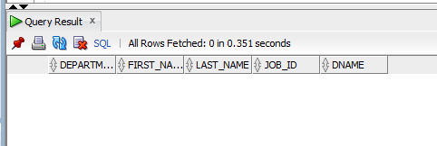

**(OR)**

select e.department_id,e.first_name,e.last_name,e.job_id,d.dname from employees e,dept d where e.department_id=d.deptno and exists(select dname from dept where dname='Finance');



1. Write a query to display all the information for those employees whose id is any id who earn the second highest salary?

Ans: select *from employees

where employee_id

in(select employee_id from employees where salary =

(select max(salary)from employees where salary<

(select max(salary) from employees)));

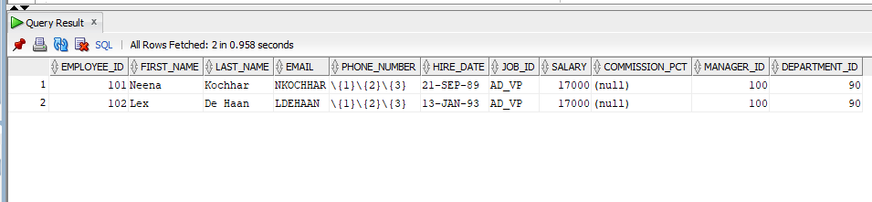

1. Write a query to display the employee number, name (first name and last name), and salary for all employees who earn more than the average salary and who work in a department with any employee with a J in their name?

Ans: select employee_id, first_name, last_name, salary from employees where salary> (select avg(salary) from employees) and department_id in (select department_id from employees where first_name LIKE '%J');

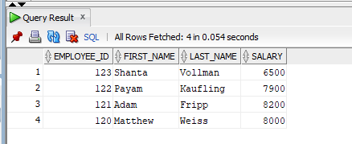

1. Write a query to display the employee number, name (first name and last name) and job title for all employees whose salary is smaller than any salary of those employees whose job title is MK_MAN.?

Ans: select employee_id, first_name, last_name, job_id from employees where salary<(select salary from employees where job_id='MK_MAN');

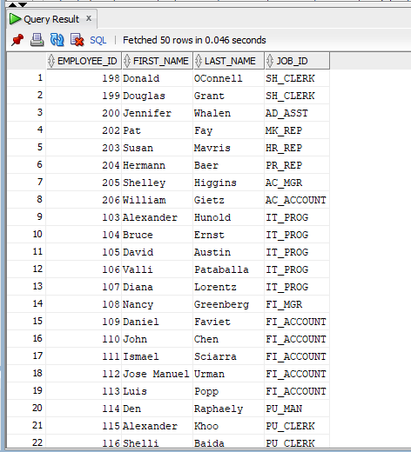

1. Write a query to display the employee name( first name and last name ) and department for all employees for any existence of those employees whose salary is more than 3700.

Ans: select e.first_name, e.last_name, d.dname from employees e,dept d where e.department_id=d.deptno and exists(select salary from employees where salary>3700);

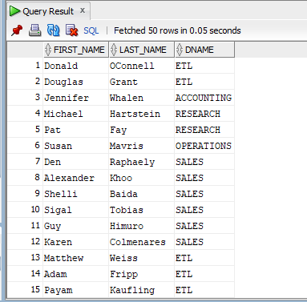

**(OR)**

select first_name, last_name, department_id from employees where exists(select salary from employees where salary>3700);

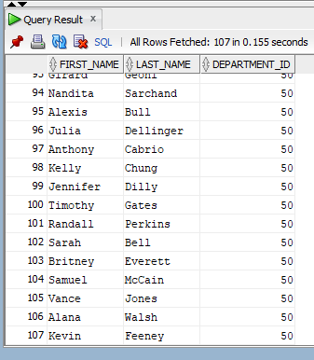

1. Write a query that will identify all employees who work in departments located in the United Kingdom?

Ans: select *from employees where department_id in(select deptno from dept where loc='UNITED KINGDOM');

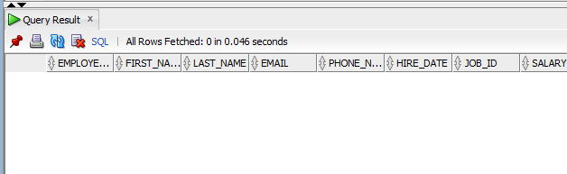

1. Write a query to get the details of employees who manage a department.

Ans: select *from employees where employee_id=any(select manager_id from dept);

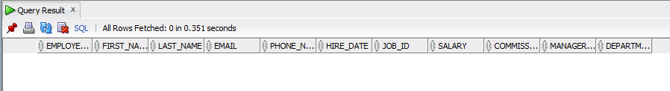

1. Write a query to display the employee id, name (first name and last name), salary, department name and city for all the employees who get the salary as the salary earned by the employee which is maximum within the joining person January 1st, 2002 and December 31st, 2003?

Ans: select e. employee_id, e. first_name, e. last_name, e. salary, d. dname, d.loc from employees e, dept d where e. department_id=d. deptno and e. salary= (select max(salary) from employees where hire_date BETWEEN ‘01/01/2002’ AND ‘’12/31/2003’);